Computer simulation of the reinforcing part of the distillation column

Yuriy N. Serditov
Saint Petersburg Electrotechnical University "LETI"
Russia, Saint Petersburg
yunserditov@stud.eltech.ru
Sergey E. Dushin
Saint Petersburg Electrotechnical University "LETI"
Russia, Saint Petersburg
dushins@yandex.ru

Sergey E. Abramkin
Saint Petersburg Electrotechnical University "LETI"
Russia, Saint Petersburg
seabramkin@etu.ru

Abstract — The purpose of the study is to increase the speed and quality of the design of process control systems on the example of the study of heat and mass transfer processes in the reinforcing part of the distillation column. Results of the research: finite-difference models of a distillation column and an air-cooled apparatus based on discrete-continuous mathematical models have been developed; patterns for finite difference models are defined; developed a highly specialized software module for modeling the technological processes of regeneration of diethylene glycol;
Keywords — distillation column; air cooler; Euler's scheme; numerical simulation; comparative analysis колонна.

INTRODUCTION
For the technological process (TP) of the absorption dehydration of natural gas, the main objective function is the qualitative preparation of natural gas for transportation through the main gas pipelines. This function is ensured by the quality of absorbents used in this TP. Note that the process of supplying the liquid absorber to the absorbers is closed. Absorbent after participation in the process of drying of natural gas is fed to the regeneration unit, where its quality indicators are restored. In this case, the quality indicator is the concentration of the absorbent. After the restoration of the properties of the absorbent, it is again fed to the gas drying unit.
Absorbent regeneration takes place in a column-type apparatus with a regular packing - a distillation column (RC). Recovery of the quality of the absorbent is carried out in the process of mass transfer with countercurrent flow of the liquid and vapor phases. The complete RC with the input section of the initial mixture is divided into two sections - distant and strengthening. It should be noted that these sections can work separately from each other as independent devices [1]. Such devices are called incomplete RC and they receive only one of the components of the system. Drift RC allows you to get a high-boiling component (absorbent) and firming RC - low-boiling (distillate, reflux, reflux). However, obtaining products in almost pure form in incomplete RC is not economically feasible, since it requires an unreasonably large expenditure of energy [2].
Currently, the study of the process of absorbent regeneration is carried out mainly on static models. But such models do not allow studying the process with parameters varying in time and space. From the point of view of the development of control systems of this kind of objects, it is necessary to study its behavior when the technological regime changes.
The report presents the results of the study of mass and heat exchange processes in the strengthening rectifying column. It was carried out on the basis of a dynamic non-linear mathematical model of mass heat exchange processes presented in [1].

the reinforcing part of the distillation column
The movement of material flows in the strengthening RС is illustrated in the diagram in fig. 1. The flow Gп with a molar fraction Cп of the initial product in the form of a vapor phase is fed under its lower nozzle. From the lower nozzle, phlegm is given with a molar fraction which represents one of the products of strengthening RC. From the lower nozzle, phlegm 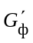 is given with a molar fraction 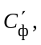 which represents one of the products of strengthening RC. The steam flow 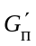 with a molar fraction 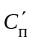 from the upper nozzle is discharged into the air cooling unit (ACU). In ACU, heat is released into the atmosphere with a flow of Qв in atmospheric air. In this case, the vapor phase is partially condensed and a stream of reflux (reflux, distillate) Gф is formed with a molar fraction of Cф. The reflux stream is then returned to the distillation column as irrigation. Steam residue condensation - distillate Gд with a molar fraction of Cд - is the main product of the consolidating distillation column.
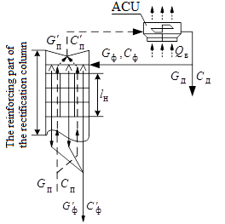
- The flow diagram of the reinforcing part of the rectification column
Simultaneously with the condensation process, air and other non-condensable gases are accumulated in the ABO working space. They are separated from the vapor-liquid mixture and penetrate through the loose connections of the apparatus from the surrounding air. The accumulation and growth of their partial pressure lead to a decrease in the vacuum in the distillation column. In this regard, the maintenance of vacuum in the distillation column at a given level is carried out by their continuous removal from the ABO. Apply to vacuum pumps, which also prevent pressure fluctuations in the system, due to changes in temperature of atmospheric air.

STUDY OF PROCESSES IN STRENGTHENING RECTIFICATION COLUMN
Dynamic mathematical models of the elements of the distillation column are presented in continuous and discrete-continuous form in [2]. It also presents the results of the study of mass transfer processes in a distillation column and heat exchange processes in ABO using computer models implemented in SimInTech.
Simulation of the process under study in SimInTech was accompanied by considerable time and complexity when changing the structure of the computer model. Based on this, one of the objectives of this study was formulated - the development of a narrowly focused program module for modeling mass and heat transfer processes.
The task of modeling this kind of processes belongs to the class of one-dimensional. Such problems are traditionally solved by the finite difference method [3]. Therefore, the development of a software product is based on the method of explicit Euler schemes (Fig. 2) [4]. The advantages of this method are the relative simplicity of the software implementation of the algorithms and the increase in the speed of the modeling process. The speed is achieved due to the minimum number of arithmetic operations.
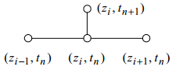
- Four-Point Explicit Difference Pattern
The disadvantages of the method are that it is not accurate enough for certain processes. Also for this method there are limitations of the integration step imposed by the stability conditions of the explicit method.
In the process of research, the transformation of discrete-continuous models from [1] into a difference form was carried out. The result is a model describing the processes in the strengthening part of the distillation column:
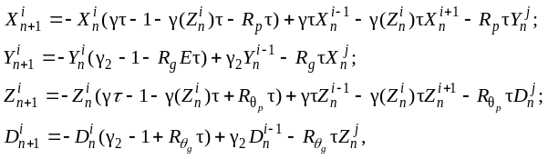 
where γ = (aθ0) / h;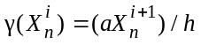;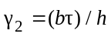; 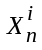 – vapor phase temperature; 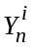 – liquid phase temperature; 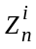 – vapor phase concentration; 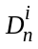 – liquid phase concentration; Rp, Rg, Rθp, Rθg – physical and technological factors.
The discrete-continuous ACU model [1] in the difference form takes the form:
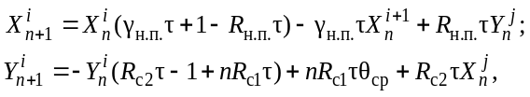 (2)
where γн.п. = (υн.п.) / h; υн.п. – heat flow rate of saturated steam; – vapor phase temperature; – liquid phase temperature; n – number of pipelines in ACU; θср – ambient temperature; Rн.п., Rс1, Rс2 – physical and technological factors.
In the course of the study, various patterns for models of the reinforcing part of the distillation column and ABO were studied. As a result of the study of dynamic and static characteristics, the following schemes have shown their effectiveness (see Fig. 3 a, b).
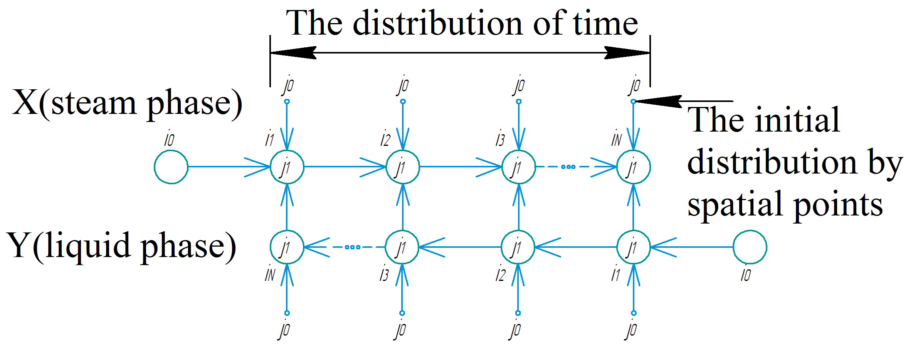
а
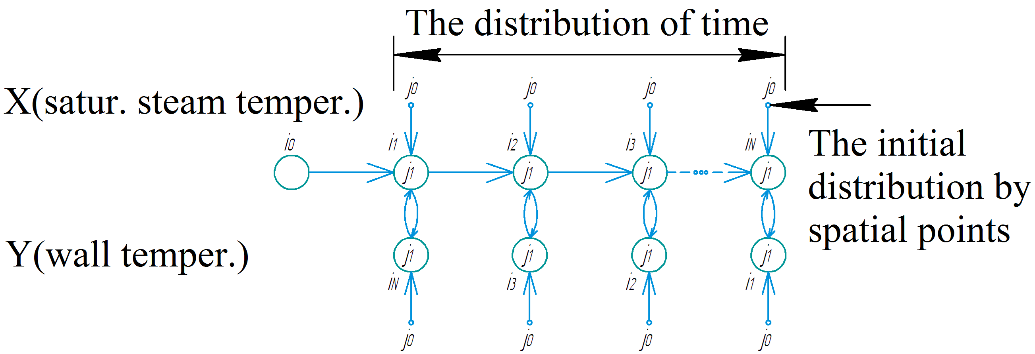
b
- Graphic schemes of forming difference models: а – strengthening part of the distillation column; b – air cooler
The implementation of difference models is implemented in the developed highly specialized software module. The graphical interface of the main window of this module is shown below (Fig. 4).
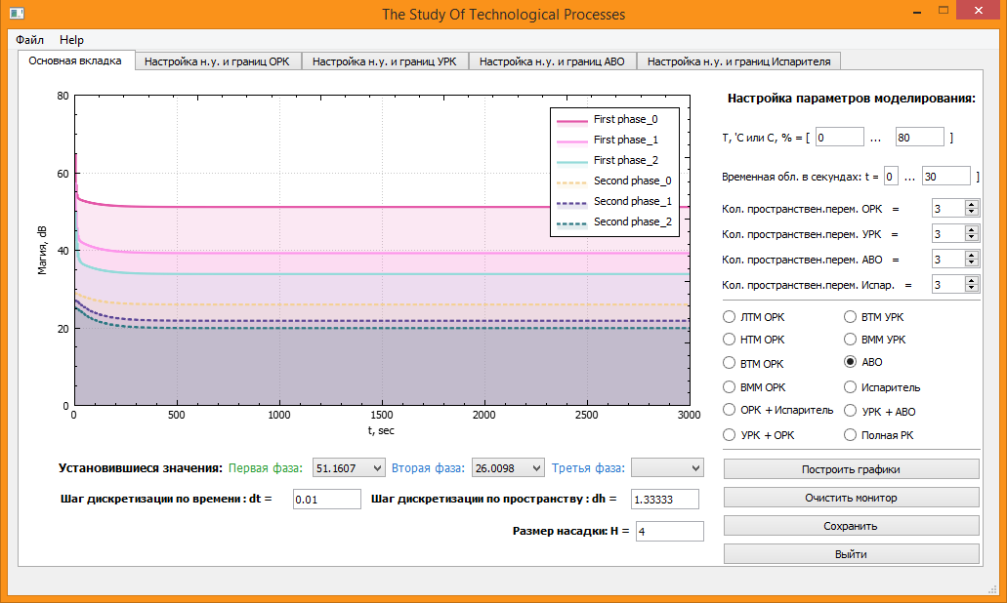
- Graphical user interface of the program module
Verification of the results was carried out in the mathematical package SimInTech. For this purpose, computer models of the reinforcing part of the distillation column and ACU were built (Fig. 5).

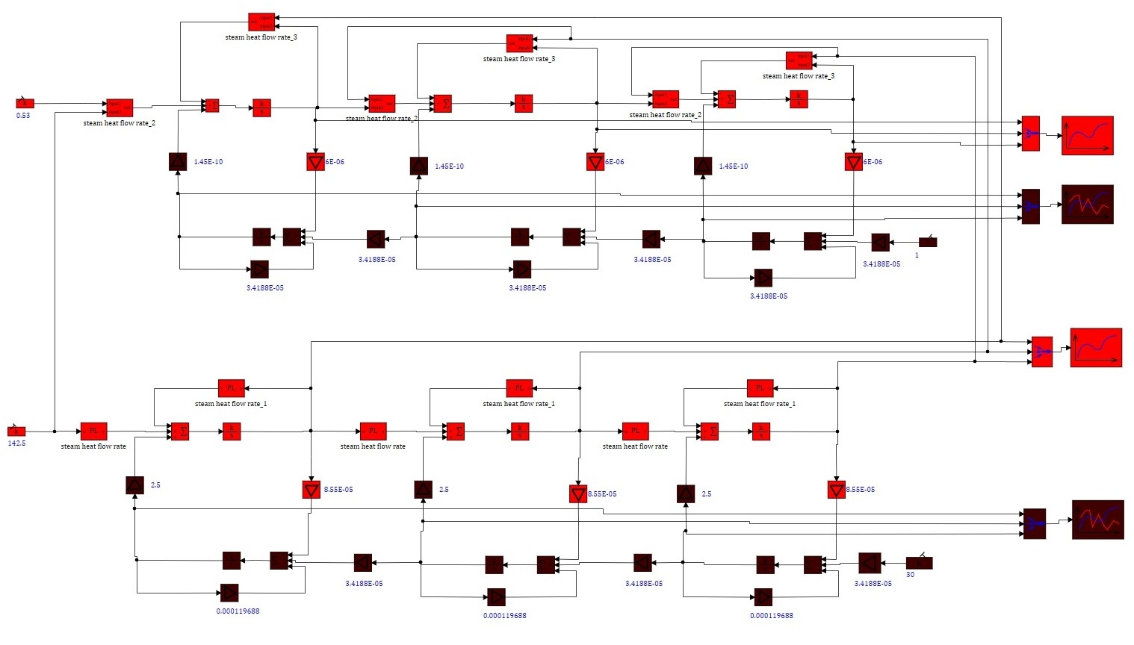
а
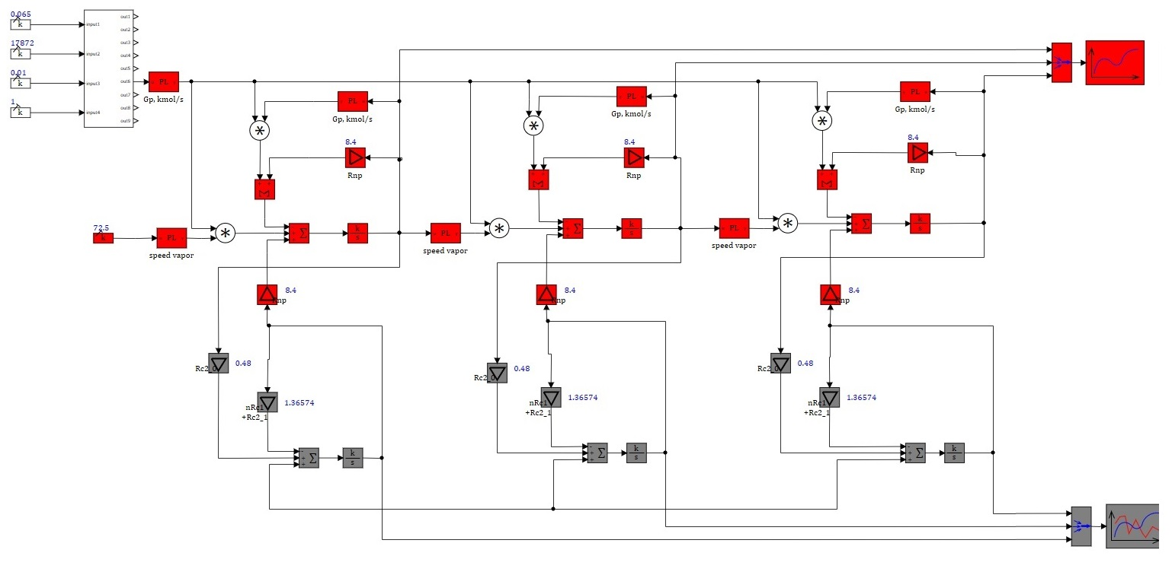
б
- Block diagrams of computer models in SimInTech: а – strengthening part of the distillation column; b – air cooler
The results of computer simulation confirmed the adequacy of difference models with real TP. In particular, in fig. 6 presents the results of modeling processes in ACU.
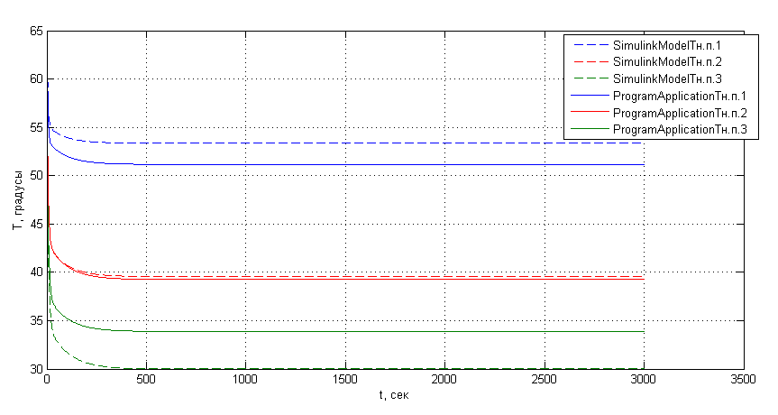
а 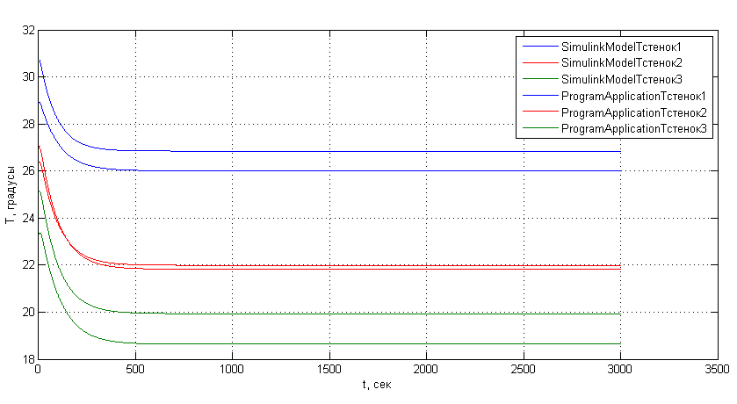
б
- Graphs of transient processes in heat exchange sections of ACU: а – on the temperature of saturated steam; b - the temperature of the glass
Simulation of heat exchange processes was carried out with the following parameters: Δτ = 0,01 - time discretization step, Δh = 1,333 - space discretization step, z = 3 - number of spatial points on the grid, t = 1000 - final simulation time.
Analysis of the graphs of the air cooling system shows that the obtained difference model adequately reflects the dynamics of the processes, and the available error (3 degrees for the saturated vapor temperature and 1 degree for the wall temperature) is not critical.

CONCLUSION
The main results of the study:
- schemes have been developed for transforming a mathematical model from a discrete-continuous form into a finite-difference form based on an explicit Euler scheme;
- difference models of the reinforcing part of the distillation column and the air cooler were developed;
- a software module was developed, which allows to adequately and quickly simulate TP belonging to the class of mass-heat exchange.

REFERENCES
- Абрамкин С.Е. Душин С.Е. Моделирование управляемых процессов абсорбционной осушки природного газа. СПб.: Изд-во СПбГЭТУ «ЛЭТИ», 2015. 160 с.
- Багатуров С.А. Основы теории и расчета перегонки и ректификации. М.: Химия, 1974. 440 с.
- Emery A. F., An Evaluation of Several Differencing Methods for Inviscid Fluid Flow Problems, J. Соmp. Phys., 2, 306—331, 1968.
- Микеладзе Ш.Е. Численные методы интегрирования дифференциальных уравнений с частными производными. М.: Изд-во АН СССР, 1963.108 с.
- Нуберт Г.П. Измерительные преобразователи неэлектрических величин: Введение в теорию, расчет и конструирование. Л: Энергия, 1970. -358 с.

.

