Modeling of heat and mass transfer processes
in the system
«distillation column – evaporator»

Yu. N. Serditov ¹, S. E. Abramkin ²
Saint Petersburg Electrotechnical University “LETI”
¹ ura-nikolaevic@yandex.ru, ² seabramkin@etu.ru

Annotation. The refinement of the existing Evaporator model has been carried out. The main disturbing influences for these processes are revealed. A computer study of the behavior of rectification processes without control was carried out in order to identify parameters that have a significant impact on them. A generalized structural diagram of a controlled rectification process is given.
Key words: rectification; mathematical modeling; mass transfer; heat exchange

INTRODUCTION
For the technological process (TP) of absorption drying of natural gas, the main target function is the quality preparation of natural gas for transportation through gas pipelines. This function is provided due to the quality of absorbents used in this TP. Note that the process of supplying a liquid absorber to the absorbers is closed. The absorbent after participating in the drying process of natural gas is fed to the regeneration unit, where its quality indicators are restored. In this case, a qualitative indicator is the concentration of absorbent. After the properties of the absorbent are restored, it is again fed to the gas dehydration unit.
Absorbent regeneration takes place in a column type apparatus with a regular packing - distillation column (RC). The restoration of the quality of the absorbent is carried out in the process of mass and heat transfer during the countercurrent flow of liquid and vapor phases. The complete RC section of the input mixture is divided into two sections - distant and strengthening. It should be noted that these sections can operate separately from each other as independent devices [1]. Such devices are called incomplete RC and they receive only one of the components of the system. Distant RC allows to obtain a high-boiling component (absorbent, diethylene glycol (DEG)), and strengthening RC - low-boiling (distillate, reflux, reflux). However, obtaining products in almost pure form in incomplete RC is economically impractical, since this requires unreasonably high energy consumption [2].
Currently, the study of the absorbent regeneration process is carried out mainly by static models. But such models do not allow studying the process with parameters changing in time and space. From the point of view of developing control systems for such objects, it is necessary to study its behavior when the technological regime changes.
The report presents the results of the study of mass and heat transfer processes in the system "distillation column - evaporator". It was carried out on the basis of a dynamic nonlinear mathematical model of heat and mass transfer processes presented in [1].

DESCRIPTION OF PHYSICS OF THE PROCESS OF RECTIFICATION IN THE TRANSFER SECTION
The system “distillation column - evaporator” consists of two interconnected systems: the distillation part of the rectification column (DRC) and the Evaporator (Heat Exchanger) itself (see Fig. 1). Mathematical models of the strengthening part of the RC are described in discrete-continuous form.
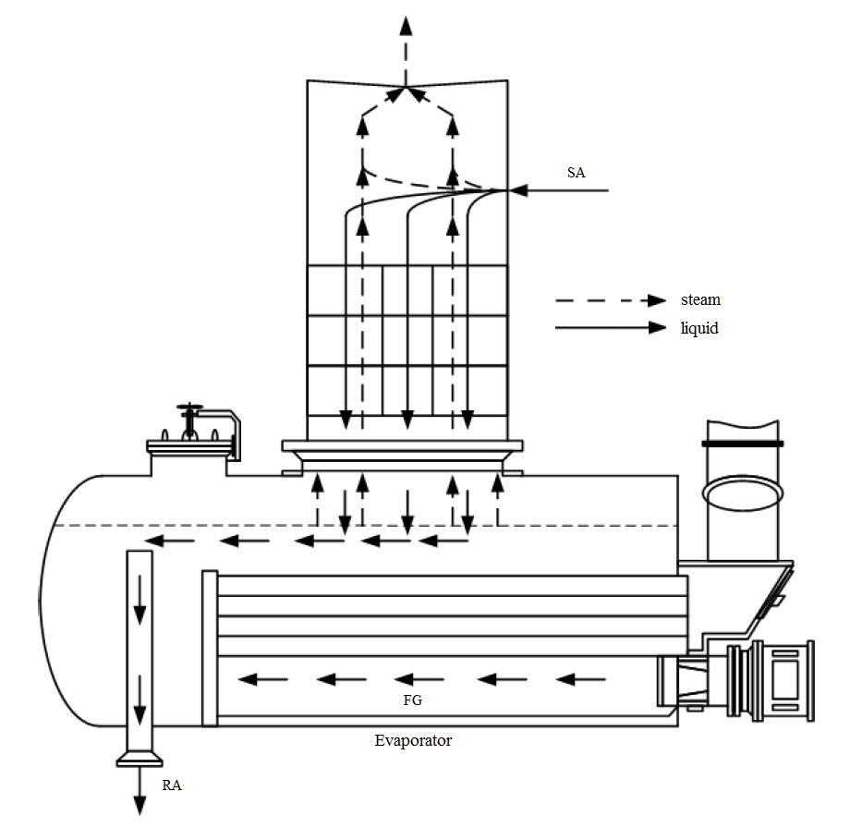
- The flow diagram of the system «distillation column - evaporator»
The following notation is used in the diagram:
flows: FG - flue gases; SА - saturated absorbent; RА is a regenerated absorbent.
The movement of material flows in the distant part of the RC is illustrated by the diagram in Fig. 1. The formation of nonequilibrium flows of steam and liquid from the initial mixture in the RC occurs due to the different boiling points of its absorbent and water. The vapor-liquid mixture is fed through the evaporation space into the distant part of the RC.
In essence, DEG is subjected to a single evaporation process twice. The first separation of the initial mixture into the vapor and liquid phases occurs precisely when saturated DEG is introduced into the evolutionary space. It is assumed that upon contact with vapors, the composition of saturated DEG does not change after the first single evaporation. The second separation occurs after passing through the mass transfer section of the DRC in the Evaporator.
Here, due to heat transfer between the outer walls of the flame tubes and the liquid phase, residual moisture is finally evaporated from it. The flow of the liquid phase is discharged from the evaporator with a given concentration.
The interaction of phases in the rectification process is carried out due to the mutual diffusion of water and absorbent from steam into liquid and vice versa, due to the difference in their concentrations.

SYSTEM MATHEMATICAL MODEL
« RECTIFICATION COLUMN - EVAPORATOR»
When developing a mathematical model (MM) of the distillation column-evaporator system, the following assumptions were made:
– for mass transfer processes:
- liquid (absorbent or reflux) to RC nozzles completely mixed;
- the basis of MM mass transfer processes is the hydrodynamic model of complete displacement;
- the longitudinal phase mixing mode is not considered;
- liquid and vapor velocities are identical on RC-section;
- concentration of the vapor and liquid are identical in cross section RC;
- idle zones in nozzles are not formed; absorbent does not hang in nozzles;
- the dependence of the equilibrium concentration of the target component (TC) in a pair is generally non-linear.
– for heat transfer processes:
- the heat capacity of the walls of the RC is small compared with the heat capacity of liquid and steam;
- there is no longitudinal mixing in each of the coolant flows, i.e. physical media in the apparatus move in the ideal displacement mode;
- lateral mixing in coolant flows is considered ideal;
- the heat flux through the wall is established instantly when temperature changes, moving countercurrent of the vapor and liquid phases.
We write the MM of interconnected heat and mass transfer processes in the form of a system of partial differential equations:
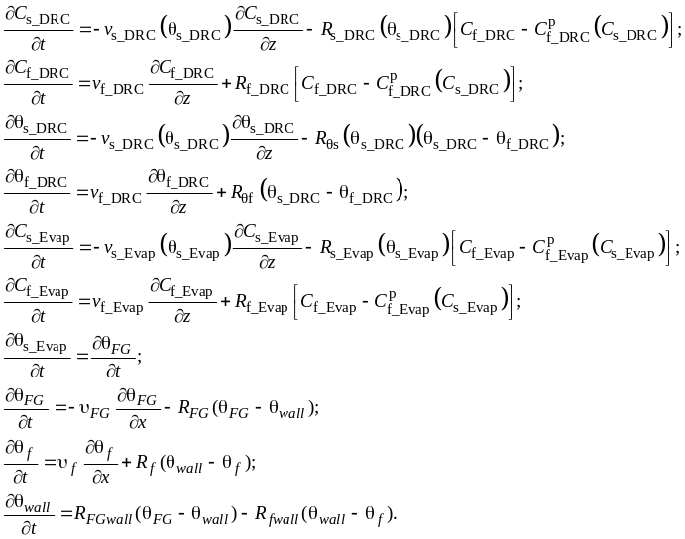 | 
, where Cs_DRC, Cf_ DRC – concentration of TC in the vapor and in the liquid; 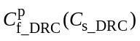 – the equilibrium concentration of TC in the liquid; vs, vf − vapor and liquid velocities; 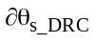, 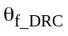, θs, θf − temperature of vapor and liquid; R_{s_DRC}, R_{s_DRC}, R_{FG} , Rs , Rf , Rθs , Rθf − physical and technological coefficients depending on the physical properties of the phases and the geometry of the RC. This model takes into account the effect of steam temperature on its physical characteristics. The vapor velocity vs, depends on the temperature θs.

RECTIFICATION MANAGEMENT
Direct process control in the RC is not feasible due to the nature of the process. This process can be controlled by regulating heat transfer processes in the air cooler and the evaporator [4].
Thus, the controlled variables of this process through the Evaporator are:
- temperature of the absorbent in the evaporator;
- level of absorbent in the evaporator;
- pressure in the "ACU - RC - evaporator" system.
The control parameters are:
- РА costs at the outlet of the evaporator, fuel gases at the inlet to the evaporator burner;
- temperature of reflux and absorbent at the entrance to the RC;
- the composition of the saturated absorbent at the entrance to the RC.
In this report, a study of the disturbing effects on the temperature of the absorbent as one of the defining parameters of the entire system.

COMPUTATIONAL EXPERIMENT
Based on the MM of interconnected heat and mass transfer processes (1) and the experience of previous works [3], a computer model of the distillation column - evaporator system was developed in the SimInTech mathematical package. Modeling was carried out with the following parameters: Δτ = 0.01 - time discretization step, t = 100000 - final simulation time.
The results of computer modeling confirmed the adequacy of the models to real technological processes.
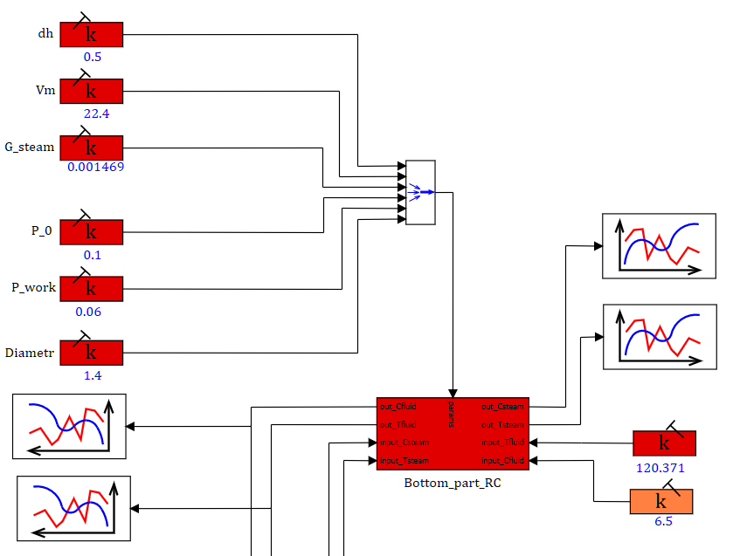
- Functional diagram of the distant part of the RC
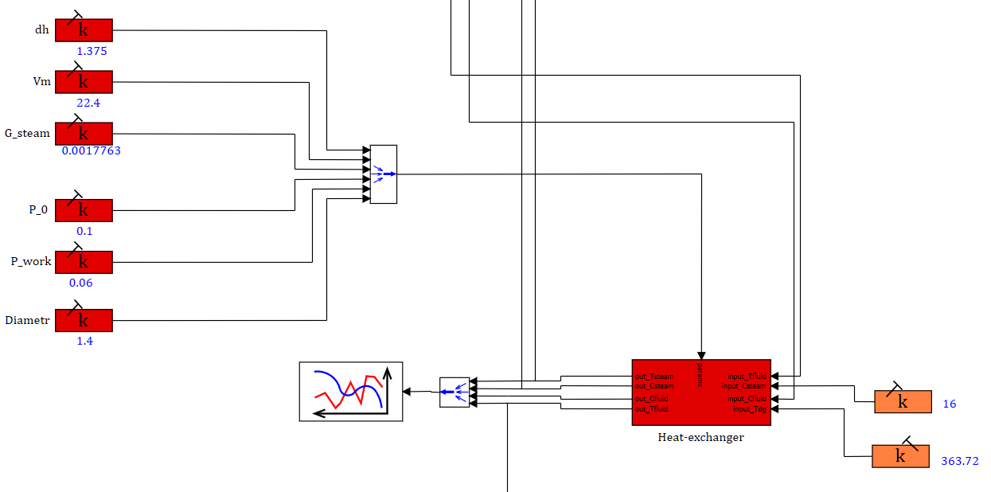
- Functional diagram of the evaporator (heat exchanger)
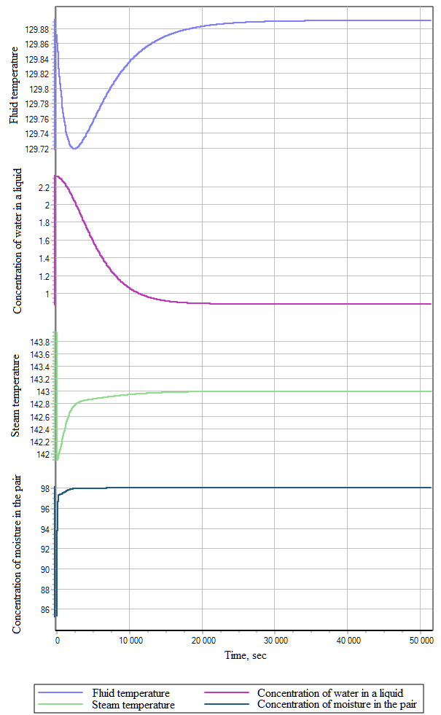
- Heat and mass transfer processes in DRC
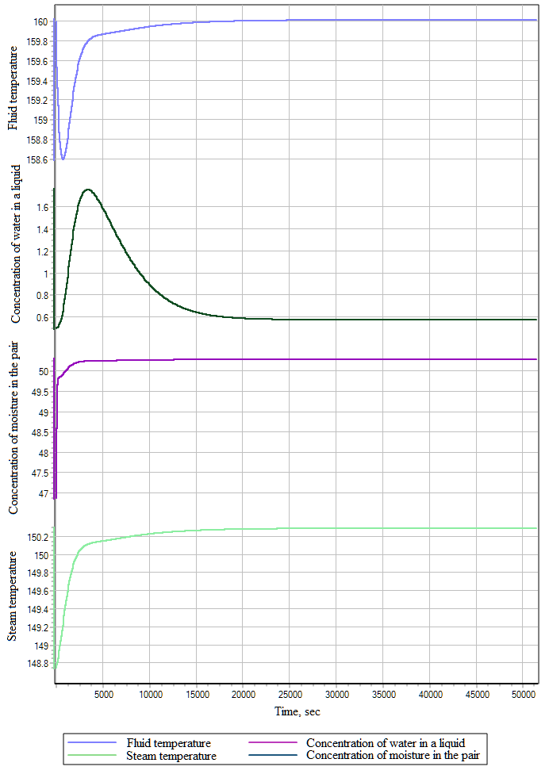

REFERENCES
[1] Abramkin S.E. Dushin S.E. Modeling of controlled processes of absorption dehydration of natural gas. SPb .: Publishing house of ETU "LETI", 2015.160 s.
[2] Bagaturov S.A. Fundamentals of the theory and calculation of distillation and rectification. M .: Chemistry, 1974.440 s.
[3] Abramkin S.E., Dushin S.E., Serditov Yu.N. The study of interconnected heat and mass transfer processes in a distillation column // XXI Intern. conf. on soft calculations and measurements (SCM-2018). Sat doc. in 2 volumes T. 1. St. Petersburg. May 23–25, 2018. SPb .: ETU LETI. S. 340-343.
[4] Anisimov I.V. Automatic regulation of the rectification process. M .: State. scientific and technical publishing house of oil. and mining fuels. industry, 1961.180 s.

- Heat and mass transfer processes in the Evaporator

CONCLUSION

The study is devoted to the analysis of the rectification process, using the example of diethylene glycol regeneration during absorption drying of natural gas. As a result of the analysis of the rectification process, controlled variables were identified, the change of which significantly affects the process. Based on a mathematical model, a computational experiment was conducted. The results of a computational experiment show that perturbations in this parameter significantly affect the heat transfer and mass transfer processes in the distillation column.

