DATA PREPROCESSING

Student Performance Analysis — AI/ML Project
Datasets: StudentPerformanceFactors.csv & college_student_placement_dataset.csv

Pre-processing stages
- Step 0 — Collected the raw data
- Step 1 — Cleaning of each dataset (duplicates, null values)
- Step 2 — Combining two datasets
- Step 3 — Encode categorical (text) columns into numbers
- Step 4 — Scale numeric columns
- Step 5 — Apply feature Scaling(Feature Selection and Feature Extraction)
- Step — Splitting of Data into Training,Validation and Testing Sets
STEP 0
Collected the Raw Data
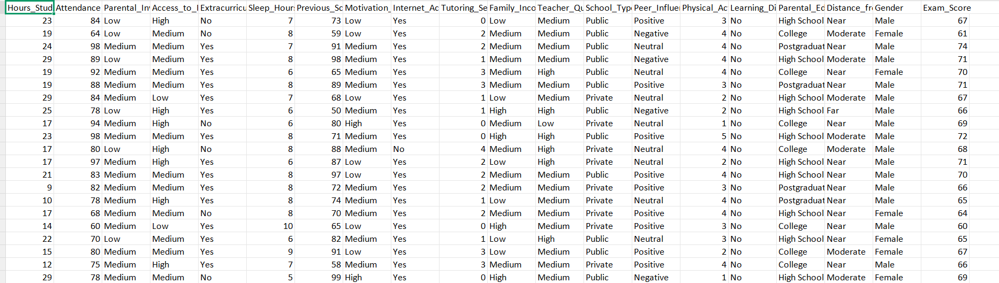1 — StudentPerformanceFactors.csv
Total no. Of Columns-20
Total no. Of Rows-6607
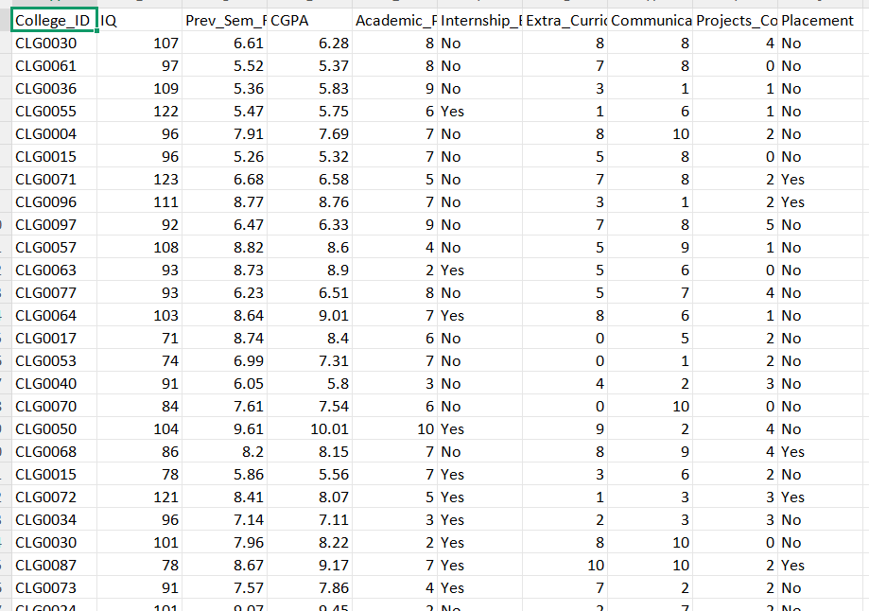
2 — college_student_placement_dataset.csv
Total no. Of Columns-10
Total no. Of Rows-10000

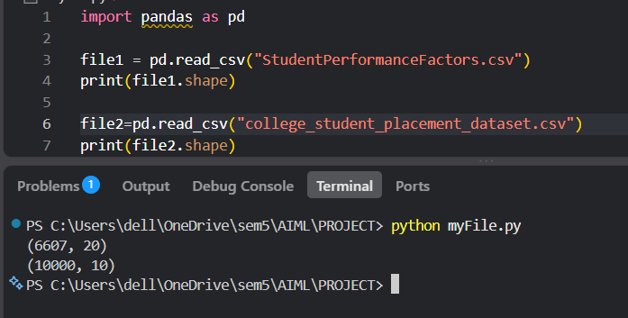
3 — Row and column counts of both raw files.
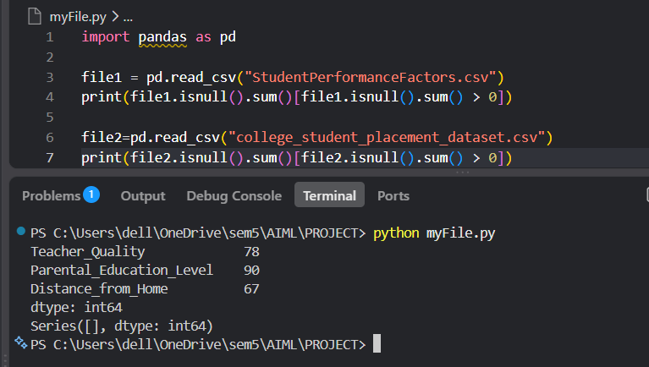
4 — Missing value counts. The performance dataset had gaps in three columns; the placement dataset had none.
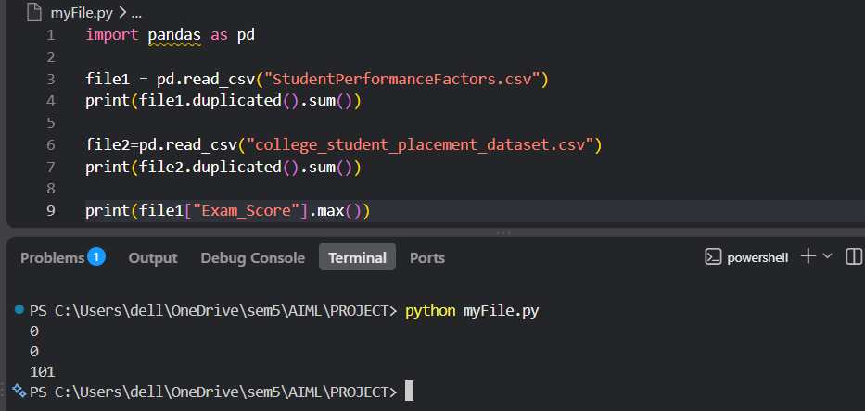
5 — Duplicate row check (zero in both files) and a data-quality issue found: one Exam_Score of 101, which is impossible on a 0–100 scale.
STEP 1
Cleaning of each dataset(duplicates,null values)
Fixing problems in files separately before combining them
- Columns that are not required are dropped(under 4% of the data, safe to remove without materially changing the dataset).
- The impossible Exam_Score of 101 was capped at 100.
- The placement dataset needed no changes here — it already had zero missing values and zero duplicates.
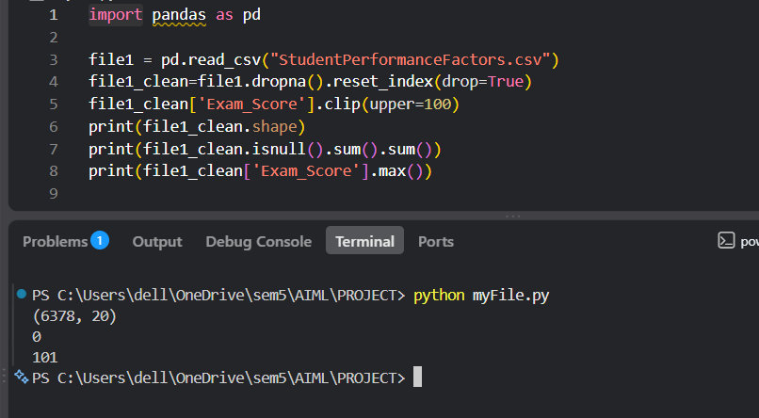
1.1 — Before/after counts confirming nulls removed and the score in range
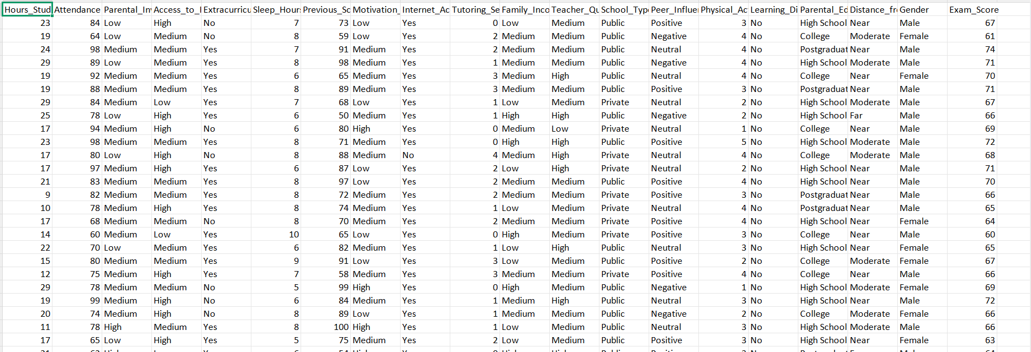
1.2 — Cleaned performance dataset
STEP 2
Combining the Two Datasets
NOTE — Rows are combined using 1:1 pairing after independently shuffling both datasets and trimming to the smaller dataset's size (6,378 rows).
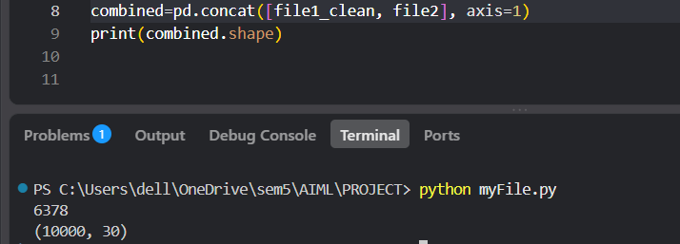
2.1 — Combination logic and resulting shape.
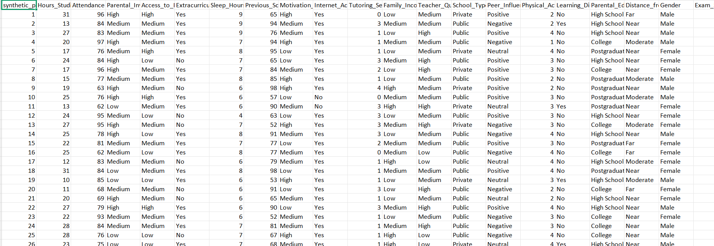
2.2 — Combined dataset
STEP 3
Encoding Categorical(text) Columns into Numbers
Machine learning models can only process numbers, so every text column needed to be converted.
- Identifier columns (synthetic_pair_id, College_ID) dropped(no need for training the model)
- Ordinal columns with a real order (e.g. Low / Medium / High) mapped to 0, 1, 2 Binary Yes/No-style columns were mapped to 0 / 1.
- Peer_Influence (Positive / Negative / Neutral)encoded into three separate 0/1 columns instead.
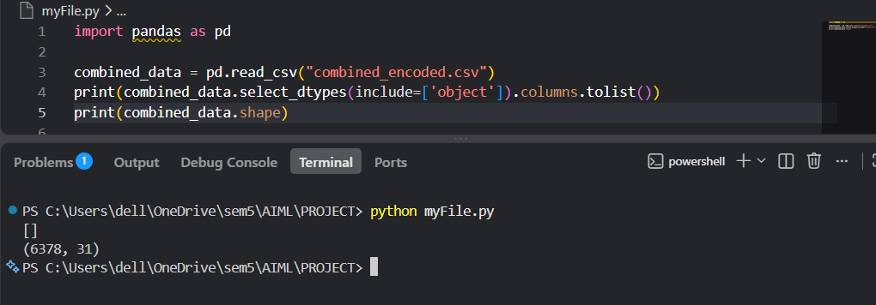3.1 — Confirmation that no text columns remain after encoding.
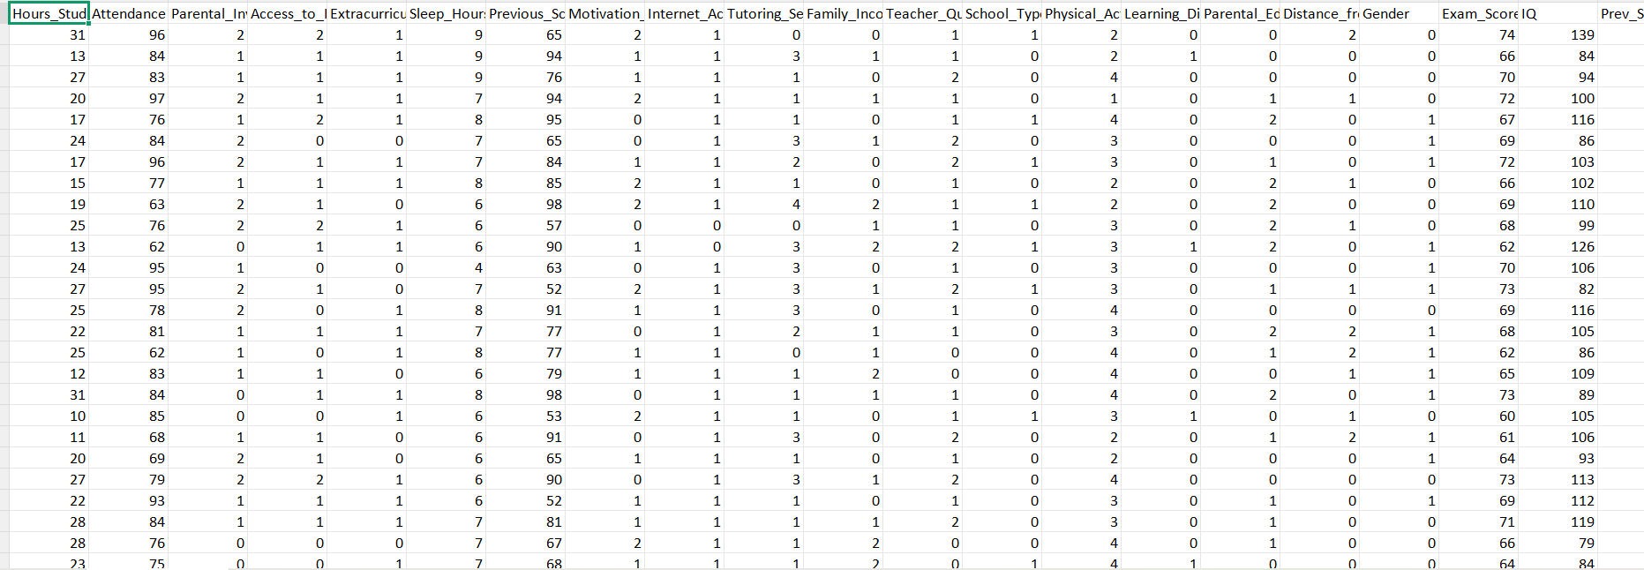
3.2 — Encoded dataset
STEP 4
Scaling Numeric Columns
Bringing every numeric feature onto a comparable range.
Columns like IQ (roughly 70-150) and School_Type (0 or 1) sit on completely different numeric scales. Left as-is, models that are sensitive to magnitude (e.g. Logistic Regression, KNN) would treat IQ as far more important purely because its numbers are bigger — not because it actually matters more. StandardScaler was applied to fix this, transforming every feature column to have a mean of 0 and a standard deviation of 1. The two target columns (Exam_Score, Placement) were unscaled, since they are outputs to predict, not inputs.
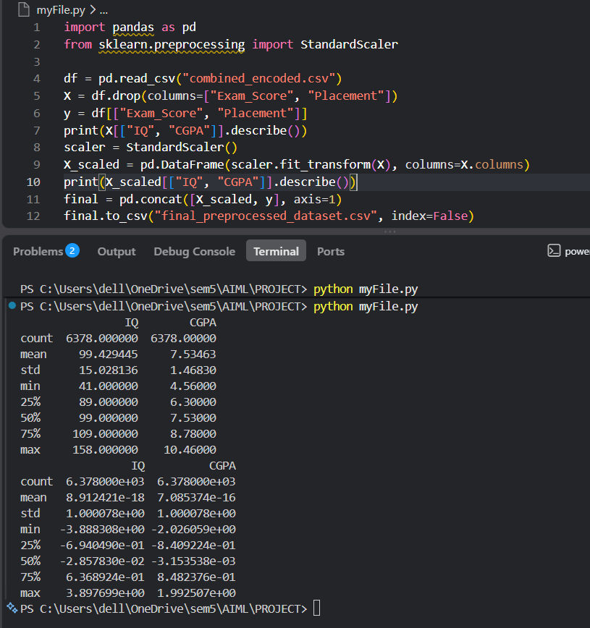
4.1 — Value ranges before and after scaling for representative columns.

Feature Scaling- columns actually matter?
In Feature scaling we differentiate the data to get a particular answer
Feature Scaling is done in SELECT ANS SPLIT.py
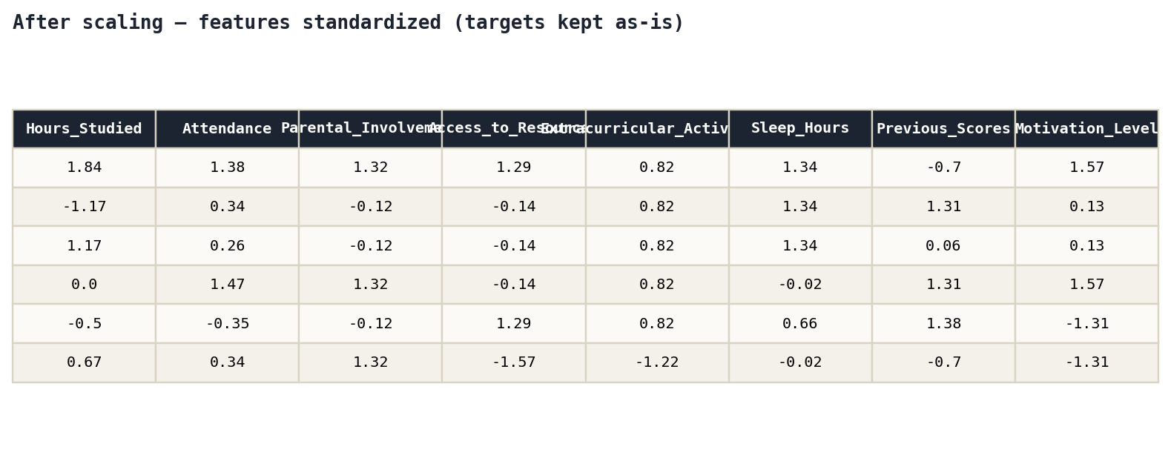
4.2 — Final feature values after scaling, first rows.
STEP 5
Splitting Data into Training,Validation and Testing Sets
• Training set = the practice questions you study from repeatedly. The model learns from this.
• Validation set = a few practice questions you set aside to check your progress while you're still studying — you look at these to decide if you need to change your study method, without letting them influence what you memorized.
• Test set = the real, final exam. You only see this once, at the very end, after you're done tweaking anything. It tells you how you'd actually perform on a totally new question you've never seen.

.

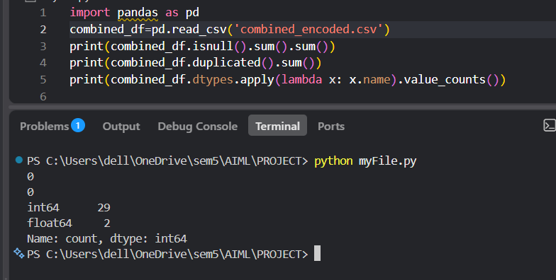
5.1 — Final null count, duplicate count, shape, and column type summary.

