Vhs019

GTM016

V20210122

ROIC pre-test

By Riviere

# Test Environment









## 測試內容

* I2C 讀寫及功能
* SPI 個腳輸出狀態是否隨 I2C 設定而變
* Ipix電流
* TestR En
* Full I2C register test(on 5 Feb, 2021)
* 其他

## 測試結果

1. I2C 讀寫及功能



測試項目：讀 PID, VID OK

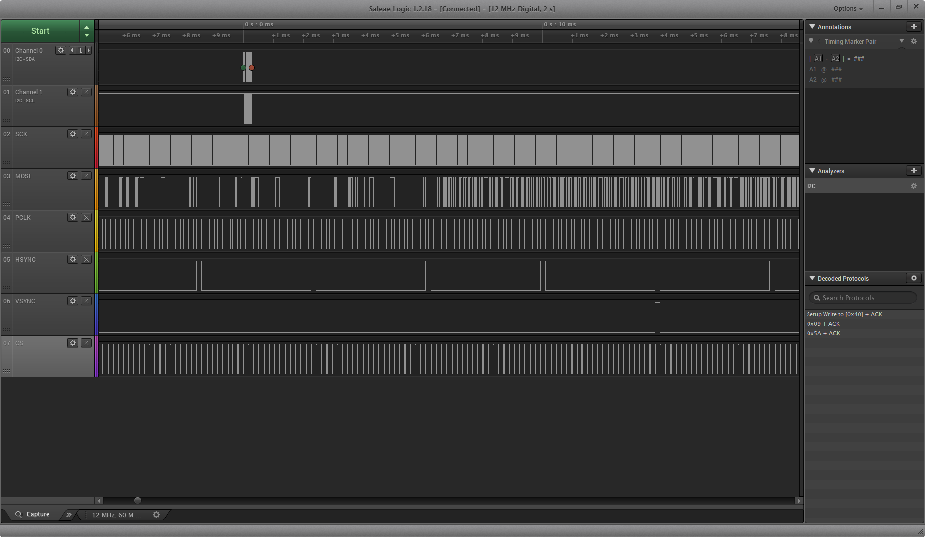

測試項目：寫 wp_code(0x5A) OK

1. SPI 個腳輸出狀態是否隨 I2C 設定而變
   1. PCLK speed

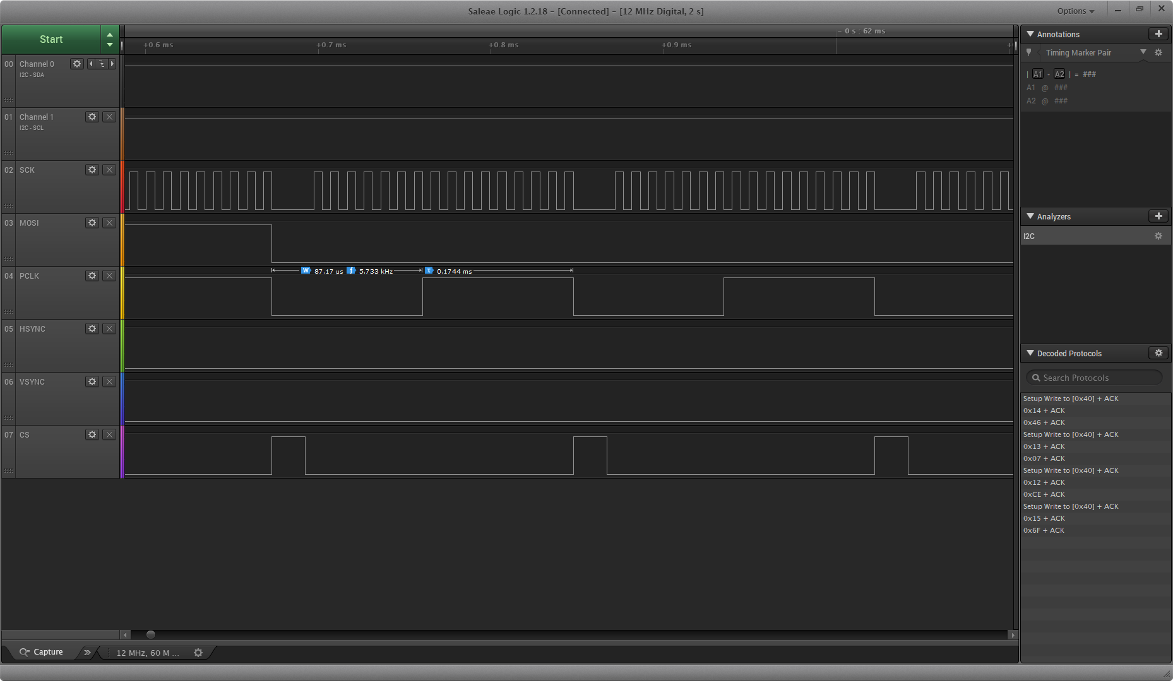

測試項目：PCLK speed default(15KHz) 5.7KHz ?

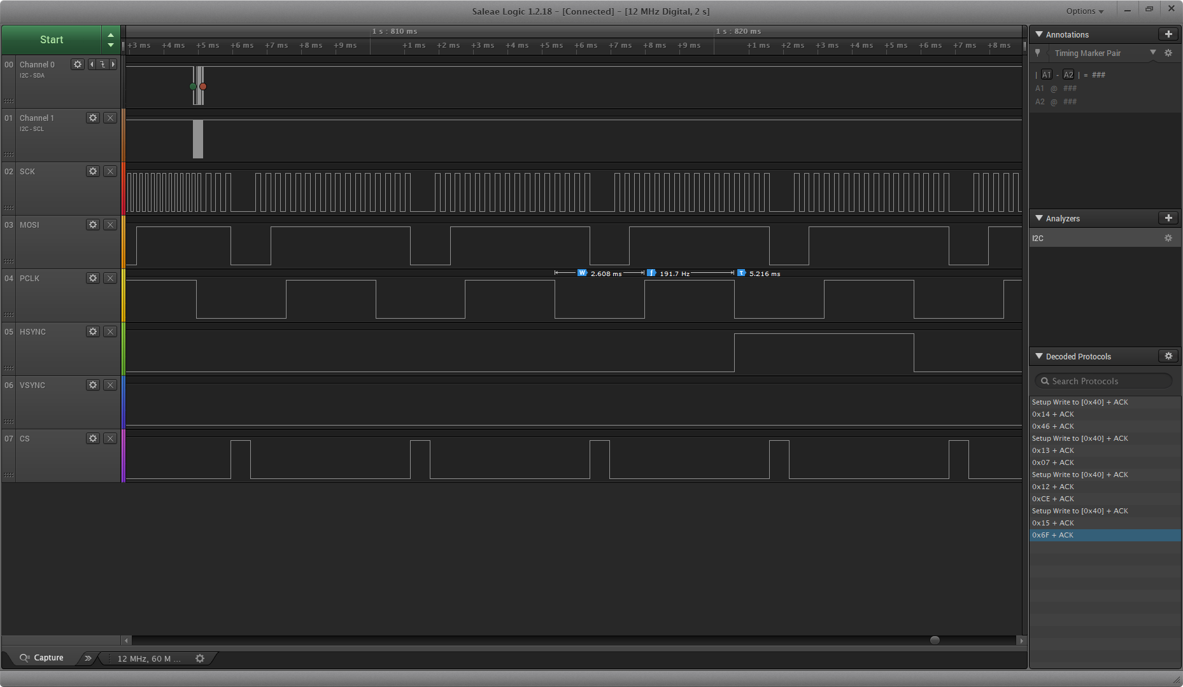

測試項目：PCLK speed (500Hz) 192Hz ?

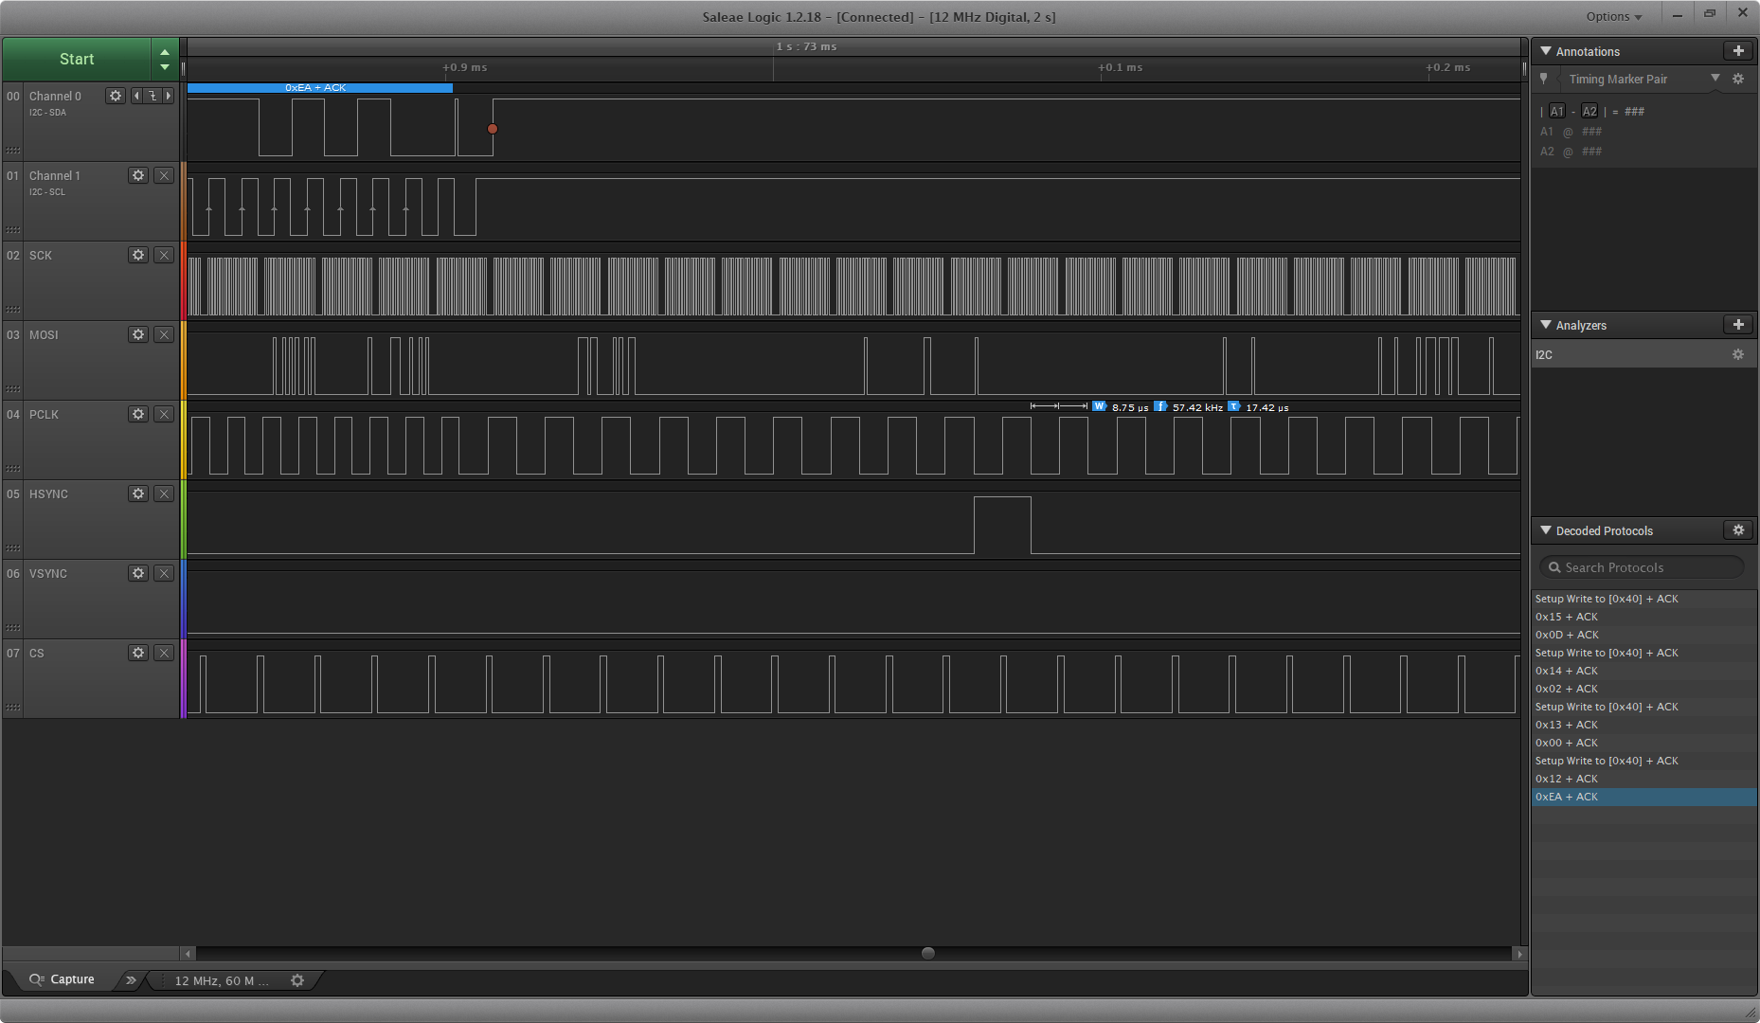

測試項目：PCLK speed recommand(150KHz) 57.5KHz ?

* 1. PCLK mask

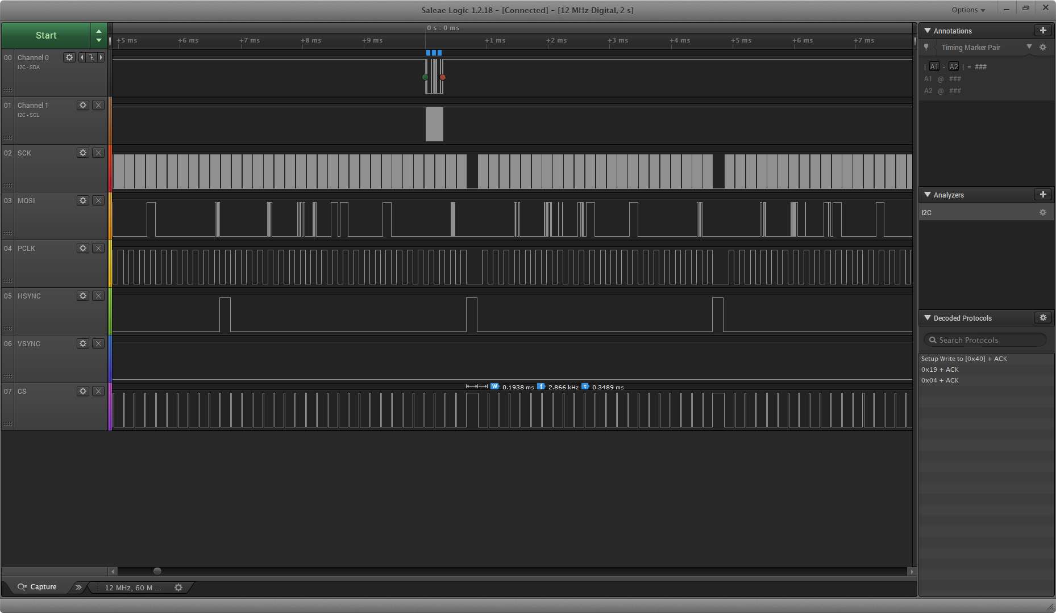

測試項目：PCLK mask OK

* 1. SPI CS mode

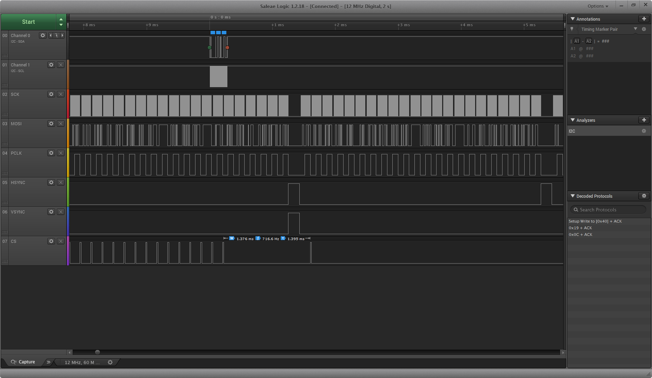

測試項目：SPI CS high when changing frame OK

* 1. SYNC length

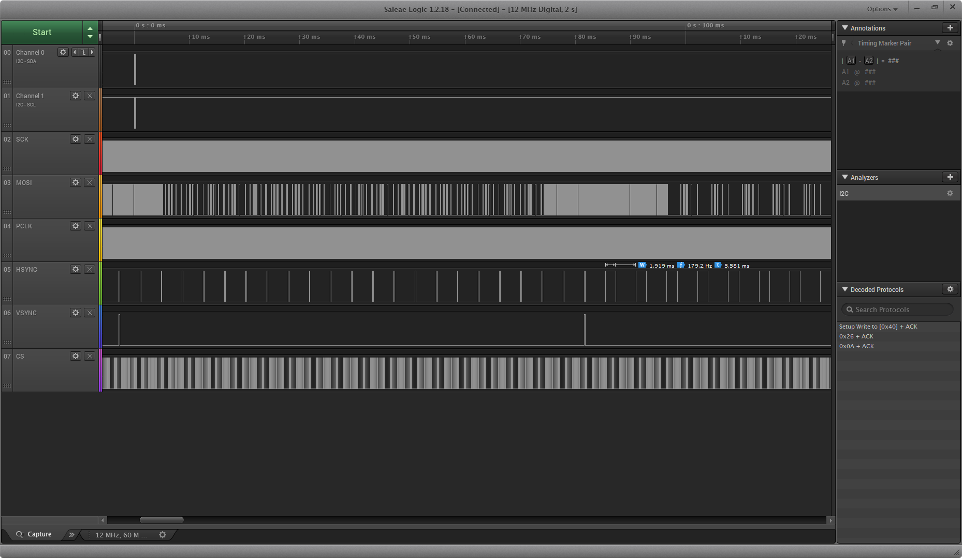

測試項目：SYNC length(10) OK (10+1 PCLK)

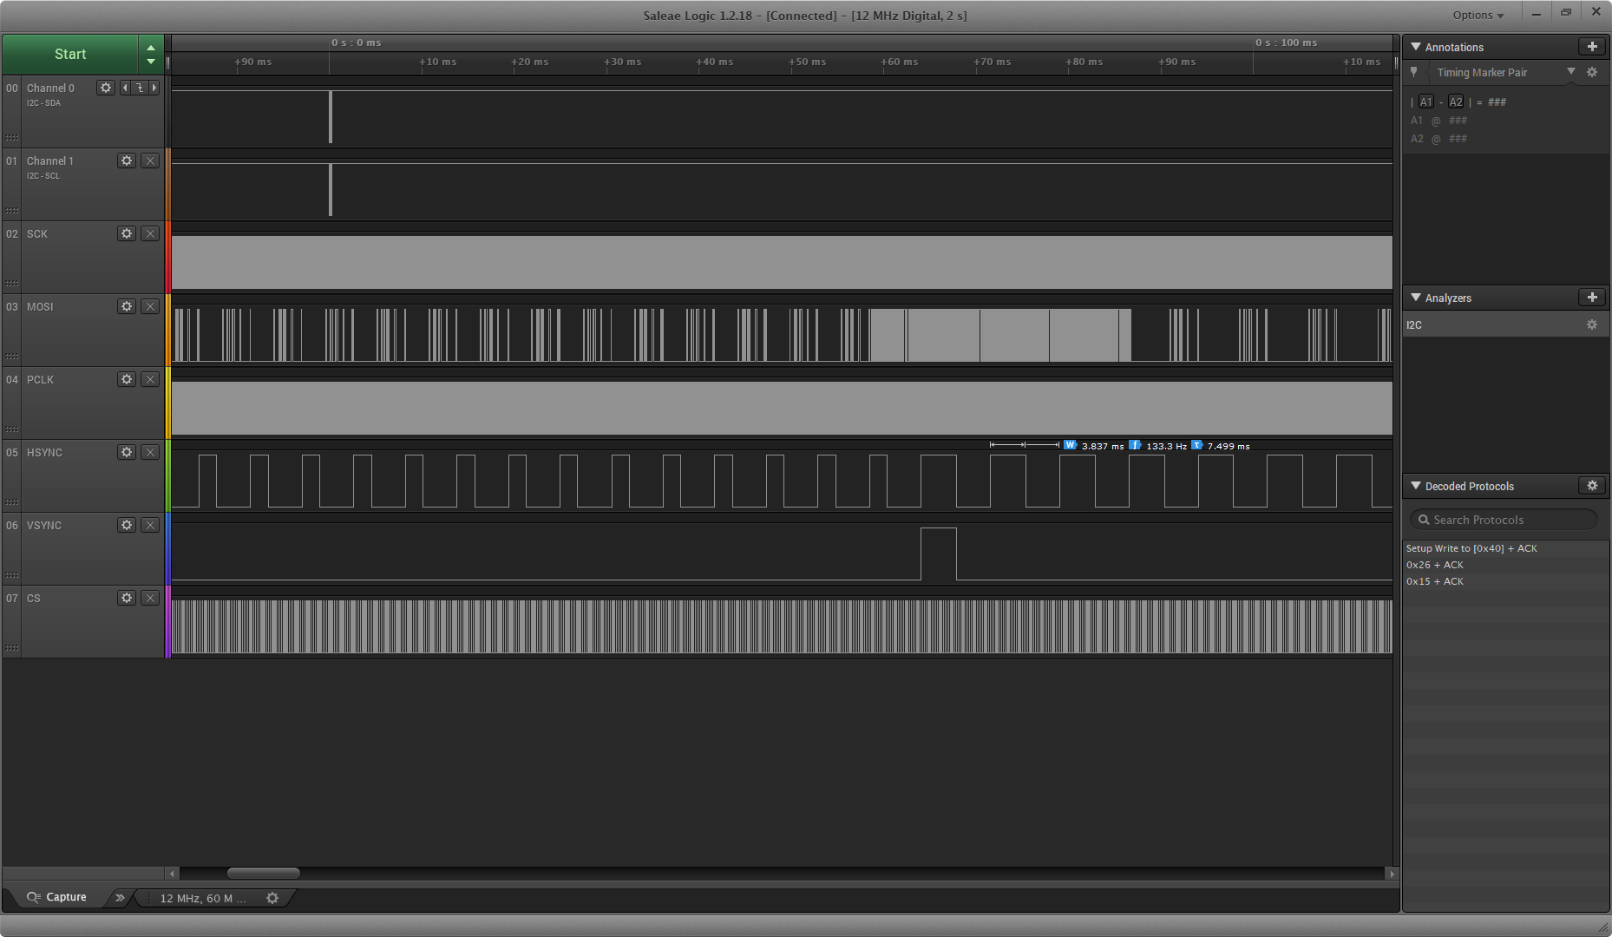

測試項目：SYNC length(21) OK (21+1 PCLK)

1. Ipix電流



測試項目： Error(max) 0.872 uA

Error(Avg) 0.425 uA

1. Test R En

|  |  |
| --- | --- |
|  |  |
| Test R all on(recommend) | Test R all off |
|  |  |
| Test R calibration on | Test R dark on |
|  |  |
| Test R reference on | Test R active on |

1. Full I2C register test



|  |  |
| --- | --- |
| Register fully test | |
|  |  |
| (16)Reg_SPIImgOut_en | (24)Sync invert |
|  |  |
| (25)PCLK Mask and SPI CS Mode | (28)Hstart |
|  |  |
| (30)Vstart | (32)Hend |
|  |  |
| (34)Vend | (38)Sync Length |
|  |  |
| (39)TestR and V-Flip(See p.11&12) | (93)Analog Out(See p.7 about Ipix) |

1. 其他問題
2. I2C SDA sometimes pull down

硬體重置可解除

另兩顆晶片一個 SDA pull low，一個 SCL pull low 無法 HW Reset 解除

1. PCLK 速度不正確(See page 3)
2. 第3~18行的 dark/reference pixel 不正確

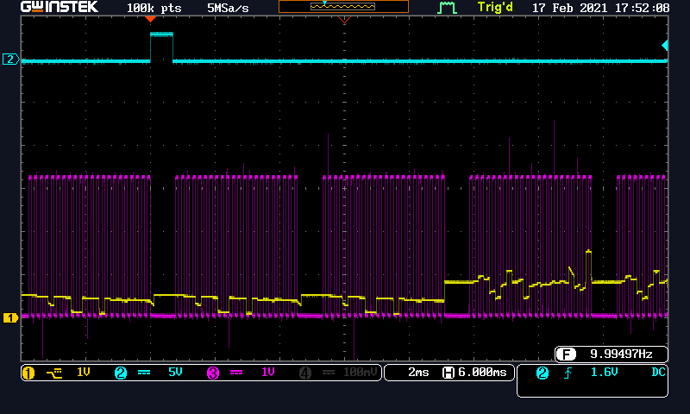

|  |  |
| --- | --- |
| 39 TestR all on  93 ipix=64uA  96 VDiff, int Vref | 39 TestR all on  93 ipix=64uA  96 VDiff, int Vref |
| 39 TestR all on  93 ipix=64uA  96 VC direct, ext Vref | 39 TestR all on  93 ipix=64uA  96 VA direct, ext Vref |
| 39 TestR all on  93 ipix=10uA  96 VA direct, ext Vref |  |