Analog Out Noise:

internal vref
last 1000 counts

Gain \ Ipix | 10uA | 40uA | 60uA
1
  Dark | 12.586
  Ref | 12.857
  Active | 13.296
  Dark | 46.053
  Ref | 44.624
  Active | 13.151
  Dark
  Ref
  Active
4
  Dark
  Ref
  Active
  Dark | 48.377
  Ref | 48.692
  Active | 16.175
  Dark
  Ref
  Active
8
  Dark
  Ref
  Active
  Dark | 47.261
  Ref | 48.045
  Active | 20.495
  Dark | 19.485
  Ref | 19.019
  Active | 17.955

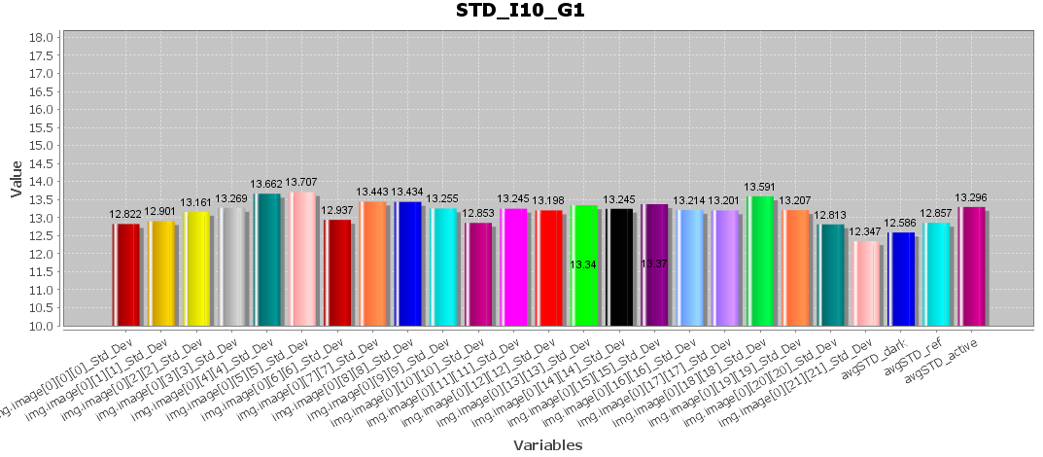 | 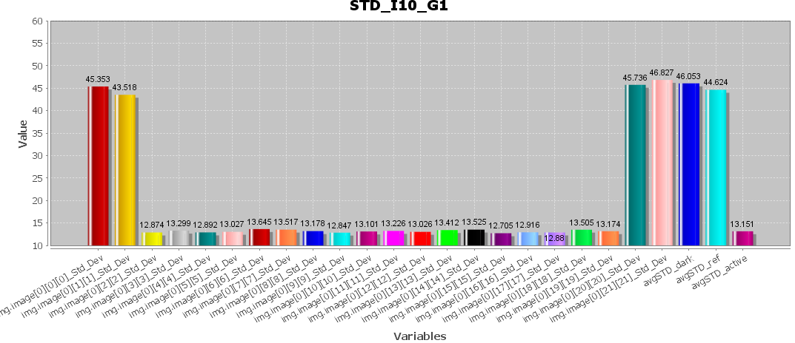
 | 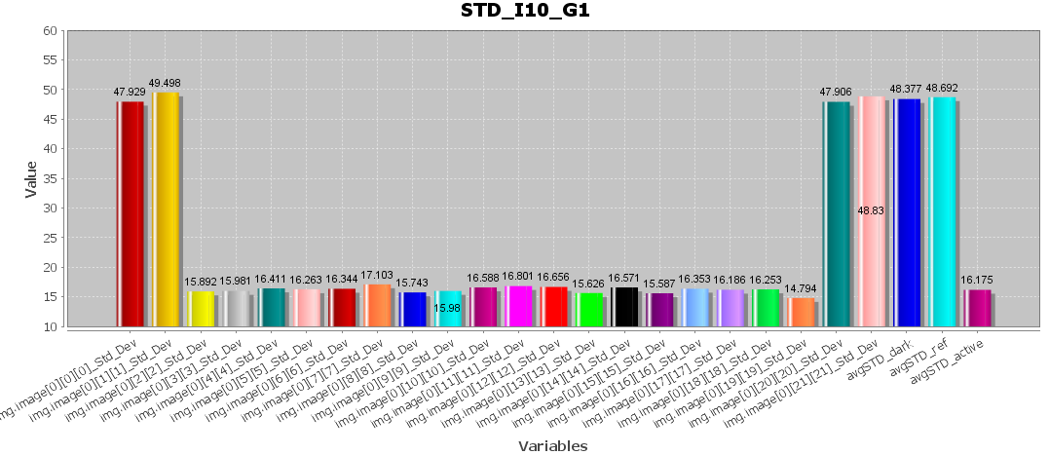
 | 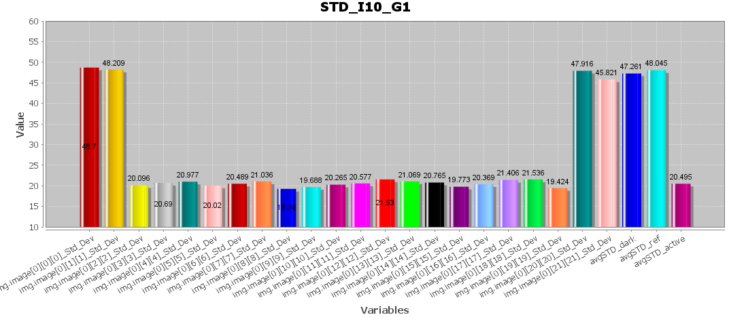 | 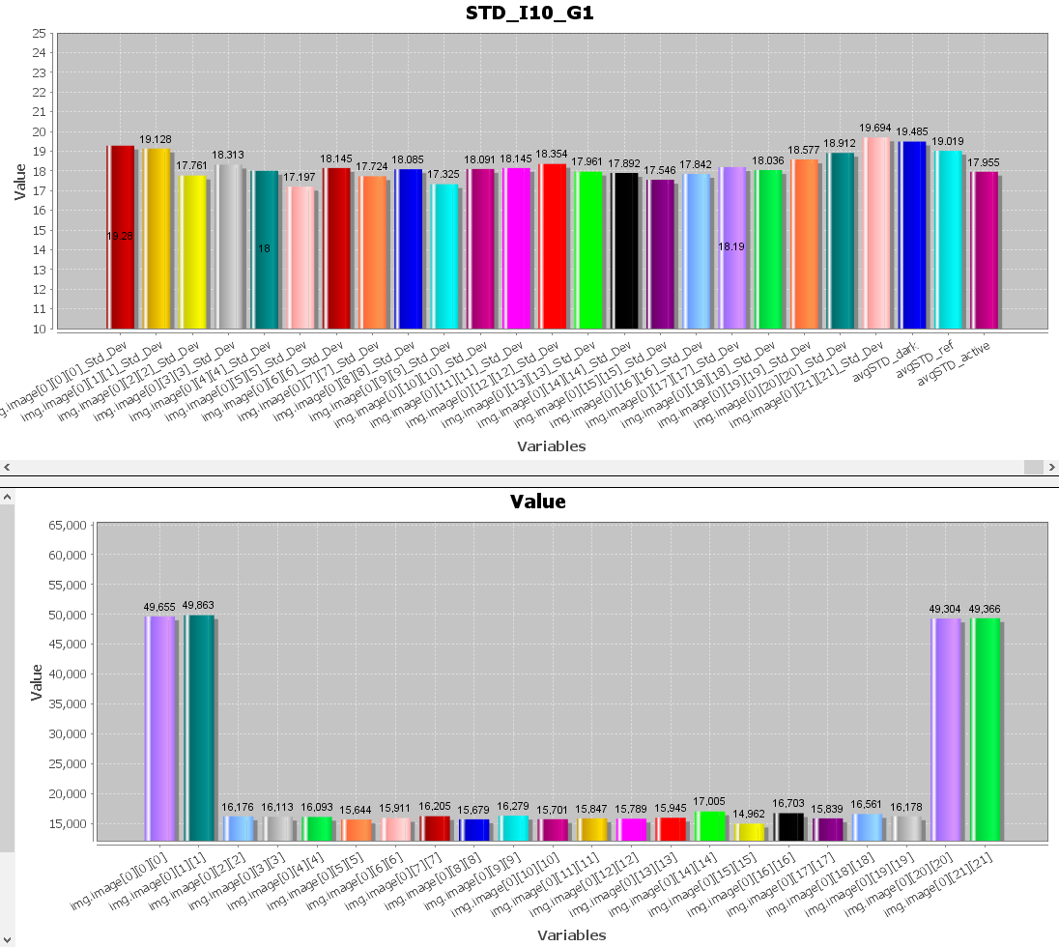  D/R saturation

Analog Out Noise:

external vref *0.5
last 1000 counts

Gain \ Ipix | 10uA | 40uA | 60uA
1
  Dark | 7.311
  Ref | 6.835
  Active | 6.598
  Dark | 29.426
  Ref | 28.527
  Active | 6.677
  Dark
  Ref
  Active
4
  Dark
  Ref
  Active
  Dark | 29.663
  Ref | 28.125
  Active | 11.42
  Dark
  Ref
  Active
8
  Dark
  Ref
  Active
  Dark | 28.648
  Ref | 28.707
  Active | 16.322
  Dark
  Ref
  Active

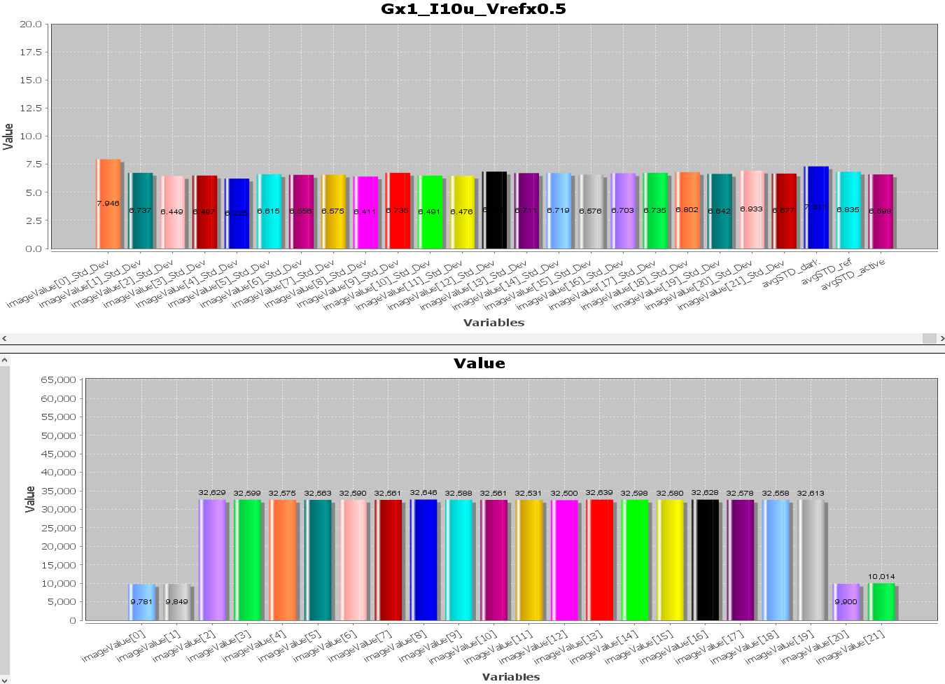 | 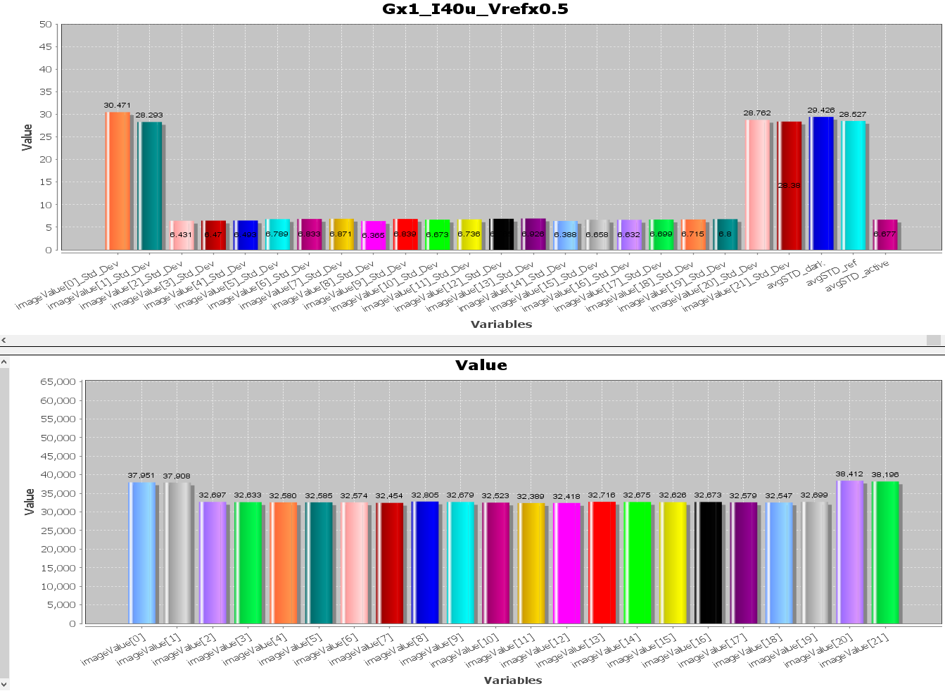
 | 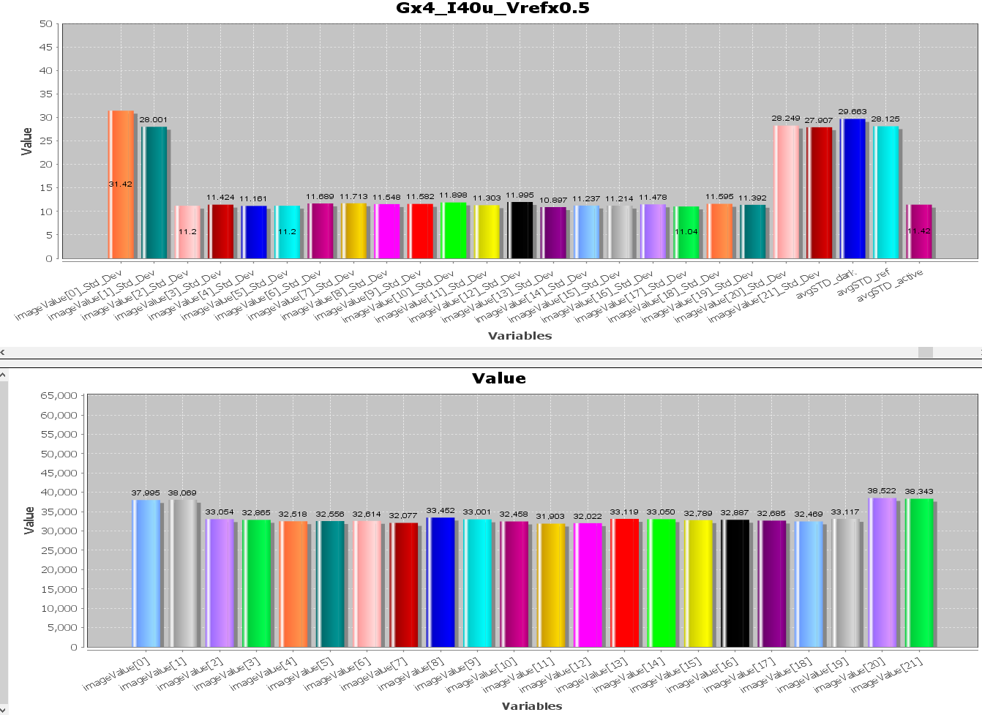
 | 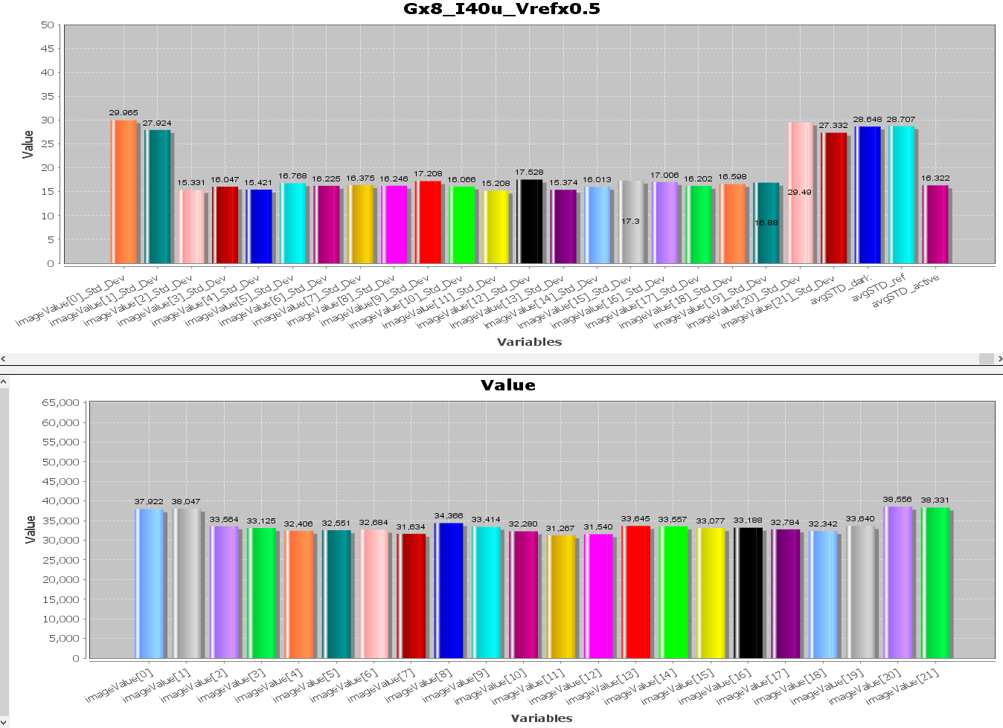

Ipix noise:

external vref *0.5
last 1000 counts

Ipix \ Gain | 4
10u
  Active | 6.38
20u
  Active | 12.205
40u
  Active | 24.955

Ipix \ Gain | 4
10u | 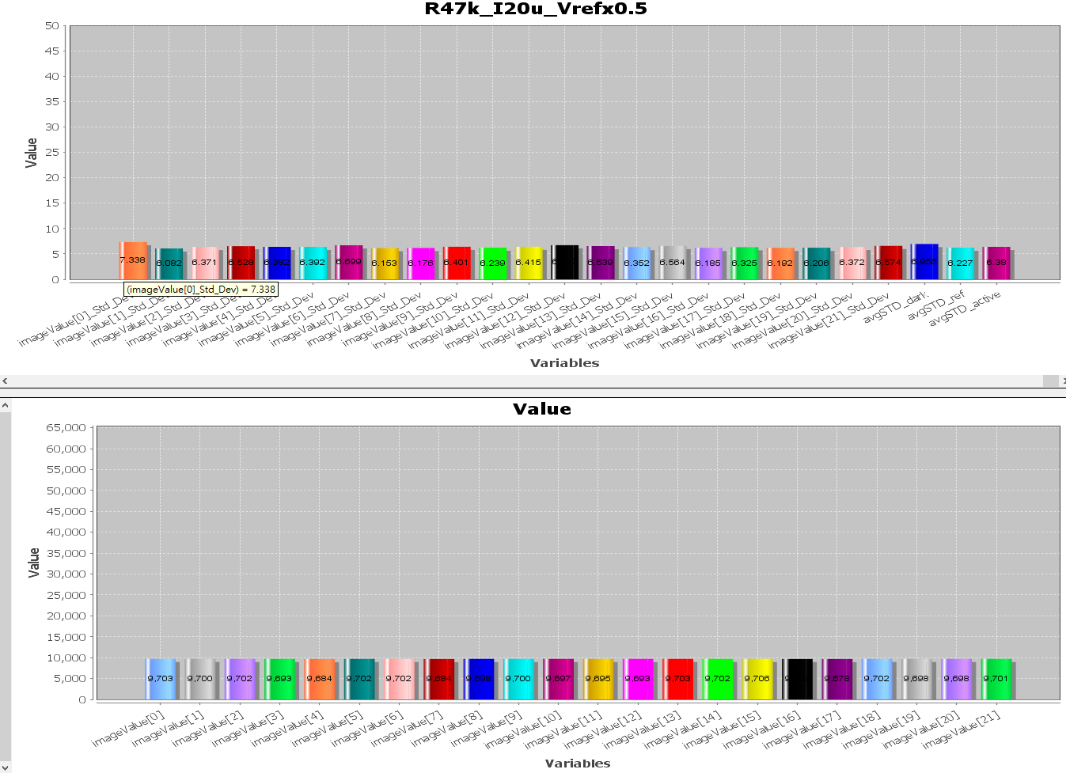
20u | 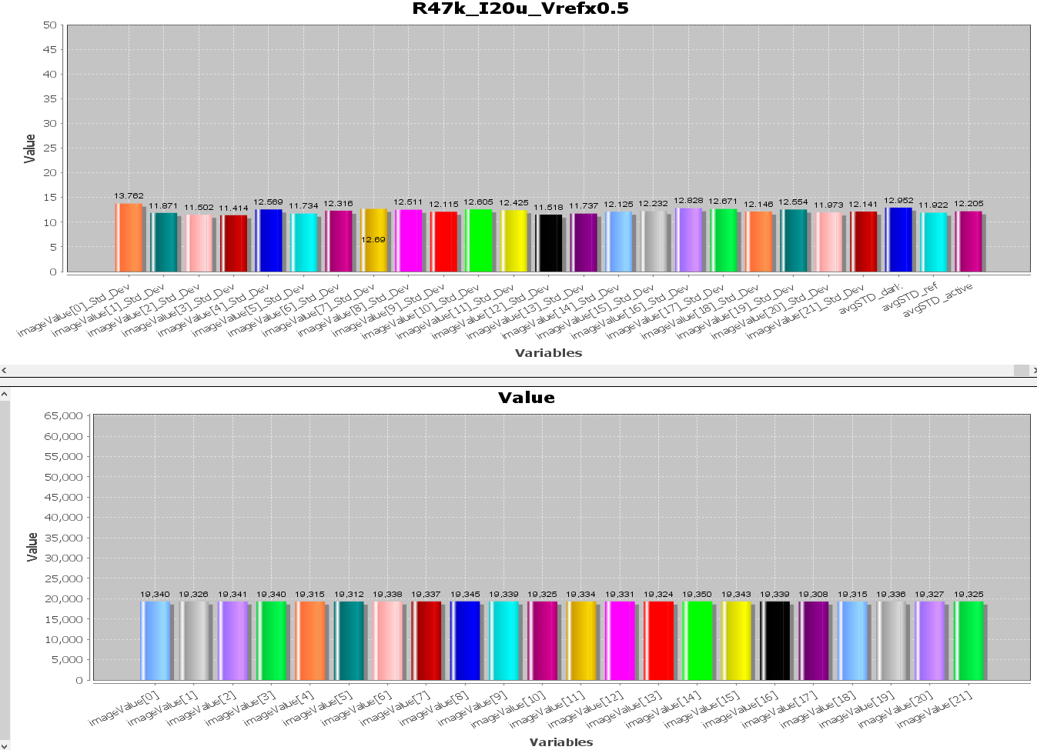
40u | 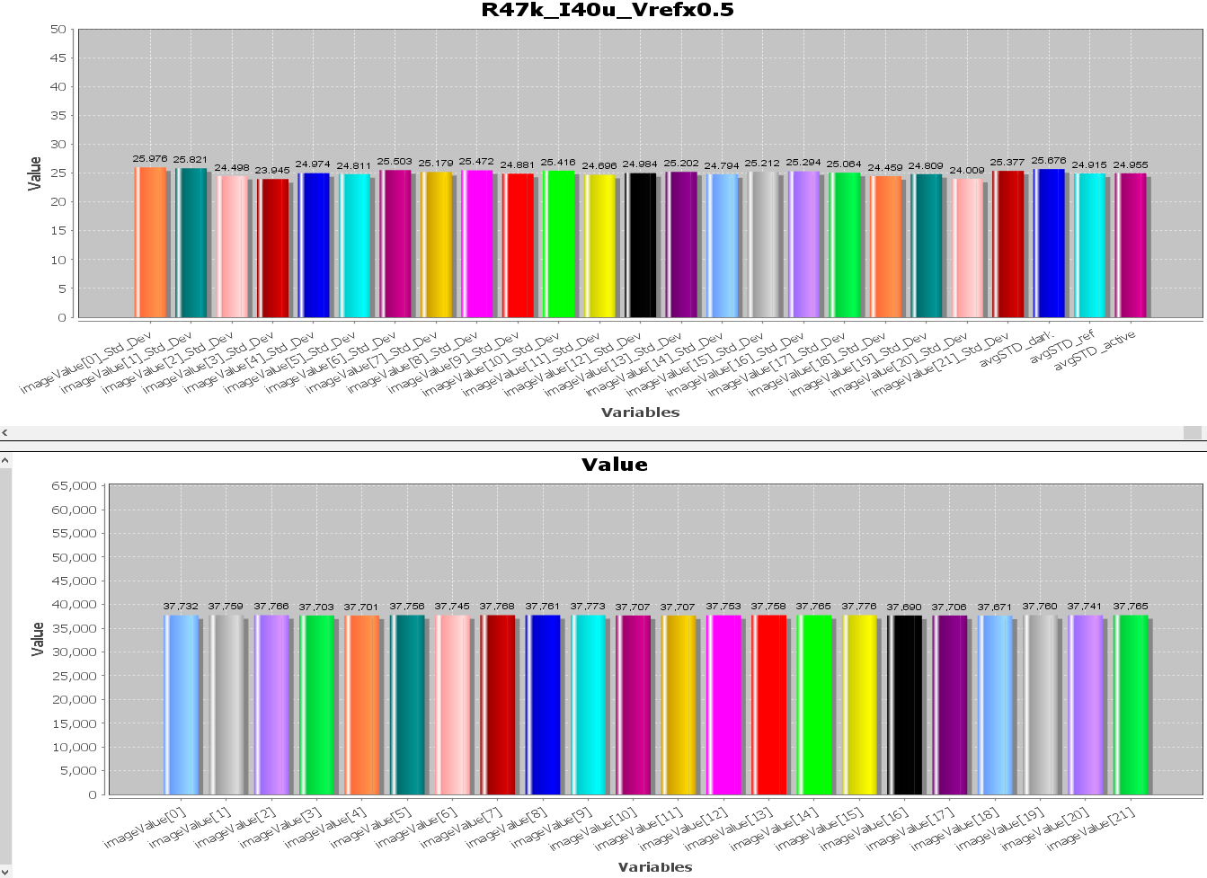

system test

Vref * ¼ to Ext. ADC with ADA4891
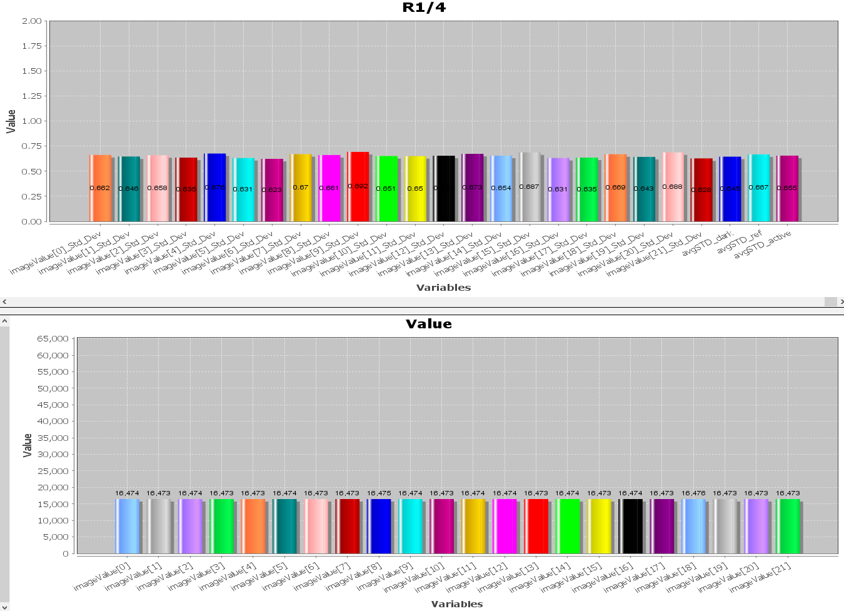

Vref * ½ to Ext. ADC with ADA4891
