GLM Assignment

You will need to use either data you have collected from your thesis, data from Dryad, or some other biological dataset from the internet. You will put together two worked examples showing the typical use of GLMs in data analysis for data that cannot be analyzed use traditional ANOVA/OLS techniques.
Show all code
Binary-
Poisson-scale counts in the west

Examples can have categorical predictors, continuous predictors, or both (as relevant). Each should include relevant data visualizations and explanation. You will be responsible for presenting and interpreting your analyses in-class using .html files from a Github repository containing your analyses (one or more .html reports as necessary). Each person should limit their presentation to 5-6 minutes.

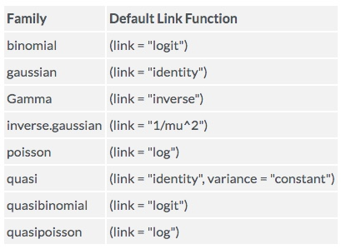

Additionally, you should organize data, files, visualizations, objects, etc. using the ‘best-practices’ we discussed early in the semester.

- Condense loose files into sub-folders to avoid cluttering up the root directory containing the .Rproj file. (e.g. data, docs, figures, tables, reference_info, etc.)
- Name files intuitively with appropriate structure and organization (e.g. 01_data_winter, 02_data_summer, etc.)
- Use intuitive object names (e.g. model_1_binomial, figure_4_seasonal, table_3_cort_baseline)
- Use library(janitor) to help clean dirty data and enforce a consistent format.
- The entire workflow should be repeatable; if we were to fork your repository, we should only have to run the .Rmd file to replicate all steps in the analysis and visualization.

Potential datasets. These are relatively ‘clean’ and do not require much pre-processing

data() #lists datasets from various installed packages; good for practice
data(package = .packages(all.available = TRUE)) #lists the data sets in all *available* packages.

install.packages(“datasets”) # package that has tons of practice data
library(datasets)
data(package="datasets")

# I prefer this package because the datasets tend to have more variables
install.packages("dslabs")
library(dslabs)
data(package="dslabs")

