Simple Use Case – Individual activity

Write a user story for your chosen simple use case.

**User story:**

As a marina staff member (Alex or another authorized employee),

Following a successful customer transaction, I want to be able to update the status of a boat slip,

so that I can manage slip availability efficiently and ensure accurate billing for all of my clients.

Using Visual Paradigm, create an activity diagram for your simple use case selection, documenting the

valid pathways through your use case. Sometimes, having a picture to work from, helps us focus our

efforts. Using the prototyping tool of your choice, create a form design for your feature and include as a

picture in your activity diagram.

Copy all of your work into a single word document and submit along with all supporting files.

**(See activity prototype in the next page)**

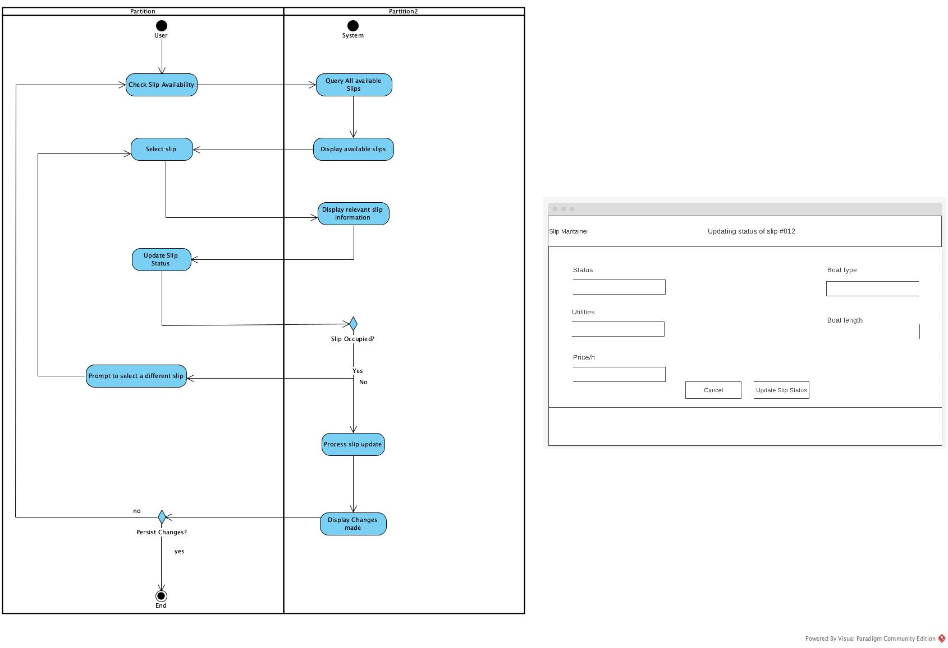

**Boat slip update process:**