**IN6299/IS6799/KM6399: CRITICAL INQUIRY**

**Use of generative artificial intelligence (AI) by professionals**

***Prepared by：***

Cheng Hangfan (G2405675G)

Liang Hou (G2401631D)

Liu Zihan (G2404273B)

**Supervisor：**

Associate Professor, Pee Loo Geok

**Semester 2, AY 2024-2025**

**Use of generative artificial intelligence (AI) by professionals**

|  |
| --- |
| Cheng Hangfan, Liang Hou, Liu Zihan  Nanyang Technological University  Singapore 637718 Email : {hangfan001; hliang008; liuz0120}@ntu.edu.sg |

# ABSTRACT

This study examines the factors leading to knowledge leakage from employees’ shadow use of generative artificial intelligence (AI) tools. Applying the Job Demands-Resources (JD-R) model, the research analyzes how job demands, job resources, and personal traits influence unauthorized AI usage and risk. Based on survey data from 217 employees, Ordinary least Squares (OLS) and Partial Least Squares (PLS) regression analyses have been conducted, and the findings show that some strong job resources, such as knowledge about AI and social capital, reduce knowledge leakage, while innovativeness increases risk. The results highlight the need for organizations to enhance employee awareness, strengthen internal support networks, and provide accessible AI solutions to mitigate risks. This study advances awareness of shadow AI behaviors and provides practical advice for enhancing corporate knowledge security.

## Author Keywords

Knowledge leakage, Shadow AI, Generative artificial intelligence, Job Demands-Resources (JD-R) model, Survey research

# INTRODUCTION

## Background

Generative artificial intelligence (AI) has emerged as one of the most widely used technologies in recent years. It began with a major advancement in machine learning, specifically the transformer architecture presented by Vaswani et al. (2017) in Attention Is All You Need. A few years later, in 2022, OpenAI launched the ChatGPT series, which in just five days attracted over a million users (Marr, 2024). Large tech firms have also created AI models and incorporated them into a range of professional fields, such as software development, marketing, customer support, and education.

The impact of AI on workplace operations is growing along with its acceptance. According to a 2023 study on AI adoption by McKinsey & Company, 60% of businesses that have integrated AI into their workflows are already regularly using generative AI tools in at least one business function. However, just 21% of respondents said their organizations had procedures in place controlling employees' usage of generative AI tools at work, indicating that few businesses are ready to handle the hazards involved (Chui et al., 2023).

The emergence of shadow AI, the unauthorized use of AI tools by staff members without corporate oversight, is an increasing problem (Wiz Experts Team, 2025). The IT sector had the highest rate of AI adoption, according to a 2024 Cyberhaven Labs study that examined the usage patterns of three million workers. Many workers utilize AI without permission from the firm, which exposes private information including source code, employment records, legal documents, and research materials (Coles, 2024). The emergence of shadow AI presents serious threats to company revenue, reputation, and data security (Gupta, 2024). As a result, businesses need to put rules in place to control the use of AI, and people need to take precautions to safeguard private data (PwC, 2023).

Although the problems associated with shadow AI have been extensively studied in the past, little is known about the precise causes of knowledge leakage. Unauthorized AI use can result in purposeful and inadvertent disclosure of private information, while current coping mechanisms are still insufficient. More study is required to understand why workers turn to shadow AI, how it causes information leaks, and what steps businesses may take to reduce this risk.

## Problem Statement

This study aims to investigate the factors affecting knowledge leaking in employees' use of shadow AI. Organizations run the danger of data breaches, intellectual property exposure, and compliance problems when these tools are used without authorization, frequently as a result of a lack of corporate support or awareness. Despite their increasing importance, the factors that lead to knowledge leaking in the application of shadow AI have not gotten much empirical attention. Determining these elements is essential to creating strategies that reduce risks and improve organizational security.

## Objectives

1. To identify and analyse the factors influencing knowledge leakage due to employees’ shadow use of generative AI in professional settings.
2. To provide actionable insights for organizations to mitigate risks, promote ethical AI usage, and establish effective policies for using generative AI.

# LITERATURE REVIEW

## Conceptual Clarification

This literature review's first portion examines the concepts of knowledge leakage and covert generative AI use. Lack and exposure are two distinct facets of knowledge leaking, according to Durst (2014). Staff turnover, which includes circumstances where employees retire, transfer to another organization, or leave for other reasons, is the most frequent cause of knowledge lack. Regardless of the specific situation, these departures usually result in the loss of tacit knowledge and relational capital, leaving the organization without enough skilled or experienced employees to cover the entire workforce.

Conversely, knowledge exposure, the primary objective of this project, defines the intentional or unintentional dissemination of an organization's private data to other parties. This is "the degree to which partners purposely appropriate or inadvertently transfer the focal firm's private knowledge," according to Jiang et al. The phrase "knowledge leakage" used in this study particularly refer to the mentioned definition of information exposure.

Additionally, the study's use of the phrase "shadow AI" (IBM, n.d.) refers to the unofficial or unapproved use of generative AI within an organization that is not under IT management. This occurrence highlights the potential risks associated with unchecked workplace technology use.

## Existing Research and Gap on Shadow AI and Knowledge Leakage

The increasing presence of shadow AI in workplaces has raised concerns about organizational knowledge security, while research on this emerging topic remains limited and fragmented. Existing studies have often explored the motivations and risks associated with technology adoption beyond organizational approval, commonly referred to as shadow IT. Shadow AI is now seen as a new and particularly risky extension of this behavior.

Early research on shadow IT highlights that employees frequently bypass formal approval processes when internal systems and resources are perceived as insufficient or inflexible for completing their tasks (Kopper & Westner, 2016). This can create gaps in oversight and increase exposure to security vulnerabilities.

Meanwhile, knowledge leakage has been traditionally examined in contexts such as strategic alliances or employee turnover, where sensitive information is either deliberately or inadvertently transferred to external parties (Jiang et al., 2013). The shadow use of generative AI introduces new dimensions to this risk, as confidential data can be exposed even during everyday work tasks. As states in Stojan’s article (2024), LayerX has a report saying that 4% employees “provide” the Generative AI tools sensitive data every week.

In addition, technical risks embedded in generative AI systems, such as the potential storage of user input for future model training, further complicate the issue (Zhang et al., 2023). Employees may unintentionally compromise proprietary information if they are unaware of these data-handling mechanisms.

Furthermore, research on human factors in knowledge leakage has emphasized that both intentional and unintentional exposure of information is often shaped by behavioral and organizational influences. For instance, a working culture that values speed above care or a lack of knowledge about security procedures can both raise the possibility of knowledge leaking.To reduce knowledge leakage, an ethical organizational climate and good security culture are needed (Wong et al., 2019).

However, despite these insights, several key research gaps remain. Current studies have not fully explored the role of job-related factors, such as workload and task complexity, in influencing shadow AI usage. Nor have they sufficiently addressed the extent to which individual characteristics, such as performance goal and innovativeness, may affect decisions to engage in unapproved AI tool use. Additionally, while various studies suggest that social capital can reduce risky knowledge-sharing behavior in organizations, its relationship to shadow AI use is not yet well understood. Finally, most prior research lacks a systematic framework for understanding how these diverse factors interact to affect knowledge leakage through shadow AI usage. By using the Job Demands-Resources (JD-R) model to examine the factors that lead to the adoption of shadow AI as well as its relationship to knowledge leakage, this study seeks to close this gap.

## Theoretical Foundation and Factor Selection

### Job Demands - Resources Model (JD-R Model)

Demerouti et al. (2001) were the first to propose the Job Demand-Resources (JD-R) model. Its core lies in dividing job characteristics into two major categories:

1. Job Demands: Refer to the physical, cognitive or emotional costs required to complete a job, such as time pressure, intensity of information processing, etc. (Demerouti et al., 2001).
2. Job Resources: Refer to situational factors that are conducive to achieving job goals, reducing job requirements or promoting personal development, such as autonomy, feedback, social support, etc. (Bakker & Demerouti, 2007).

This model holds that excessively high job demands can lead to a consumptive process, which in turn triggers burnout or bad behavior. And sufficient working resources enhance employee work engagement and innovative behaviors through the motivation process (Bakker & Demerouti, 2007). Furthermore, subsequent studies incorporate "Personal Resources" into the model, referring to factors like self-efficacy and personality personal characteristics (e.g. innovativeness and goal orientation), which can further buffer the negative impact brought by high demands or enhance the motivating effect of resources (Xanthopoulou et al., 2007).

For the research scenario of "knowledge leakage occurs when employees use generative AI in the shadow", the JD-R model provides multiple perspectives:

1. Demand perspective: The JD-R model states that high levels of job demands, such as the intensity of information processing and time pressure, can cause stress and fatigue (Demerouti et al., 2001). In the context of shadow AI use, these demanding conditions may cause employees to unintentionally disclose sensitive knowledge when using generative AI tools in informal and unauthorized situations.
2. Resource perspective: If employees have a high level of knowledge self-efficacy (Bandura, 1997) or task-technology fit to AI tools (Goodhue, 1998), they can manage and utilize AI more effectively, thereby reducing the risk of leakage caused by insufficient skills or excessive cognitive load.
3. Personal resources: The innovation (Xanthopoulou et al., 2007) and performance goal orientation (Payne et al., 2007) of employees will affect their motivation to try new tools and their risk assessment tendency during the usage process. In our research framework, we will refer to these personal resources as "Individual Factors", and both terms will be used interchangeably in the subsequent sections of this paper.

The JD-R model's flexibility and adaptability make it particularly suitable for explaining the "shadow use" behavior of employees using generative AI and the potential risk of knowledge leakage. This model provides a theoretical framework to help us understand why employees use AI tools through informal channels and how this behavior is associated with knowledge leakage.

### The theoretical basis of the research hypothesis

Based on the JD-R model and this study’s background, we propose four main hypotheses:

* H1: Employees experiencing higher job demands (task variety, autonomy in methods, information processing, problem solving, specialization, task significance, time pressure) will be more likely to engage in knowledge leakage through shadow AI use.
* H2: Employees with greater job resources (job experience, knowledge self-efficacy, task-technology fit, knowledge about AI, social capital) will be less likely to engage in knowledge leakage through shadow AI use.
* H3: Employees with higher innovativeness will be more likely to engage in knowledge leakage through shadow AI use.
* H4: Employees with higher performance goal orientation will be more likely engage in knowledge leakage through shadow AI use.

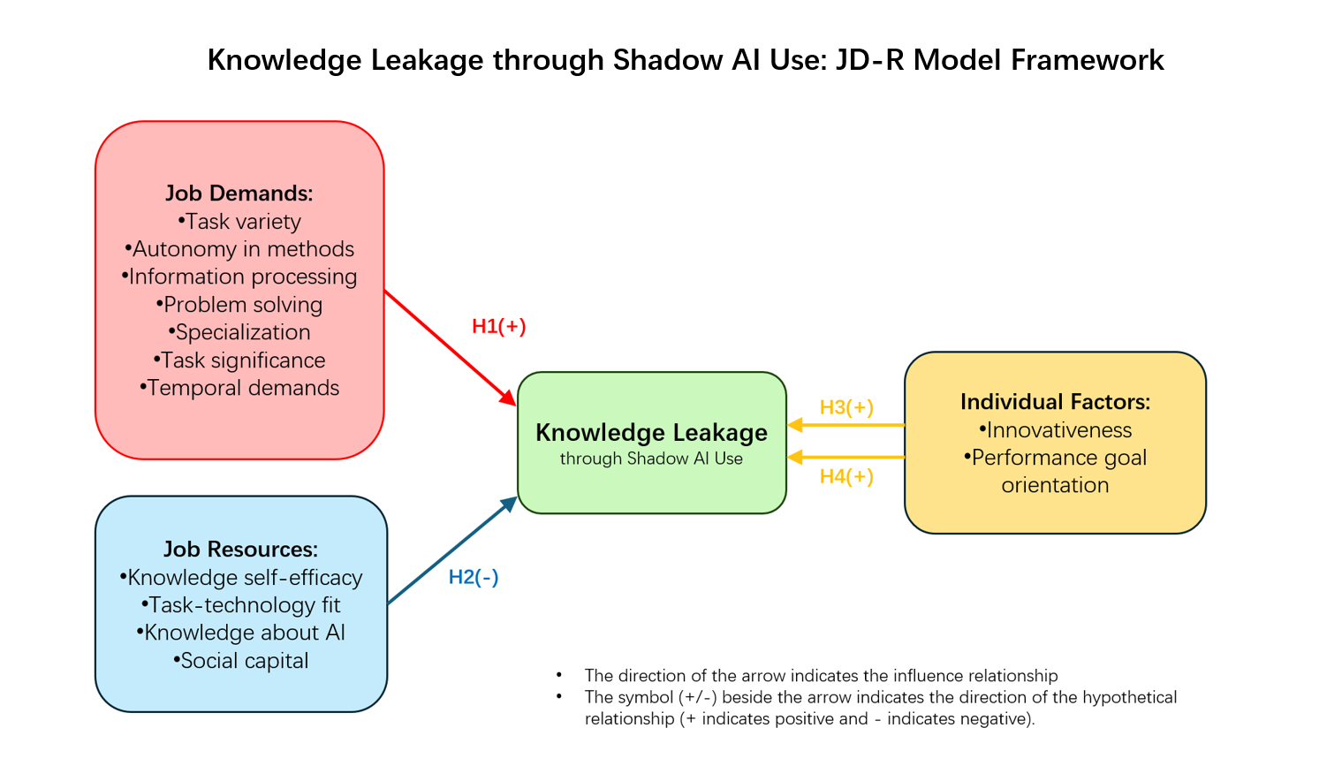

**Figure 1. Knowledge leakage through shadow AI use with JD-R model**

Next, we will explain in detail about the theoretical basis of each hypothesis as shown in Figure 1:

H1: Job Demands

According to the JD-R model’s consumption process, excessive job requirements might result in resource depletion and lower risk awareness and self-monitoring, and thereby increase the probability of bad behaviors (Bakker & Demerouti, 2007). When employees feel that their work tasks are overly burdensome, they are more inclined to seek informal technical solutions, even if this may violate organizational policies (Haag & Eckhardt, 2017). Morgeson & Humphrey (2006) research indicates that characteristics such as the complexity of work tasks, information processing requirements, and diversity can increase the cognitive burden of employees, which may lead them to seek shortcuts and assistive tools to deal with challenges (Sweller, 1988).

H2: Job Resources

The JD-R model’s incentive process indicates that sufficient working resources can enhance engagement and autonomy and alleviate the negative effects brought about by high demand (Xanthopoulou et al., 2007). Especially, knowledge self-efficacy (Bandura, 1997) and task-technology fit (Goodhue, 1998) can help employees carefully construct prompts and filter results, avoiding the leakage of sensitive information from the source. Study shows that adequate organizational resources are associated with lower policy violations (D'Arcy et al., 2014). When employees have abundant working resources, they are more capable of effectively responding to work challenges under the premise of following organizational norms.

H3: Individual Factor-Innovativeness

Personal resources have expanded the JD-R model, emphasizing how traits such as innovativeness and self-efficacy affect work behavior (Xanthopoulou et al., 2007). Based on findings from Ritala et al. (2021), highly innovative individuals possess a stronger experimental spirit and risk tolerance, and are more likely to adopt emerging technologies to solve work problems. This trait enables them to show a stronger motivation to try and fault tolerance when facing new technologies. However, if they lack the corresponding awareness of risk assessment, it may lead to information security risks.

H4: Individual Factor-Performance goal orientation

Vandewalle (1997) pointed out that performance goal orientation belongs to a trait of personal resources, driving employees to be result-oriented. Individuals have a high performance goal orientation focus more on the outcome rather than the process, and are more inclined to seek quick solutions to exhibit their abilities and get recognition from others. Research indicates that risk behavior and performance goal orientation are positively correlated (Barsky, 2008).

# METHODOLOGY

This study employed a quantitative survey-based approach to investigate the factors associated with the unapproved use of generative AI tools for work-related tasks.

## Sample and Data Collection

A total of 365 individuals who reported using unapproved generative AI tools in the workplace were recruited. Following data cleaning procedures, including the removal of incomplete and invalid responses, a final sample of 217 valid questionnaires was retained for analysis. Data was collected using a structured online survey instrument, designed to measure multiple constructs relevant to task characteristics, individual factors, and technology use.

## Measures

Survey items were organized into predefined factors based on theoretical frameworks. Each factor was assessed using multiple items to ensure comprehensive coverage of the construct.

## Data Analysis Procedures

1. Reliability Analysis: Cronbach's alpha was used to assess each factor's internal consistency in order to guarantee the measurement scales' dependability.
2. Descriptive Statistics: Descriptive analyses were conducted to summarize the distributions and central tendencies of the factor scores.
3. Correlation Analysis: To investigate the bivariate correlations between the important variables, Pearson correlation analysis was performed.
4. Partial Least Squares (PLS) Regression: PLS regression was employed to model the predictive relationships between multiple independent and dependent variables, particularly addressing potential issues of multicollinearity and limited sample size.
5. Ordinary Least Squares (OLS) Regression: To investigate the predictive correlations between the variables, OLS multiple linear regression studies were conducted.
6. Visualization: Scatter plots and other graphical techniques were utilized to illustrate analysis results.

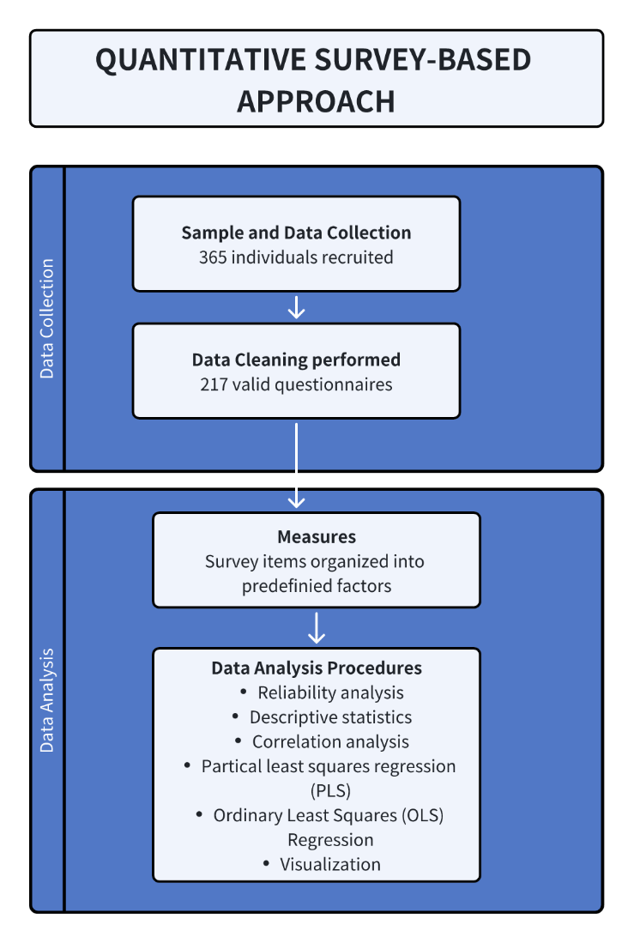

**Figure 2. Quantitative survey-based approach process**

# Overview of the Analysis

People who have previously employed unapproved generative AI tools for work-related tasks were surveyed online to collect data for this study. At first, 365 answers in all were received.

Two exclusion criteria were used as part of data pre-processing to guarantee the dataset's quality and applicability. First, 358 valid examples were obtained by excluding responses from people who were born after 2004 and those who said they had never used generative AI tools. Second, a method of attention check was used, whereby participants had to accurately respond to two survey control questions. Participants were only kept for analysis if they answered 1 ("Strongly Disagree") or 2 ("Disagree") on both attention check items. 217 valid responses were left for additional analysis following this filtering procedure.

The cleansed dataset was then subjected to multiple statistical analysis phases. To provide a summary of the sample's behavioral and demographic traits, descriptive statistics were calculated. Reliability analysis was conducted to assess the internal consistency of key constructs. To investigate the bivariate correlations between important constructs, correlation analysis was used. Ordinary Least Squares (OLS) regression analysis was employed to explore predictive relationships between variables, followed by Partial Least Squares (PLS) regression to further evaluate predictive correlations and address potential multicollinearity issues. The basis for assessing the research model and drawing theoretical and practical conclusions is provided by the findings of these analyses.

A detailed mapping of all factors examined here can be found in Appendix A.

## Reliability Analysis

Table 1 displays the findings of our reliability analysis. Each construct had a Cronbach's Alpha score between 0.79 and 0.86, which was greater than the generally accepted cutoff of 0.7. This indicated that the overall reliability level was relatively high, and the internal consistency of each construct was good, providing a reliable basis for the subsequent statistical analysis and model construction. Except for Social capital (0.795), the reliability of all variables was above 0.8. Among them, the variable reliability involved in H1, H3 and H4 was at the forefront, indicating that the measurement of these constructs was relatively accurate, which was helpful for evaluating their relationship with knowledge leakage more accurately.

|  |  |
| --- | --- |
| Variable | Cronbach's Alpha |
| Task variety | 0.821 |
| Autonomy in methods | 0.825 |
| Information processing | 0.859 |
| Problem solving | 0.823 |
| Specialization | 0.825 |
| Task significance | 0.843 |
| Temporal demand | 0.847 |
| Knowledge self-efficacy | 0.816 |
| Task-tech fit | 0.806 |
| Knowledge about AI | 0.821 |
| Social capital | 0.795 |
| Innovativeness | 0.840 |
| Performance goal orientation | 0.824 |
| Knowledge leakage | 0.858 |

**Table 1. Cronbach's Alpha**

## Descriptive Statistics

The central trends and dispersions of the major constructs in the sample (N = 217) were compiled using descriptive statistics. Table 2 presents the findings.

On a five-point Likert scale, the variable's mean values often fell between 2.60 and 3.41, showing moderate levels across the constructs.

Specifically, **Information Processing** had the highest mean score (M = 3.41, SD = 0.96), suggesting that participants generally perceived a relatively high degree of information handling in their tasks. This was closely followed by **Specialization** (M= 3.37, SD = 1.06) and **Task Significant** (M = 3.35, SD = 1.09), indicating the importance and distinctiveness of their work roles.

|  |  |  |  |  |  |
| --- | --- | --- | --- | --- | --- |
| **Variable** | **Category** | **M** | **SD** | **Min** | **Max** |
| Task variety | Job Demands | 3.27 | 1.03 | 1.33 | 5.00 |
| Autonomy in methods | 3.27 | 1.00 | 1.33 | 5.00 |
| Information processing | 3.41 | 0.96 | 1.50 | 5.00 |
| Problem solving | 3.33 | 1.04 | 1.00 | 5.00 |
| Specialization | 3.37 | 1.06 | 1.33 | 5.00 |
| Task significance | 3.35 | 1.09 | 1.33 | 5.00 |
| Temporal demand (Time Pressure) | 3.24 | 1.11 | 1.00 | 5.00 |
|  | 3.32 | 1.04 |  | |
| Knowledge self-efficacy | Job Resources | 2.64 | 0.99 | 1.00 | 4.67 |
| Task-technology fit | 2.60 | 1.01 | 1.00 | 5.00 |
| Knowledge about AI | 2.75 | 1.06 | 1.00 | 5.00 |
| Social capital | 2.62 | 0.99 | 1.00 | 4.33 |
|  | 2.65 | 1.01 |  | |
| Innovativeness | Individual Factors | 3.24 | 1.10 | 1.00 | 5.00 |
| Performance goal orientation | 3.25 | 1.06 | 1.00 | 5.00 |
| Knowledge leakage | 3.24 | 1.11 | 1.00 | 5.00 |
|  | 3.24 | 1.09 |  | |

**Table 2. Descriptive statistics**

In contrast, **Task-Tech Fit** (M = 2.60, SD = 1.01) and **Social Capital** (M = 2.62, SD = 0.99) recorded the lowest mean scores, suggesting relatively weaker perceived alignment between tasks and technology, and lower perceived access to informational and relational resources among participants. **Knowledge Self-Efficacy** (M=2.64, SD = 0.99) and **Knowledge about AI** (M = 2.75, SD = 1.06) also exhibited lower averages, indicating moderate confidence and familiarity with AI tools among participants.

Overall, the categorized constructs revealed meaningful differences. **Job Demands** showed a relatively high overall mean (M = 3.32, SD = 1.04), suggesting that participants experienced moderate to high levels of work-related complexity and cognitive load. **Job Resources** had the lowest mean (M = 2.65, SD = 1.01), indicating limited perceived support from technology and organizational resources. Meanwhile, **Individual Factors** were moderately high (M = 3.24, SD = 1.09), highlighting the important role of personal attributes. These patterns provide a useful context for interpreting the subsequent PLS analysis results.

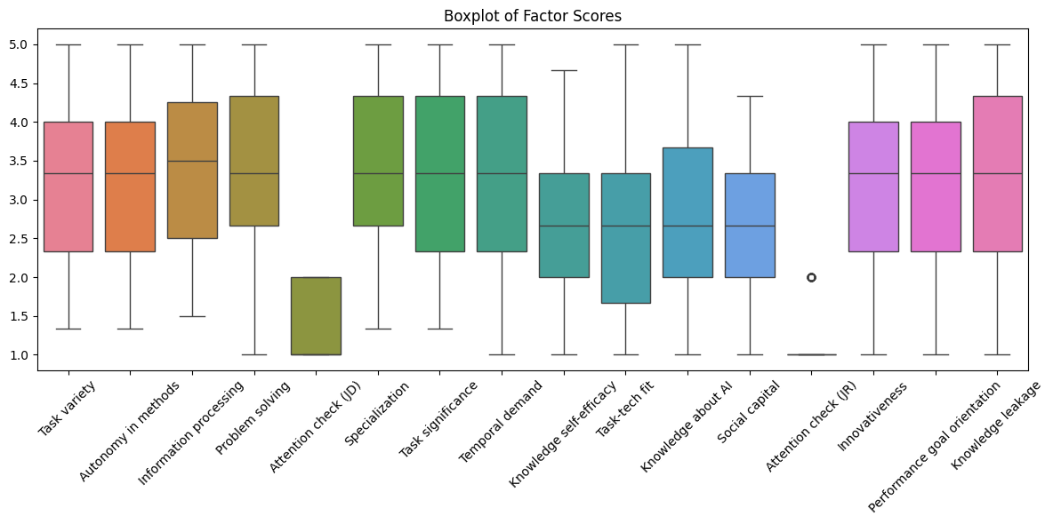**Figure 3. Boxplot of factor scores**

## Correlation Analysis

While knowledge-related and resource-related factors (such as Knowledge self-efficacy, Task-tech fit, and Social capital) showed negative or weaker correlations with task characteristics, task-related factors (such as Task variety, Autonomy, and Specialization) showed positive correlations with each other, based on the correlation analysis (Cronbach's Alpha). The validity of the factors' classification in this study is generally supported by this pattern.

In terms of job demand, all variables (Task variety, Autonomy in methods, Information processing, Problem solving, Specialization, Task significance and Temporal demand) were significantly positively correlated with Knowledge leakage (r=0.39-0.52). Among them, **Task significance** (r=0.52) and **Temporal demand** (r=0.45) had the strongest correlation, supporting the H1 hypothesis.

On the contrary, in terms of working resources, the four variables (Knowledge self-efficacy, Task-tech fit, Knowledge about AI and Social capital) were all moderately negatively correlated with Knowledge leakage (r= -0.31 to -0.40), among which the inhibitory effects of **Knowledge about AI** and **Social capital** were the most obvious (both r=-0.40), verifying the H2 hypothesis.

In terms of individual factors, both **Innovativeness** (r=0.51) and **Performance goal orientation** (r=0.50) showed a strong positive correlation with Knowledge leakage, which was a strong support for H3 and H4.

It is worth noting that there is also a high correlation between these individual factors and variables of job demand. Such as the correlations between **Innovativeness** and **Performance goal orientation** (r=0.59), **Task significance** and **Performance goal orientation** (r=0.56), indicating that these factors may reinforce each other and jointly influence the decision-making behavior of employees.

Finally, it was found in the analysis that there was a high collinearity among multiple predictor variables, which suggests that the variance inflation factor (VIF) needs to be tested in subsequent studies to ensure the independent effect of each factor.

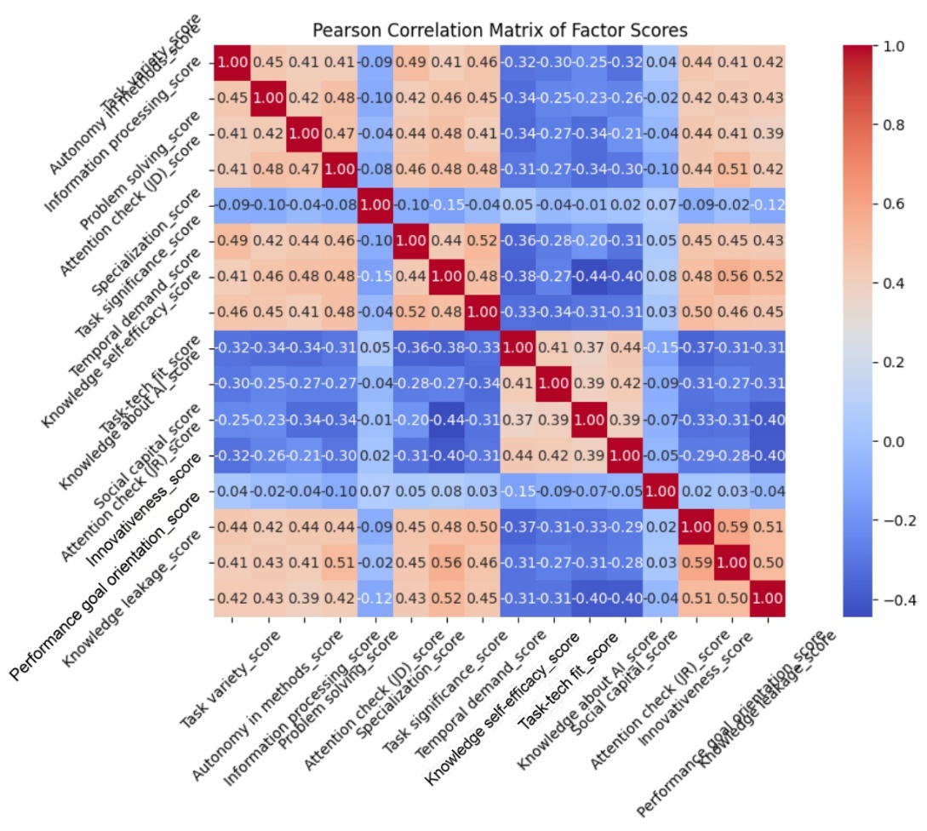

**Figure 3. Pearson correlation matrix**

## PLS Regression Results

It’s obviously in Table 3 that the correlation coefficient between the "**Knowledge leakage score**" predicted by the model and the actual value was 0.667, which indicated that the model had a moderately strong predictive ability in capturing the latent variable of **Knowledge leakage**. Squared the correlation coefficient (0.667²≈0.44), it can be known that the model can explain approximately 44% of the variance. This is already an effective predictive level in questionnaire studies in the fields of organizational behavior and social sciences, especially considering the complexity of Knowledge leakage behavior.

|  |  |
| --- | --- |
| Variable | Value |
| Knowledge leakage score | 0.667 |
| Knowledge leakage score R² | 0.44 |

**Table 3. PLS**

From the scatter plot of "Prediction vs Actual values", most data points are generally distributed around the ideal fitting line of y=x, indicating that the model captured the relationship between Knowledge leakage and the predictor variables. But there was a certain degree of "contraction" at extremely high and low values, implying that the model had a slight mean reversion effect in the performance of extreme values. The data points in the median value area (with actual values ranging from -0.5 to 1.0) showed a large vertical dispersion, suggesting that the prediction accuracy of the model was limited in some cases. It is also interesting to note that the model's predictions seem to be more concentrated in regions with higher (>1.0) and lower (<-1.0) actual values.

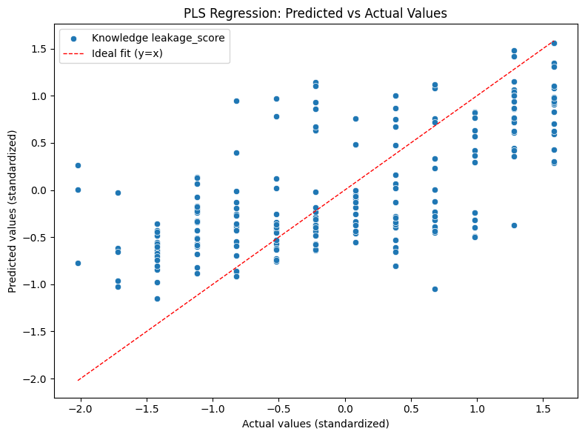

**Figure 4. PLS regression**

## OLS Regression Results

The following four tables clearly show the results of OLS Regression. This OLS model shows moderately high explanatory power for Knowledge leakage on 217 samples. R²=0.445, adjusted R²=0.410, the F statistic was highly significant (F=12.54, p<10⁻¹⁹), indicating that the overall fit of the model was good. Model diagnosis showed that the residuals were approximately normally distributed (Omnibus and Jarque-Bera tests with p values >0.28) and there was no autocorrelation problem (Durbin-Watson value =1.987). The VIF of each variable is within the range of 1.45-2.02, indicating that multicollinearity is not severe, which is conducive to stably estimating the independent contribution of each variable.

After controlling for all other factors, the study found that there were four variables that had a unique impact on knowledge leakage: **Knowledge about AI** (β=-0.147, p=0.030) and **Social capital** (β=-0.153, p=0.036) significantly inhibited knowledge leakage, while **Innovativeness** (β=0.154, If p=0.035) significantly promoted knowledge leakage; The positive effect of **Performance goal orientation** (β=0.143) was close to the significant level (p=0.064), providing weak support. It is notable that all the job demand variables, as well as Knowledge self-efficacy and Task-tech fit, did not reach a significant level in the multiple regression, which contrasts with their significant correlation in the correlation analysis. This difference may have two reasons: On the one hand, the influence of these variables may be mediated or masked by individual traits or other resource variables; On the other hand, the sample size of the study (n=217) may not be sufficient compared to the 13 predictor variables in the model, resulting in insufficient statistical testing power to detect the independent contributions of these factors after controlling for other variables, especially when there is a certain correlation among multiple predictor variables.

Overall, the regression results partially support the research hypothesis: H2 and H3 are verified, H4 receives weak support, but does not directly support H1. This discovery suggests that if organizations want to reduce the risk of knowledge leakage caused by shadow AI, they should focus on enhancing employees' knowledge level and social capital regarding AI, and at the same time provide targeted guidance to employees with high innovation and high-performance orientation. Subsequent studies may consider integrating multiple work requirements into composite indicators, expanding the sample size, or adopting regularization/structural equation models to examine the effect paths of these factors and the potential mediating or moderating mechanisms more precisely.

|  |  |
| --- | --- |
| Metric | Value |
| Dependent Variable | Knowledge leakage score |
| R-squared | 0.445 |
| Adj. R-squared | 0.410 |
| F-statistic | 12.54 |
| Prob (F-statistic) | 5.83e-20 |
| Log-Likelihood | -266.70 |
| No. Observations | 217 |
| Df Residuals | 203 |
| Df Model | 13 |

**Table 4. Model summary**

|  |  |  |  |  |  |  |
| --- | --- | --- | --- | --- | --- | --- |
| Variable | Coefficient | Std Error | t-value | P>|t| | [0.025 | 0.975] |
| const | 1.3852 | 0.510 | 2.716 | 0.007 | 0.380 | 2.391 |
| Task variety score | 0.0754 | 0.072 | 1.048 | 0.296 | -0.067 | 0.217 |
| Autonomy in methods score | 0.1055 | 0.074 | 1.430 | 0.154 | -0.040 | 0.251 |
| Information processing score | 0.0178 | 0.077 | 0.231 | 0.818 | -0.134 | 0.170 |
| Problem solving score | 0.0098 | 0.075 | 0.132 | 0.895 | -0.137 | 0.157 |
| Specialization score | 0.0898 | 0.073 | 1.226 | 0.222 | -0.055 | 0.234 |
| Task significance score | 0.1229 | 0.076 | 1.622 | 0.106 | -0.027 | 0.272 |
| Temporal demand score | 0.0525 | 0.070 | 0.748 | 0.455 | -0.086 | 0.191 |
| Knowledge self-efficacy score | 0.0628 | 0.072 | 0.867 | 0.387 | -0.080 | 0.205 |
| Task-tech fit score | -0.0135 | 0.069 | -0.195 | 0.846 | -0.150 | 0.123 |
| Knowledge about AI score | -0.1474 | 0.068 | -2.179 | 0.030 | -0.281 | -0.014 |
| Social capital score | -0.1528 | 0.072 | -2.114 | 0.036 | -0.295 | -0.010 |
| Innovativeness score | 0.1541 | 0.073 | 2.117 | 0.035 | 0.011 | 0.298 |
| Performance goal orientation score | 0.1432 | 0.077 | 1.866 | 0.064 | -0.008 | 0.295 |

**Table 5. Coefficients**

|  |  |
| --- | --- |
| Metric | Value |
| Omnibus | 2.528 |
| Prob(Omnibus) | 0.282 |
| Skew | -0.204 |
| Kurtosis | 2.672 |
| Durbin-Watson | 1.987 |
| Jarque-Bera (JB) | 2.472 |
| Prob(JB) | 0.291 |
| Cond. No. | 101 |

**Table 6. Model diagnostics**

|  |  |
| --- | --- |
| Feature | VIF |
| const | 77.216604 |
| Task variety score | 1.616529 |
| Autonomy in methods score | 1.621173 |
| Information processing score | 1.634106 |
| Problem solving score | 1.770009 |
| Specialization score | 1.773142 |
| Task significance score | 2.016854 |
| Temporal demand score | 1.800155 |
| Knowledge self-efficacy score | 1.520382 |
| Task-tech fit score | 1.456618 |
| Knowledge about AI score | 1.514193 |
| Social capital score | 1.520958 |
| Innovativeness score | 1.887042 |
| Performance goal orientation score | 1.952000 |

**Table 7. VIF values**

# Conclusion

## Findings

In this study, the factors influencing knowledge leakage caused by employees' shadow use of generative AI were investigated using the Job Demands-Resources (JD-R) model. Through the collection of survey data from 365 participants and with the usage of Ordinary Least Squares (OLS) and Partial Least Squares (PLS) regression analyses, the study determined how job demands, job resources and individual factors impact the likelihood of knowledge leakage when employees use unapproved AI tools.

The results showed that while job demands (H1), such as task significance and temporal demand, were highly positively correlated with knowledge leakage, they did not maintain significant predictive power in the regression analysis. In contrast, job resources, including knowledge about AI and social capital, were found to significantly reduce the risk of knowledge leakage, supporting the hypothesis H2 that well-informed employees and strong organizational networks can act as protective factors. Among personal traits, innovativeness (H3) was a significant positive predictor of knowledge leakage, and performance goal orientation (H4) showed a marginally positive influence, suggesting that employees who are highly innovative or competitive may be more inclined to take risks when adopting generative AI informally.

Based on these findings, organizations are encouraged to invest in employee education on the risks and proper use of generative AI, strengthen internal knowledge-sharing networks, and offer accessible, approved AI solutions to reduce the temptation of shadow AI use. Additionally, targeted interventions for employees who demonstrate high innovativeness or performance-driven behaviors may help mitigate potential risks while still supporting innovation and productivity.

## Limitations and Future Research

The study has various limitations in spite of its contributions. First, it is difficult to draw conclusions about the causal inference between predictors and knowledge leaking behaviors due to the cross-sectional survey design. In addition, while the sample size was sufficient for preliminary analysis, it might not have offered enough statistical power to identify weaker effects when modeling many predictors at once. Further, potential multicollinearity among job demand variables may have masked some effects in multivariate regression, even though variance inflation factors (VIF) remained within acceptable thresholds. Also, the study's primary focus was on the self-reported experiences of the employees, which could introduce response biases like social desirability effects.

In order to better capture the dynamic evolution of shadow AI usage behaviors over time, future research could use longitudinal designs to overcome these limitations. Expanding the sample size and applying advanced modeling techniques, such as structural equation modeling (SEM) or regularization methods, could provide deeper insights into the mediating and moderating relationships between job factors, personal characteristics, and knowledge leakage. Qualitative approaches, such as in-depth interviews, may also enrich understanding by exploring employees' motivations and perceptions regarding shadow AI in greater detail. Ultimately, continued research is critical to developing effective organizational strategies that balance the opportunities and risks of generative AI technologies in the workplace.

# REFERENCES

Bakker, A. B., & Demerouti, E. (2007). The Job Demands-Resources model: State of the art. Journal of Managerial Psychology, 22(3), 309-328. <https://doi.org/10.1108/02683940710733115>

Bandura, A. (1997). Self-efficacy: The exercise of control. W. H. Freeman.

Barsky, A. (2008). Understanding the ethical cost of organizational goal-setting: A review and theory development. Journal of Business Ethics, 81(1), 63-81. <https://doi.org/10.1007/s10551-007-9481-6>

Chui, M., Hall, B., Singla, A., Sukharevsky, A., & Yee, L. (2023, August 1). The state of AI in 2023: Generative AI’s breakout year. McKinsey & Company.

Coles, C. (2024, May 21). Shadow AI: How employees are leading the charge in AI adoption and putting company data at risk. Cyberhaven. <https://www.cyberhaven.com/blog/shadow-ai-how-employees-are-leading-the-charge-in-ai-adoption-and-putting-company-data-at-risk>

Demerouti, E., Bakker, A. B., Nachreiner, F., & Schaufeli, W. B. (2001). The job demands-resources model of burnout. Journal of Applied Psychology, 86(3), 499-512. <https://doi.org/10.1037/0021-9010.86.3.499>

Durst, S., & Aisenberg Ferenhof, H. (2014). Knowledge leakages and ways to reduce them in small and medium-sized enterprises (SMEs). Information, 5(3), 440-450. January 25, 2025 at 10:45 AM

D'Arcy, J., Herath, T., & Shoss, M. K. (2014). Understanding employee responses to stressful information security requirements: A coping perspective. Journal of Management Information Systems, 31(2), 285-318. <https://doi.org/10.2753/MIS0742-1222310210>

Goodhue, D. L. (1998). Development and measurement validity of a task-technology fit instrument for user evaluations of information systems. Decision Sciences, 29(1), 105-138. <https://doi.org/10.1111/j.1540-5915.1998.tb01346.x>

Gupta, A. (2024, February 6). The dangers of uncontrolled AI: Shadow AI and ethical risks. Securiti. https://securiti.ai/blog/dangers-of-uncontrolled-ai/

Haag, S., & Eckhardt, A. (2017). Shadow IT. Business & Information Systems Engineering, 59(6), 469-473. <https://doi.org/10.1007/s12599-017-0497-x>

IBM. (n.d.). What is Shadow AI? IBM - United States. Retrieved October 25, 2024, from <https://www.ibm.com/think/topics/shadow-ai>

Jiang, X., Li, M., Gao, S., Bao, Y., & Jiang, F. (2013). Managing knowledge leakage in strategic alliances: The effects of trust and formal contracts. Industrial Marketing Management, 42(6), 983-991.

Kopper, A., & Westner, M. (2016). Deriving a framework for causes, consequences, and governance of shadow IT from literature. Retrieved from <https://www.researchgate.net/publication/297698668_Deriving_a_Framework_for_Causes_Consequences_and_Governance_of_Shadow_IT_from_Literature>

Marr, B. (2024, February 20). A short history of ChatGPT: How we got to where we are today. *Forbes*. https://www.forbes.com/sites/bernardmarr/2023/05/19/a-short-history-of-chatgpt-how-we-got-to-where-we-are-today/

Morgeson, F. P., & Humphrey, S. E. (2006). The Work Design Questionnaire (WDQ): Developing and validating a comprehensive measure for assessing job design and the nature of work. Journal of Applied Psychology, 91(6), 1321-1339. <https://doi.org/10.1037/0021-9010.91.6.1321>

Payne, S. C., Youngcourt, S. S., & Beaubien, J. M. (2007). A meta-analytic examination of the goal orientation nomological net. Journal of Applied Psychology, 92(1), 128-150. <https://doi.org/10.1037/0021-9010.92.1.128>

PwC. (2023, October). Decoding security risks: Challenges posed by generative AI. PwC China. <https://www.pwccn.com/zh/industries/telecommunications-media-and-technology/publications/decoding-security-risks-challenges-posed-generative-ai-oct2023.html>

Ritala, P., Baiyere, A., Hughes, M., & Kraus, S. (2021). Digital strategy implementation: The role of individual entrepreneurial orientation and relational capital. Technological Forecasting and Social Change, 171, Article 120961. <https://doi.org/10.1016/j.techfore.2021.120961>

Ritala, P., Vanhala, M., & Parida, V. (2021). Innovativeness and risk-taking in SMEs. International Journal of Innovation Management, 25(2), 2150023.

Stojan, J. (2024, August 16). Employees are leaking data over GenAI tools: Here's what enterprises need to do. VentureBeat. Retrieved January 25, 2025, from https://venturebeat.com/business/employees-are-leaking-data-over-genai-tools-heres-what-enterprises-need-to-do

Sweller, J. (1988). Cognitive load during problem solving: Effects on learning. Cognitive Science, 12(2), 257–285. <https://doi.org/10.1207/s15516709cog1202_4>

Vandewalle, D. (1997). Development and validation of a work domain goal orientation instrument. Educational and Psychological Measurement, 57(6), 995-1015. <https://doi.org/10.1177/0013164497057006009>

Vaswani, A., Shazeer, N., Parmar, N., Uszkoreit, J., Jones, L., Gomez, A. N., Kaiser, L., & Polosukhin, I. (2017). Attention is All you Need. arXiv (Cornell University), 30, 5998–6008. <https://arxiv.org/pdf/1706.03762v5>

Wiz Experts Team. (2025, January 22). *What is shadow AI? why it’s a threat and how to embrace and manage it*. wiz.io. <https://www.wiz.io/academy/shadow-ai>

Wong, W. P., Tan, H. C., Tan, K. H., & Tseng, M. L. (2019). Human factors in information leakage: mitigation strategies for information sharing integrity. Industrial Management & Data Systems, 119(6), 1242–1267.

Xanthopoulou, D., Bakker, A. B., Demerouti, E., & Schaufeli, W. B. (2007). The role of personal resources in the job demands-resources model. International Journal of Stress Management, 14(2), 121-141. <https://doi.org/10.1037/1072-5245.14.2.121>

Zhang, D., Xia, B., Liu, Y., Xu, X., Hoang, T., Xing, Z., Staples, M., Lu, Q., & Zhu, L. (2023). Navigating privacy and copyright challenges across the data lifecycle of generative AI. arXiv preprint, arXiv:2311.18252. <https://arxiv.org/abs/2311.18252>

# Appendix A Factors Mapping Table

Note that these final factors are revised and provided by our supervisor.

|  |  |  |  |
| --- | --- | --- | --- |
| Construct (Source) | Definition/notes | Items | Options |
| **Job Demands** | | | |
| Task variety (Morgeson & Humphrey, 2006) |  | e.g. The above task was diverse in that various knowledge was required. | Strongly Disagree - Strongly Agree (five-point Likert scale) |
| Autonomy in methods (Morgeson & Humphrey, 2006) |  | e.g. I had autonomy for the above task, in that I was allowed to decide what tools to use to complete the task. | Strongly Disagree - Strongly Agree (five-point Likert scale) |
| Information processing (Morgeson & Humphrey, 2006) |  | e.g. The above task required me to analyze a lot of information. | Strongly Disagree - Strongly Agree (five-point Likert scale) |
| Problem solving (Morgeson & Humphrey, 2006) |  | e.g. The above task required me to deal with problems I had not encountered before. | Strongly Disagree - Strongly Agree (five-point Likert scale) |
| Attention check | Answer should be strongly disagree or disagree. | The above task was completed without using any third-party generative AI tool(s). | Strongly Disagree - Strongly Agree (five-point Likert scale) |
| Specialization (Morgeson & Humphrey, 2006) |  | e.g. The above task was specialized in that it required subject-matter expertise. | Strongly Disagree - Strongly Agree (five-point Likert scale) |
| Task significance (Morgeson & Humphrey, 2006) |  | e.g. The above task was important in that the outcome could affect my performance. | Strongly Disagree - Strongly Agree (five-point Likert scale) |
| Temporal demand (time pressure) |  | e.g. There was time pressure in completing the above task, due to insufficient time allocated. | Strongly Disagree - Strongly Agree (five-point Likert scale) |
| **Job Resources** | | | |
| Knowledge self-efficacy | More knowledge, less use of AI | e.g. I have the knowledge needed to complete the above task without AI. | Strongly Disagree - Strongly Agree (five-point Likert scale) |
| Task-tech fit (adapted from Goodhue (1998)) | Not sufficient -> more use of AI | e.g. The technologies provided by my organization were sufficient for completing the above task. | Strongly Disagree - Strongly Agree (five-point Likert scale) |
| Knowledge about AI | More knowledge (about risks and limitations), less likely to use AI | e.g. I have knowledge about the benefits of AI tools. | Strongly Disagree - Strongly Agree (five-point Likert scale) |
| Social capital | Relational, structural, cognitive dimensions.    More social capital, less use of AI. | e.g. I can rely on others in my organization for help if I need it. | Strongly Disagree - Strongly Agree (five-point Likert scale) |
| Attention check | Should be the same answer as above. | I have the expertise needed to complete the above task without AI. | Strongly Disagree - Strongly Agree (five-point Likert scale) |
| **Individual factors** |  |  |  |
| Innovativeness (adapted from (Ritala et al., 2021)) | More innovative, mor likely to try AI. | e.g. In general, I prefer innovative rather than tried and true approaches to work. | Strongly Disagree - Strongly Agree (five-point Likert scale) |
| Performance goal orientation (adapted from Vandewalle (1997)) | More performance goal, more competitive, more likely to take risk to use AI. | e.g. In general, I focus on showing that I can perform better than my coworkers. | Strongly Disagree - Strongly Agree (five-point Likert scale) |
| Knowledge leakage |  | e.g. To complete the above task, I had to provide confidential information to the AI tool(s). | Strongly Disagree - Strongly Agree (five-point Likert scale) |
|  |  | My employer had a policy that prohibits the use of third-party AI tools. | Yes  No  I don’t know. |

**Table A. Factors mapping**

# APPENDIX B SURVEY

## Use of Generative Artificial Intelligence (AI) by Professionals Survey

## Demographic Information

1. Year of Birth:  
 ○ 1940 - 2004 (Dropdown or manual input)

2. Gender:  
 ○ Male  
 ○ Female  
 ○ Other

3. Have you used any third-party generative AI tools (e.g., ChatGPT, Claude, Deepseek), in the past six months? “Third-party generative AI tools” refer to those not provided/managed by your employer:

○ No, never.  
 ○ Yes – once a month.  
 ○ Yes – several times a month.  
 ○ Yes – once a week.  
 ○ Yes – several times a week.  
 ○ Yes – once a day.  
 ○ Yes – several times a day.

4. If Yes, which third-party generative AI tools have you used?

Please specify: _______________

5. What is your latest job position?  
 ○ Administrative (e.g., assistant, coordinator)  
 ○ Entry-level/Intern  
 ○ Executive/Director/C-level  
 ○ Manager/Supervisor  
 ○ Professional (e.g., accountant, consultant, engineer, lawyer, teacher)  
 ○ Sales/Customer Service  
 ○ Technical specialist (e.g., technician)  
 ○ Other (please specify): _______________

6. Job experience: I have worked in this and other similar positions for ___ years and ___ months.

7. Which industry is the above job in?  
 ○ Agriculture  
 ○ Arts/Entertainment  
 ○ Construction/Real Estate  
 ○ Education/Training  
 ○ Energy/Utilities  
 ○ Finance/Banking/Insurance  
 ○ Food Services  
 ○ Government/Public Administration  
 ○ Healthcare/Medical Services  
 ○ Hospitality/Tourism  
 ○ Information Technology/Software  
 ○ Manufacturing  
 ○ Media  
 ○ Nonprofit/Social Services  
 ○ Professional Services and Consulting  
 ○ Retail  
 ○ Telecommunications  
 ○ Transportation/Logistics  
 ○ Other (please specify): _______________

8. The above job is______:  
 ○ Full-time  
 ○ Part-time  
 ○ Other (please specify): _______________

## Job Demands

1. Recall a work task for which you had to use third-party generative AI tool(s). Describe the tool, task, and goal. For example: “Use [name AI tool] to [describe task and goal]”  
    Please specify: ____________
2. The above task was diverse in that various knowledge was required.

|  |  |  |  |  |  |  |
| --- | --- | --- | --- | --- | --- | --- |
| Strongly Disagree | ○1 | ○2 | ○3 | ○4 | ○5 | Strongly Agree |

1. The above task was diverse in that different skills were required

|  |  |  |  |  |  |  |
| --- | --- | --- | --- | --- | --- | --- |
| Strongly Disagree | ○1 | ○2 | ○3 | ○4 | ○5 | Strongly Agree |

1. The above task was diverse in that a wide range of activities were involved.

|  |  |  |  |  |  |  |
| --- | --- | --- | --- | --- | --- | --- |
| Strongly Disagree | ○1 | ○2 | ○3 | ○4 | ○5 | Strongly Agree |

1. I had autonomy for the above task, in that I was allowed to decide what tools to use to complete the task.

|  |  |  |  |  |  |  |
| --- | --- | --- | --- | --- | --- | --- |
| Strongly Disagree | ○1 | ○2 | ○3 | ○4 | ○5 | Strongly Agree |

1. I had autonomy for the above task, in that I was allowed to decide what tools to determine what methods to use.

|  |  |  |  |  |  |  |
| --- | --- | --- | --- | --- | --- | --- |
| Strongly Disagree | ○1 | ○2 | ○3 | ○4 | ○5 | Strongly Agree |

1. I had autonomy for the above task, in that I was allowed to decide what tools to make judgment about how to complete the task.

|  |  |  |  |  |  |  |
| --- | --- | --- | --- | --- | --- | --- |
| Strongly Disagree | ○1 | ○2 | ○3 | ○4 | ○5 | Strongly Agree |

1. The above task required me to analyze a lot of information.

|  |  |  |  |  |  |  |
| --- | --- | --- | --- | --- | --- | --- |
| Strongly Disagree | ○1 | ○2 | ○3 | ○4 | ○5 | Strongly Agree |

1. The above task required me to engage in much thinking.

|  |  |  |  |  |  |  |
| --- | --- | --- | --- | --- | --- | --- |
| Strongly Disagree | ○1 | ○2 | ○3 | ○4 | ○5 | Strongly Agree |

1. The above task required me to monitor a great deal of information to identify changes.

|  |  |  |  |  |  |  |
| --- | --- | --- | --- | --- | --- | --- |
| Strongly Disagree | ○1 | ○2 | ○3 | ○4 | ○5 | Strongly Agree |

1. The above task required me to monitor a great deal of information to deal with potentially inaccurate information.

|  |  |  |  |  |  |  |
| --- | --- | --- | --- | --- | --- | --- |
| Strongly Disagree | ○1 | ○2 | ○3 | ○4 | ○5 | Strongly Agree |

1. The above task required me to deal with problems I had not encountered before.

|  |  |  |  |  |  |  |
| --- | --- | --- | --- | --- | --- | --- |
| Strongly Disagree | ○1 | ○2 | ○3 | ○4 | ○5 | Strongly Agree |

1. The above task required me to solve problems that had no obvious correct answer.

|  |  |  |  |  |  |  |
| --- | --- | --- | --- | --- | --- | --- |
| Strongly Disagree | ○1 | ○2 | ○3 | ○4 | ○5 | Strongly Agree |

1. The above task required me to develop unique ideas or solutions.

|  |  |  |  |  |  |  |
| --- | --- | --- | --- | --- | --- | --- |
| Strongly Disagree | ○1 | ○2 | ○3 | ○4 | ○5 | Strongly Agree |

1. The above task was completed without using any third-party generative AI tool(s).

|  |  |  |  |  |  |  |
| --- | --- | --- | --- | --- | --- | --- |
| Strongly Disagree | ○1 | ○2 | ○3 | ○4 | ○5 | Strongly Agree |

1. The above task was specialized in that it required subject-matter expertise.

|  |  |  |  |  |  |  |
| --- | --- | --- | --- | --- | --- | --- |
| Strongly Disagree | ○1 | ○2 | ○3 | ○4 | ○5 | Strongly Agree |

1. The above task was specialized in that it required domain-specific skills.

|  |  |  |  |  |  |  |
| --- | --- | --- | --- | --- | --- | --- |
| Strongly Disagree | ○1 | ○2 | ○3 | ○4 | ○5 | Strongly Agree |

1. The above task was specialized in that it required specialized tools/procedures/materials.

|  |  |  |  |  |  |  |
| --- | --- | --- | --- | --- | --- | --- |
| Strongly Disagree | ○1 | ○2 | ○3 | ○4 | ○5 | Strongly Agree |

1. The above task was important in that the outcome could affect my performance.

|  |  |  |  |  |  |  |
| --- | --- | --- | --- | --- | --- | --- |
| Strongly Disagree | ○1 | ○2 | ○3 | ○4 | ○5 | Strongly Agree |

1. The above task was important in that the outcome could affect my organization’s performance.

|  |  |  |  |  |  |  |
| --- | --- | --- | --- | --- | --- | --- |
| Strongly Disagree | ○1 | ○2 | ○3 | ○4 | ○5 | Strongly Agree |

1. The above task was important in that the outcome could affect many other people.

|  |  |  |  |  |  |  |
| --- | --- | --- | --- | --- | --- | --- |
| Strongly Disagree | ○1 | ○2 | ○3 | ○4 | ○5 | Strongly Agree |

1. There was time pressure in completing the above task, due to insufficient time allocated.

|  |  |  |  |  |  |  |
| --- | --- | --- | --- | --- | --- | --- |
| Strongly Disagree | ○1 | ○2 | ○3 | ○4 | ○5 | Strongly Agree |

1. There was time pressure in completing the above task, due to firm deadlines.

|  |  |  |  |  |  |  |
| --- | --- | --- | --- | --- | --- | --- |
| Strongly Disagree | ○1 | ○2 | ○3 | ○4 | ○5 | Strongly Agree |

1. There was time pressure in completing the above task, due to urgency of the situation.

|  |  |  |  |  |  |  |
| --- | --- | --- | --- | --- | --- | --- |
| Strongly Disagree | ○1 | ○2 | ○3 | ○4 | ○5 | Strongly Agree |

## Job Resources

1. I have the knowledge needed to complete the above task without AI.

|  |  |  |  |  |  |  |
| --- | --- | --- | --- | --- | --- | --- |
| Strongly Disagree | ○1 | ○2 | ○3 | ○4 | ○5 | Strongly Agree |

1. I have the skills to complete the above task without AI.

|  |  |  |  |  |  |  |
| --- | --- | --- | --- | --- | --- | --- |
| Strongly Disagree | ○1 | ○2 | ○3 | ○4 | ○5 | Strongly Agree |

1. I am confident in my ability to complete the above task without AI.

|  |  |  |  |  |  |  |
| --- | --- | --- | --- | --- | --- | --- |
| Strongly Disagree | ○1 | ○2 | ○3 | ○4 | ○5 | Strongly Agree |

1. The technologies provided by my organization were sufficient for completing the above task.

|  |  |  |  |  |  |  |
| --- | --- | --- | --- | --- | --- | --- |
| Strongly Disagree | ○1 | ○2 | ○3 | ○4 | ○5 | Strongly Agree |

1. The technologies provided by my organization were easy to use for the above task.

|  |  |  |  |  |  |  |
| --- | --- | --- | --- | --- | --- | --- |
| Strongly Disagree | ○1 | ○2 | ○3 | ○4 | ○5 | Strongly Agree |

1. The technologies provided by my organization were always up and running for the above task.

|  |  |  |  |  |  |  |
| --- | --- | --- | --- | --- | --- | --- |
| Strongly Disagree | ○1 | ○2 | ○3 | ○4 | ○5 | Strongly Agree |

1. I have knowledge about the benefits of AI tools.

|  |  |  |  |  |  |  |
| --- | --- | --- | --- | --- | --- | --- |
| Strongly Disagree | ○1 | ○2 | ○3 | ○4 | ○5 | Strongly Agree |

1. I have knowledge about the limitations of AI tools.

|  |  |  |  |  |  |  |
| --- | --- | --- | --- | --- | --- | --- |
| Strongly Disagree | ○1 | ○2 | ○3 | ○4 | ○5 | Strongly Agree |

1. I have knowledge about the risks of AI tools

|  |  |  |  |  |  |  |
| --- | --- | --- | --- | --- | --- | --- |
| Strongly Disagree | ○1 | ○2 | ○3 | ○4 | ○5 | Strongly Agree |

1. I can rely on others in my organization for help if I need it.

|  |  |  |  |  |  |  |
| --- | --- | --- | --- | --- | --- | --- |
| Strongly Disagree | ○1 | ○2 | ○3 | ○4 | ○5 | Strongly Agree |

1. I have good relationships with others in my organization.

|  |  |  |  |  |  |  |
| --- | --- | --- | --- | --- | --- | --- |
| Strongly Disagree | ○1 | ○2 | ○3 | ○4 | ○5 | Strongly Agree |

1. I can communicate/interact effectively with others in my organization.

|  |  |  |  |  |  |  |
| --- | --- | --- | --- | --- | --- | --- |
| Strongly Disagree | ○1 | ○2 | ○3 | ○4 | ○5 | Strongly Agree |

1. I have the expertise needed to complete the above task without AI.

|  |  |  |  |  |  |  |
| --- | --- | --- | --- | --- | --- | --- |
| Strongly Disagree | ○1 | ○2 | ○3 | ○4 | ○5 | Strongly Agree |

## Individual factors

1. In general, I prefer innovative rather than tried and true approaches to work.

|  |  |  |  |  |  |  |
| --- | --- | --- | --- | --- | --- | --- |
| Strongly Disagree | ○1 | ○2 | ○3 | ○4 | ○5 | Strongly Agree |

1. In general, I prefer to learn new things rather than tried and true approaches to work.

|  |  |  |  |  |  |  |
| --- | --- | --- | --- | --- | --- | --- |
| Strongly Disagree | ○1 | ○2 | ○3 | ○4 | ○5 | Strongly Agree |

1. In general, I prefer to experiment with original approaches rather than tried and true approaches to work.

|  |  |  |  |  |  |  |
| --- | --- | --- | --- | --- | --- | --- |
| Strongly Disagree | ○1 | ○2 | ○3 | ○4 | ○5 | Strongly Agree |

1. In general, I focus on showing that I can perform better than my coworkers.

|  |  |  |  |  |  |  |
| --- | --- | --- | --- | --- | --- | --- |
| Strongly Disagree | ○1 | ○2 | ○3 | ○4 | ○5 | Strongly Agree |

1. I prefer work that allows me to prove my ability to others.

|  |  |  |  |  |  |  |
| --- | --- | --- | --- | --- | --- | --- |
| Strongly Disagree | ○1 | ○2 | ○3 | ○4 | ○5 | Strongly Agree |

1. I enjoy it when others are aware of how well I am performing at work.

|  |  |  |  |  |  |  |
| --- | --- | --- | --- | --- | --- | --- |
| Strongly Disagree | ○1 | ○2 | ○3 | ○4 | ○5 | Strongly Agree |

1. To complete the above task, I had to provide confidential information to the AI tool(s).

|  |  |  |  |  |  |  |
| --- | --- | --- | --- | --- | --- | --- |
| Strongly Disagree | ○1 | ○2 | ○3 | ○4 | ○5 | Strongly Agree |

1. To complete the above task, I had to provide sensitive information to the AI tool(s).

|  |  |  |  |  |  |  |
| --- | --- | --- | --- | --- | --- | --- |
| Strongly Disagree | ○1 | ○2 | ○3 | ○4 | ○5 | Strongly Agree |

1. To complete the above task, I had to provide proprietary information to the AI tool(s).

|  |  |  |  |  |  |  |
| --- | --- | --- | --- | --- | --- | --- |
| Strongly Disagree | ○1 | ○2 | ○3 | ○4 | ○5 | Strongly Agree |

1. My employer had a policy that prohibits the use of third-party AI tools.

○ Yes  
 ○ No  
 ○ I don’t know.