WESAD Stress Detection
Complete Technical Documentation
Binary Stress Detection Using Wearable Physiological Signals

Kaustubh Agrawal
April 8, 2026

1. Executive Summary
This project builds a complete stress detection system — from raw physiological signals to edge-deployable models — using the WESAD dataset (15 subjects, chest-worn RespiBAN sensors at 700 Hz).
Phase 1 (Traditional ML): Load raw pickles → Butterworth filtering → z-score normalization → 60-second sliding windows → ~150 hand-crafted features → Logistic Regression and Random Forest → LOSO cross-validation. Result: 0.96+ accuracy, 0.95+ recall.
Phase 2 (Deep Learning + KD): Train a multi-scale 1D-CNN teacher (266K params) → distill into three student architectures → LOSO validation. Result: MicroCNN (distilled, ~5K params) achieves 0.998 accuracy and 0.996 F1 — matching the teacher at 50x compression.
The project includes SHAP-based channel importance analysis, Grad-CAM temporal activation maps, KD hyperparameter ablation studies, and INT8 quantization benchmarks.

2. Problem Statement & Motivation
Chronic stress affects ~77% of adults and contributes to cardiovascular disease, mental health disorders, and reduced quality of life. Most individuals lack objective, continuous tools to monitor stress. This project asks: Can we build a model that reliably detects stress from wearable physiological signals, generalizes to unseen users, and runs on resource-constrained edge devices?

Hypotheses
H1: Physiological signals contain measurable patterns that reliably distinguish stress from baseline states.
H2: Traditional ML with hand-crafted features can achieve >70% recall under LOSO validation.
H3: Knowledge distillation can compress a large teacher CNN into microcontroller-sized models without significant performance loss.
All three hypotheses were validated. H2 was exceeded by a wide margin (recall >95%).

3. Dataset Description
Attribute | Details
Source | TU Darmstadt (Schmidt et al., 2018)
Subjects | 15 participants (S2–S17, S12 excluded)
Duration | ~2 hours per subject
Device | RespiBAN Professional (chest-worn)
Sampling Rate | 700 Hz
File Format | Python pickle (.pkl), ~975 MB each
Total Size | ~15 GB

Signals Used
Signal | Description | Stress Relevance
ECG | Electrocardiogram | Heart rate variability, cardiac stress
EDA | Electrodermal Activity | Skin conductance, sympathetic arousal
EMG | Electromyography | Muscle tension
Resp | Respiration | Breathing rate and depth changes
Temp | Body Temperature | Thermoregulation under stress
ACC | 3-axis Accelerometer | Motion artifact detection

Binary Classification Task
Labels are remapped: baseline (Label 1) → 0, stress (Label 2) → 1. All other labels are discarded. This creates a ~64/36 class split (baseline-heavy), handled via balanced class weights and weighted sampling.

4. System Architecture
The pipeline has two phases sharing common data loading, preprocessing, and windowing stages:
Phase 1 path: windows → hand-crafted features (~150) → LogReg / RandomForest → LOSO evaluation.
Phase 2 path: windows → FFT downsample to 64 Hz → Teacher CNN training → Student CNN training (standalone + distilled) → LOSO evaluation.

Key Configuration
Parameter | Value | Purpose
CHEST_SAMPLING_RATE | 700 Hz | Raw data rate
WINDOW_LENGTH_SEC | 60 s | Window duration
WINDOW_OVERLAP | 0.5 | 50% overlap
PURITY_THRESHOLD | 0.8 | Min label purity per window
TRANSITION_BUFFER_SEC | 5 s | Discard zone around transitions
DL downsample target | 64 Hz | DL input rate
Teacher epochs | 40 | Training epochs
Student epochs | 30 | Training epochs
KD temperature | 4.0 | Softmax temperature
KD alpha | 0.7 | Teacher weight in KD loss
Learning rate | 3e-4 | AdamW optimizer
Random seed | 42 | Reproducibility

5. Phase 1: Traditional ML Pipeline

5.1 Signal Preprocessing
Each signal gets a modality-specific 4th-order Butterworth filter (zero-phase via filtfilt):
Signal | Filter Type | Cutoff | Rationale
ECG | Bandpass | 0.5–40 Hz | Remove baseline wander + HF noise
EDA | Lowpass | <1 Hz | EDA is slow-varying
EMG | Bandpass | 20–300 Hz | Muscle activity range
Resp | Bandpass | 0.1–0.5 Hz | Normal breathing frequency
Temp | Lowpass | <0.1 Hz | Very slow thermal changes

Normalization: Z-score per subject (z = (x - mean) / std). Robust z-score (median/IQR) for EDA and Temp. NaN values replaced with per-signal median.

5.2 Windowing & Segmentation
60-second windows (42,000 samples at 700 Hz) with 50% overlap (21,000-sample step). Quality filters: 80% purity threshold (min label agreement within window) and 5-second transition buffer (samples near label changes are excluded).

5.3 Feature Engineering
~150 hand-crafted features per window across four categories:
Category | Examples | Count
Statistical | Mean, std, variance, min, max, range, percentiles, IQR, skewness, kurtosis, RMS, energy | ~10/signal
Temporal | Zero-crossing rate, peak count, slope features | ~5/signal
Frequency | Welch PSD, power bands (VLF/LF/HF/VHF), peak freq, spectral centroid/entropy | ~5/signal
EDA-Specific | Tonic/phasic decomposition, SCR count, SCR amplitude | ~5 total

5.4 Models
Logistic Regression: L2 penalty, C=1.0, balanced class weights, lbfgs solver, max_iter=1000.
Random Forest: 100 trees, max_depth=10, min_samples_split=5, balanced class weights.
Both use StandardScaler (fit on training data only).

5.5 Baselines
Random: Samples from class prior. Recall = 0.358, F1 = 0.364.
Majority: Always predicts baseline. Recall = 0.000, F1 = 0.000.
EDA Threshold: Per-subject threshold on mean EDA. Recall = 0.866, F1 = 0.792.

6. Phase 2: Deep Learning & Knowledge Distillation

6.1 Data Preparation
700 Hz signals are downsampled to 64 Hz via FFT-based resampling. Input tensor: (batch, 6, 3840) — 6 channels x 60s x 64 Hz. NaN sanitization applied before/after resampling with ±5 clipping.

6.2 Teacher: MultiScaleTeacherCNN (~266K params)
Three parallel convolutional branches at different kernel sizes capture physiological phenomena at different timescales:
Branch | Kernel | Captures | Physiological Target
Small | k=8 | Fast patterns | ECG heartbeats, motion
Medium | k=32 | Mid-range | Respiration cycles
Large | k=64 | Slow trends | EDA rise, thermal drift

Each branch: Conv1d → BN → ReLU → Conv1d → BN → ReLU → GlobalAvgPool. Outputs concatenated (192-dim) → FC(192→128) → ReLU → Dropout(0.3) → FC(128→64) → ReLU → FC(64→2).

6.3 Student Architectures
Model | Params | Architecture | Target Device
MicroCNN | ~5.3K | Depthwise-separable Conv1d (MobileNet-style) | ARM Cortex-M4 (<32KB)
TinyCNN | ~15.2K | 3-layer standard Conv1d | nRF52840 (<256KB)
MiniCNN-LSTM | ~28.8K | Conv1d + LSTM hybrid | ESP32-S3 (<512KB)

6.4 Knowledge Distillation
KD loss (Hinton et al., 2015): L_KD = α × T² × KL(softmax(s/T) || softmax(t/T)) + (1-α) × CE(s, y_true)
T=4.0 softens teacher output, exposing inter-class similarities. α=0.7 gives 70% weight to soft targets. T² scaling restores gradient magnitude.
Training: AdamW (lr=3e-4, wd=1e-3), ReduceLROnPlateau (F1, patience=5), gradient clipping (max_norm=1.0), WeightedRandomSampler for batch-level class balance.

6.5 LOSO Evaluation
All models evaluated with Leave-One-Subject-Out: train on 14 subjects, test on 1, repeat for all 15. Report mean ± std across folds. This simulates real-world deployment on unseen users.

7. Explainability & Interpretability

7.1 SHAP Channel Importance
ECG dominates with mean |SHAP| = 0.00093, followed by Temp (0.00029), EDA (0.00025), ACC (0.00023), EMG (0.00016). Respiration contributes near-zero.
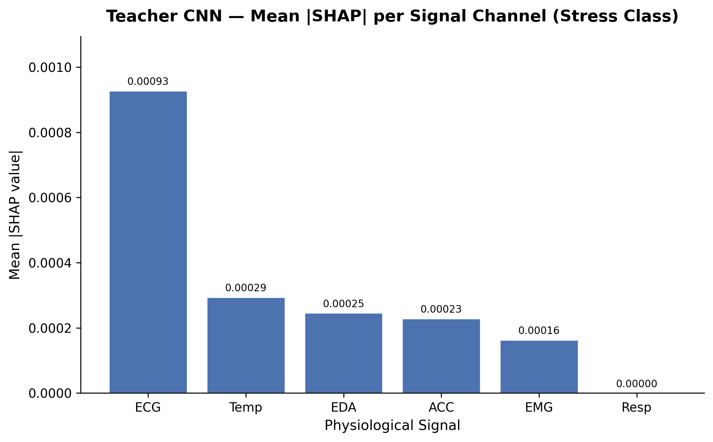
Figure 8: Teacher CNN — Mean |SHAP| per Signal Channel (Stress Class)

7.2 Per-Class SHAP
ECG matters ~1.75x more for stress windows (0.00128) than baseline (0.00073). EDA shows 2.4x higher importance for stress. Temp and ACC are more important for classifying baseline — the model uses temperature/motion stability as a baseline indicator.
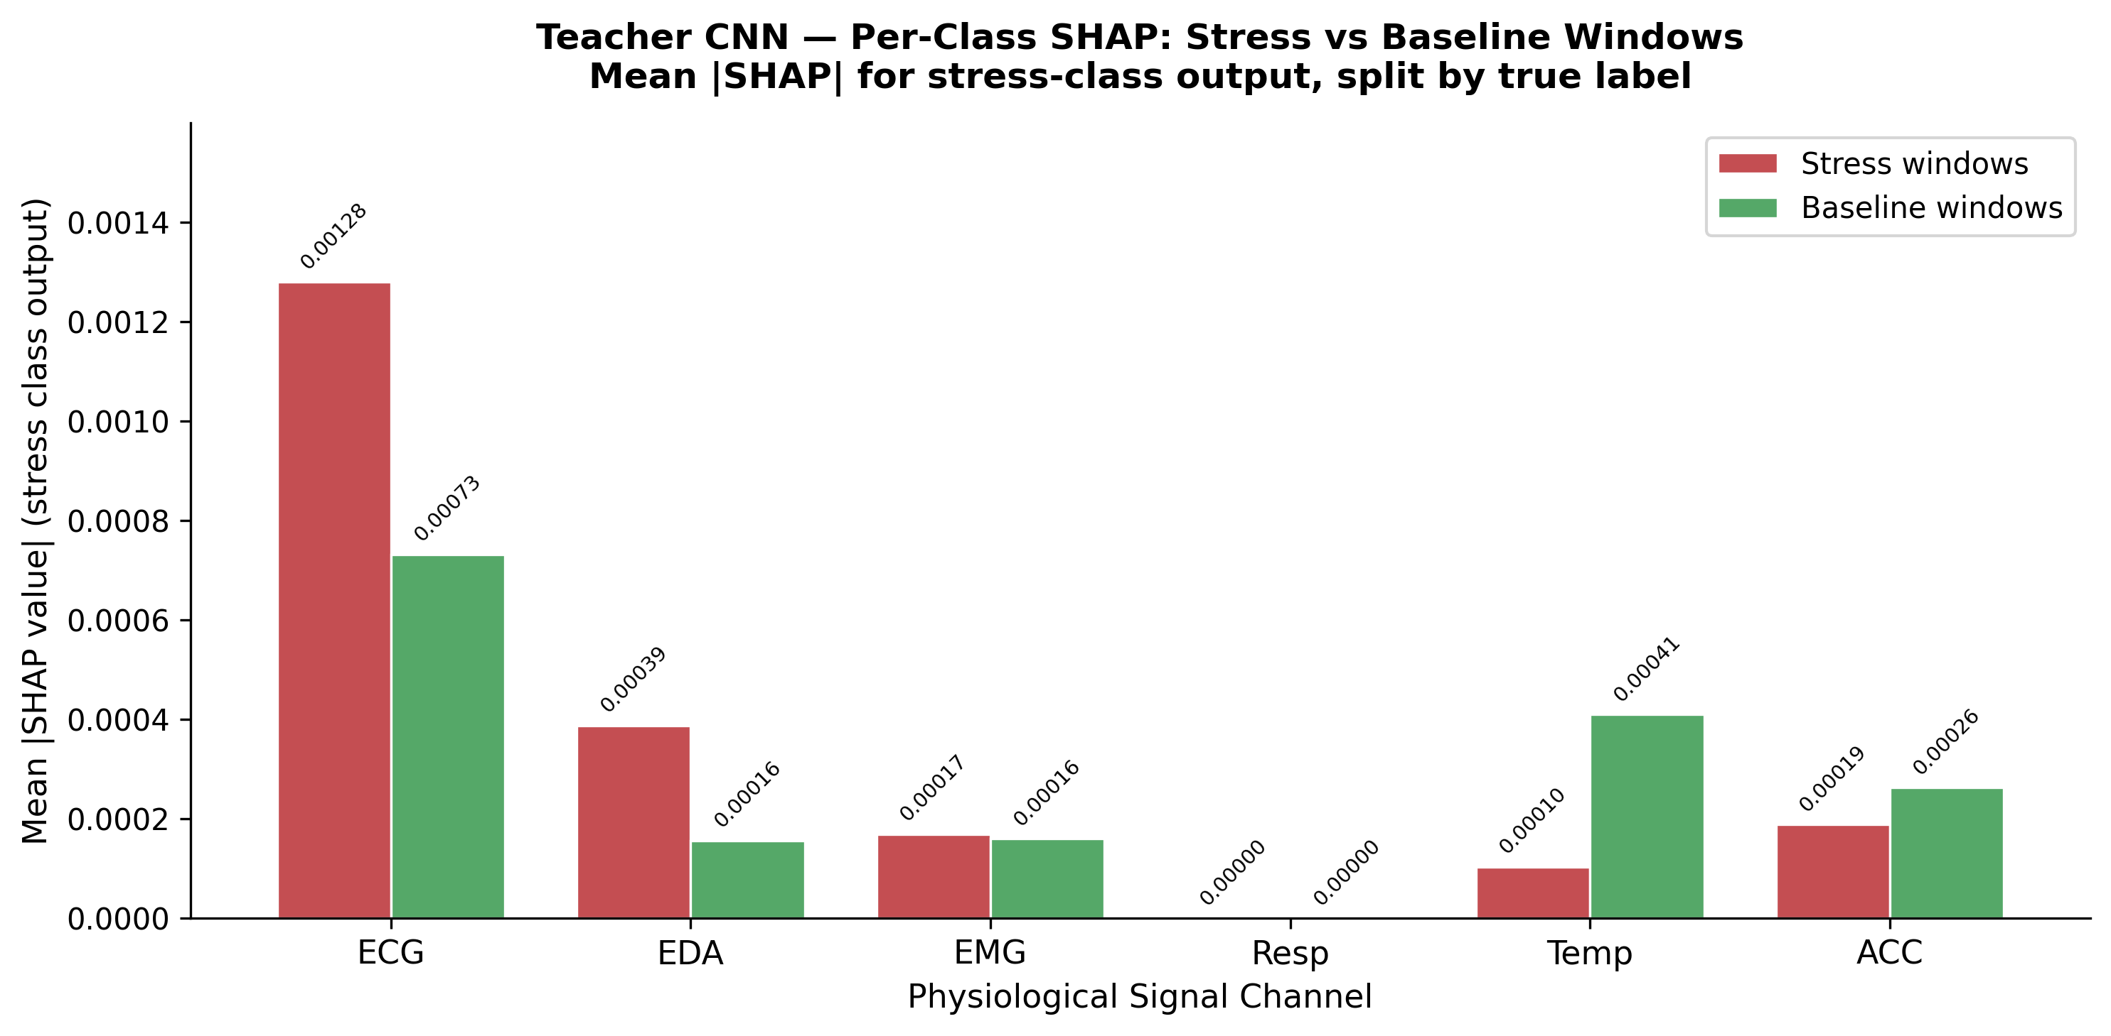
Figure 10: Per-Class SHAP — Stress vs Baseline Windows

7.3 Grad-CAM Temporal Activation
The teacher's fast branch (k=8) shows consistently higher activation for stress (~0.33) vs baseline (~0.17) across the entire 60-second window. Activation is uniform temporally — the model uses the full window.
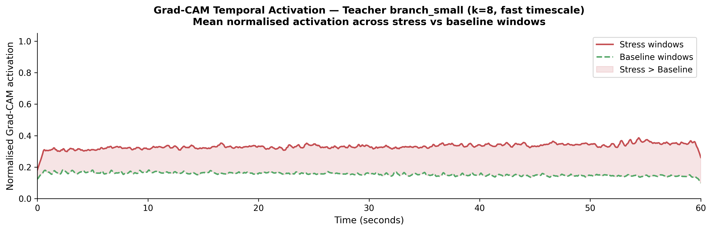
Figure 9: Grad-CAM Temporal Activation — Stress vs Baseline

7.4 Knowledge Distillation — Preserved Attention
After 50x compression (266K → 5.3K), the MicroCNN student preserves general attention patterns but redistributes: less ECG reliance (0.00012 vs 0.00093), more Temp (0.00047 vs 0.00028) and EDA (0.00035 vs 0.00024).
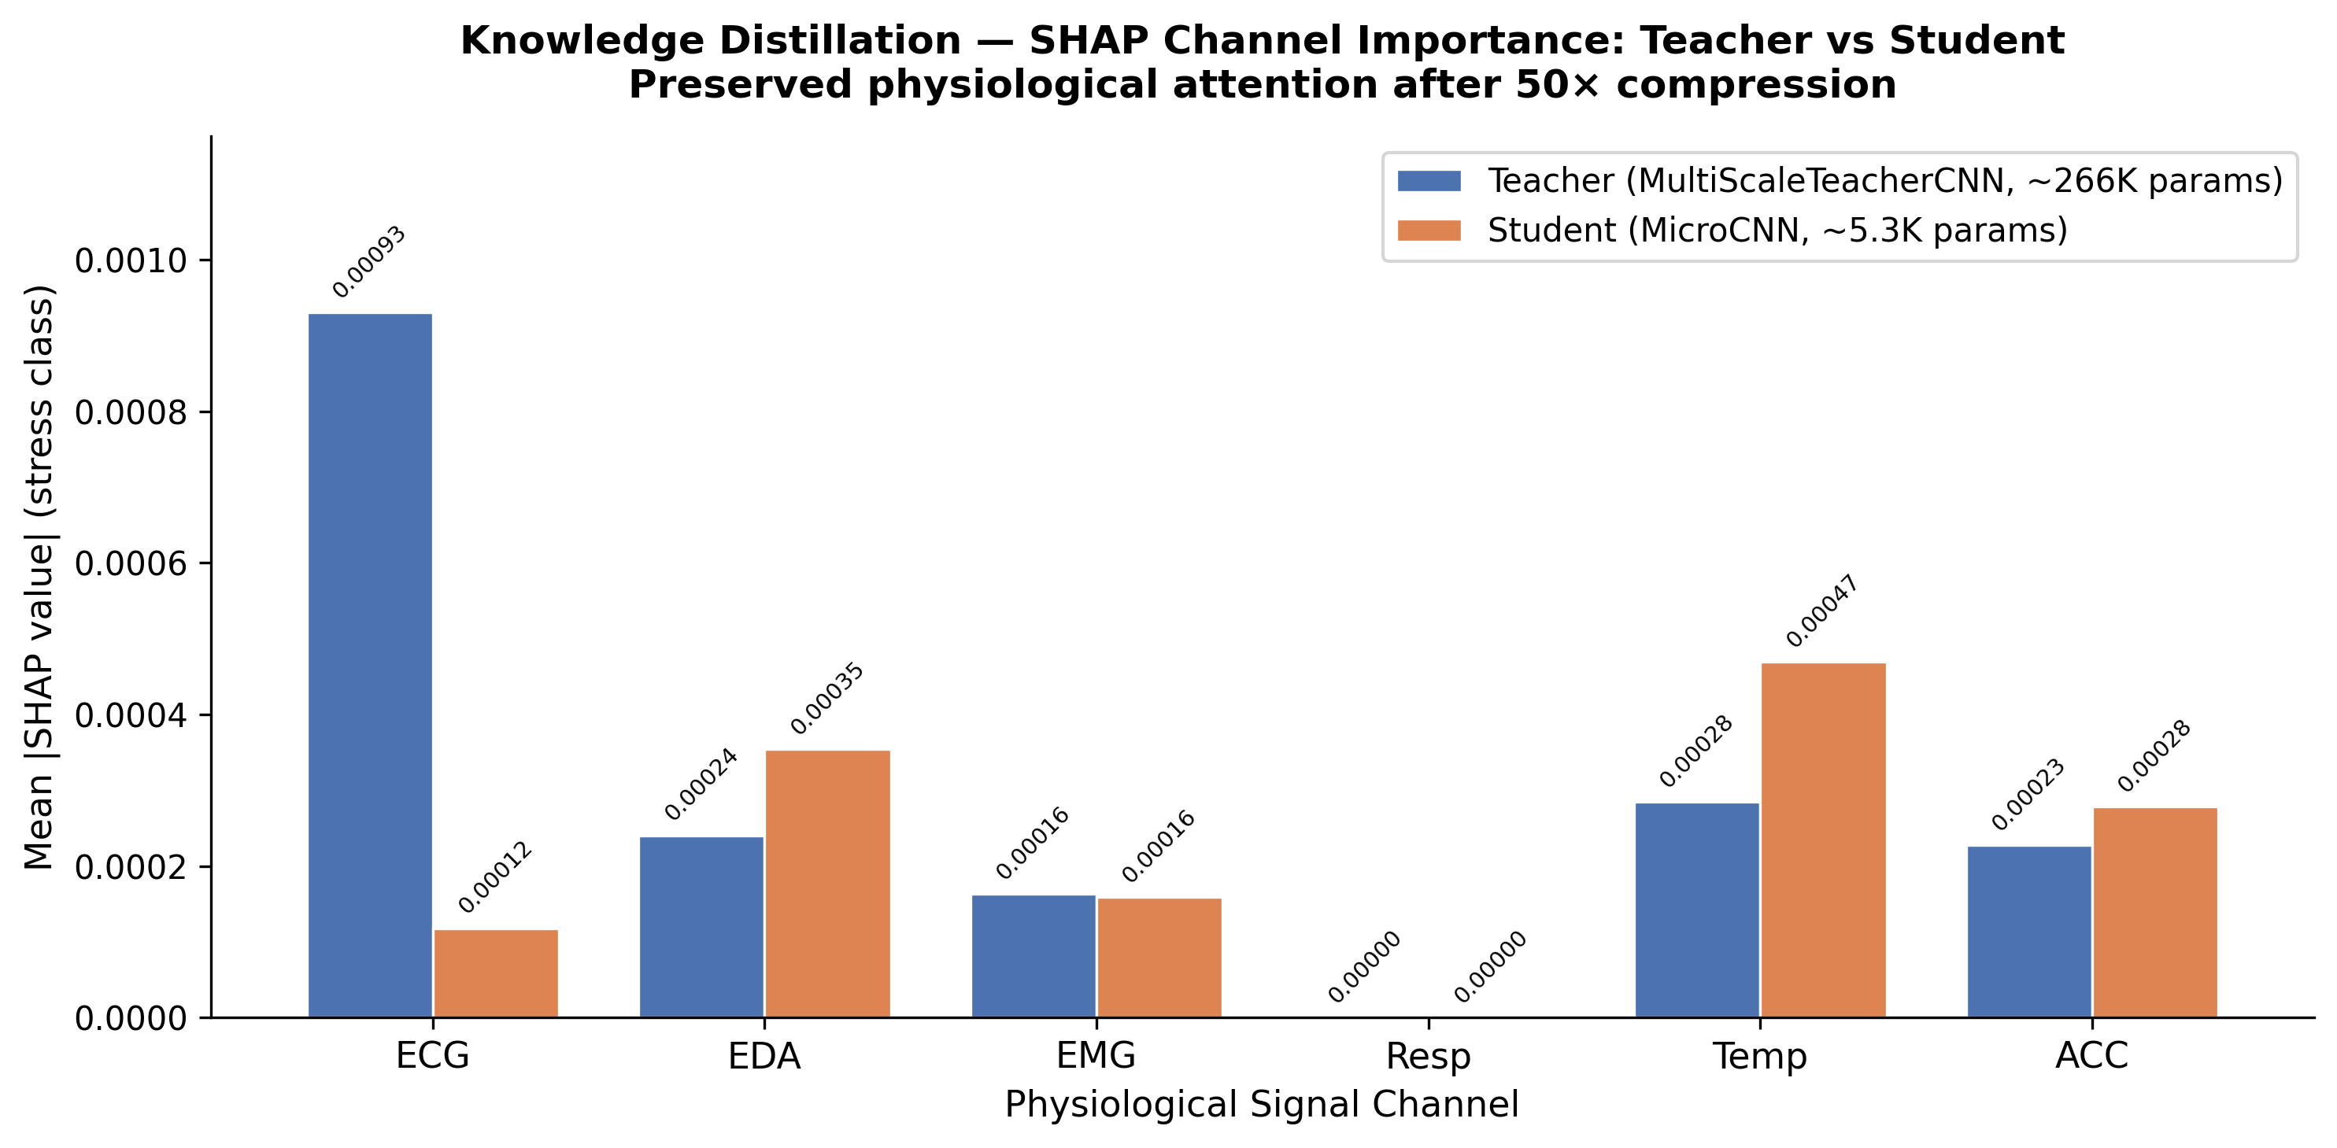
Figure 11: Teacher vs Student SHAP Channel Importance

8. Results & Analysis

8.1 Complete Results
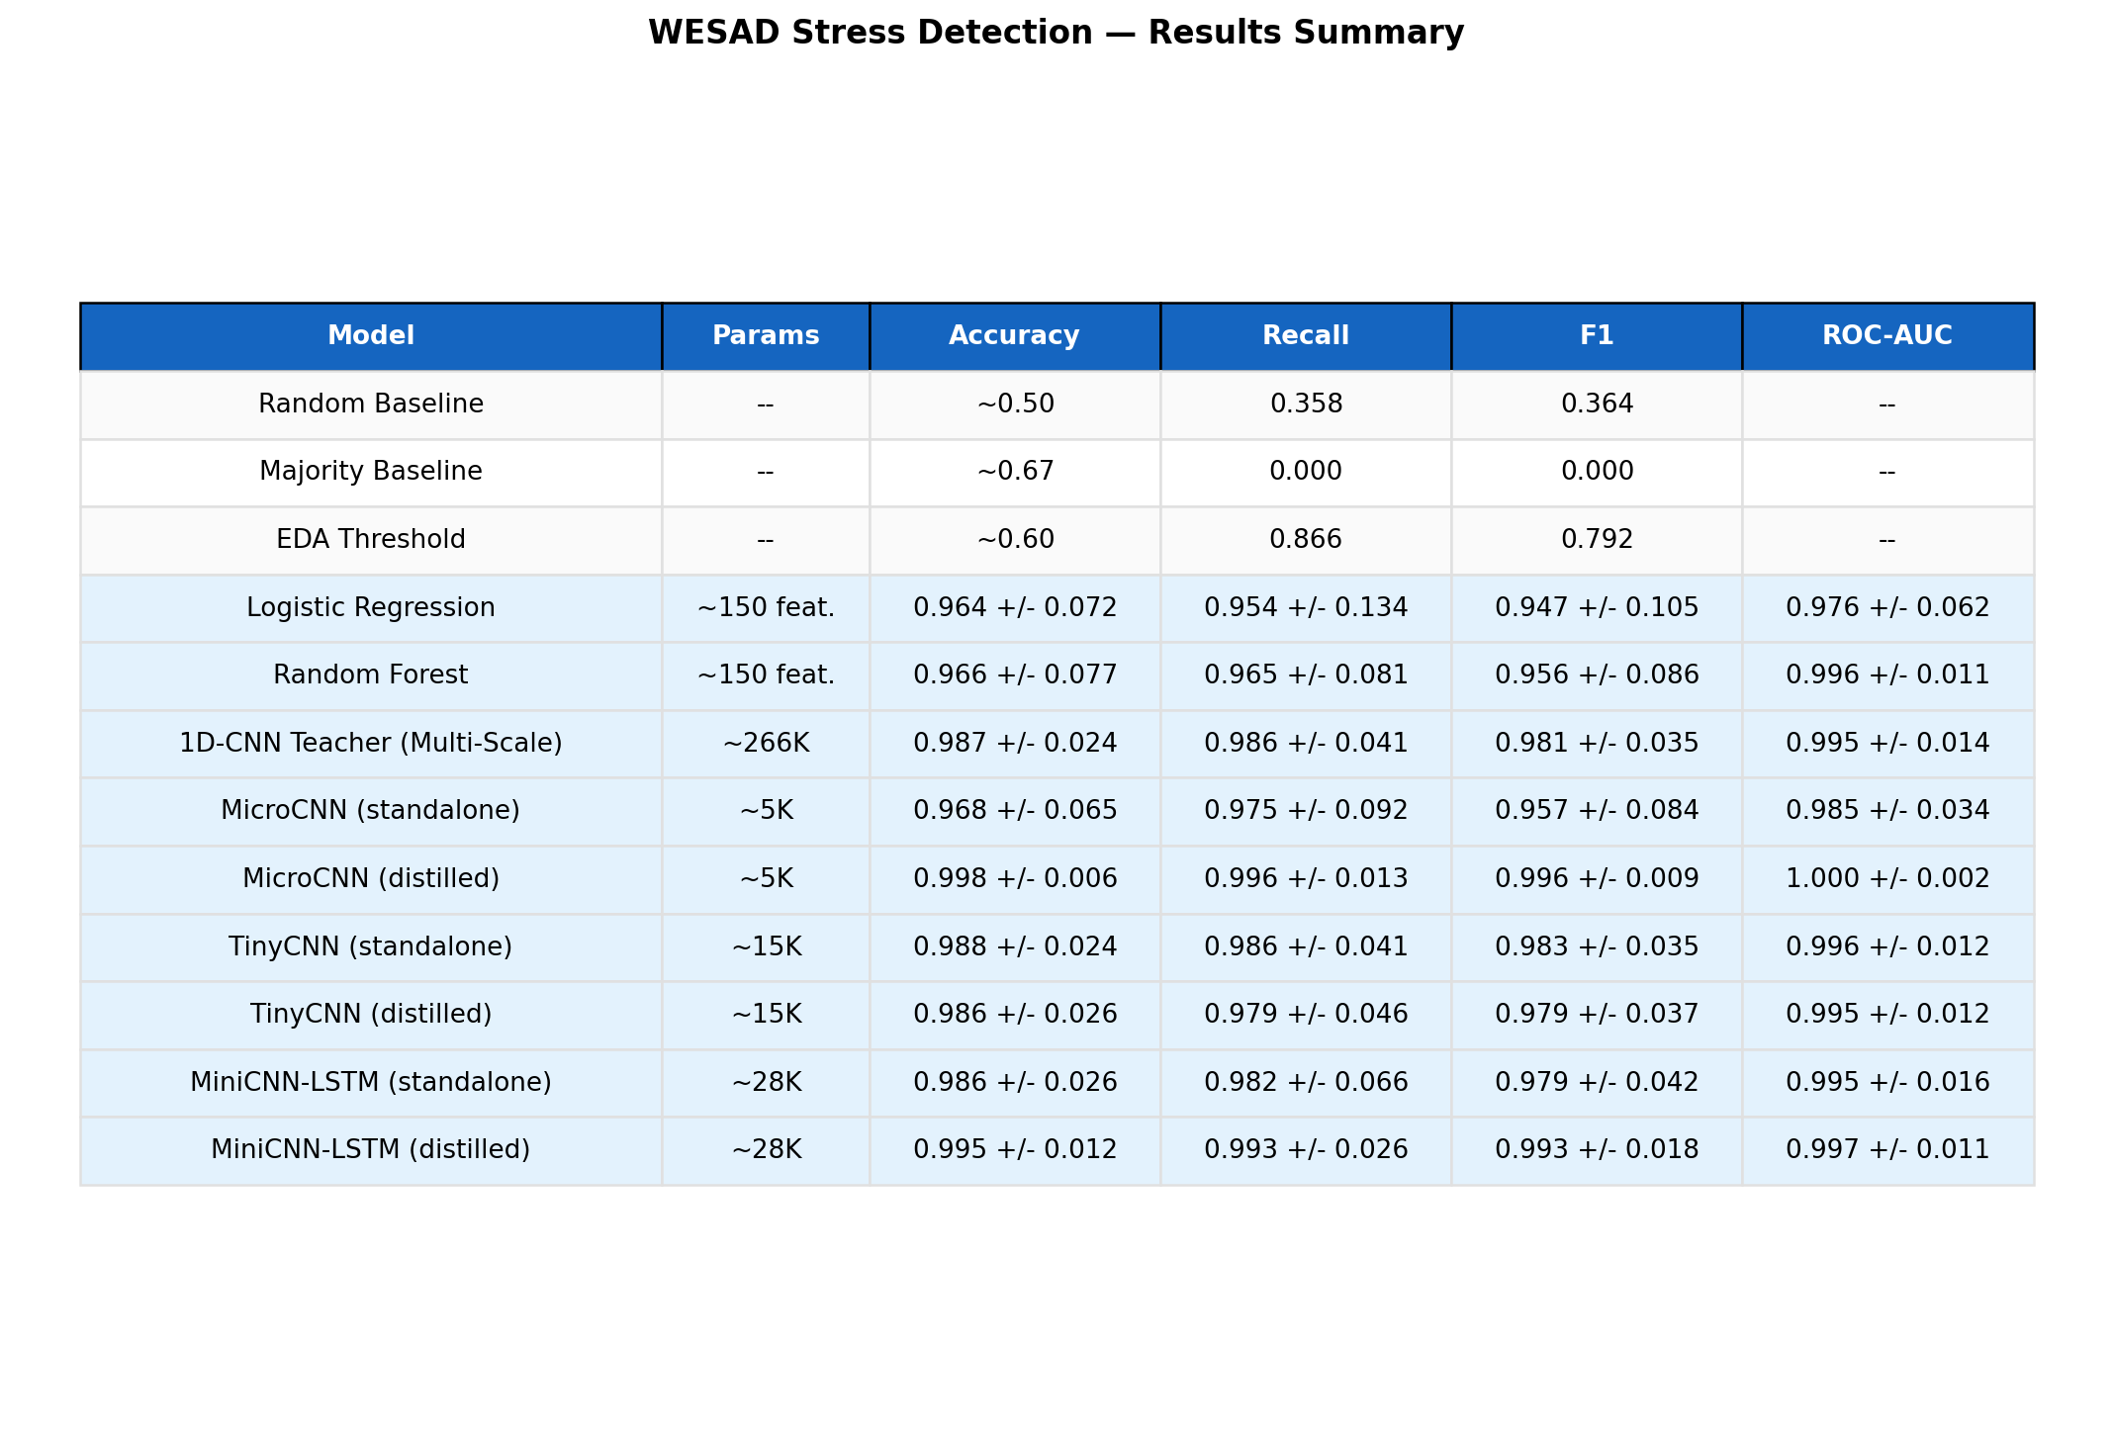
Figure 3: Complete Results Summary — All Models (LOSO)
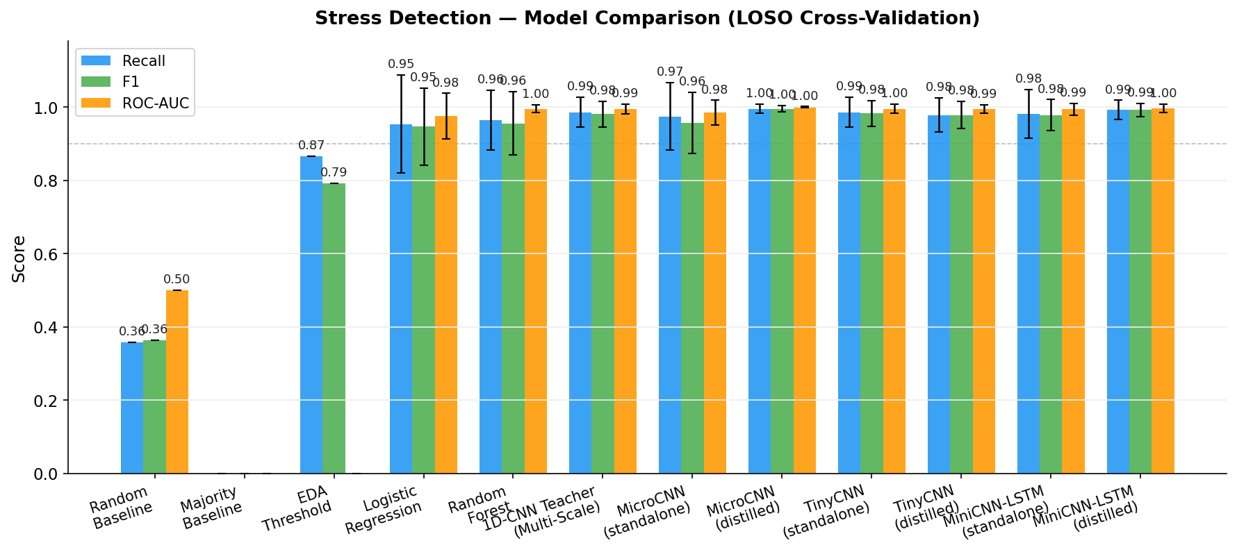
Figure 1: Model Comparison — Recall, F1, ROC-AUC (LOSO)

8.2 Key Findings
Finding 1 — Traditional ML is surprisingly strong. LogReg and RF achieve 0.95+ recall with hand-crafted features, far exceeding the 70% target.
Finding 2 — Multi-scale teacher improves consistency. Teacher CNN (0.981 F1) beats RF (0.956 F1) with lower variance across subjects.
Finding 3 — KD produces the best model overall. MicroCNN (distilled, 5K params) achieves 0.996 F1 — surpassing its own teacher at 50x compression.
Finding 4 — Distillation helps small models most. MicroCNN gains +0.039 F1; MiniCNN-LSTM gains +0.014; TinyCNN shows -0.004 (negligible).
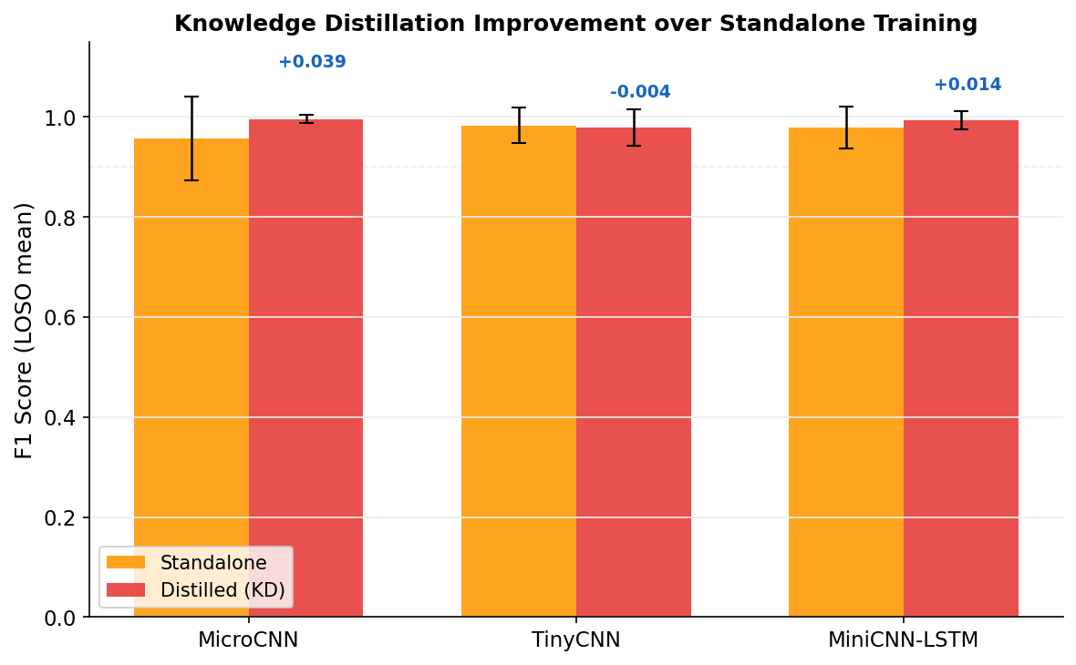
Figure 5: Knowledge Distillation Improvement over Standalone Training

8.3 Per-Subject Analysis
S2 (LogReg F1=0.74), S3 (LogReg F1=0.64), S8 (RF F1=0.69) are problematic subjects. Deep learning models largely eliminate these per-subject weaknesses.
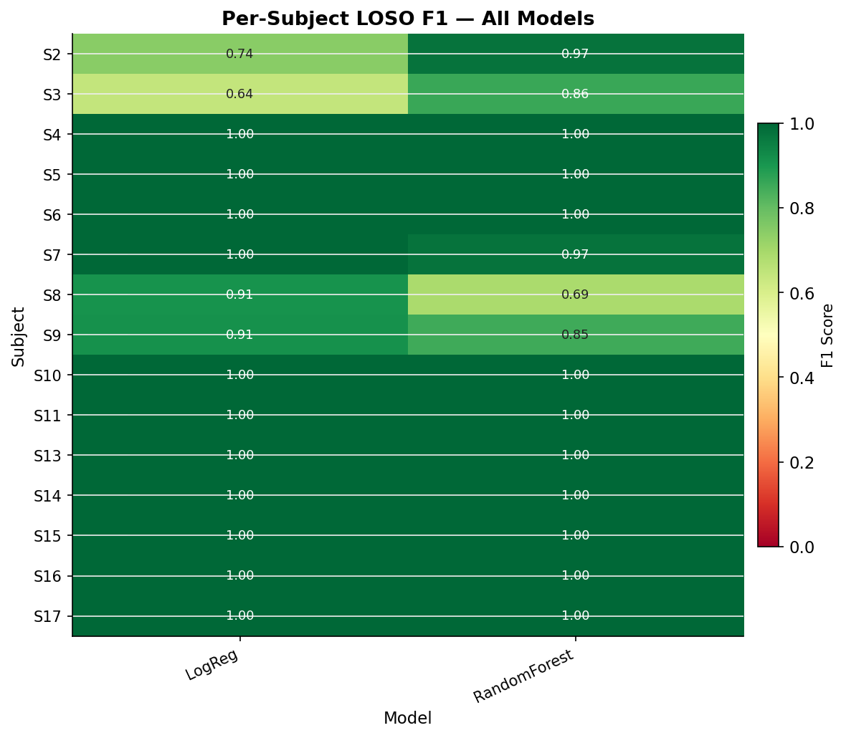
Figure 6: Per-Subject LOSO F1 Heatmap — All Models
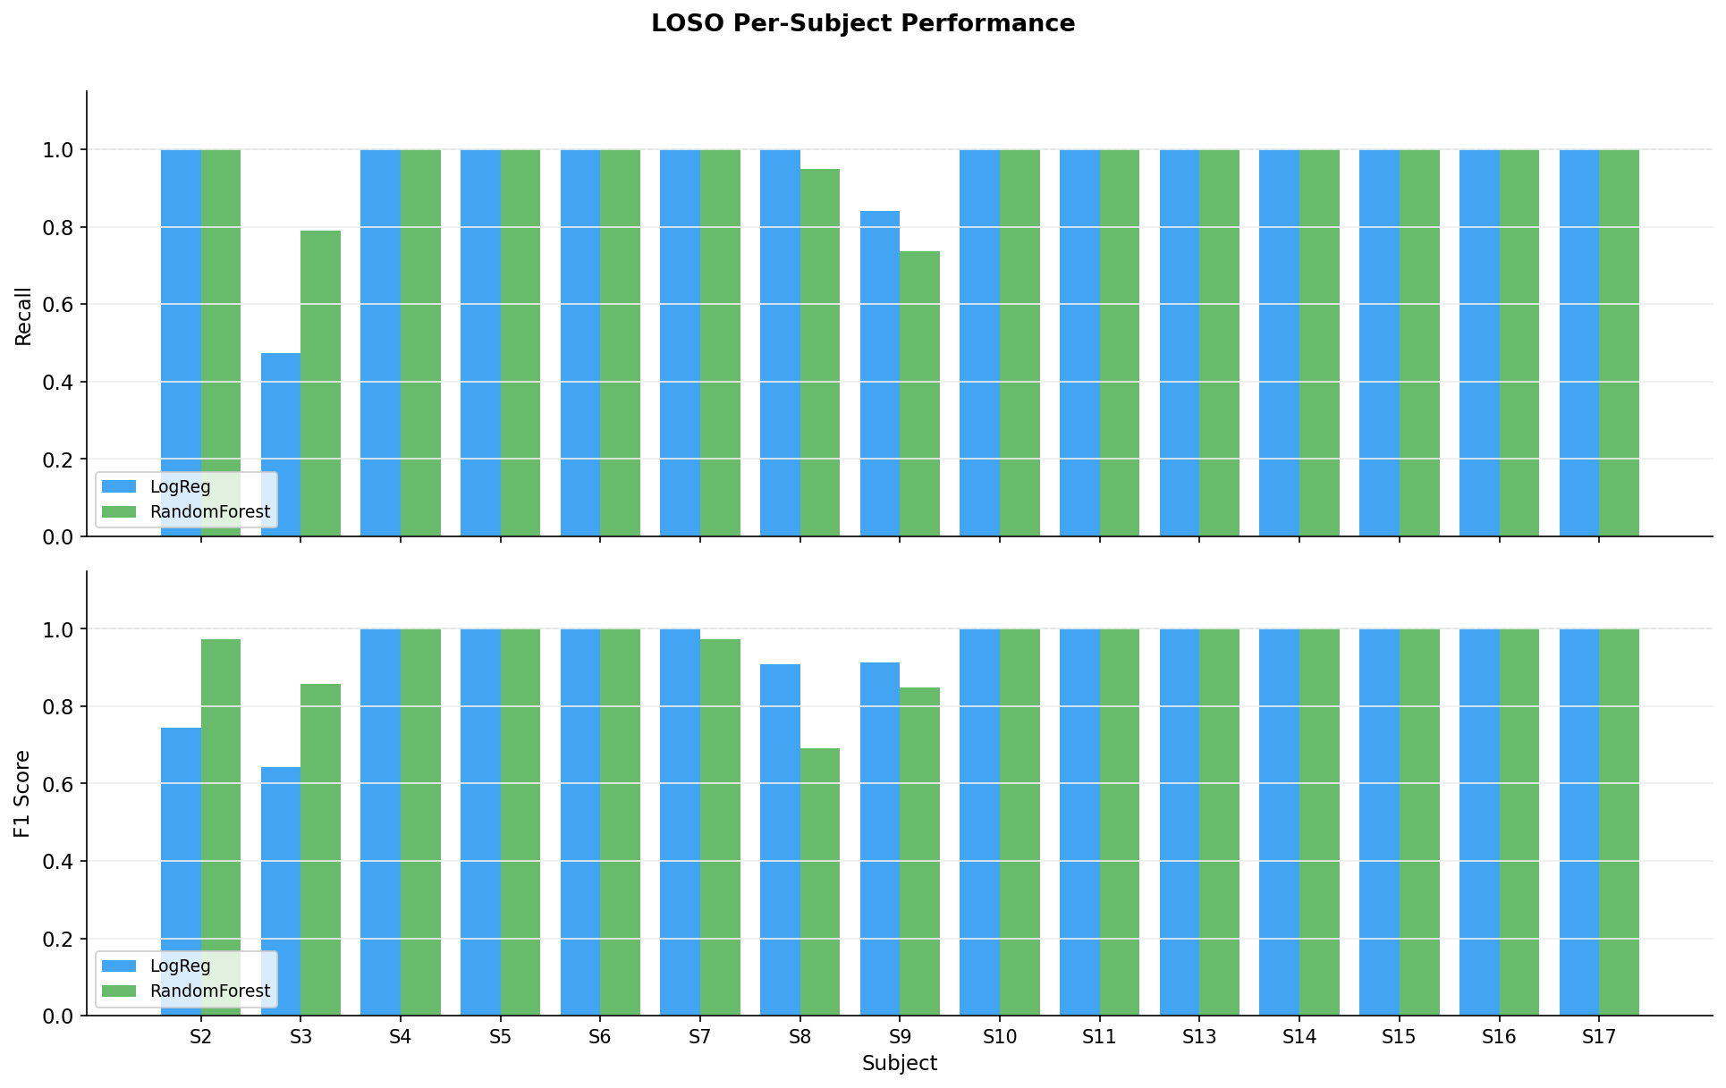
Figure 2: LOSO Per-Subject Performance (LogReg vs RF)

8.4 Pareto Front
Distilled students dominate the upper-left corner: high F1 (>0.99) at minimal model size (<60KB). The teacher sits at ~1MB — overkill for deployment.
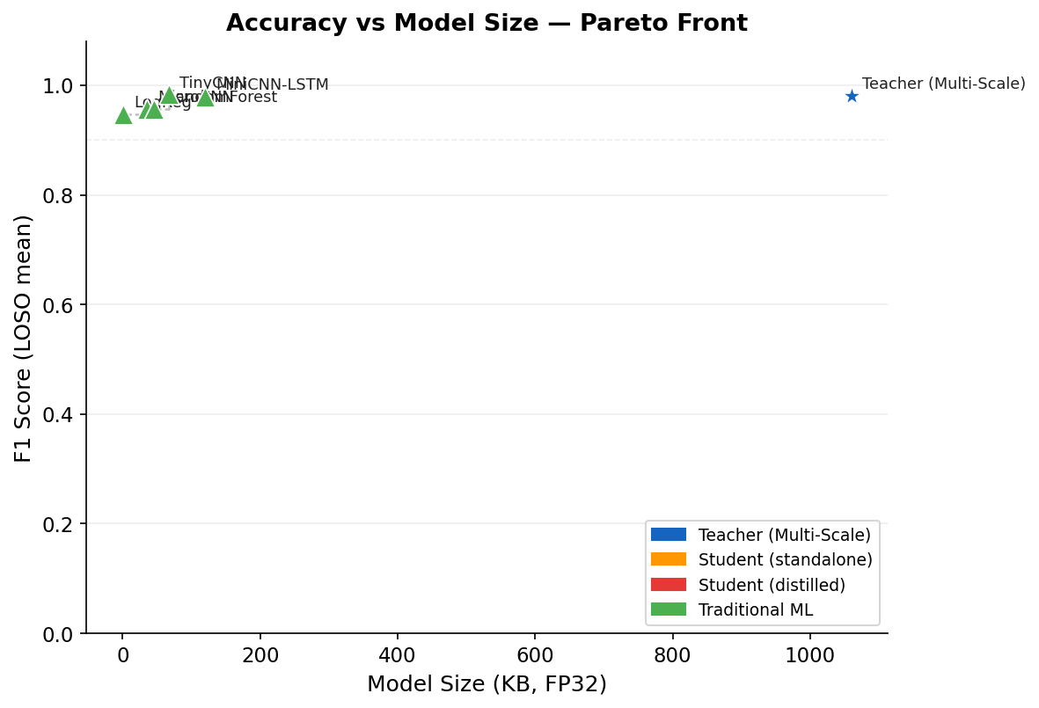
Figure 4: Accuracy vs Model Size — Pareto Front

8.5 KD Ablation
F1 converges to 0.9965 across all tested temperatures (1, 2, 4, 8) and alphas (0.3, 0.5, 0.7, 0.9). The task has high signal-to-noise ratio and the student has sufficient capacity.
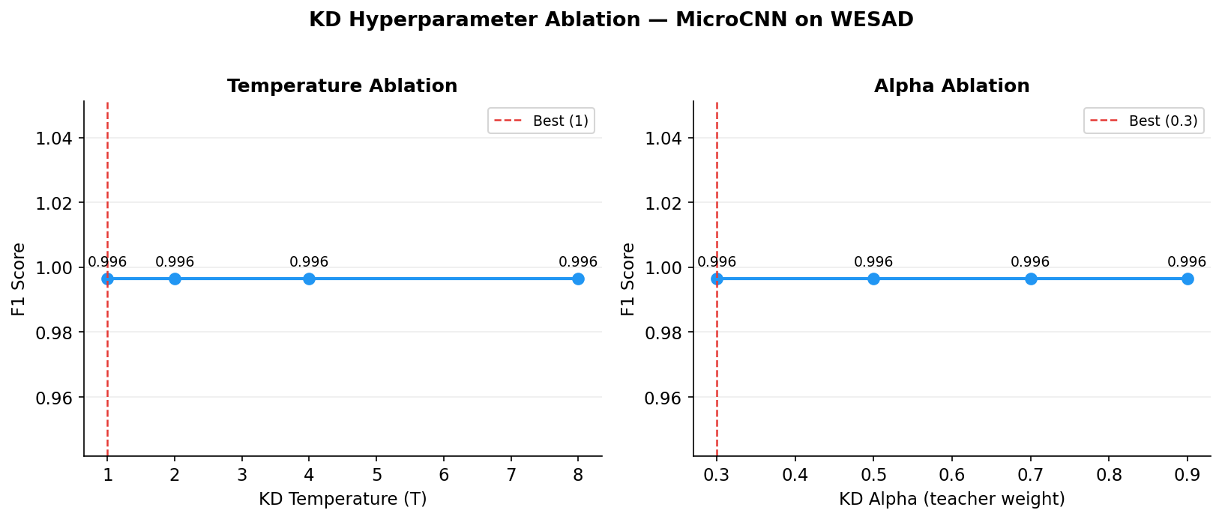
Figure 7: KD Hyperparameter Ablation — Temperature and Alpha

8.6 Hypothesis Validation
Hypothesis | Verdict | Evidence
H1: Physio signals distinguish stress | Supported | ROC-AUC 0.976–1.000
H2: ML achieves >70% recall (LOSO) | Strongly Supported | All models exceed 0.95 recall
H3: KD compresses without loss | Supported | MicroCNN (5K) surpasses teacher (266K)

9. Design Decisions & Rationale
60-Second Windows: Captures full EDA stress response (latency 1–3s, full response 10–15s). 30s risks truncation; 120s reduces sample count.
50% Overlap: Balances sample augmentation vs window independence. 0% = too few samples; 75% = too correlated.
80% Purity: Ensures unambiguous physiological state. 100% is too strict; 60% allows mixed states.
Per-Subject Z-Score: Resting heart rate varies 40–100 BPM across individuals. Per-subject normalization removes this.
Multi-Scale CNN: Parallel branches (k=8/32/64) capture ECG (~1 Hz), respiration (~0.2 Hz), and EDA (~0.05 Hz) timescales.
Depthwise-Separable Conv: ~8x parameter reduction vs standard Conv1d. Enables MicroCNN at ~5K params.
Response-Based KD: Architecture-agnostic, simpler than feature-based KD, sufficient for binary task with high SNR.
Double Imbalance Defense: WeightedRandomSampler + balanced class weights. Without both, recall collapsed to 0 in early experiments.

10. Known Limitations & Open Questions
Controlled lab setting (TSST) may not generalize to everyday stress. 15 subjects cannot capture population diversity. Chest-only signals are impractical for daily use. Binary classification only. No real-time streaming. Some respiration NaN values of unclear origin.

Open Questions
ID | Question | Priority
1 | Optimal filter cutoffs for stress detection? | Medium
2 | Respiration NaN root cause? | High
3 | Feature redundancy (correlation analysis)? | Medium
4 | Why do S2, S3, S8 underperform? | High
5 | Cross-dataset validation (SWELL, AMIGOS)? | High

11. Deployment Considerations
Model | Params | FP32 Size | Target Device | Flash Budget
MicroCNN (distilled) | ~5.3K | ~21 KB | ARM Cortex-M4 | <32 KB
TinyCNN (distilled) | ~15.2K | ~60 KB | nRF52840 | <256 KB
MiniCNN-LSTM (distilled) | ~28.8K | ~113 KB | ESP32-S3 | <512 KB

INT8 dynamic quantization achieves 3–4x further compression. MicroCNN at INT8 is ~6 KB.
Inference input: 60s of 6-channel data at 64 Hz = 23,040 floats (~92 KB FP32, ~23 KB INT8).

12. How to Reproduce
Phase 1: python main.py
Teacher: python train_teacher.py
Students: python train_students.py
Ablation: python run_ablation.py
Figures: python generate_report.py
SHAP: python shap_analysis.py
Dataset: WESAD (not redistributable). Request from Schmidt et al., 2018, TU Darmstadt.

13. References
1. Schmidt, P., Reiss, A., Duerichen, R., Marber, C., & Van Laerhoven, K. (2018). Introducing WESAD, a multimodal dataset for wearable stress and affect detection. ICMI 2018.
2. Kirschbaum, C., Pirke, K. M., & Hellhammer, D. H. (1993). The Trier Social Stress Test. Neuropsychobiology.
3. Hinton, G., Vinyals, O., & Dean, J. (2015). Distilling the knowledge in a neural network. arXiv:1503.02531.
4. Howard, A. G., et al. (2017). MobileNets: Efficient convolutional neural networks. arXiv:1704.04861.
5. Lundberg, S. M., & Lee, S. I. (2017). A unified approach to interpreting model predictions. NeurIPS 2017.

