Calder at Mytholmroyd

|  |  |
| --- | --- |
| Flow Derivation Review | July 2017 |

Site Details

Station Number: F1204

River Name: Calder

Station Name: Mytholmroyd

Grid Reference: SE0116226048

Station Datum: 87.461 mAOD [Tower Surveys 9/11/2009]

Bankfull Level: 91.4 (approximately)

Mean Bed Level: ??

Description of station:

The site comprises a multi-path crossed-path ultrasonic time of flight gauge, designed to measure full range of flows. There is a low flow control Crump weir downstream, frequently drowned. Level is measured by a pressure transducer under the road bridge. In the past there were also upward looking ultrasonic transducers but these were frequently affected by silt and are no longer used. The telemetry and gauging equipment are housed in a masonry building on the right bank, at the back of the car park. There is also a separate level site located a few metres upstream of the bridge, originally put in for flood warning. This gauge has been retained and comprises a steel stilling tube with cabinet mounted on top, housing a shaft encoder. Access to the channel is via a hooped ladder.

Site History

The flow station was commissioned in 1989, originally known as Caldene Bridge but since renamed to Mytholmroyd to match the adjacent level gauge. It is thought the upstream level site pre-dates this, but the digital archive for it only starts in 1996.

The gauge comprises a crossed path time of flight ultrasonic, with transducers mounted in sloping racks in the lower channel and vertical racks fixed to the bridge abutments in the upper channel. The lower racks originally had lexan dome covers to protect the transducers, however these frequently blocked up with silt and have since been removed.

A low flow weir was also built downstream of the gauging section, although its purpose is not entirely clear. It usually appears to be drowned out but may retain water level at very low flows to provide sufficient cover for the transducers.

The gauge has suffered problems over the years with paths dropping out, especially at higher flows. This may be due to high silt load or to aeration from pipes and outfalls in the channel upstream. The original USMP was replaced with an S2000 gauge in 2008. There is a rating curve in Sked which has historically been used to infill gaps in the derived flow series when the gauge data is missing.

The upstream level site is used to trigger alarms for flood warning purposes. The gauge zero for this is different to the flow site, despite being only a few metres upstream (the green tube in the site photo below, the ultrasonic transducers are under the road bridge), which has caused confusion when reporting levels in the past.

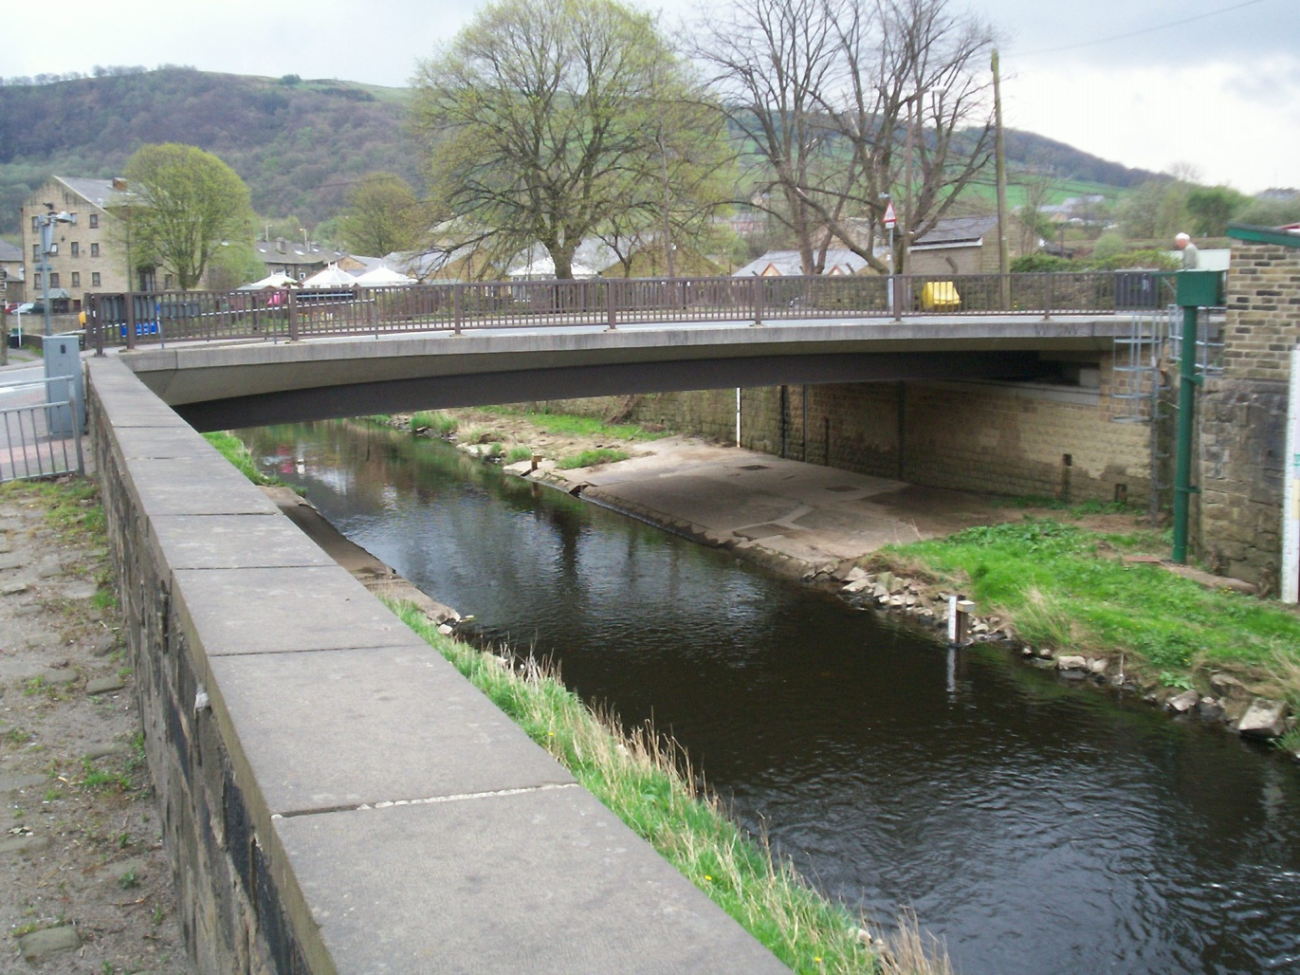

Evaluation

This is an interim evaluation to reconsider rating C only. It has been prompted by recent updates to the upper Calder hydraulic models, which looked in detail at the flows and levels at Caldene Bridge, the location for the gauging station. Modelling was carried out by Thomas MacKay Ltd (under contract to Mott MacDonald) in development of the Mytholmroyd flood alleviation scheme design.

The current rating C was developed in 2014 and based largely on the ultrasonic gauge records, refer to the 2014 review report for the details of this. The conclusion from that review was that rating C was an improvement of the previous rating B, but there was still considerable uncertainty above 3m stage due to a lack of check gaugings and still a suspicion that the ultrasonic was perhaps over-predicting the higher flows when compared to the few available gaugings. This was attributed to the fact that the upper paths never work, so the calculated flow from the ultrasonic is always based on extrapolation of velocities from the lower paths in the centre of the channel, which are likely to be higher than those on the raised bank sections towards the sides of the high flow channel.

This conclusion was borne out in the modelling, which identified a greater head loss across the bridge structure and suggested higher stages for a given flow compared to rating C. A new rating D was proposed, largely following rating C in the lower sections, where we have high confidence, but then fitted through the model data points above 3.1m stage. Figure 1 below shows the existing rating C and new rating D. Figure 2 shows the model runs used to derive rating D, more detail of this can be found in the Mytholmroyd FAS Hydrology and Hydraulic Modelling Reports.

Figure 1: Rating C and Proposed Rating D

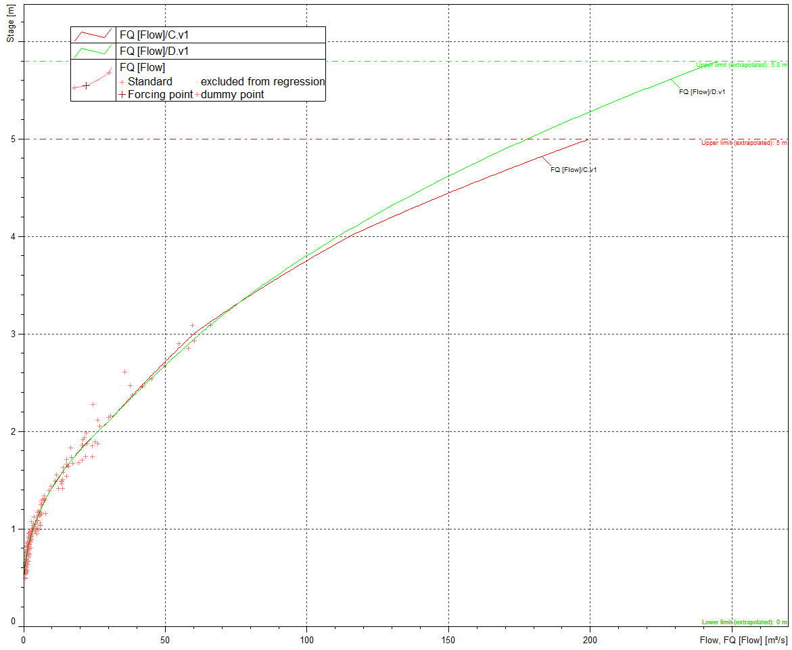

Figure 2: Model Results for Rating D Development

Other Ratings

No other ratings are known of, NFFS still uses the previous rating B.

Conclusions

The detailed modelling has shown that the current rating C is over-estimating flow above a stage of around 3.1m. A revised rating D has been developed based on the model results and is thought to give a more reliable estimate of the highest flows at this site.

Recommendations

* Rating C should be amended to reduce flow slightly above 3m in line with the model results;
* More gaugings above 3m stage are still needed to confirm the revised rating as a priority;
* Major changes to this site are planned as part of the Flood Alleviation Scheme, including removal of the Caldene Bridge and widening of the channel to provide greater conveyance of flood flows. This will necessitate a change to the flow derivation for this station, including a replacement for the current ultrasonic gauge and eventually a further revised rating curve.

Approval and Sign Off

|  |  |  |  |  |
| --- | --- | --- | --- | --- |
| Review carried out by: | | | | |
| Team | Name | Job Title | Signature | Date |
| Hydrology | David Lindsay | Technical Specialist |  | 04/07/2017 |

|  |  |  |  |  |
| --- | --- | --- | --- | --- |
| Recommendations approved by: | | | | |
| Team | Name | Job Title | Signature | Date |
| Hydrology | Brian Leigh | Hydrologist |  | 10/07/2017 |