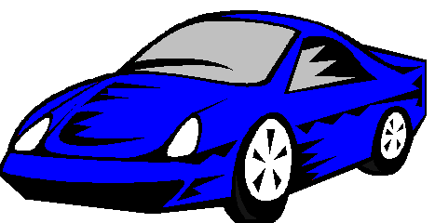

Compact Cars: Blue Compact

Key Features:

- Seats 4 adults
- 4 Cylinder Engine
- Authentic “blue” appearance in most natural lighting
- Standard Transmission
- 85 MPG highway / 55 MPG city

