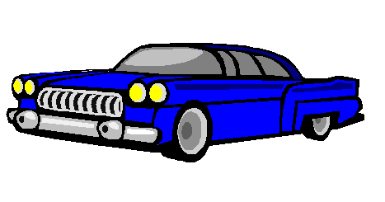

Fullsize Cars: Blue Fullsize

Key Features:

- Seats 6 adults
- 8 Cylinder Engine
- Air Conditioning
- Automatic Transmission
- Fully functional passenger-side airbags
- Power windows and locks
- GPS Navigational system

