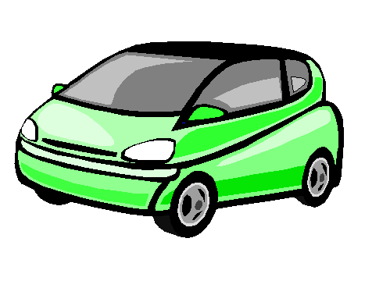

Minivans: Green Minivan

Key Features:

- Seats 7 adults
- 6 Cylinder Engine
- Air Conditioning
- Automatic Transmission
- Removable rear seats
- Power Windows and Locks
- Greener than both the blue and red minivans!

