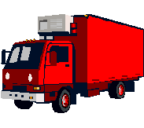

Trucks: Red Truck

Key Features:

- Seats 3 adults
- 8 Cylinder Engine
- Air Conditioning
- Automatic Transmission
- Very large cargo space
- Trailer Hitch

