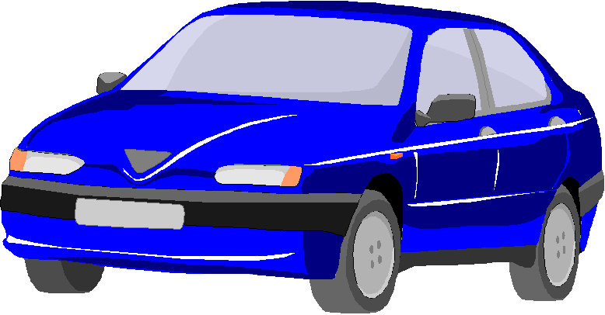

Midsize Cars: Blue Midsize

Key Features:

- Seats 5 adults
- 6 Cylinder Engine
- Air Conditioning
- Automatic Transmission
- Power windows and locks

