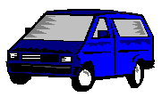

Fullsize Vans: Blue Van

Key Features:

- Seats 9 adults
- 8 Cylinder Engine
- Air Conditioning
- Automatic Transmission
- Removable rear seats
- Large cargo area

