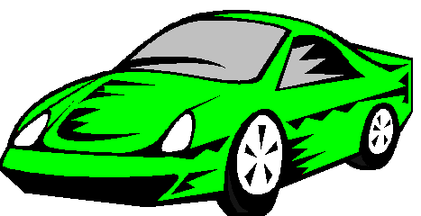

Compact Cars: Green Compact

Key Features:

- Seats 4 adults
- 4 Cylinder Engine
- Standard Transmission
- Less red than the “Blue Compact”
- 85 MPG highway / 55 MPG city

