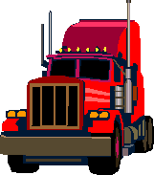

Trucks: Red Hauler

Key Features:

- Seats 3 adults
- Diesel Engine
- Air Conditioning
- Automatic Transmission
- Sleeper area
- Full size detachable cargo retainer

