Raymond Ivey

CS 328 – Design Documentation

1.1 – Opening the App and Camera

This document covers the usage of the Image Editing app created for Project 2.

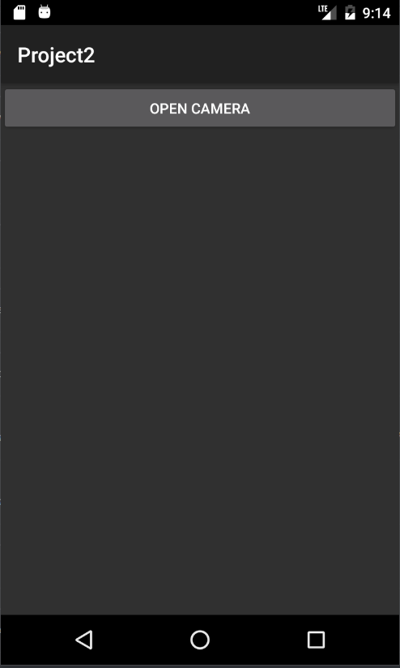
Upon opening the app, you will be presented with a single button that opens the camera for you.

Simply press the Open Camera button to open the camera and take a picture.

1.2 Taking a Picture

After opening up the Camera, you will presented with the Camera Screen

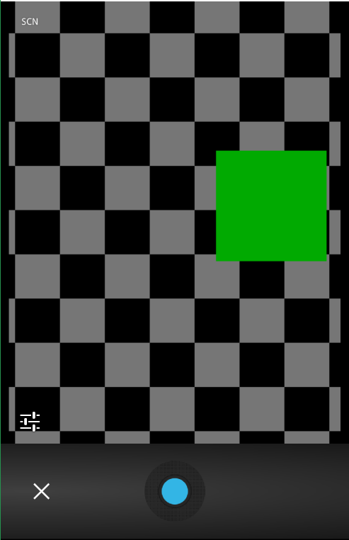

Simple point your phone at what you want to take a picture of, then click the round button at the bottom of the camera app. This will bring up a second screen

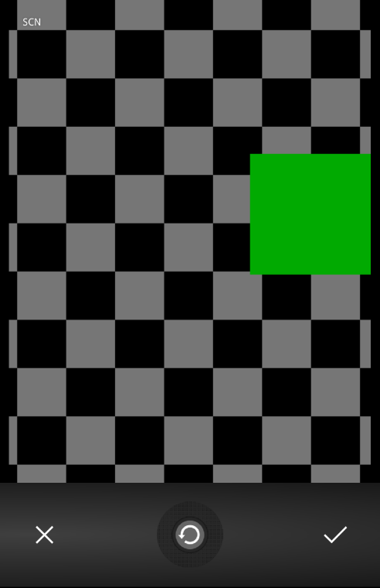

In order to save your image and move to editing, click the check mark. To cancel taking a picture, press the X on the bottom left. To retake the picture, press the circular reset button in the middle. When you move on to the Edit Screen, you will be presented with your image, as well as 9 image editing options.

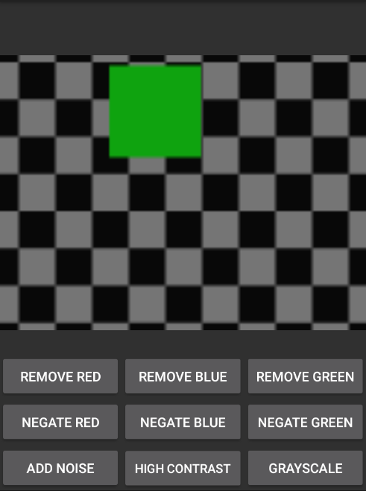
1.3 Editing your Image

There are 9 effects that can be applied to an image.
Remove Red – This will remove all red color from your picture
Remove Blue – This will remove all Blue Color from your Picture
Remove Green – This will remove all Green Color from your Picture
Negate Red – This will “negate” the Red in your picture by removing 255 from the value of each red pixel
Negate Blue – This will “negate” the Blue in your picture by removing 255 from the value of each Blue pixel
Negate Green – This will “negate” the Green in your picture by removing 255 from the value of each Green pixel
Add Noise – This will add “noise” To your picture by changing the color of each pixel by a small amount
Grayscale – This will turn every pixel gray
High Contrast – This will cause each color pixel to be set to either 0, or 255.

System Requirements

This was tested on an Android 6.0 device. Images should scale to any resolution Android Phone

