**Open Drone ID**

Bluetooth Broadcast Specification

**Draft** Specification Version 0.60.0

Protocol version 0

August 23, 2018

Contents

1 Introduction 3

2 Related Documents 3

3 Technical solution 3

4 Implementation Overview 4

5 BLE (Bluetooth 4.x compatible) Advertisements 4

Beacon Definition 4

Additional BLE 4.x Frame Details 4

Transmitting Frequency 5

6 Bluetooth 5.0 Extended Advertisements 6

Bluetooth 5 Extended Advertisement Primary (Pointer) Packet 7

Aux Ptr Field Details 8

Bluetooth 5 Extended Advertising Secondary Packet 8

7 Compliance and Interoperability 9

Update History

|  |  |  |  |
| --- | --- | --- | --- |
| Version | Date | Changes | Author |
| 0.54 | 3/1/2018 | Started Change Control (initial version baseline) | G. Cox, Jan S. |
| 0.56 | 4/20/2018 | Added BT5 Extended Advertisements | G. Cox |
| 0.58.4 | 6/06/2018 | Minor changes to background, added footnote for WiFi and added IETF RFC2119 reference. | G. Cox,  J. Takei |
| 0.60.0 | 8/23/2019 | Extracted Bluetooth Section to a stand-alone document | G. Cox |

# Introduction

On December 19th 2017 the Federal Aviation Administration (FAA) published the UAS Remote Tracking & ID ARC Report[1] to update the public about the latest results from the Aviation Rulemaking Committee (ARC) chartered by the FAA.

Within the ARC recommendation were some options for “Broadcasting” a Drone ID. This specification is designed to meet such needs expressed in the ARC Report.

**This document is currently in *DRAFT* and is under a standardization process within the ASTM F38 Remote ID Workgroup. The outcome of this collaboration will most certainly result in many changes as a part of this process.**

# Related Documents

*Open Drone ID – Message Specification*: Contains the details of the Open Drone ID Messages that are referenced in this document.

# Technical solution

The solution outlined in this specification is for the broadcasting category of drone identification. In the ARC, several solutions were discussed. The primary advantages of this technology are:

* Commoditized open standard supported by most modern smartphones as a receiving device
* Very low part(s) cost to add to a drone
* Very low weight with solutions below 10g
* Robust protocol implementation with congestion handling and up to 1km range (v5.0 AE).
* Very easy to retrofit to existing drones

The range of Bluetooth V4.0 depends on the transmit power, as well as the exact transmitter and receiver setup including the antenna and external noise sources. Tests have been conducted to show a range from a drone to a smartphone of over 200m. For better antenna installations at critical sites the range could be increased to more than 1km. Based on the specifications, with Bluetooth V5.0, the range will quadruple. This range will be suitable for most scenarios while providing 2 huge benefits:

1. Public Safety Departments cost of acquiring receivers could potentially be minimized to the cost of their available smartphones.   
2. The general public can use their smartphone to read the Drone IDs and help by accurately reporting airspace contention or security problems.

Bluetooth uses three different beacon channels that can broadcast messages to non-specific endpoints. Although the remaining 37 channels operate in the 2.4 Ghz range, where WiFi resides, the channels are much narrower and specifically the beacon channels are outside of the bands of typical WiFi traffic[2]. (see Figure 1 below).  
  
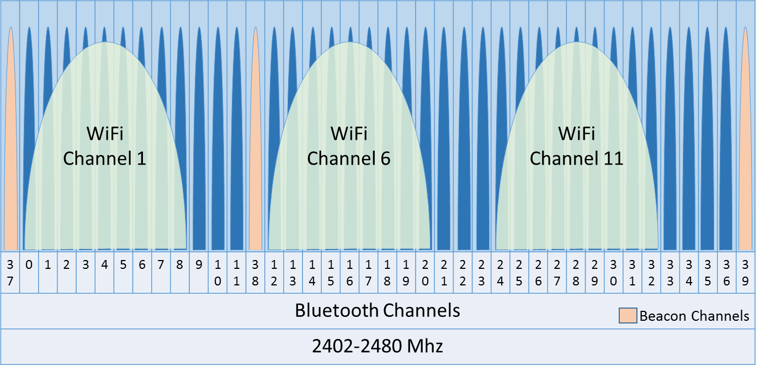

Figure – Bluetooth Channels

# Implementation Overview

In this specification, the intent is to use a Bluetooth radio to send connectionless broadcast frames (Advertisements) that work with both BT 4.x and 5.x receivers. Supporting both architectures allows for compatibility with existing BT4 receivers (like most cell phones as of 2018), yet can still take advantage of the range enhancements (4x) of BT5 which is starting to ship with newer cell phones and can also be installed as external receivers.

# BLE (Bluetooth 4.x compatible) Advertisements

BLE supports a “Broadcast Frame” to go out on the beacon channels with a custom message length limit of 26 bytes. These broadcast messages shall be “uncoded” and conform to Bluetooth Core Specification 5.0, Volume 6, Part B, Sections 2.1 and 2.3.1.[3]

## Beacon Definition

These BLE frames shall be sent as illustrated below in Figure 2.

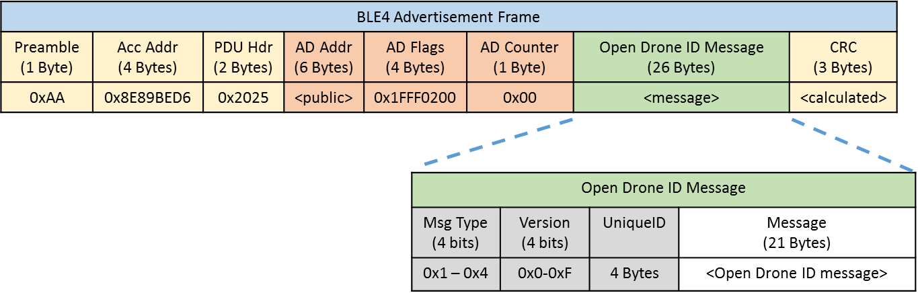

Figure –BLE Advertisement Frame Format

## Additional BLE 4.x Frame Details

|  |  |  |  |
| --- | --- | --- | --- |
| Field | Size* | Value | Contents |
| Preamble | 1 | 0xAA | LE 1M Packet |
| Acc Address | 6 | 0x8E89BED6 | Broadcast Packet |
| PDU Hdr | 2 | 0x2025 | |  |  |  | | --- | --- | --- | | PDU Type | 0x2 | ADV_NONCONN_IND – Connectionless Advertisement | | RFU | 0 | Reserved | | ChSel | 0 | Reserved | | TxAdd | 0 | Indicates AD Addr is HW Address (rather than random) | | RxAdd | 0 | Reserved | | Len | 0x25 | 37 Bytes | |
| AD Addr | 6 | 0xXXXXXX | Unique Hardware Address of Bluetooth MAC |
| AD Flags | 4 | 0x1FFF0200 | |  |  |  | | --- | --- | --- | | Length | 0x1F | 31 Bytes (excluding this field) | | Type | 0xFF | Manufacturer Specific | | Mfg Code | 0x0200 | Intel (this is a placeholder until a mfg code is established by the standards collaboration. | |
| AD Counter | 1 | 0xXX | Msg Counter: Start at 0, increment for each message of the same type |
| ODID Msg | 26 | <26 Bytes> | Open Drone ID Message – see section 0 (  *Message* Definitions) |
| CRC | 3 | <calculated> | CRC Error Correction Data as defined in Bluetooth Core Specification 5.0, Volume 6, Part B, Section 3.1.1 |

## Transmitting Frequency

These 26 byte long messages, as defined in the *Open Drone ID Message Specification*, shall be sent by each drone Bluetooth beacon. Depending on whether the data is static or dynamic, the messages will be sent at a low or higher frequency (respectively).

As such, the following message frequencies shall be maintained:  
**Static: Every 3 seconds.  
Dynamic: 3 per second.**

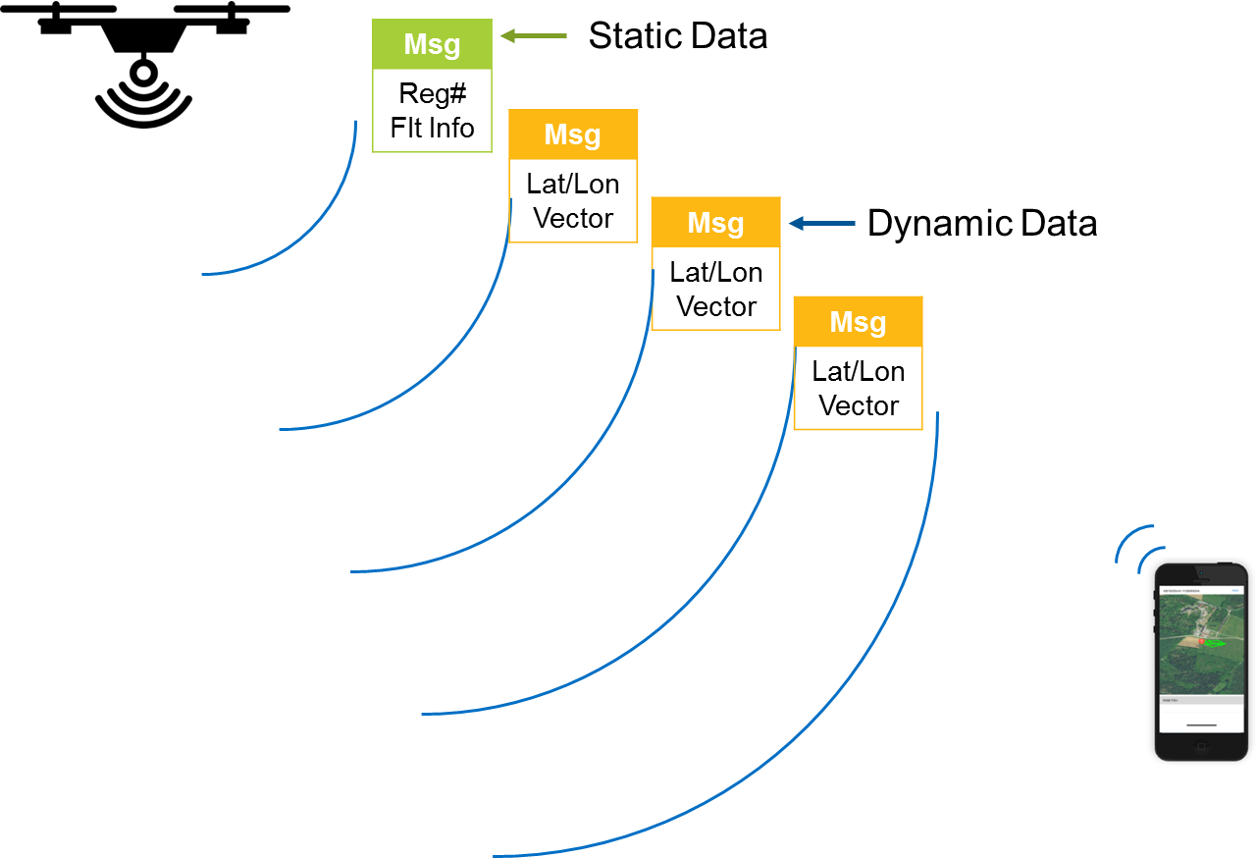

Figure - Static and Dynamic Messages

# Bluetooth 5.0 Extended Advertisements

If Implementing this specification using Bluetooth 5, In addition to sending standard (ADV_NONCONN_IND) BLE (4.2) advertisements, Bluetooth 5 Extended Advertisements (ADV_EXT_IND + AUX_ADV_IND) must be sent as well at the same rate as Dynamic Data (see Section 3 *Transmitting Frequency*) and they must be sent on an LE Coded (S=8) PHY. This will add Forward Error Correction (FEC) and increase the range of the advertisements by 4x. These messages shall conform to Bluetooth Core Specification 5.0, Volume 6, Part B, Sections 2.2 (LE Coded PHY, S=8).

While BLE (4.2) advertisements broadcast on the beacon channels 37,38,39, Bluetooth 5 adds Extended Advertising that allow for up to 255 byte advertisements on the “non-beacon” channels by implementing a pointer in the primary beacons directing the receiver to read from the secondary channel.

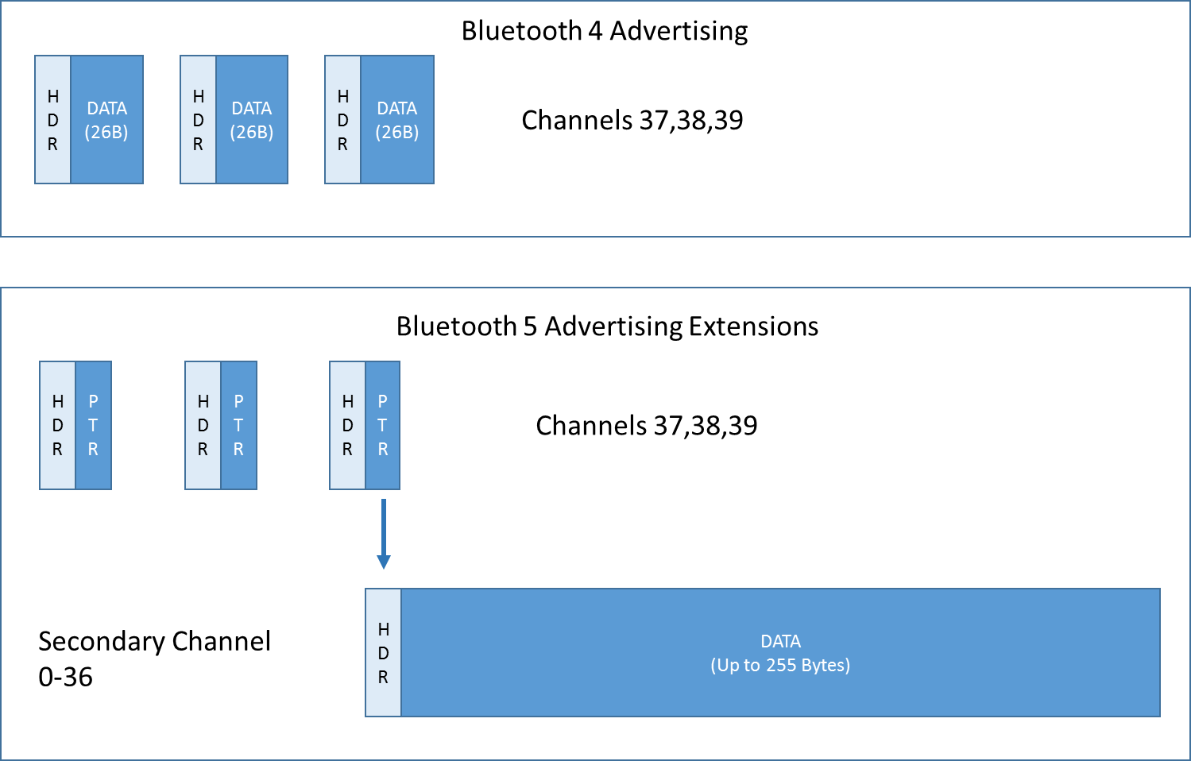

Figure - Bluetooth 4 and 5 Extended Advertising Comparison

When performing a Bluetooth 5 Advanced Advertisement, all messages must be sent together as a single “message pack” as illustrated below in Figure 5Figure 1.

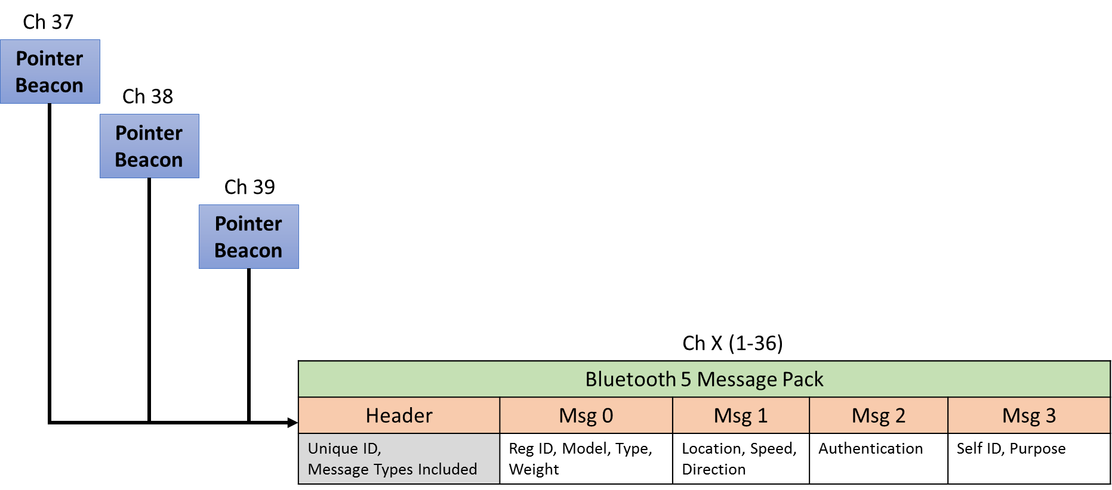

Figure -- Bluetooth 5 Message Pack

## Bluetooth 5 Extended Advertisement Primary (Pointer) Packet

The Bluetooth 5 Extended Advertisement Primary packet includes a pointer to the Secondary Packet as illustrated below. Therefore, the Primary packet shall be broadcast through all 3 beacon channels, followed by the Secondary packet on the remaining channels (see <reference to packet spreading algorithm).

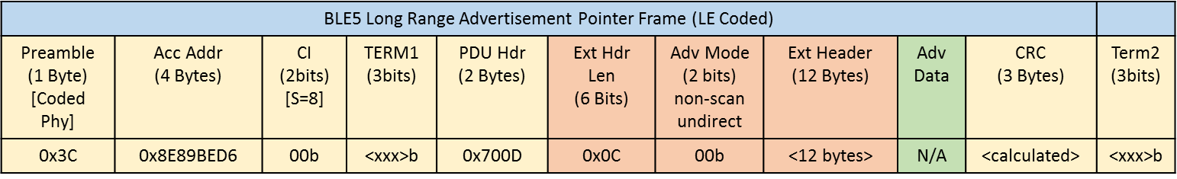

Additional Primary Packet Details

|  |  |  |  |
| --- | --- | --- | --- |
| Name | Size* | Value | Value Description |
| Preamble | 1 | 0x3C | LE Coded PHY |
| Acc Addr | 6 | 0x8E89BED6 | Broadcast Packet |
| CI | 2 bits | 00b | Coding Indication: FEC Block 2 is coded using S=8 (longest range) |
| Term1 | 3 bits | xxxb | FEC Block 1 Termination as defined in Bluetooth Core Specification 5.0, Volume 6, Part B, Section 3.3.1 |
| PDU Hdr | 2 | 0x700D | |  |  |  |  | | --- | --- | --- | --- | | Field | Bits | Hex | Desc | | PDU Type | 0111 | 0x7 | ADV_EXT_IND (Primary) | | RFU | 0 | 0x0 | Reserved | | ChSel | 0 | Reserved | | TxAdd | 0 | Reserved | | RxAdd | 0 | Reserved | | Len | 0010 0101 | 0x0D | 13 Bytes | |
| Ext Hdr | 12 |  | |  |  |  |  |  | | --- | --- | --- | --- | --- | | Field | Size* | Bits (binary) | Hex | Desc | | Flags | 1 | 0001 1001 | 0x19 | Field Selection (AdvA, ADI, Aux Ptr) | | AdvA | 6 | <HW ADDR> | 0xXXXXXX | Adv Address (HW Addr) | | ADI | 2 | 0000 0000 0000 xxxx | 0x0000 – 0x000F | Advertising Data ID (12bits) = 0  Advertising Set ID (4bits): Increment each time data changes | | Aux Ptr | 3 | cccc cca0  dddd dddd  dddd d010 | 0xXXXXXX | cccccc = Channel  a = clock accuracy  0 = 30us offset multiplier  dddddd = offset/delay  010 =LE Coded Phy  ** See Aux Ptr Field Details below. | |
| CRC | 3 |  | CRC Error Correction Data as defined in Bluetooth Core Specification 5.0, Volume 6, Part B, Section 3.1.1 |
| Term2 | 3bits |  | FEC Block 2 Termination as defined in Bluetooth Core Specification 5.0, Volume 6, Part B, Section 3.3.1 |

* Bytes

## Aux Ptr Field Details

The Aux Ptr Field in the Primary Packet shall be implemented in accordance to the Bluetooth Core Specification 5.0, Volume 6, Part B, Section 2.3.4.5 with the following guidance.

|  |  |
| --- | --- |
| Channel Index | Shall be calculated using the following formula: Channel = (Current Channel + 9) % 36 This will ensure some entropy by hopping through the channels and spreading out the beacons to minimize the effects of external interference. |
| Clock Accuracy (CA) | 0: 51 – 500ppm  1: 0 - 50ppm |
| Offset Units | 0: 30us |
| Aux Offset/Delay | This represents the time offset from when the primary packet is sent and the secondary packet. Since all 3 primary packets are sent prior to the secondary packet, the offset is different for each one. This offset should be calculated based on the Bluetooth Core Specification 5.0 specification.  The following offsets may be used as guidance :  Beacon 1: 166 us  Beacon 2: 114 us  Beacon 3: 62 us  These calculations are based on a primary packet time of 1552us + a T_MAFS (minimum aux frame space) of 300us divided by the offset multiplier unit of 30us. The time of sending the current beacon + remaining beacons must be included. Thus, Beacon 1 includes the time of itself + 2 more beacons + T_MAFS. |
| Aux PHY | 010: LE Coded Phy |

## Bluetooth 5 Extended Advertising Secondary Packet

The secondary packet contains the actual desired advertisement. Additionally this packet contains a 16 bit “Message Type Mask” which includes bit representing that message types included. All message types supported shall be represented within a single Secondary Packet in the order of lowest message type (index) first. Only the messages selected in the Message Type mask shall be presented within the single Secondary Advertising Packet (with a capacity of up to 255 bytes).

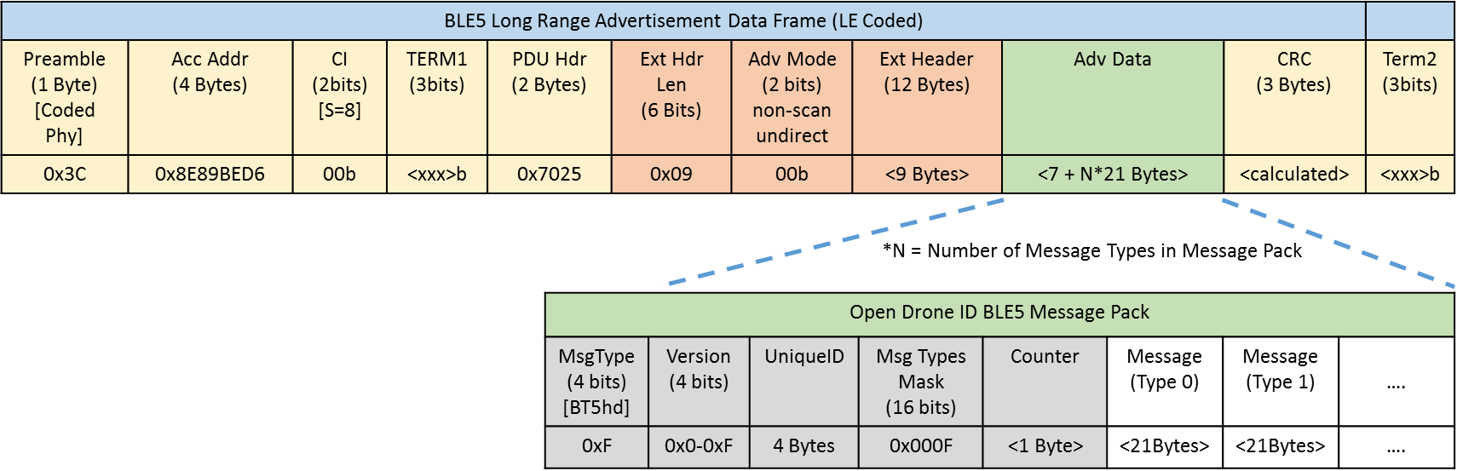

|  |  |  |  |
| --- | --- | --- | --- |
| Name | Size* | Value | Value Description |
| Preamble | 1 | 0x3C | LE Coded PHY |
| Acc Addr | 6 | 0x8E89BED6 | Broadcast Packet |
| CI | 2 bits | 00b | Coding Indication: FEC Block 2 is coded using S=8 (longest range) |
| Term1 | 3 bits | xxxb | FEC Block 1 Termination as defined in Bluetooth Core Specification 5.0, Volume 6, Part B, Section 3.3.1 |
| PDU Hdr | 2 | 0x70XX | |  |  |  |  | | --- | --- | --- | --- | | Field | Bits | Hex | Desc | | PDU Type | 0111 | 0x7 | AUX_ADV_IND (Secondary) | | RFU | 0 | 0x0 | Reserved | | ChSel | 0 | Reserved | | TxAdd | 0 | Reserved | | RxAdd | 0 | Reserved | | Length | xxxx xxxx | 0xXX | 18 + N*21 Bytes where N is the number of Messages in the Message Pack |  | |
| Ext Hdr | 12 |  | |  |  |  |  |  | | --- | --- | --- | --- | --- | | Field | Size* | Bits (binary) | Hex | Desc | | Flags | 1 | 0000 1001 | 0x09 | Field Selection (AdvA, ADI) | | AdvA | 6 | <HW ADDR> | 0xXXXXXX | Adv Address (HW Addr) | | ADI | 2 | 0000 0000 0000 xxxx | 0x0000 – 0x000F | Advertising Data ID (12bits) = 0  Advertising Set ID (4bits): Increment each time data changes | |
| CRC | 3 |  | CRC Error Correction Data as defined in Bluetooth Core Specification 5.0, Volume 6, Part B, Section 3.1.1 |
| Term2 | 3bits |  | FEC Block 2 Termination as defined in Bluetooth Core Specification 5.0, Volume 6, Part B, Section 3.3.1 |

# Compliance and Interoperability

As of this version, compliance can be “self-certified” using the following means:

1. Every “shall”, “must” and any other logical directive in this document must be implemented.  
   (See IETF RFC2119 for adopted definitions of imperatives: https://www.ietf.org/rfc/rfc2119.txt)
2. Interoperability shall be verified against “known working” clients for both BLE 4 and Bluetooth 5 Extended Advertising receivers.
3. Hardware/RF/Signal compliance TBD.
4. If a system is not compliant with this spec, then it may not claim, advertise or display references to “Open Drone ID”.

1. <https://www.faa.gov/news/updates/?newsId=89404>
2. Based on common router configurations that choose channels 1,6,11 by default
3. <https://www.bluetooth.com/specifications/bluetooth-core-specification>