**Open Drone ID**

WiFi Broadcast Specification

**Draft** Specification Version 0.60.0

Protocol version 0

August 23, 2018

Contents

1 Introduction 3

2 Related Documents 3

3 Implementation Overview 3

4 Transmitting Frequency 3

5 WiFi Beacon Frames 4

6 Compliance and Interoperability 5

Update History

|  |  |  |  |
| --- | --- | --- | --- |
| Version | Date | Changes | Author |
| 0.60.0 | 8/23/2018 | Established a separate WiFi spec document | G. Cox |
|  |  |  |  |
|  |  |  |  |
|  |  |  |  |
|  |  |  |  |
|  |  |  |  |
|  |  |  |  |
|  |  |  |  |

# Introduction

On December 19th 2017 the Federal Aviation Administration (FAA) published the UAS Remote Tracking & ID ARC Report[1] to update the public about the latest results from the Aviation Rulemaking Committee (ARC) chartered by the FAA.

Within the ARC recommendation were some options for “Broadcasting” a Drone ID. This specification is designed to meet such needs expressed in the ARC Report.

**This document is currently in *DRAFT* and is under a standardization process within the ASTM F38 Remote ID Workgroup. The outcome of this collaboration will most certainly result in many changes as a part of this process.**

# Related Documents

*Open Drone ID – Message Specification*: Contains the details of the Open Drone ID Messages that are referenced in this document.

# Implementation Overview

As detailed in this specification, a connectionless broadcast mechanism can be implemented using WiFi as well using a similar mechanism by attaching to the standard beacons that are routinely broadcast by WiFi access points (what we ordinarily see as the SSID). This beacon messages have a “vendor specific tag” within the broadcast frame that allows additional data to be sent along with the SSID. Just like Bluetooth, using this does not require connecting to any specific wireless network since (on the receiver) it utilizes the mechanism that simply listens for SSID broadcasts and makes the data available for display.

# Transmitting Frequency

These 26 byte long messages, as defined in the *Open Drone ID Message Specification*, shall be sent by each drone beacon. Depending on whether the data is static or dynamic, the messages will be sent at a low or higher frequency (respectively).

As such, the following message frequencies shall be maintained:  
**Static: Every 3 seconds.  
Dynamic: 3 per second.**

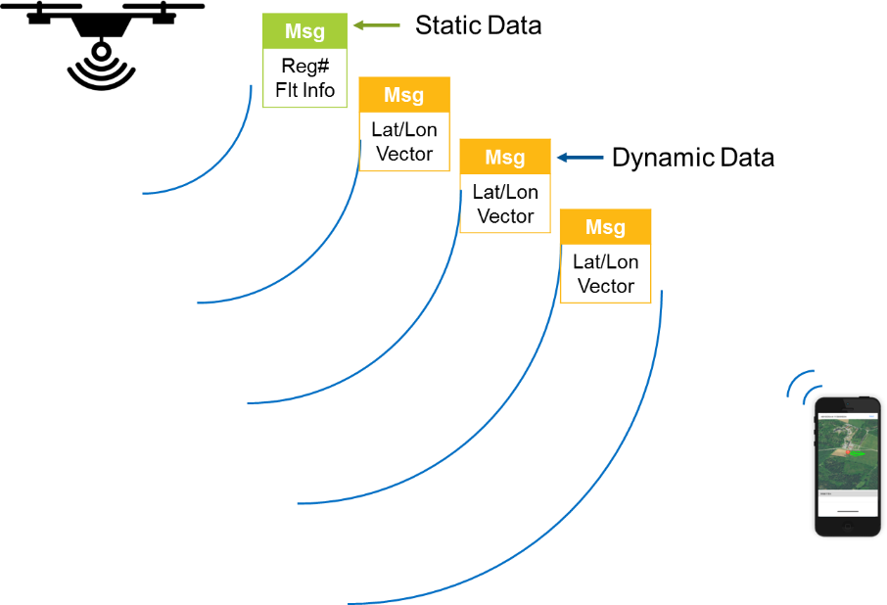

Figure 3 - Static and Dynamic Messages

# WiFi Beacon Frames

For aircraft implementing this protocol beacon frame sent by the aircraft, a “mangement frame” of type “beacon” as prescribed by the *IEEE 802.11-2016 Part 11*[2] WiFi specification must be sent at the interval described in section 3 . This frame must include the following:

1. A, SSID of “ODID-<unique ID hex string(8)>
2. A vendor specific tag (221) with the following format:

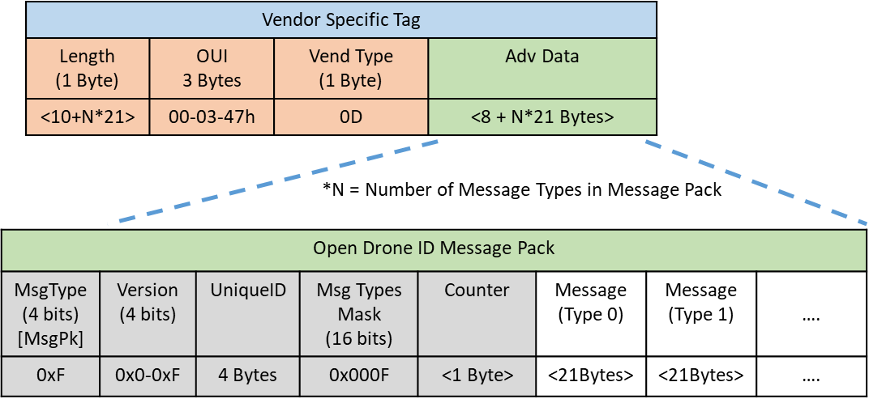

The grouping of frames into message packs shall be based on the prescribed interval in section 3 . Therefore, all dynamic message types (such as Location message) may be in a single message pack, and all static message types may be in a single pack.

The details of these messages are contained in the *Open Drone ID Message Specification*.

# Compliance and Interoperability

As of this version, compliance can be “self-certified” using the following means:

1. Every “shall”, “must” and any other logical directive in this document must be implemented.  
   (See IETF RFC2119 for adopted definitions of imperatives: https://www.ietf.org/rfc/rfc2119.txt)
2. Interoperability shall be verified against “known working” clients for both BLE 4 and Bluetooth 5 Extended Advertising receivers.
3. Hardware/RF/Signal compliance TBD.
4. If a system is not compliant with this spec, then it may not claim, advertise or display references to “Open Drone ID”.

1. <https://www.faa.gov/news/updates/?newsId=89404>
2. 802.11-2016 - IEEE Standard for Information technology--Telecommunications and information exchange between systems Local and metropolitan area networks--Specific requirements - Part 11: Wireless LAN Medium Access Control (MAC) and Physical Layer (PHY) Specifications  
   https://ieeexplore.ieee.org/document/7786995/  
   