**IT20028732**

7. The threshold is defined as 0.5 what 1783 means is the count of boxes with a confidence higher than the threshold.

8. Anchor boxes can help get the scale and aspect ratio of a required object box. Anchor box sizes are determined by the sizes of the objects in the dataset

10. Images picked 0115 and 0116 both of them are an image of car except the car is more visiblae in 0115 than in 0116 but 0116 detected the car and 0115 didn’t.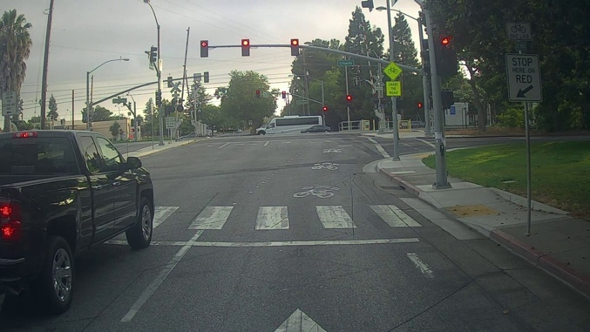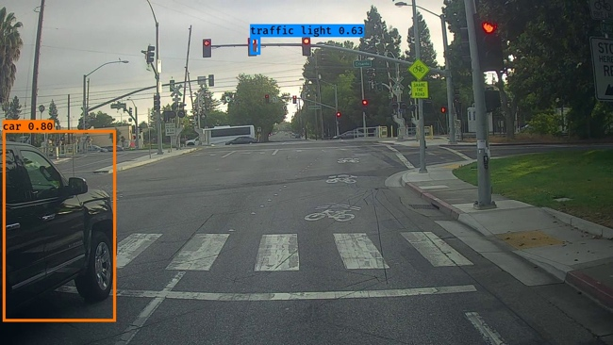

Increased max boxes to 20

Found 2 boxes for 0116.jpg  
Found 0 boxes for 0115.jpg

Set score_threshold=.3

Found 10 boxes for 0116.jpg

Found 10 boxes for 0115.jpg

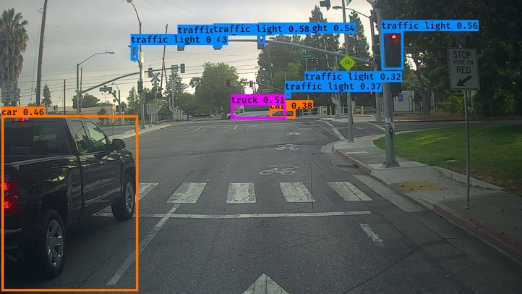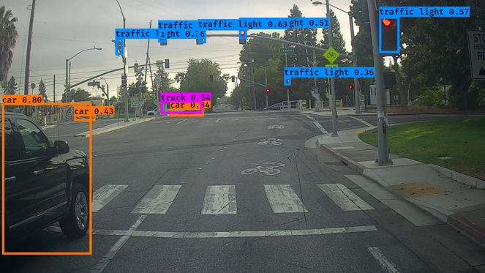

The truck is detected now but a lot of incorrect bounding boxes was also created

iou_threshold =.7

Found 0 boxes for 0115.jpg

Found 2 boxes for 0116.jpg

