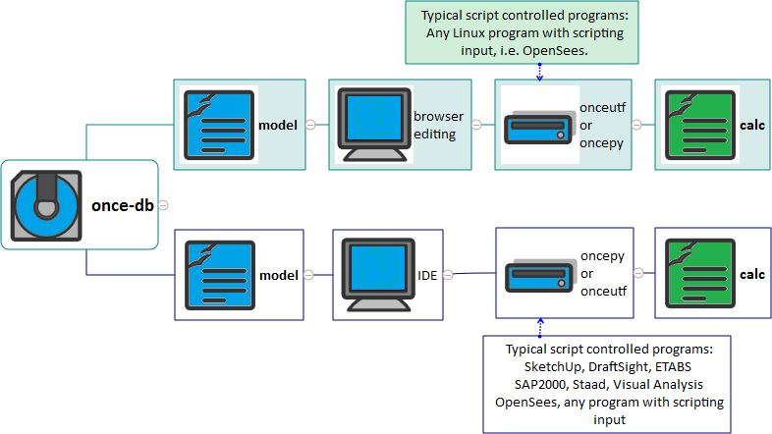
once-db
- model
  - browser editing
    - onceutf or oncepy
      - calc
- model
  - IDE
    - oncepy or onceutf
      - calc
- Typical script controlled programs: SketchUp, DraftSight, ETABS SAP2000, Staad, Visual Analysis OpenSees, any program with scripting input
- Typical script controlled programs: Any Linux program with scripting input, i.e. OpenSees.

