SPSE Jecna Test Case

Test Case ID: 1 | Test Designed by: Adéla Kopecká
Test Name: Verify launching of app
Brief description: Test opening of app
Pre-conditions: setting up database, base on app installation notes and installed app
Dependencies and Requirements: SQL Server (Microsoft), LogIn to database base on installation notes, hardware

Step | Test Steps | Test Data | Expected Result | Notes
1 | Open folder with app instalation | nothing | nothing
2 | Open folder called Application Files and there select folder OmegaSportExplorerClubOmegaSportExplorerClub_2_0_0_0 | nothing | nothing
3 | Open  OmegaSportExplorerClub.dll.config.deploy chnge | nothing | nothing
4 | Fill all Database setting parts | nothing | nothing
5 | Fill all Email Verification Sender parts and Stm information about e-mail service and then save it | nothing | nothing | Stm information have to match your entered email more info in installation notes
6 | Launch app | nothing | Aplication will launch succesfulli and afte few seconds will notifi you with succesfull connecting to database  just like in picture number 1

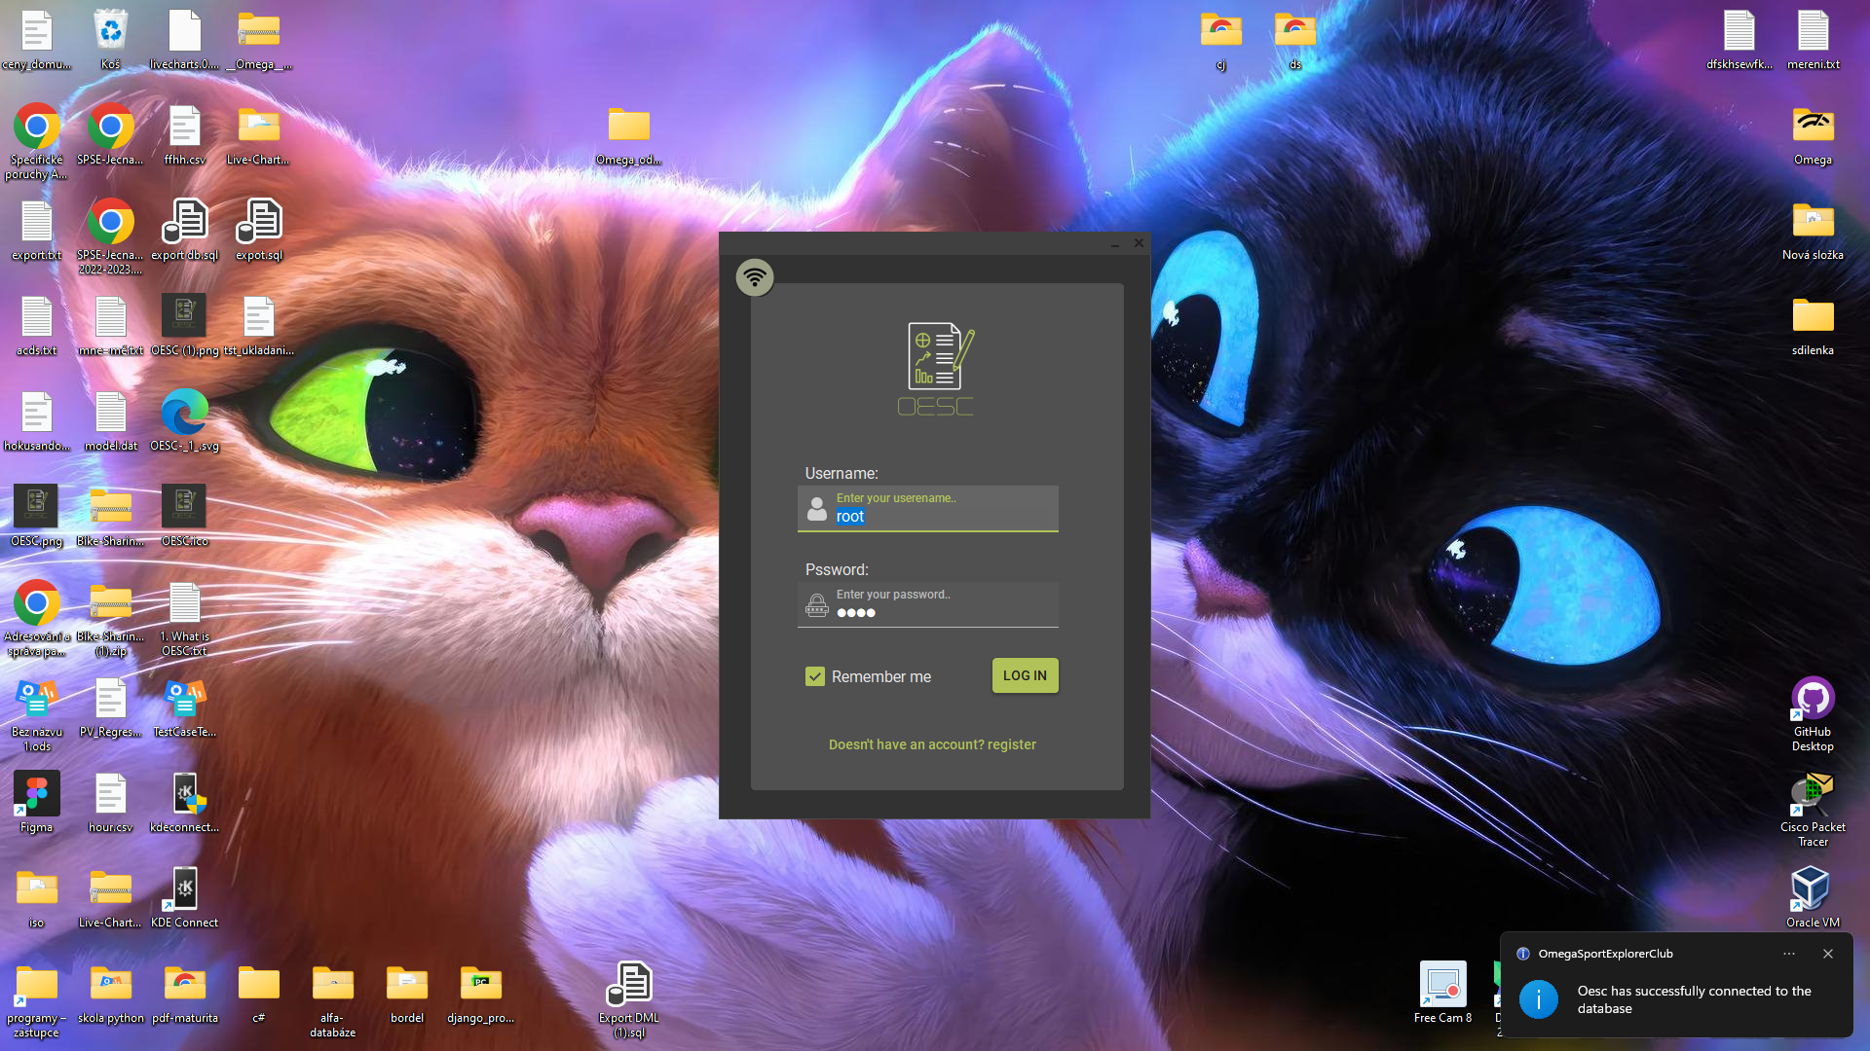
picture 1.

