**A Final Project Report On**

**EDU-SANCHAL**



Submitted in the Partial Fulfillment of the

Requirements for the Degree of Bachelor of Computer Engineering Awarded by Pokhara University

**Submitted By:**

**Aayushma Gubhaju (20070048)**

**Muna Sunar (20070071)**

**Nischal Malla (20070072)**

**Riwaj Bhurtel (20070080)**

**Surakshya Adhikari (20070417)**

**Supervisor:**

**Dr. Uday Raj Dhungana**

**Program Co-ordinator**

**School of Engineering**

**Faculty of Science and Technology**

**Pokhara University**

**August, 202**

# COPYRIGHT

The author has granted authorization to the Pokhara University Central Library and Library of School of Engineering to grant unrestricted access to this report for inspection. Furthermore, the author has agreed to the potential for extensive reproduction of this report for educational purposes by either the supervisors or, in their absence, by the program coordinator wherein the project was done. It is understood that proper acknowledgment will be accorded to both the author of the report and the School of Engineering, Pokhara University in any utilization of the report's contents. Unauthorized copying, publication, or any other form of exploitation of this report for financial gain without explicit consent from the School of Engineering, Pokhara University and the author is strictly prohibited. Requests seeking permission to replicate or employ any segment of the report's content should be directed to:

Program Coordinator

School of Engineering

Pokhara University

# STUDENT’S DECLARATION

We hereby declare that this project work entitled **EDU-SANCHAL** is based on our original work. All concepts, data, code, and any other work from external sources have been properly cited and referenced in accordance with the guidelines provided by School of Engineering, Pokhara University.

We owe all the liabilities relating to the authenticity and originality of this project work and project report.

1. Aayushma Gubhaju (20070048) …………………………….
2. Muna Sunar (20070071) …………………………….
3. Nischal Malla (20070072) …………………………….
4. Riwaj Bhurtel (20070080) …………………………….
5. Surakshya Adhikari (20070417) …………………………….

Date: 2024/08/24

# SUPERVISOR’S RECOMMENDATION

This is to certify that this project report entitled **EDU-SANCHAL** prepared and submitted by below listed team of students in partial fulfilment of the requirements of the degree of Bachelor of Computer Engineering awarded by Pokhara University, has been prepared and completed under my supervision.

I hereby recommend the same for acceptance by School of Engineering, Pokhara University.

1. Aayushma Gubhaju (20070048)
2. Muna Sunar (20070071)
3. Nischal Malla (20070072)
4. Riwaj Bhurtel (20070080)
5. Surakshya Adhikari (20070417)

…………………………..

**Dr. Uday Raj Dhungana**

Program Co-ordinator

School of Engineering

Pokhara University

Date: 2024/08/23



**School of Engineering**

**Pokhara University**

# External Examiner’s Recommendation

The undersigned certified that they have evaluated this project report entitled **EDU-SANCHAL** submitted by **Aayushma Gubhaju, Muna Sunar, Nischal Malla, Riwaj Bhurtel** and **Surakshya Adhikari** and their oral presentationfor partial fulfillment of the degree of Bachelor of Computer Engineering and recommended to the School of Engineering, Pokhara University for acceptance of this project work/report.

…………………………….

Er. Rajendra Bahadur Thapa

Assistant Professor

Gandaki College of Engineering & Science

Lamachaur, Pokhara, Kaski

…………………………….

Mr. Ramesh Chalise

Assistant Professor

La Grandee International College

Simalchaur, Pokhara, Kaski

Date: 2024/08/23



**School of Engineering**

**Pokhara University**

# LETTER OF APPROVAL

This project report entitled **EDU-SANCHAL** submitted by **Aayushma Gubhaju, Muna Sunar, Nischal Malla, Riwaj Bhurtel** and **Surakshya Adhikari** for partial fulfillment of the degree of Bachelor of Computer Engineering has been accepted by the School of Engineering, Pokhara University upon the recommendations of Supervisor and with the approval by the following examiner.

**External Examiner:**

Er. Rajendra Bahadur Thapa

Assistant Professor

Gandaki College of Engineering & Science

Dr. Udaya Raj Dhungana

Assistant Professor

(Coordinator)

Bachelor of Computer Engineering

Bachelor of Software Engineering

School of Engineering

Pokhara University

Lamachaur, Pokhara, Kaski

Mr. Ramesh Chalise

Assistant Professor

La Grandee International College

Simalchaur, Pokhara, Kaski

Date: 2024/08/23

# ABSTRACT

This proposal outlines the development of a **School Management System with Advanced Assignment Module**. The system will feature a user-friendly interface and scalable architecture, making it accessible and effective for a wide range of users. Key functionalities include a plagiarism detection tool to uphold academic integrity and an automated MCQs checker to streamline grading processes. The system aims to enhance both the administrative and educational experience, providing a modern solution to the evolving needs of the institution.

The system will integrate predictive analytics, utilizing machine learning models such as linear regression and decision trees to provide accuracy. The proposed system will not only provide student related features but also enhance user engagement and satisfaction through a robust and attractive interface.

**Keywords:** Enhancement, Management, Assignment, Plagiarism detection, User-friendly interface, Machine Learning

# ACKNOWLEDGEMENT

Firstly, we would like to extend our profound gratitude to our supervisor, Dr. Udaya Raj Dhungana. His mentorship, and expertise were instrumental in shaping our understanding and approach to problem-solving. Despite our status as beginners, he skillfully directed our vision, helping us break down complex problem and apply systematic analysis. His dedication to our success has been exceptional, and we are deeply thankful for his invaluable contribution to this project.

We express our sincere gratitude to the program coordinator, Dr. Uday Raj Dhungana whose visionary idea laid the foundation for this project. Dr. Udaya Dhungana invaluable feedback and insights played a pivotal role in elevating the quality of work.

We wish to convey our deep appreciation to our families for standing by us through the demanding phases of the project. Their unwavering support, understanding, and invaluable patience were a source of great strength and encouragement.

TABLE OF CONTENTS

COPYRIGHT i

STUDENT’S DECLARATION ii

SUPERVISOR’S RECOMMENDATION iii

External Examiner’s Recommendation iv

LETTER OF APPROVAL v

ABSTRACT vi

ACKNOWLEDGEMENT vii

LIST OF FIGURES x

LIST OF TABLES xi

LIST OF ABBREVIATION xii

CHAPTER 1: INTRODUCTION 1

1.1 Background 1

1.2 Problem Statement 1

1.3 Objectives 2

1.4 Applications 2

1.5 Project Features 3

1.6 System Requirement 3

CHAPTER 2: LITERATURE REVIEW 5

2.1 Literature Review 5

2.1.1. Introduction to Student Record Management Systems 5

2.1.2. Challenges in Traditional Student Record Management 5

2.2 Related Works 6

CHAPTER 3: METHODOLOGY 8

3.1.1.1 Requirement Analysis: 8

3.1.1.2 Design & Development: 9

3.1.2 Feedback 9

3.6 ER Diagram 17

CHAPTER 5: 23

CONCLUSION AND RECOMMENDATION 23

5.2 Final Outcome 23

REFERENCES 25

# LIST OF FIGURES

Figure 1: Incremental Model ----------------------------------------------------------------------- 8

Figure 2: System Architecture -------------------------------------------------------------------- 14

Figure 3: Plagiarism Detection---------------------------------------------------------------------15

Figure 4: ER Diagram------------------------------------------------------------------------------ 17

Figure 5: Sequence Diagram ---------------------------------------------------------------------- 19

Figure 6: Class Diagram ----------------------------------------------------------------------------20

Figure 7: Use-Case Diagram -----------------------------------------------------------------------21

Figure 8: Activity Diagram ------------------------------------------------------------------------22

# LIST OF TABLES

Table 1: Related Works……………………………………………….….………….…6

Table 2: Test Report for Manual Testing………………………………………………12

# LIST OF ABBREVIATION

SQL Structured Query Language

UI/UX User Interface/User Experience

SDLC Software Development Life Cycle

OMR Optical Mark Recognition

CSS Cascade Style Sheet

MCQ Multiple Choice Questions

PBKDF Password-Based Key Derivation Function

REST API Representable State Transfer Application Programming Interface

UML Unified Modelling Language

UAT User Acceptance Testing

# CHAPTER 1: INTRODUCTION

## Background

The condition of education has undergone significant transformation due to the advancements in technology and evolving approaches. The traditional method of administration, mostly characterized by manual record keeping, tedious information systems and communication channels, has become increasingly outdated and inefficient.

The Edu-Sanchal project is envisioned to be the simplified user-friendly assistance platform for the digitalized management of the school operations including student information, academic performance monitoring, assignment management, communication modules and marking system, replacing the problems with the traditional approaches; with the advancements including Machine Learning to generate digital OMR enriched MCQs, Marking System and Assignment Management powered by Plagiarism Checking.

The development and implementation of the system will have the potential to revolutionize the way institutions will operate, assisting them to focus on their core purpose of providing quality education and proper management in an increasingly digital world.

This platform is designed with a focus on simplicity and user-friendliness, ensuring that both educators and administrators can easily navigate and utilize its features. It addresses common challenges associated with traditional management approaches, offering a streamlined and integrated solution. By integrating these cutting-edge technologies, the proposed system not only modernizes school operations but also enhances the overall educational experience. It provides a robust framework that is scalable and adaptable to future needs, ensuring that our engineering department remains at the forefront of digital education innovation.

## Problem Statement

In the past, educational institutions often relied on outdated methods for managing student records, such as paper-based systems, spreadsheets, or basic database applications. These traditional approaches present numerous challenges in an increasingly digital and data-driven world. The current challenges include:

* **Manual Administrative:** To manage data and information, many schools continue to use antiquated technologies and manual documentation. This labor-intensive process is more prone to errors and miscalculations which can lead to inaccurate assessment and evaluation of students’ performance.
* **Data Fragmentation and Inconsistency:** There is data fragmentation and inconsistency when various systems are used to manage school administration. This makes it difficult for educators and administrators to get current, reliable information when they need it.
* **Lack of Scalability and Adaptability:** Many School Management Systems are not scalable or flexible enough to meet the various demands and changing specifications of organizations.
* **Delayed access to scored marks:** Due to the lack of a platform provided by the administration, the students have to wait for a long time to view the scored marks which can lead to irritation and discouragement.

Due to such issues, Edu-Sanchal is developed to overcome all the challenges in administration and management of internal marks management of educational institutions. Edu-Sanchal specifically intends to promote the effective management of the students records and assignment submission.

## Objectives

The main objectives of this project are:

* To design an intuitive and accessible user interface to ensure ease of use for both administrators and students.
* To build a scalable system architecture to handle increasing data and user load efficiently.
* To develop and integrate a plagiarism checker for assignments to ensure academic integrity.

## Applications

The application of our proposed system extends across various areas:

* **Record Management:** The system provides a centralized platform for storing and managing student as well as teacher records.
* **Assignment Management:** Our platform simplifies the way of managing the assignments across the classes. It involves the creation of assignments, submission of assignments and marking of the submitted assignments.
* **Plagiarism Detection:** The system, which is equipped with a plagiarism detector allows educational institutions to go forward with the tracking and management of assignments using digitalized, user-friendly platforms, supporting the growth and development of students.
* **Scalability and Accessibility:** The system offers scalability and accessibility, making it suitable for institutions of all sizes and locations to access the system via web browsers.

## Project Features

The proposed system will have some of these potential features:

* **User Authentication and Access Control:** Implement secure login mechanism for administrators, teachers, and students with role-based access control.
* **Administrative Management:** Allow administrators to manage student profiles, academic records and manage teacher portals.
* **Plagiarism Checker:** Provide functionality for teachers to add the assignments with graded units, deadline and resources, and for the students to add their work and view the resources provided.
* **Grade Management:** Allow teachers to record and manage student grades for assignments, assessments, and exams, with the ability to calculate cumulative grades.

## System Requirement

**1.6.1 Software Requirement**: The software requirements for the Edu-Sanchal system:

1. **Backend Development:**
   * Programming Language: Python
   * Framework: Django
   * Database Management System: SQLite
2. **Frontend Development:**
   * UI/UX Design Tools: Figma
   * CSS Framework: CSS
3. **Authentication and Security:**
   * Hashing Algorithm: Argon2, Bcrypt, PBKDF2
4. **Additional Requirements:** 
   * Reporting and Analytics

**1.6.2 Hardware Requirement:** The hardware requirements for the EDU-SANCHAL system:

1. **Database Server:** 
   * DBMS: MySQL
2. **Client Devices:** 
   * Desktop Computers/Laptops: Client Devices used by administrators, teachers, and students should meet minimum hardware requirements.
3. **Backup:** 
   * Backup Storage: The code, database, and all the critical data are regularly set to back up in the cloud and other platforms securing the data in case of data loss or system failure

# CHAPTER 2: LITERATURE REVIEW

## Literature Review

The Edu-Sanchal is the platform used by various educational institutions for a secure, simple, and alternative solution to the conventional and tedious paper-based systems. In the context of Nepal, the approaches of major systems are also performed using traditional management systems, full of errors and a poor validation.

Educational Institution needs a simple solution that can run individual functions, connect their entire operation, use the web as a key communication and managerial tool, and simplify daily operational responsibilities with the competition evolving in the advancement of technology.



### Introduction to Student Record Management Systems

Student record management is a critical component of educational administration, involving the collection, storage, processing, and reporting of data related to students' academic and personal information. Traditionally, this process was handled manually or through rudimentary digital tools, leading to inefficiencies and challenges in maintaining accurate, accessible, and secure records. With the advent of advanced information technologies, there has been a significant shift towards the development of comprehensive student information systems (SIS) that address these challenges.

### ****Challenges in Traditional Student Record Management****

1. **Inefficiency and Human Error**  
   Early studies highlight the inefficiencies associated with manual student record management. The reliance on paper-based systems or simple databases often led to time-consuming processes, with a high potential for human error. Errors in data entry, difficulties in record retrieval, and delays in information processing were common, negatively impacting institutional efficiency (Kashorda et al., 2007).
2. **Data Inaccuracy and Fragmentation**  
   Research by Reigeluth and Garfinkle (1994) pointed out that fragmented systems with isolated data storage often resulted in inconsistencies across different records. Inaccuracies in student information, such as mismatched records or outdated data, were frequent and problematic, particularly when making administrative decisions or reporting to external bodies (Macfadyen & Dawson, 2010).
3. **Limited Accessibility and Security Concerns**  
   The lack of secure, remote access in traditional systems posed significant challenges, particularly in scenarios requiring data retrieval outside office hours or from different locations (Ojo & Adebayo, 2012).

## Related Works

|  |  |  |
| --- | --- | --- |
| **S. No** | **Title** | **Features** |
| **1.** | A study by Verma & Singh (2017) | Offers a practical solution for student marks management, allowing student to view their marks and syllabus in real-time by promoting transparency and empowering them to take ownership of their learning |
| **2.** | A study conducted by Smith & Jones  (2018) | Examine the impact of student marks management system on student learning by offering students immediate access to their grades and course materials and support the idea that better access to academic data can contribute to improved student performance |
| **3.** | A study conducted by Sharma & Tiwari (2020) | This web app caters to the online learning environment by providing a user-friendly platform for managing student progress and offering timely feedback |
| **4.** | A study by Sharma and Singh (2021) | It includes basic data analytics supporting the assertion that student marks management systems can be reliable and valid for assessing student learning |

Table 1: Related Works

# CHAPTER 3: METHODOLOGY

## Software Development Approach

This chapter states the methodology used to reach the objectives of the project. The processes which are followed in designing, developing, and maintaining the project is known as the Software Development Life Cycle (SDLC). We look forward to the methods we are using to achieve the checkpoints in this chapter.

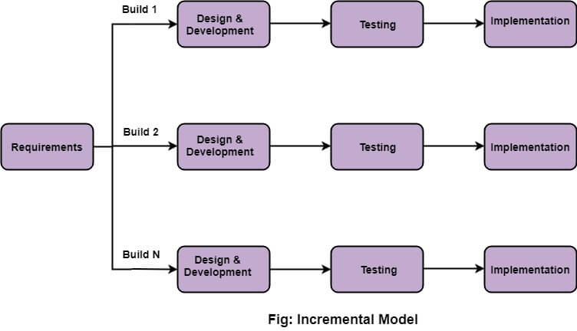

Figure 1- Incremental Model

**3.1.1 Phases of Incremental Model**

Following are the phases in Incremental model:

### 3.1.1.1 Requirement Analysis:

In the first phase of the incremental model, the product analysis expertise identifies the requirements. And the system functional requirements are understood by the requirement analysis team. To develop the software under the incremental model, this phase performs a crucial role.

### 3.1.1.2 Design & Development:

In this phase of the Incremental model of SDLC, the design of the system functionality and the development method are finished with success. When software develops new practicality, the incremental model uses style and development phase.

**3.1.1.3 Testing**

In the incremental model, the testing phase checks the performance of each existing function as well as additional functionality. In the testing phase, the various methods are used to test the behavior of each task.

**3.1.1.4 Implementation:**

Implementation phase enables the coding phase of the development system. It involves the final coding that design in the designing and development phase and tests the functionality in the testing phase. After completion of this phase.

### 3.1.2 Feedback

After releasing the project, the last step is feedback. In this phase, the team receives feedback about the product and works through the feedback.

In this way, the project is carried out using Incremental Model.

## **Data Collection**

**3.2.1 Requirements Gathering**

**Surveys and Questionnaires:** Distribute surveys to a broader audience to gather additional insights on user needs, usability preferences, and specific features required in the application.

**Document Analysis:** Review existing systems from institutional policies on student evaluation and record-keeping to ensure compliance and relevance in the new application.

**3.2.2 Data for System Design**

**User Stories:** Compile user stories based on the requirements gathered, detailing the interactions between users and the system.

**Data Models**: Identify the key data entities, such as student profiles, teacher profiles, course details, internal marks, and assignments and define their relationships for database design.

**3.2.3 Data Generation**

**Simulated Data Mock Data Creation:** Generate simulated data for students, teachers, courses, and marks to be used in the initial development stages. This helps in testing the system's functionality before real data is available.

**Test Cases:** Develop test cases using the simulated data to validate different functionalities of the application, such as data entry, data retrieval, and report generation.

**3.2.4 Real Data Integration**

**Pilot Data:** After initial validation with simulated data, integrate real data from a pilot group of students and teachers to further test the application in a controlled environment.

**Continuous Data Collection:** Set up mechanisms for continuous data collection as the application is used, ensuring that the system can handle real-time data entry and processing.

**3.3 Phases of Development**

**Phase 1: Core Features Implementation Student and Teacher Profiles:** Develop modules for managing student and teacher profiles, including personal information, course assignments, and roles. Internal Marks Recording: Implement the basic functionality for teachers to record and update internal marks. Basic Reporting: Create simple reports for internal marks that can be viewed by students and administrators.

**Phase 2: Plagiarism Detection in Assignment:** Develop a plagiarism detection module for checking the uploaded assignments assigned to students.

**Phase 3: System Optimization and Integration**

**User Interface Refinement:** Improve the user interface based on feedback from the pilot phase to enhance usability.

**Integration with External Systems:** Integrate the application with other institutional systems, such as Learning Management Systems (LMS) or external databases.

**Security and Compliance:** Implement advanced security measures, including data encryption, role-based access controls, and compliance with data protection regulations.

**3.4 Tools and Technologies**

**Frontend Development:** Utilize Bootstrap for responsive design, ensuring the application is accessible on various devices.

**Backend Development:** Use Django for the backend development, leveraging its powerful ORM for database management and its built-in security features.

**Database Management:** Use PostgreSQL for robust data storage and management, ensuring scalability and performance.

**APIs:** Develop RESTful APIs for integration with other educational tools and services**.**

**3.5 Experimental Validation**

**Testing Phases**

**Unit Testing:** Perform unit tests on individual components during each increment to ensure they function as expected.

**Integration Testing:** After each increment, conduct integration testing to verify that newly developed components work seamlessly with existing ones.

**System Testing:** Conduct comprehensive system testing at the end of each phase to validate the application’s overall functionality, performance, and security.

**Pilot Testing:** Select a small group of teachers and students to use the application in a real educational environment.

**Feedback Collection:** Collect feedback from pilot users on the application’s usability, functionality, and performance.

**Iteration Based on Feedback:** Make necessary adjustments based on the feedback received, refining the application incrementally.

**Manual Testing:**

Manual testing is essential for validating the system’s behavior, ensuring accurate calculations and confirming that the user interface is intuitive and user-friendly.

The following test case shown in the table were implemented to test the system’s usability as well as validity. By thoroughly testing our system using a variety of manual test cases we can help ensure that the system is ready for production use.

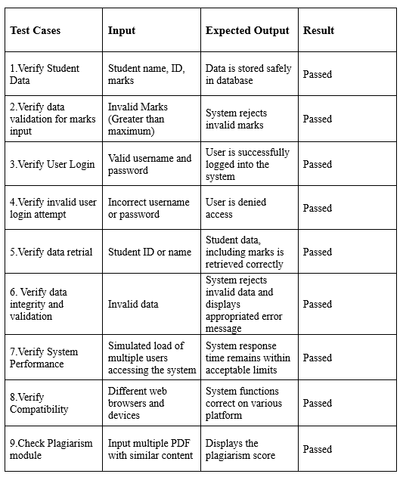

Table 2: Test Report for Manual Testing

**3.6 User Acceptance Testing (UAT)**

**Final Testing:** Conduct UAT with a larger group of users, including a cross-section of all user types (teachers, students, administrators).

**Validation:** Ensure that the application meets all user requirements and is ready for full-scale deployment.

**3.7 Implementation**

**Deployment Staging Environment:** First deploy the application in a staging environment to test deployment scripts, monitor for any deployment-specific issues, and conduct final checks.

**Production Environment:** Deploy the application to the production environment, ensuring minimal downtime and disruption to existing processes.

**3.8 Monitoring and Maintenance**

**Performance Monitoring:** Implement monitoring tools to track the application’s performance, user activity, and system functionalities.

**Continuous Improvement:** Establish a process for regular updates and improvements based on user feedback, technological advancements, and changing educational needs.

**3.9 Conclusion**

The methodology outlined above provides a structured and iterative approach to developing a robust educational web application. By following the Incremental Model, the project ensures that the application evolves to meet user needs effectively, is thoroughly tested and validated, and is seamlessly integrated into the educational environment.

# Chapter 4 System Design

**4.1 System Design**

During the system design phase, we worked on figuring out how the school management system will be built. We used the tools like UML diagram to create detail plans for how things like data processes, and different parts of the system will work together. This helped us get a clear picture of what we need to do when it came time to build the system.

**4.2 System Architecture**

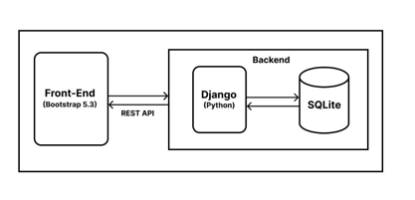The proposed system has been developed with a decoupled architecture having separate frontend and backend. The system architecture allowed the frontend and backend to be developed independently and provide modularity this architected design is scalable as well as it provides ability to scale frontend and backend separately to handle large volume of data. It also provided other benefits such as ease of debug and flexibility. If there is a bug in frontend, it is easier to debug because the code us isolated from the backend.

Figure 2: System Architecture

As shown in the Figure 2 above, the system consists of three major components: the database, stores all the records of the students ranging from the user credentials to score marks of students; the middle component which can be called as backend which services the request of users and interacts with database acting as processing layer between frontend and databased; and the user, interacting with the system through the frontend which provides UI frontend interface. In a nutshell the user interacts with the system through the frontend and the user requests are responded by the middle layer according to the data stored in the database.

**4.2 Plagiarism Detection**

Plagiarism detection involves scanning a document and comparing its content against assignments assigned to the students. The detection tool identifies matching or similar text which can be a potential plagiarized content. This process helps ensure that the work is original, maintains academic integrity, and prevents the unauthorized use of others' ideas or words. Plagiarism detection is crucial in both educational and professional settings to uphold ethical standards and give proper credit to original authors.

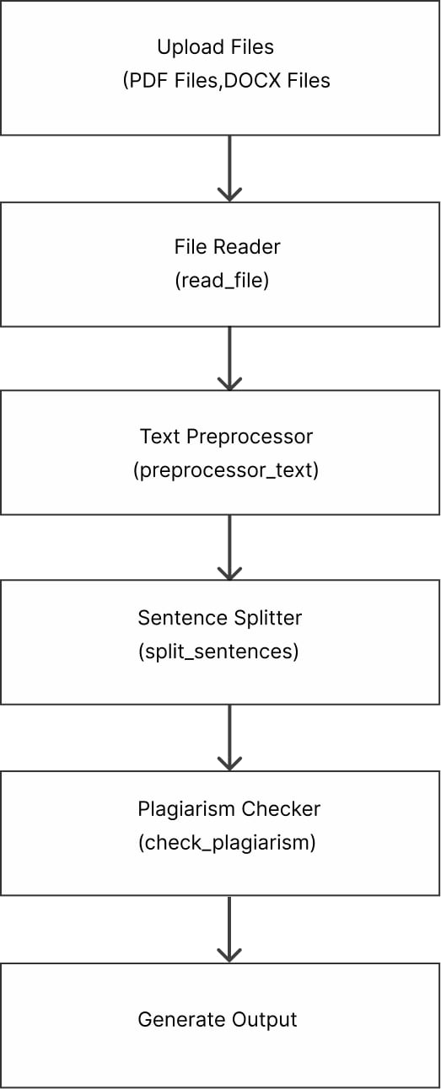

Figure 3: Plagiarism Detection

* **Libraries Used:**
* **os:** Provides functions to interact with the operating system, such as listing files in a directory NumPy**.**
* **re**: A library that provides tools for matching and manipulating strings based on patterns.
* **PyPDF2**: A library used to read and manipulate PDF files, particularly for extracting text.
* **difflib:** Contains classes and functions for comparing sequences, particularly useful for calculating similarity ratios.
* **docx2txt**: allows users to convert the content of a .docx file into plain text format, making it easier to process or analyze the text.

### 3.6 ER Diagram

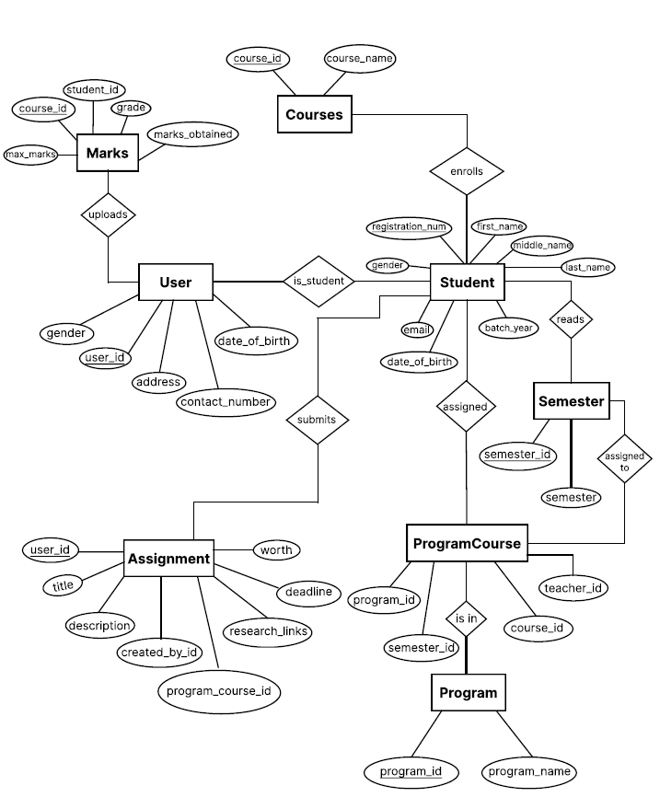

Figure 4: ER Diagram

**3.7 Sequence Diagram**

This sequence diagram outlines the step-by-step interactions between ta actors (students, teachers, admin), the system, and the database emphasizing the flow of request and responses in the describes scenario:

**Student’s Interactions:**

1. The student sends a login request to the system
2. The system forwards the login requires to the database and waits for response
3. The database processes the request and sends the request to the system
4. The system relays the login response back to the student.
5. Subsequently, the student requests access to their marks from the system.
6. The system queries the database to retrieve the requested marks.
7. The database provides the marks data to the system, which in turn, delivers the result to the students.

**Teacher Interactions:**

1. The teacher initiates a login request which is transmitted tot the system.
2. The system, in turn, queries the database for authentication and retrieves the response.
3. The system communicated the login response to the teacher.
4. The teacher sends a request to the system to view the courses they are teaching for to assign marks.
5. The system queries the database to obtain necessary course or to upload marks information.
6. The database supplies the requested data to the system.
7. The system delivers the course information or uploaded marks to the teacher.

**Admin interactions:**

1. The admin initiates a login requests, which is send to the system
2. The system forwards the login request to the database to the authentication.
3. The database processes the requests sand sends the login response back to the system.
4. The system communicates the login response to the admin, indicating whether the login was successful.

After a successful login, the admin can perform various actions.

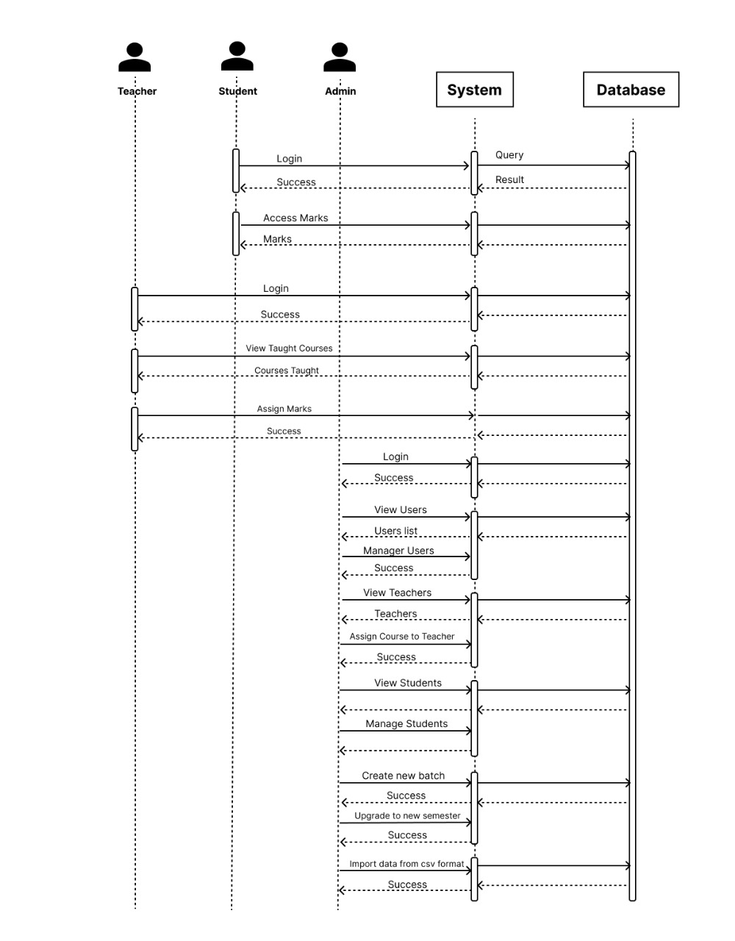

Figure 5: Sequence Diagram

**3.8 Class Diagram**

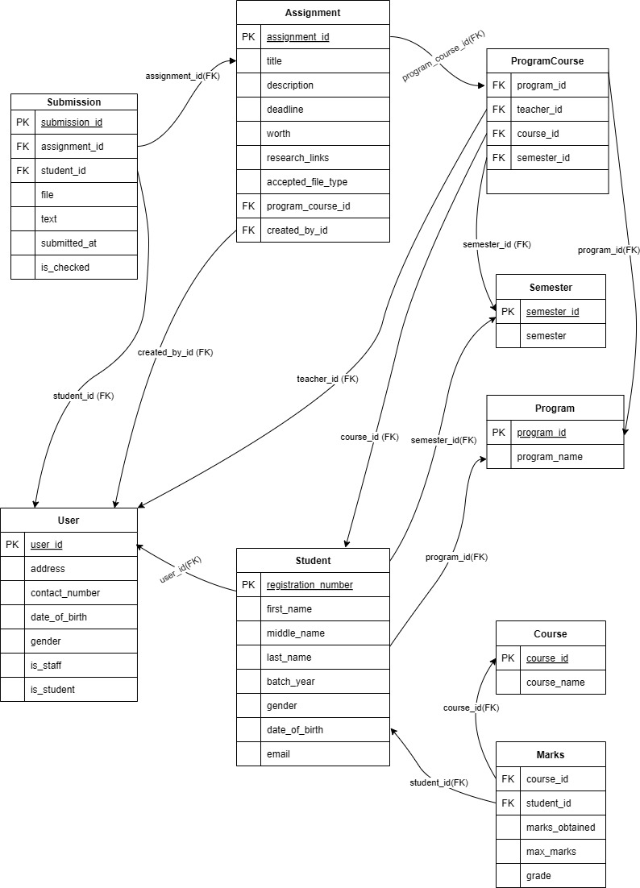

Figure 6: Class Diagram

**3.8 Use Case Diagram**

The use case diagram helps to provide a high-level overview of how different user interacts with the system and the main functionality the system offers.

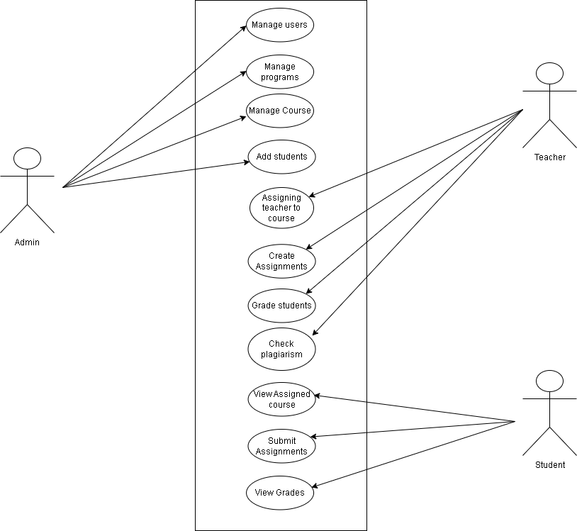

Figure 7: Use-Case Diagram

Here, the fig shows the user roles and their functionalities supported by the system the user supports multiple user roles: admin, teacher and students.

**Admin**: have the maximum functionalities ranging from viewing mark to managing users and their roles, managing course, programs and many more.

**Teachers**: Teacher cans view the courses taught by them and update the marks of students for the courses taught.

**Students:** can view their semester marks and upload assignments.

**3.9 Activity Diagram**

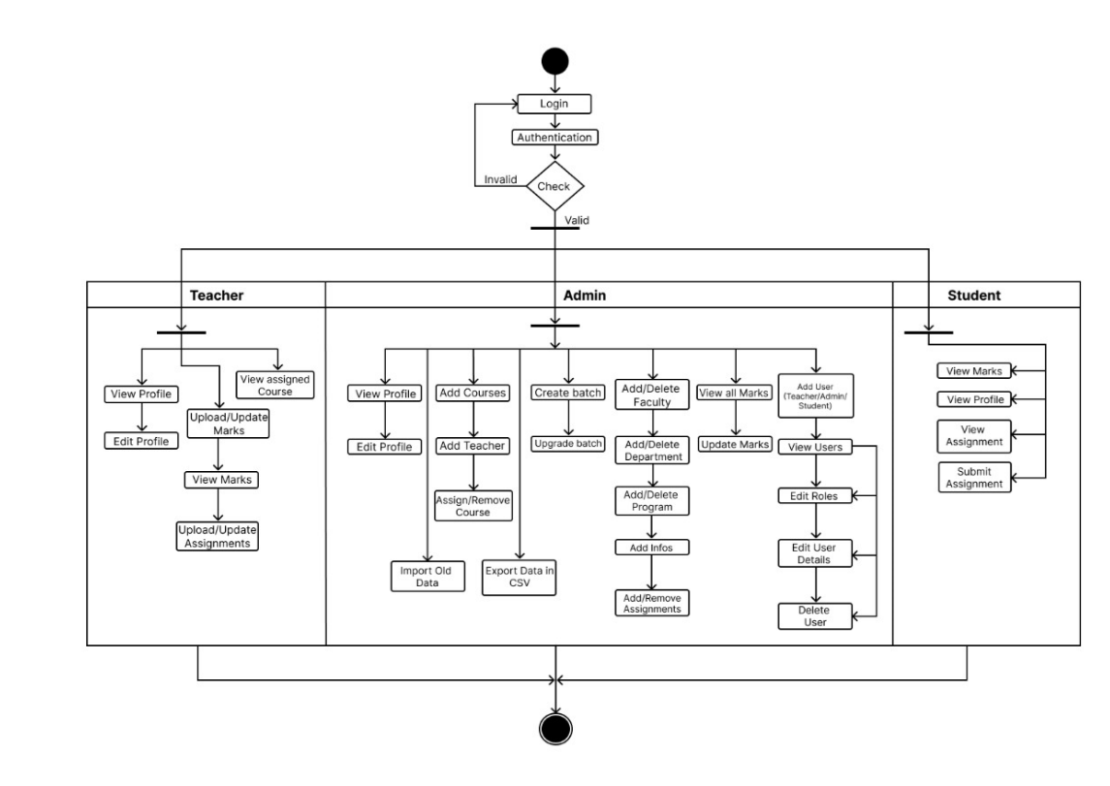

Figure 8: Activity Diagram

# CHAPTER 5:

# CONCLUSION AND RECOMMENDATION

**5.1 Conclusion**

We believe that the development of “EDU-Sanchal” provides a comprehensive platform that will improve administrative effectiveness and boost educational results inside our institution as we continue to develop our system. The main functions of our project internal mark upload, deadline-driven assignment submission and plagiarism detection are thoughtfully planned and integrated. Every component is being created to make sure it satisfies the demands of educators and students. As we continue to finish the project, we're committed to producing a system that will expedite procedures, uphold academic integrity, and enhance the user experience overall.

### 5.2 Final Outcome

1. **Internal Marks Upload:** There is now a simplified feature in the system for uploading internal marks. Instructors may effortlessly enter and amend student grades straight into the platform, guaranteeing precise recording of grades and instantaneous student access.
2. **Assignment Submission with Deadlines:** Students can now turn in their assignments online through an integrated enhanced assignment submission platform. The site has deadline management tools that ensure that assignments are completed on time by automatically tracking submission timelines, alerting students to impending deadlines, and enforcing cut-off hours for late submissions.
3. **Plagiarism Check:** A powerful plagiarism detection technology included into the system automatically verifies the authenticity of student inputs. By identifying possible instances of plagiarism and giving instructors and students thorough reports to confirm the originality of submitted work, this tool contributes to the maintenance of academic integrity.

**5.3 Limitation and Future Recommendation**

**Limitations**

Here are some of the limitations of the proposed system:

* **Resource Constraints:** The project was limited by available resources, including budget, time, and skilled personnel, which affected the scope and pace of development.
* **Technical Challenges:** Integration of advanced features such as plagiarism detection required specialized technical expertise, which posed challenges during development.
* **Scalability Issues:** Although designed to be scalable, the system may face challenges in handling a significantly increased number of users or data load without further optimization.

**Future Recommendation**

Edu-Sanchal is a solution intended as a basic internal marks management system targeted for students, teachers and administration. However, it still lacks many features for proper user management.

* **Enhanced Machine Learning Capabilities:** Future developments could include the incorporation of more advanced machine learning algorithms to personalize learning experiences, such as adaptive learning paths and predictive analytics for student performance.
* **Integration with Learning Management Systems (LMS):** Integrating the system with existing LMS platforms would provide a more cohesive educational ecosystem, facilitating seamless data exchange and improving overall user experience.
* **Advanced Data Analytics:** Implementing more advanced data analytics tools would help teachers gain deeper insights into student performance and adjust their teaching methods to better cater to the individual needs of each student.
* **Continuous User Feedback and Iterative Improvements:** Regularly collecting feedback from users and incorporating it into system updates will ensure that the platform remains relevant, user-friendly, and capable of meeting evolving educational needs.

# REFERENCES

1. A.K. Verma and S.K. Singh, "A Review of Student Marks Management Systems," Indian journal of science and technology, vol. 13, no. 10, pp. 1107-1115, Mar. 2010
2. Joshi, Vikram. "Council Post: Seven Reasons Why a Website's Front-End and Backend Should Be Kept Separate." Forbes, Forbes Magazine, 14 Apr. 2022, www.forbes.com/sites/forbestechcouncil/2018/07/19/seven-reasons-why-a-websitesfront-end-and-back-end-should-be-kept-separate/
3. M.J. Smith and J.R. Jones, "The Impact of Student Marks Management Systems on Student Learning," IEEE Xplore, Aug. 01, 2018
4. R.K. Sharma and S.K. Singh, "Assessing the Reliability and Validity of Student Marks Management Systems," Journal of Information Systems and Engineering, vol. 8, no. 1, p. 61, 2021.
5. S.K. Sharma and S.C. Tiwari, "The Use of Student Marks Management Systems in

Online Learning," Indian journal of science and technology, vol. 5, no. 15, pp. 506-512, Mar. 2020

1. S.P. Singh and R.K. Sharma, "The Role of Student Marks Management Systems in Promoting Equity and Inclusion," Journal of Information Systems and Engineering, vol. 18, no. 2, p. 15, 2022.