Student name: -Kumbhar Dilip
College name: - Indus University
Week 4 assignment: - Cyber Security Internship
Sid: - dg/september/cyber/264
Mail: - dilipkumbhar.dginternshub@gmail.Com
Task 4: - Theory + Practical
Submission Date: - 30st September 2026

Sr. No. | Content
1 | Cover page
2 | Introduction to Network Security
3 | Lab Setup
4 | Network Architecture
5 | Apache Installation
6 | Nmap Basic Scan
7 | Advanced Nmap Scan
8 | Wireshark Analysis
9 | Learning Outcomes
10 | Conclusion


Objective:
Understand basic network setup and perform initial security testing in a lab environment.

Tools Used:
- VMware Workstation
- Kali Linux
- Ubuntu Server
- Apache Web Server
- Nmap
- Wireshark

Introduction to Network Security: -
Network security is the practice of protecting a computer network, its devices, systems, and data from unauthorized access, attacks, misuse, and damage. It includes security technologies, policies, procedures, and practices that help keep information confidential, accurate, and available to authorized users. Network security is important for homes, schools, businesses, banks, hospitals, government organizations, and other institutions that use computer networks.
Why Do We Need Network Security?
Network security is needed because computer networks face many types of threats, such as:
- Unauthorized access: Prevents attackers or unauthorized users from accessing systems and information.
- Malware and viruses: Helps protect computers and networks from malicious software.
- Data theft: Protects sensitive information such as passwords, financial information, and personal data.
- Cyberattacks: Helps defend against attacks such as phishing, ransomware, denial-of-service (DoS), and network intrusion.
- Data protection: Prevents unauthorized modification or destruction of important data.
- Privacy: Ensures that confidential communication and information are accessible only to authorized people.
- Business continuity: Helps organizations continue their operations even when security incidents occur.
Advantages of Network Security
- Protects confidential and sensitive information.
- Prevents unauthorized access to network resources.
- Reduces the risk of malware and cyberattacks.
- Improves privacy and data protection.
- Helps organizations maintain reliable network services.
- Protects devices such as computers, servers, routers, and mobile devices.
- Helps organizations comply with security policies and regulations.
Benefits of Network Security
The major benefits include:
- Confidentiality – Only authorized users can access sensitive information.
- Integrity – Protects data from unauthorized changes or corruption.
- Availability – Keeps network services and resources accessible when needed.
- Authentication – Verifies the identity of users and devices.
- Access control – Determines which users can access particular resources.
- Risk reduction – Reduces the possibility and impact of security incidents.
- Trust and reliability – Create a safer environment for communication and sharing information.
Common Network Security Tools
Some commonly used network security tools are:
- Firewall: Monitors and controls incoming and outgoing network traffic based on security rules.
- Antivirus/Anti-malware: Detects and removes malicious software.
- IDS (Intrusion Detection System): Monitors network activity and alerts administrators about suspicious activity.
- IPS (Intrusion Prevention System): Detects and can automatically block certain malicious network activity.
- VPN (Virtual Private Network): Encrypts network communication and provides a secure connection over an untrusted network.
- Wireshark: A network protocol analyzer used to capture and examine network traffic.
- Nmap: A network scanning tool used to discover hosts, services, and open ports.
- SIEM (Security Information and Event Management): Collects and analyzes security logs and events to help identify threats.
- Password managers: Help users create and securely store strong passwords.

Lab Setup Explanation
Lab Architecture:-
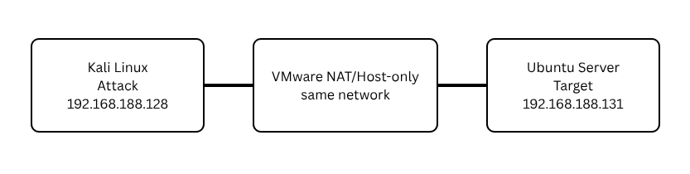
Virtual Machines: -
Machine | Role | Example IP
Kali Linux | Attacker | 192.168.188.128
Ubuntu Server | Target | 192.168.188.131
Both virtual machines were connected using the same VMware NAT (or Host-Only) network.
Network Verification
The following commands were used:
Kali Ubuntu
ip a hostname -I
Connectivity was verified using:
- ping 192.168.188.131
- ping 192.168.188.128
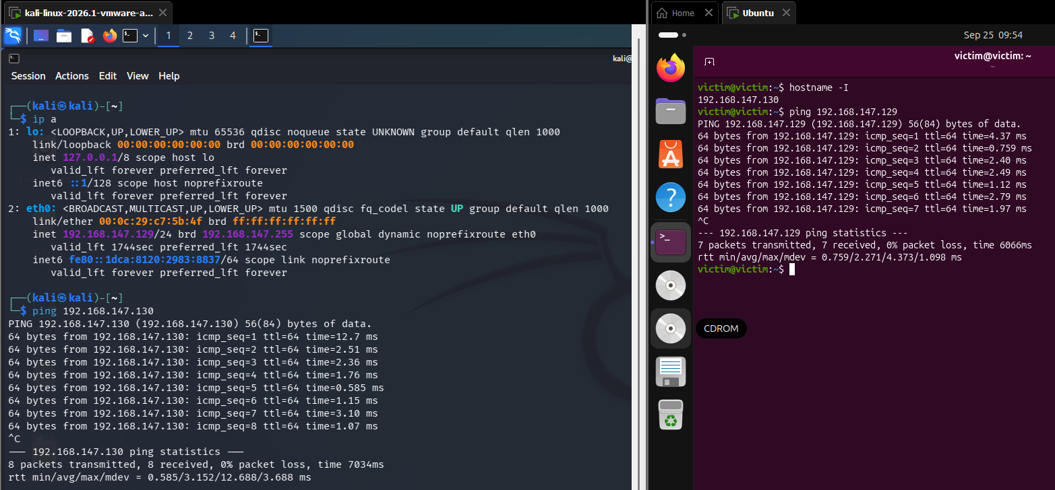
Service Installation and Configuration
Apache Web Server Installation: -
The Apache web server was installed on Ubuntu Server.
Commands Used
- sudo apt update
- sudo apt install apache2 -y
The service was started using:
- sudo systemctl start apache2
- sudo systemctl enable apache2
Service status was checked using:
- sudo systemctl status apache2
The web server was tested from Kali by opening:
http://localhost
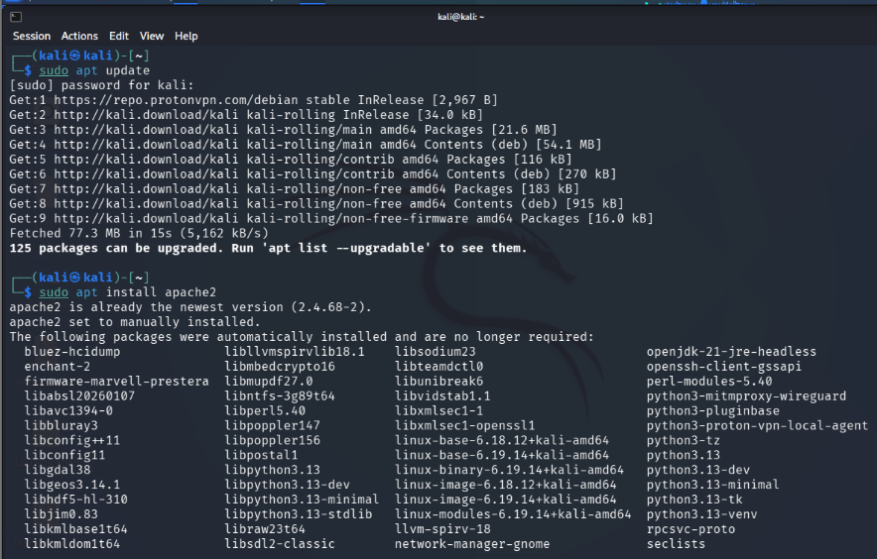
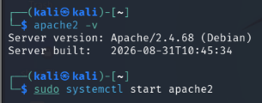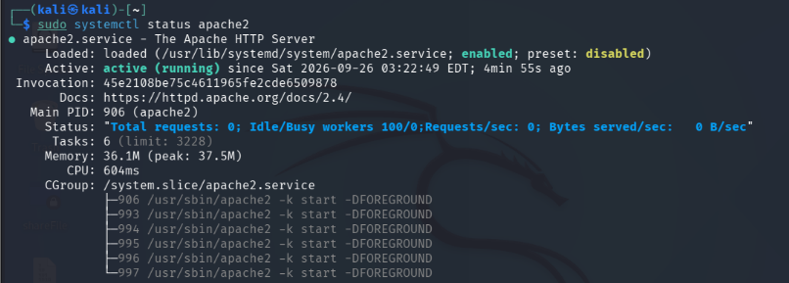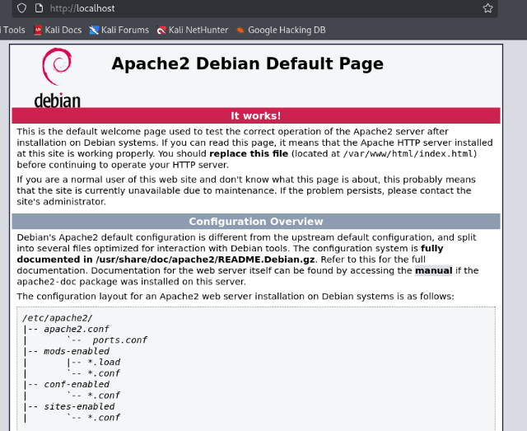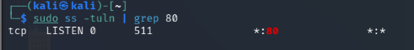

Nmap Scan Analysis
Basic Network Scan
Nmap was used from Kali Linux to scan the Ubuntu Server.
Command:
nmap 192.168.188.131
The scan identified open ports.
Example Results
Port | State | Service
21 | Open | ftp
80 | Open | HTTP
Meaning
- Port 22 allows secure remote login.
- Port 80 hosts the Apache web server.

Advanced Nmap Analysis
Service Detection
Command:
nmap -sV 192.168.188.128
This identified running services.
Port | Service
21 | ftp
53 | Domain
80 | Apache HTTP Server
OS Detection
Command:
sudo nmap -O 192.168.188.128
The scan detected the target operating system as Linux.
Saving Scan Results
Command:
nmap -sV 192.168.188.128 -oA week4_scan
Generated files:
- week4_scan.nmap
- week4_scan.xml
- week4_scan.gnmap
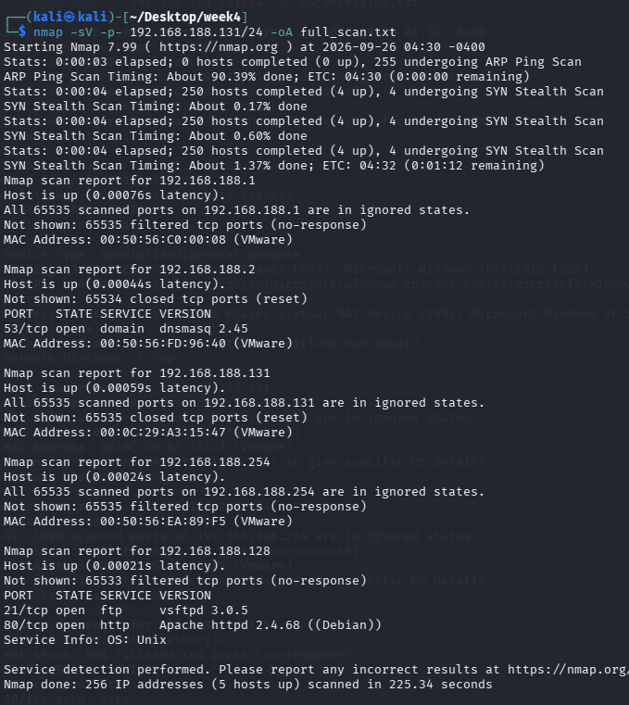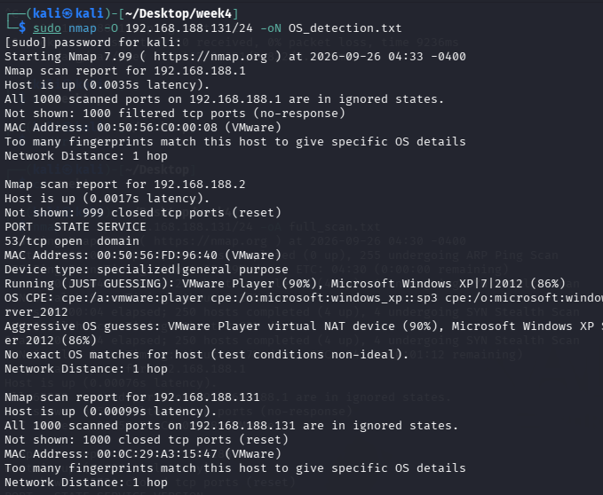
Nmap Findings
Open Ports
Port | Service | Risk
21 | ftp | Medium
53 | Domain | Medium
80 | HTTP | Medium

Observations
- DNS service was available on port 53.
- FTP service was available on port 21.
- Apache HTTP service was available on port 80.
- Nmap successfully detected the running services and open ports.

Wireshark Traffic Analysis
Packet Capture
Wireshark was used on Kali Linux to capture network traffic.
During capture:
- Apache webpage was opened.
- Ping was executed.
- DNS requests were generated.
The captured traffic included:
- HTTP
- DNS
- ICMP
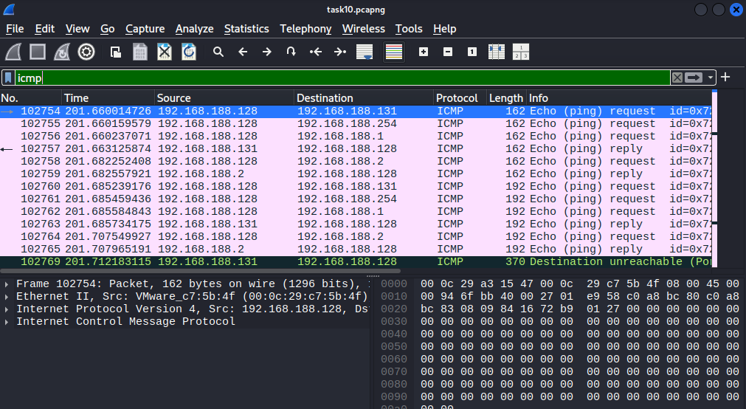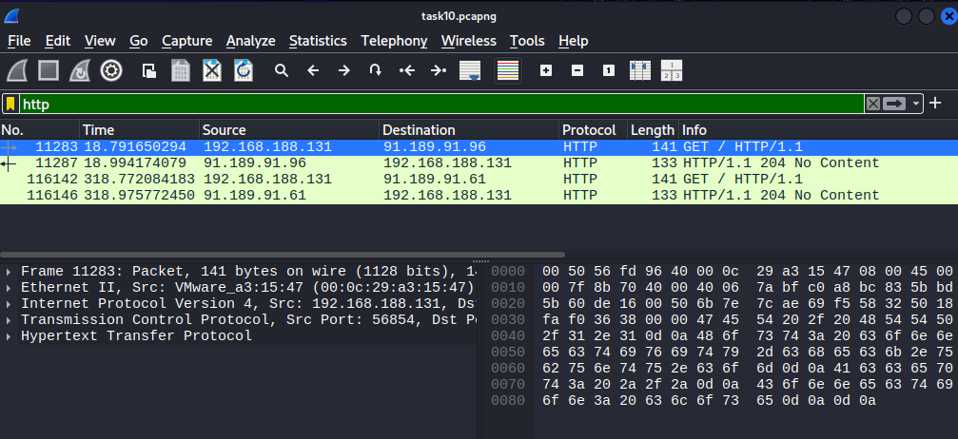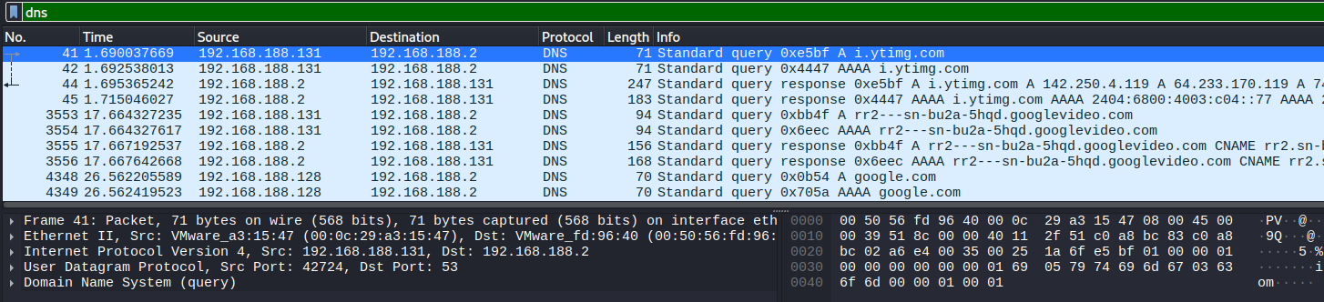
Learning Outcomes and References
Learning Outcomes: -
During this lab I learned:
- How to create a virtual network in VMware.
- How to connect multiple virtual machines.
- How to install and configure Apache.
- How to perform Nmap scanning.
- How to identify open ports and services.
- How to capture network traffic using Wireshark.
- How to analyze HTTP, DNS, and ICMP packets.
- How to save scan results and packet capture files.
References: -
- Nmap Official Documentation https://nmap.org/docs.html
- Wireshark Official Documentation https://www.wireshark.org/docs/relnotes/
- Apache HTTP Server Documentation https://httpd.apache.org/docs/
- Ubuntu Documentation https://ubuntu.com/desktop/docs/en/latest/
- Kali Linux Documentation https://www.kali.org/docs/

Conclusion
- Successfully created a virtual network using VMware.
- Connected Kali Linux and Ubuntu Server on the same network.
- Verified network connectivity using the ping command.
- Installed and configured the Apache Web Server on Ubuntu.
- Confirmed that the web server was running properly.
- Used Nmap to identify open ports on the target machine.
- Detected running services such as Domain and Apache.
- Captured network traffic using Wireshark.
- Analyzed HTTP, DNS, and ICMP packets during communication.
- Gained practical experience in basic network security testing and traffic analysis in a safe lab environment.

