

Student Name: -Kumbhar Dilip
College Name: - Indus University
Internship: - Cyber Security Internship
Organization: - DG Intern Hub
Week 6 Assignment: - Web Security & Vulnerability Testing (VAPT Basics)
SID: - dg/September/cyber/264
Mail: - dilipkumbhar.dginternshub@gmail.com
Task 6: - Theory + Practical

S. No. | Section Title | Description / Contents
01 | Cover Page | Project title, name, internship details, and submission date.
02 | Introduction to VAPT | Definition, purpose, importance, and VAPT workflow.
03 | Tools Used | Burp Suite, OWASP ZAP, DVWA.
04 | Lab Setup | System requirements, local URL, configuration, and security level.
05 | OWASP Vulnerability Notes | SQL Injection, Cross-Site Scripting (XSS), broken authentication, and security misconfiguration.
06 | SQL Injection Testing | Testing methodology, test input, actual output, and screenshot evidence.
07 | Reflected XSS Testing | Testing steps, payload, observed result, and screenshot evidence.
08 | Stored XSS Testing | Testing steps, persistence verification, observed result, and screenshot evidence.
09 | Burp Suite Analysis | Captured HTTP requests and responses with sensitive information redacted.
10 | OWASP ZAP Scan | Scan procedure, alert summary, and exported report.
11 | Findings and Mitigation | Evidence, risk level, impact, recommended fixes, and retest results.
12 | Conclusion and References | Learning outcomes, limitations, official documentation, and references.

What is VAPT?
VAPT stands for Vulnerability Assessment and Penetration Testing. It is a cybersecurity process used to identify security weaknesses in websites, applications, networks, and systems.
- Vulnerability Assessment: Identifies and evaluates potential security weaknesses.
- Penetration Testing: Safely tests whether identified weaknesses can be exploited within an authorized scope.
- Purpose: To improve security and reduce the risk of data theft, unauthorized access, and attacks.
Why is VAPT important?
- Identifies security weaknesses before attackers exploit them.
- Helps protect sensitive information.
- Improves application security.
- Supports security compliance and risk management.
- Helps developers fix vulnerabilities.

Basic VAPT workflow
1. Define scope and obtain authorization
2. Set up the testing environment
3. Identify potential vulnerabilities
4. Validate findings safely
5. Assess risks and impacts
6. Recommend fixes and retest
Tools Used
Explain the purpose of each tool you used in the project.

1. Burp Suite Community Edition
Burp Suite helps inspect communication between a browser and a web application. Its Proxy and HTTP history features allow testers to examine requests, parameters, cookies, and responses.

2. OWASP ZAP
ZAP is a web application security testing tool. It can crawl pages, identify potential security issues, show risk alerts, and generate reports.
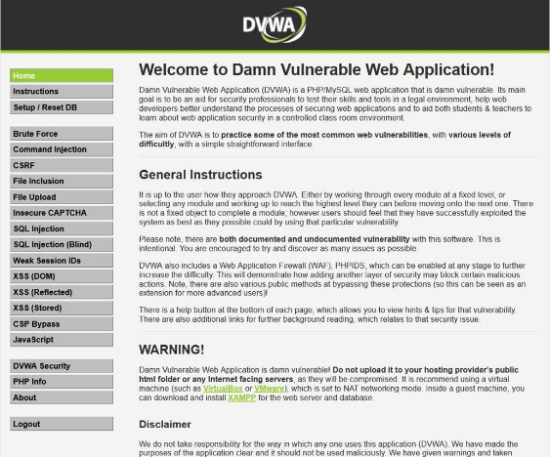
3. DVWA
Damn Vulnerable Web Application is an intentionally vulnerable application designed for learning and practicing web security testing in a controlled environment.
Lab Setup
What is a testing lab?
A testing lab is a controlled environment in which you can practice security testing without affecting real users or production systems.
Lab setup procedure
- Installed Docker or XAMPP on the computer.
- Installed DVWA and started the required services.
- Opened DVWA in a web browser.
- Installed Burp Suite Community Edition and OWASP ZAP.
- Configured the browser to send traffic through Burp Suite.
- Selected DVWA's Low security level for introductory testing.
Example lab configuration
Component | Configuration
Operating system | Linux(Kali Linux)
Web application | DVWA
Web browser | Burp's built-in browser
Proxy tool | Burp Suite Community Edition
Scanner | OWASP ZAP
Docker DVWA URL | http://127.0.0.1:42001
Security level | Low
Change the details to match your actual environment. The URL above applies to the Docker setup described earlier; an XAMPP installation may use a different URL.

OWASP Vulnerability Notes
OWASP provides guidance on common web application security risks. This project focuses on four important topics.
1. SQL Injection (SQLi)
SQL Injection happens when untrusted input changes the intended database query. It may expose information or allow unauthorized database operations.
Prevention: Use parameterized queries, validate input, and restrict database permissions.
2. Cross-Site Scripting (XSS)
XSS occurs when untrusted content is handled in a way that allows scripts to execute in a user's browser.
- Reflected XSS: Input is reflected in the immediate response.
- Stored XSS: Content is stored and rendered later.
Prevention: Apply context-aware output encoding, safe templating, and suitable sanitization.
3. Broken Authentication
Authentication weaknesses may allow unauthorized users to access accounts, particularly when login or session controls are inadequate.
Prevention: Use multi-factor authentication, strong password controls, secure session management, and login throttling.
4. Security Misconfiguration
This occurs when applications or servers use insecure settings, such as default credentials, exposed debugging information, or unnecessary services.
Prevention: Apply security updates, disable unnecessary services, remove defaults, and use secure configuration settings.

SQL Injection Testing
Objective
To understand how specially crafted input can affect database query behavior in a vulnerable application.
Testing procedure
- Log in to DVWA using valid credentials.
- Intercept and inspect login requests using Burp Suite.
- Navigate to the SQL Injection vulnerability module.
- Enter the SQL injection payload into User ID.
- Submit the payload and observe returned user records.
- Analyse unauthorized database access and query manipulation risks.
- Recommend prepared statements and proper input validation.
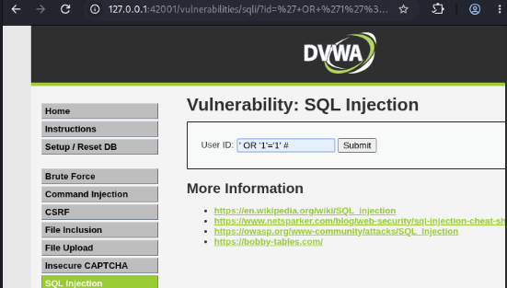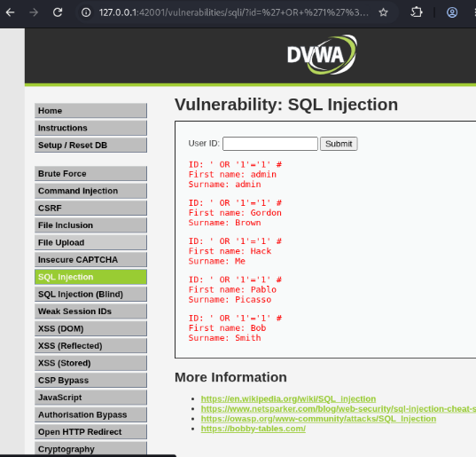
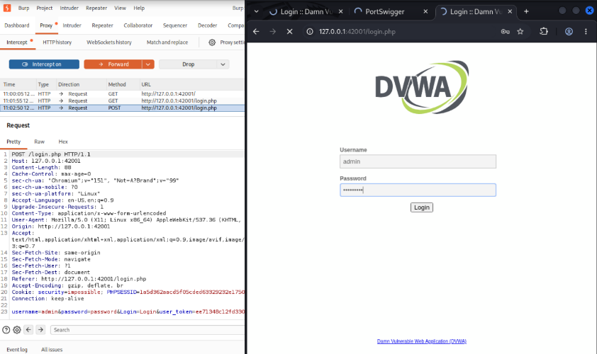

Reflected XSS Testing
Objective
To test whether the application safely handles input that is immediately returned in the response.
Testing procedure
- Open DVWA.
- Select XSS (Reflected).
- Enter a normal value and observe the output.
- In the local lab, enter the assigned harmless XSS test payload.
- Submit the form.
- Observe whether the input is displayed as text or executes as a script.
- Capture the result.
Example test payload:
<script>alert('XSS’) </script>
Observation
If a browser alert appears because the submitted input is interpreted as executable JavaScript, that supports the finding of reflected XSS in the tested context. If it is blocked or displayed as text, record that result accurately.
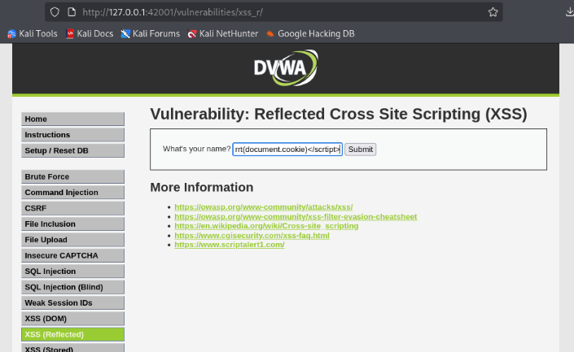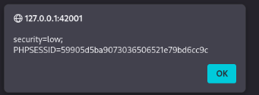
Stored XSS Testing
Objective
To determine whether submitted content is stored and later rendered unsafely.
Testing procedure
- Open DVWA's XSS (Stored) module.
- Locate the guestbook or message form.
- Enter a normal message and observe how it appears.
- In the local lab, submit the assigned harmless XSS test payload.
- Check whether the content appears in the guestbook.
- Reload the page and check whether the entry persists.
- Record whether the content executes, is safely displayed, or is blocked.
Observation
Stored XSS differs from reflected XSS because the submitted content may be saved and delivered to users on subsequent visits.
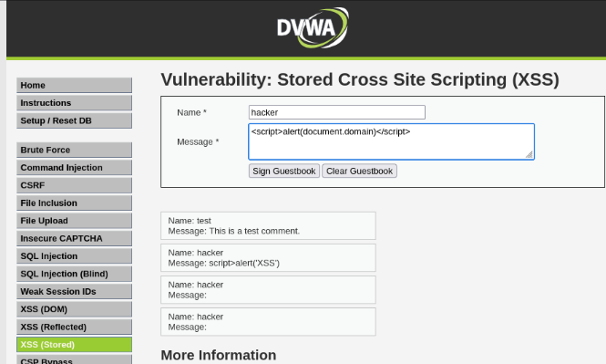
Burp Suite Analysis
Objective
To inspect the HTTP communication generated during SQL Injection and XSS testing.
Testing procedure
- Start Burp Suite.
- Open the browser configured to use Burp.
- Open DVWA and submit a test form.
- Select Proxy → HTTP history.
- Find and select the relevant request.
- Review the Request and Response panels.
- Record the method, URL, parameters, response status, and relevant output.
What to explain in your report
Item | Meaning
HTTP method | Indicates the request type, such as GET or POST
URL and parameters | Identify the page and submitted values
Headers | Provide request and response metadata
Cookies | May maintain a login session
Response status | Indicates the HTTP result, such as 200 OK
Response body | Contains the returned page or application data
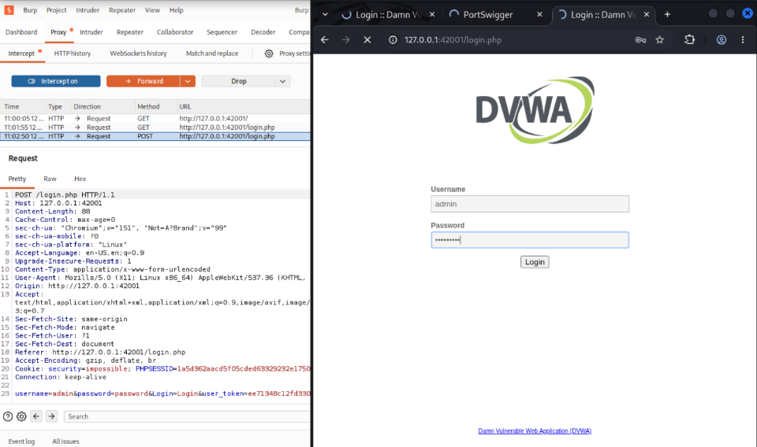

OWASP ZAP Scan
Objective
To identify potential web application security issues using an automated scan of the local DVWA lab.
Testing procedure
- Start DVWA and verify that it is accessible.
- Launch OWASP ZAP.
- Enter the local DVWA URL in Quick Start.
- Start the scan.
- Wait for crawling and scanning to finish.
- Open the Alerts tab.
- Review each alert, affected URL, risk level, evidence, and remediation advice.
- Export the report in an available format such as HTML or PDF.
Example findings summary
The table below shows how to organize results. Replace the examples with the alerts actually found by your scan.
Finding | Risk | Action
Missing security header | Often Low or Informational, depending on context | Review and configure the header
Potential information disclosure | Depends on evidence and impact | Remove unnecessary details
Potential injection issue | Requires validation | Review query construction and test evidence
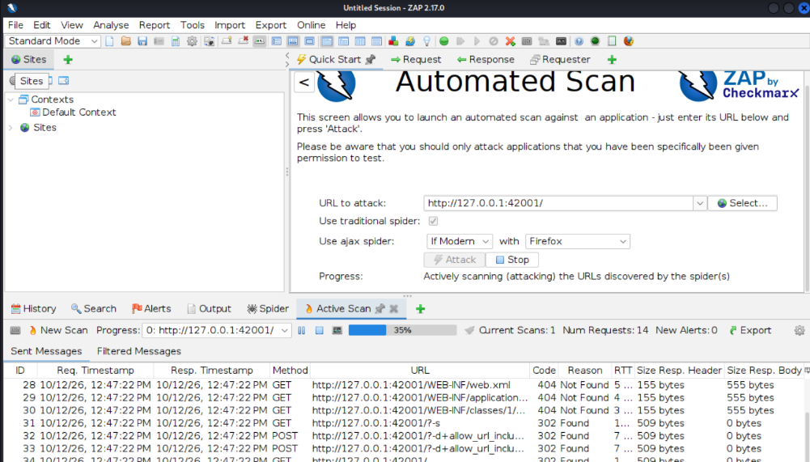

Findings, Risk Levels, and Mitigation
This page summarizes what you discovered and how each issue can be fixed.
Understanding risk levels
Level | Meaning
Critical | Severe impact with significant potential for compromise
High | Serious weakness that could cause substantial damage
Medium | Meaningful risk that needs remediation
Low | Lower-impact weakness
Informational | Observation that may help with security assessment
Risk must be based on actual evidence, impact, exploitability, and the testing context. Do not assign a High or Critical rating automatically just because a tool displays an alert.
Findings report table
Vulnerability | Evidence | Mitigation
SQL Injection | Actual DVWA output and request | Parameterized queries
Reflected XSS | Actual response and browser behavior | Context-aware output encoding
Stored XSS | Stored content and reload result | Safe output rendering
Security misconfiguration | Validated ZAP alert or manual evidence | Secure configuration and patching
Broken authentication | Test evidence, if tested | MFA and secure session controls
For each row, include the actual severity, affected URL, impact, recommended fix, and retest result. If a test was not performed, write Not tested. If the evidence is insufficient, write Inconclusive.
Retesting
After applying a fix, repeat the relevant test to verify that the issue no longer occurs and that the change has not broken normal functionality.
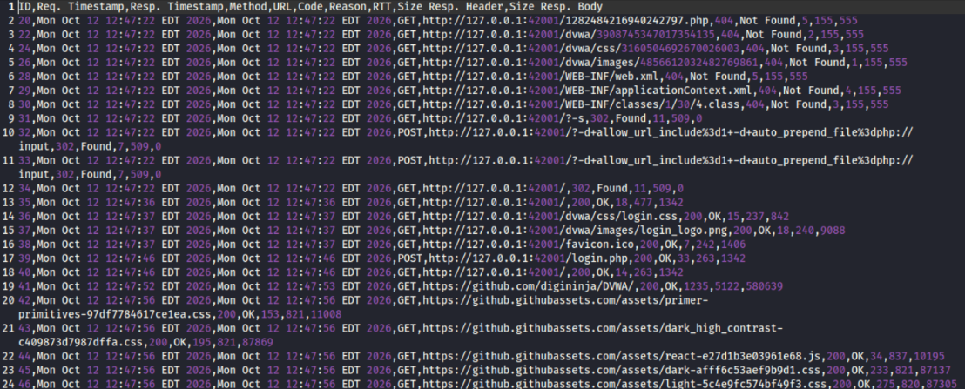
Conclusion
During this project, I learned the fundamentals of web application security testing and the purpose of Vulnerability Assessment and Penetration Testing. I studied SQL Injection, Cross-Site Scripting, Broken Authentication, and Security Misconfiguration. I practiced testing in DVWA, inspected HTTP requests and responses using Burp Suite, and reviewed potential vulnerabilities using OWASP ZAP. I learned how to document evidence, understand risk levels, and recommend security improvements. This project helped me understand the importance of secure coding, regular testing, and proper configuration. I also learned that findings must be validated before they are reported as confirmed vulnerabilities. Overall, this project improved my practical understanding of web security and basic VAPT workflows.
References
Use official documentation for the tools and security concepts used in your project.
- OWASP Top 10: OWASP Top 10
- DVWA: DVWA official GitHub repository
- Burp Suite: Burp Suite documentation
- OWASP ZAP: OWASP ZAP documentation

