**DBMS Assignment 5**

**Riya Chaudhary**

**17070122056**

**CS3**

1. Give library wise book details.

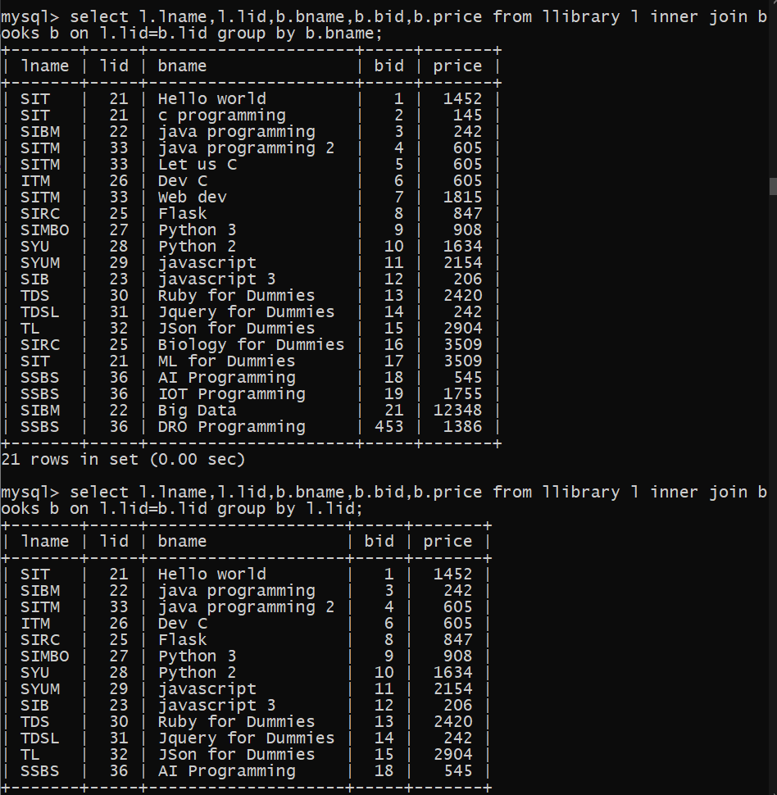

2. Give bookwise total copies which are available.

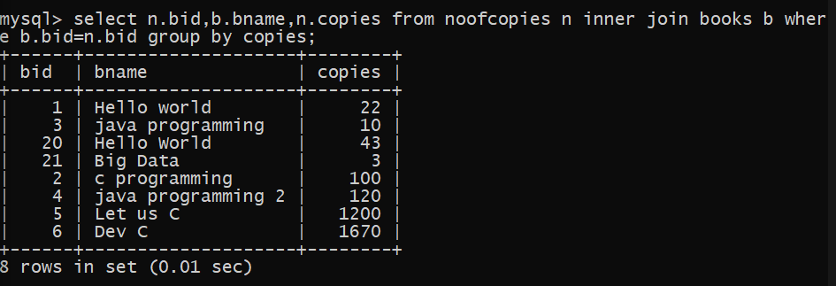

3. Which library has total copies more than 100?

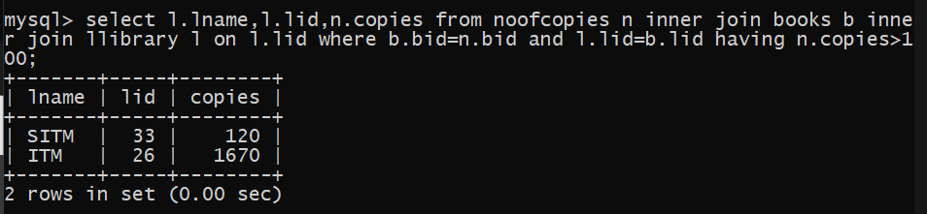

4. Give institute wise department details.

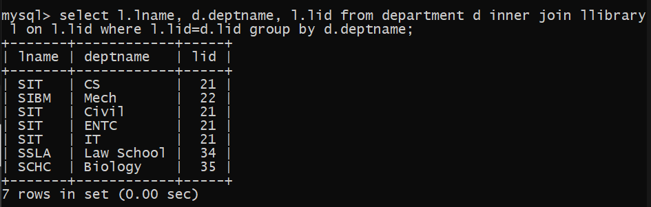

5. Give citywise seller details.

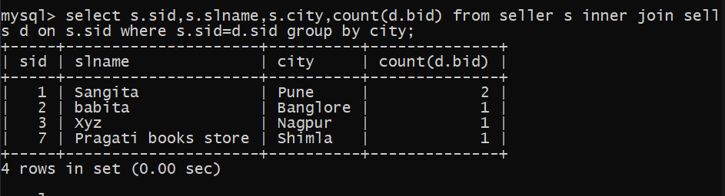

6. Give author wise book details that have authored more than 2 books.

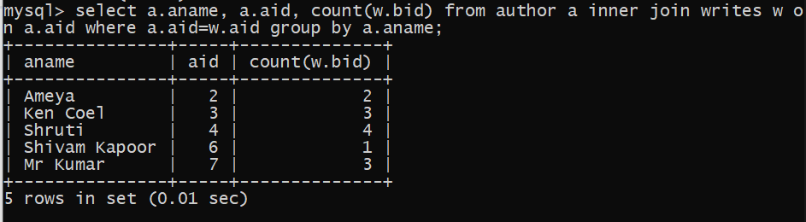

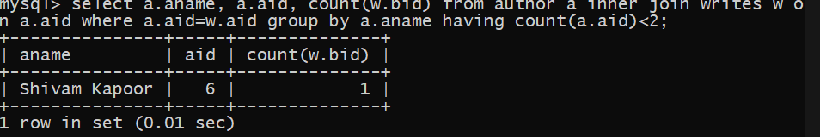

7. Give book details library wise whose price is less than 1000

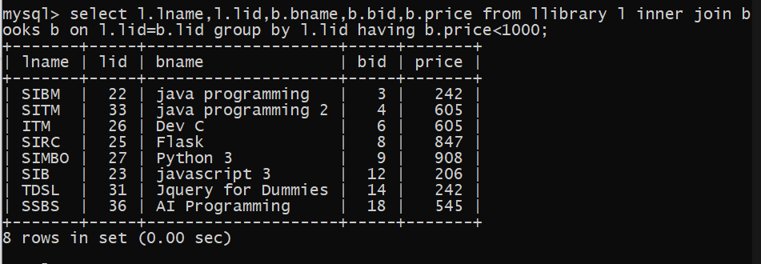

8. Give department wise staff details

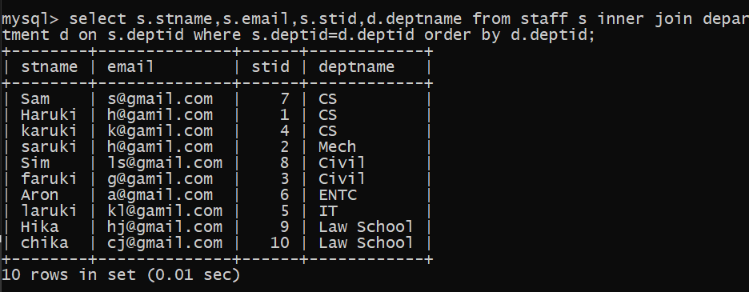

9. How many books are issued library wise

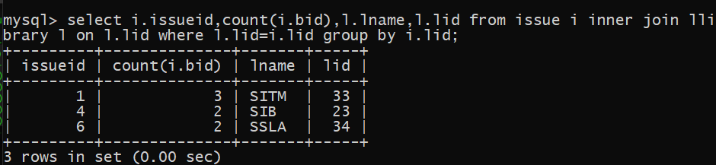

10. Give purchase details publisher wise.

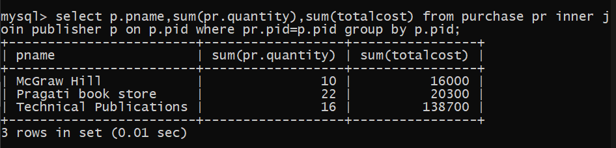

11. Display books in a descending order of their cost.

