**DBMS Assignment 6**

**Riya Chaudhary**

**17070122056**

**CS3**

1. Students in the IT department.

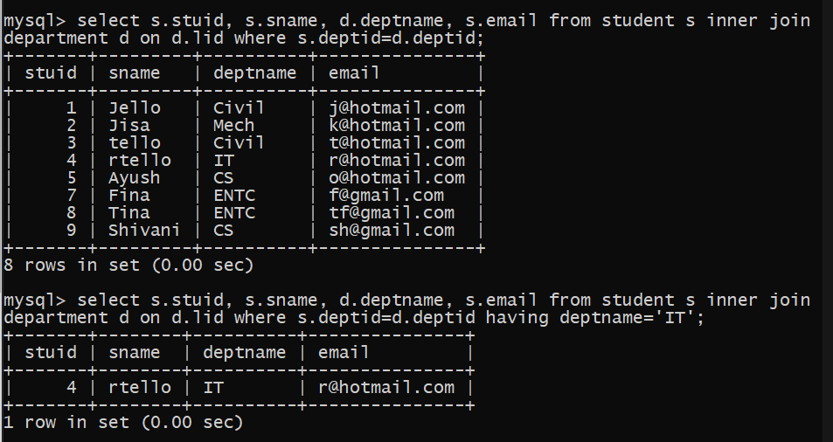

1. Books in SIT library.

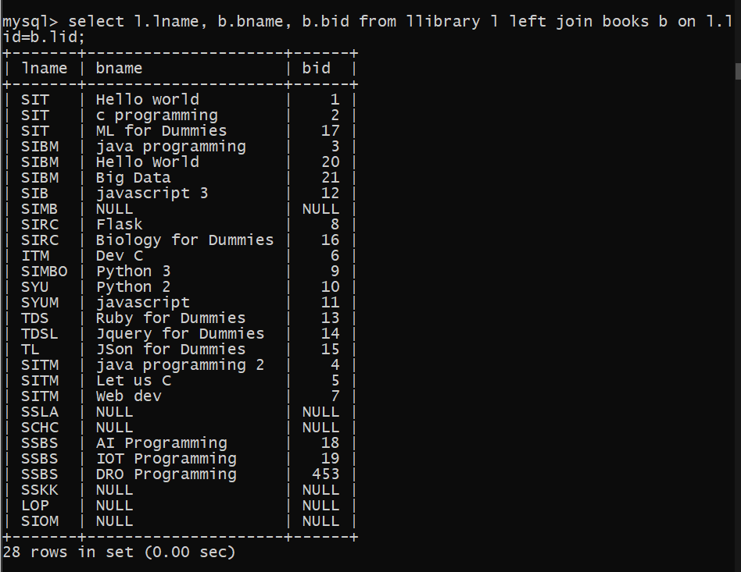

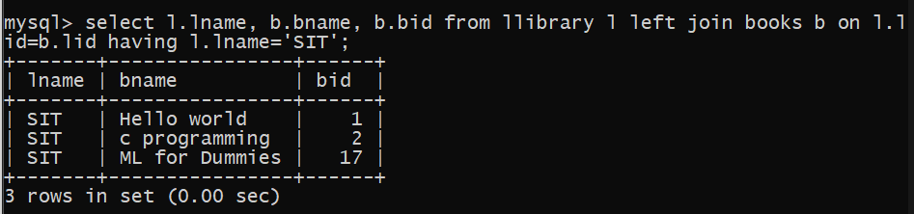

3. Books with less than 3 copies in SIT Library.

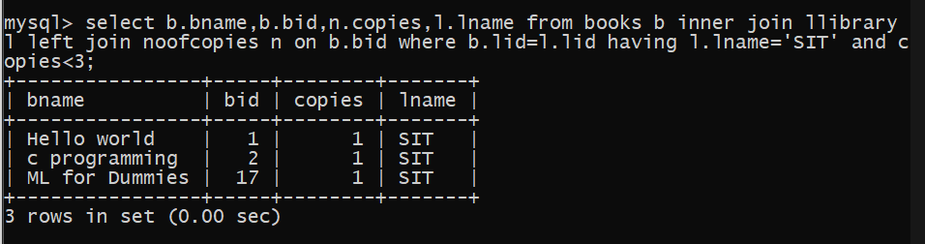

4. Sellers in the same city as SIT.

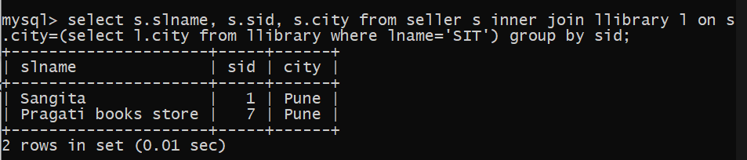

5. Sellers selling books to SIT.

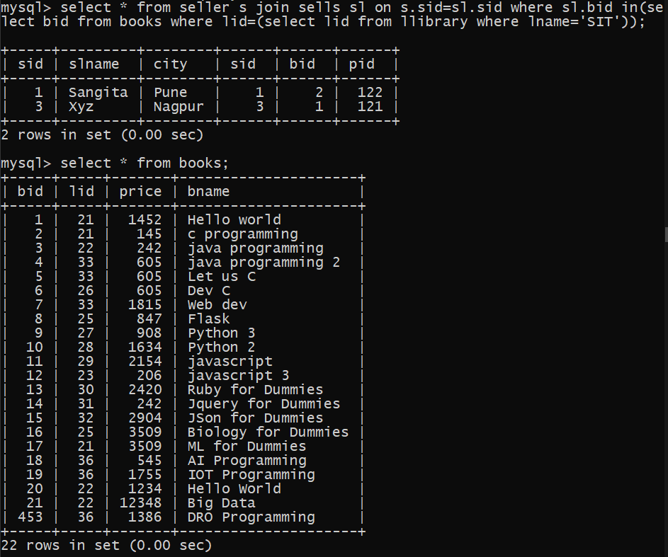

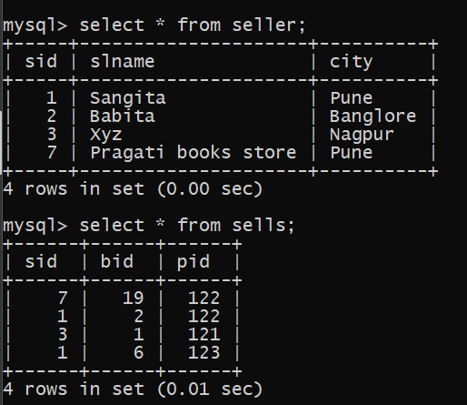

6. Books authored by Brian Kernighan, and published by Tata McGraw Hill.

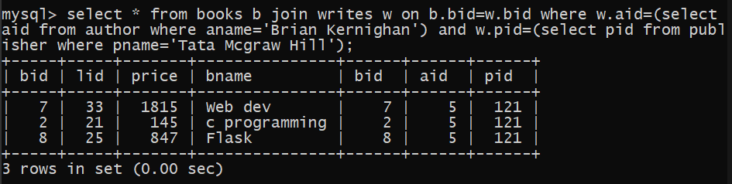

7. Books authored by Ken Thompson.

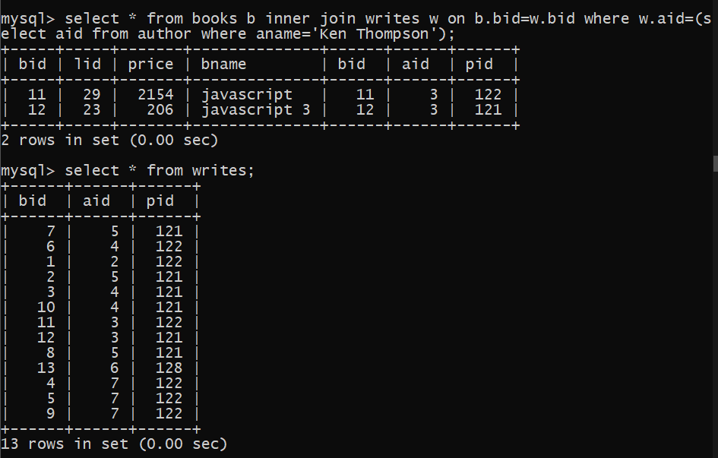

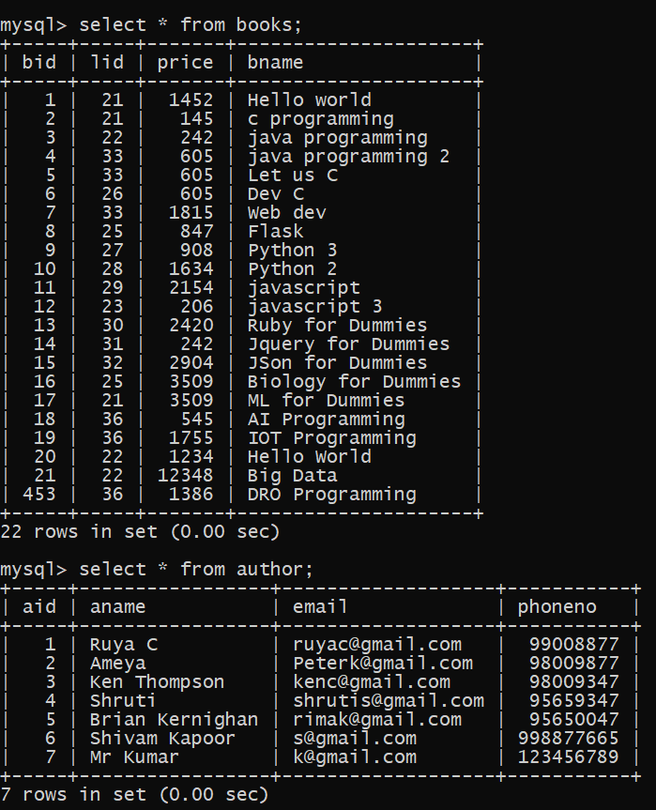

8. Books issued by Mayank.

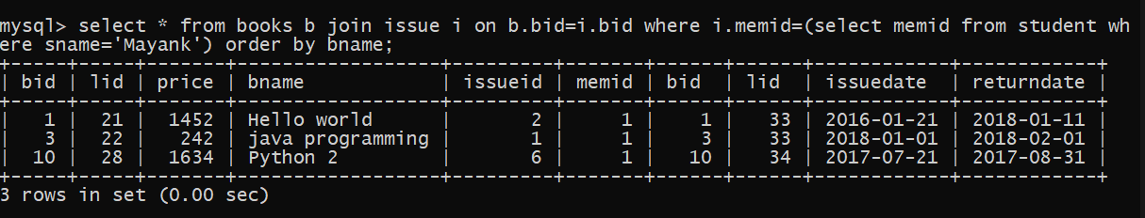 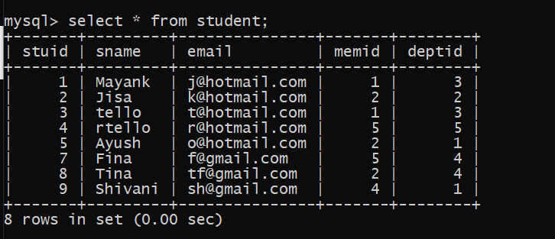

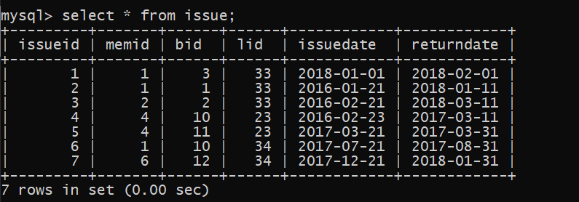

9. Books issued by SLS staff.

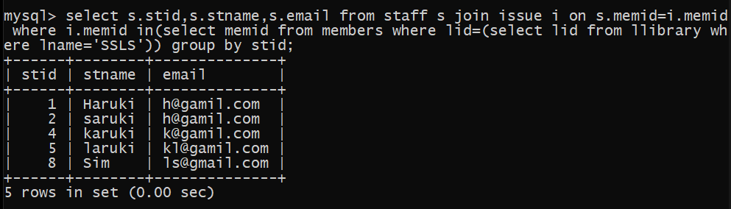 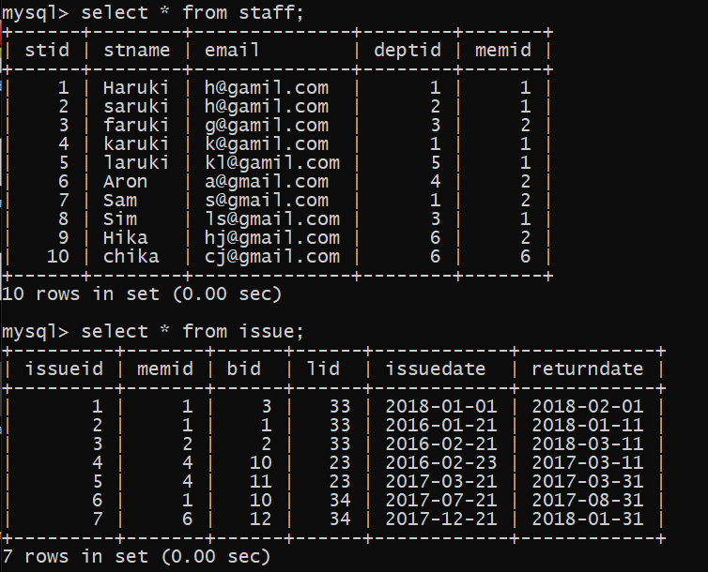

10. Publisher that provides books to SSBS through College Book Store.

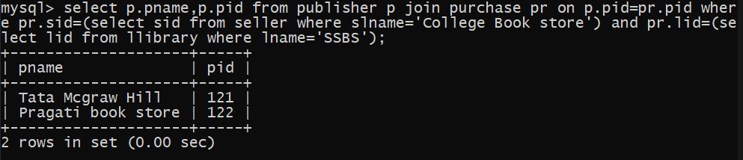

11. Institutes whose staff and students have issued book with bid 4444.

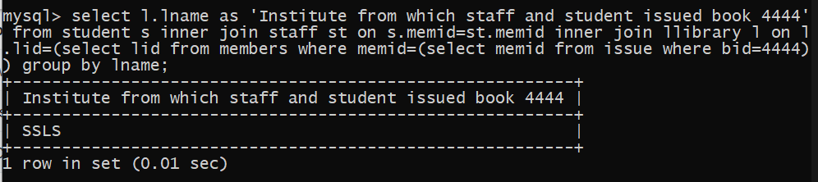

12. Sellers selling to libraries in the same city.

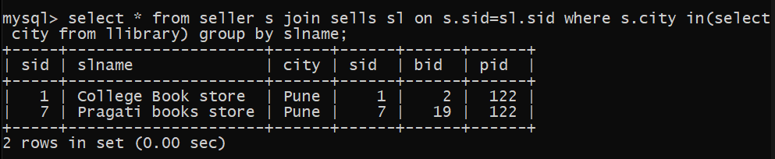

13. Authors with books costing more than rs 500.

