**Selenium Locators Assignment:**

**Problem 1**- Open <https://www.phptravels.net/hotels> website and locate the following and Write xpath.

* PHPTRAVLES Logo
* Home
* Flights
* Tours
* Company
* Signup Btn
* Login Btn
* Agents DropDown

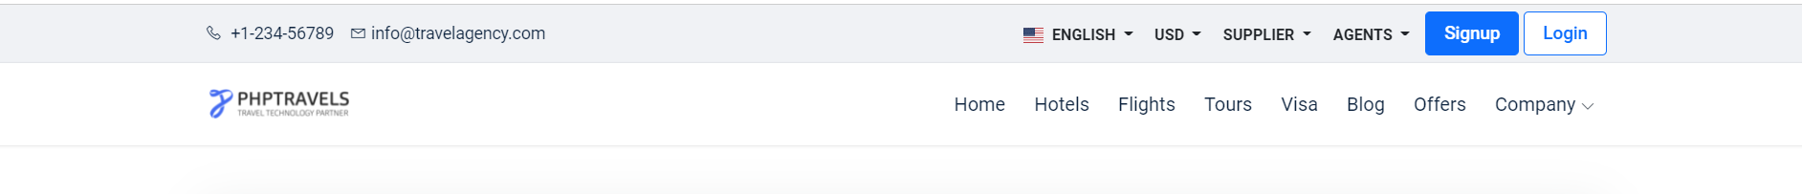

*Note - You have to use Id, Name, Class, CSS Selector, TagName and write Relative and absolute xpath*

**Problem 2**- Write **Xpath** for Below Web elements using Xpath Axes (such as preceding, following, ancestor, following-sibling etc..)

* Check in - Calendar Icon
* Check Out – Calendar Icon
* “- ” for Adults
* “+” for Adults
* “-“ for Childs
* “+” for Childs

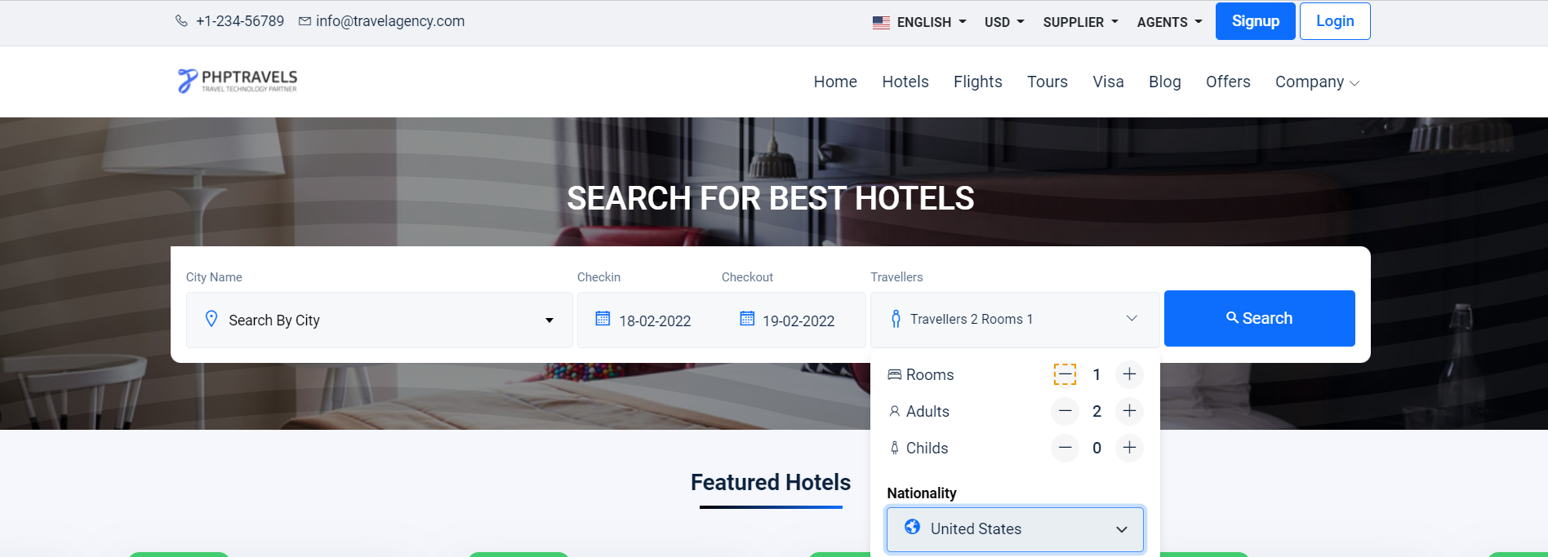

**Note : Don’t Use Indexes**

Solution 1:

RELATIVE XPATH

- PHPTRAVLES LOGO

//header/div[2]/div[1]/div[1]/div[1]/div[1]/div[1]/a[1]/img[1]

-HOME

//a[contains(text(),'Home')]

-FLIGHTS

//a[contains(text(),'flights')]

-TOURS

//a[contains(text(),'Tours')]

-COMPANY

//header/div[2]/div[1]/div[1]/div[1]/div[1]/div[2]/nav[1]/ul[1]/li[8]/a[1]

-SIGNUP BUTTON

//header/div[1]/div[1]/div[1]/div[2]/div[1]/div[1]/a[1]

-LOGIN BUTTON

//header/div[1]/div[1]/div[1]/div[2]/div[1]/div[1]/a[2]

-AGENTS DROP DOWN

//button[@id='agents']

ABSOLUTE XPATH

-PHPTAVLES LOGO

|  |
| --- |
| /html[1]/body[1]/header[1]/div[2]/div[1]/div[1]/div[1]/div[1]/div[1]/a[1]/img[1]  -HOME |
| /html[1]/body[1]/header[1]/div[2]/div[1]/div[1]/div[1]/div[1]/div[2]/nav[1]/ul[1]/li[1]/a[1]  -FLIGHTS |
| /html[1]/body[1]/header[1]/div[2]/div[1]/div[1]/div[1]/div[1]/div[2]/nav[1]/ul[1]/li[3]/a[1]  -TOURS |
| /html[1]/body[1]/header[1]/div[2]/div[1]/div[1]/div[1]/div[1]/div[2]/nav[1]/ul[1]/li[4]/a[1]  COMPANY |
| /html[1]/body[1]/header[1]/div[2]/div[1]/div[1]/div[1]/div[1]/div[2]/nav[1]/ul[1]/li[8]/a[1]  SIGN UP BUTTON |
| /html[1]/body[1]/header[1]/div[1]/div[1]/div[1]/div[2]/div[1]/div[1]/a[1]  -LOGIN BUTTON |
| /html[1]/body[1]/header[1]/div[1]/div[1]/div[1]/div[2]/div[1]/div[1]/a[2]  -AGENT DROP DOWN |
| /html[1]/body[1]/header[1]/div[1]/div[1]/div[1]/div[2]/div[1]/div[1]/div[4]/div[1]/button[1] |
|  |