**WEBSITE**

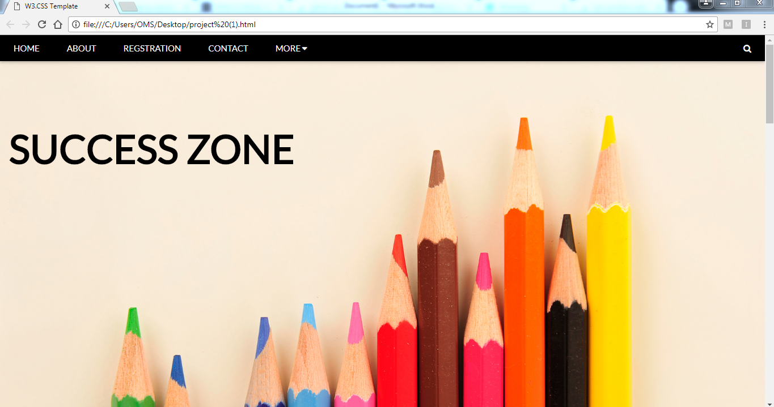

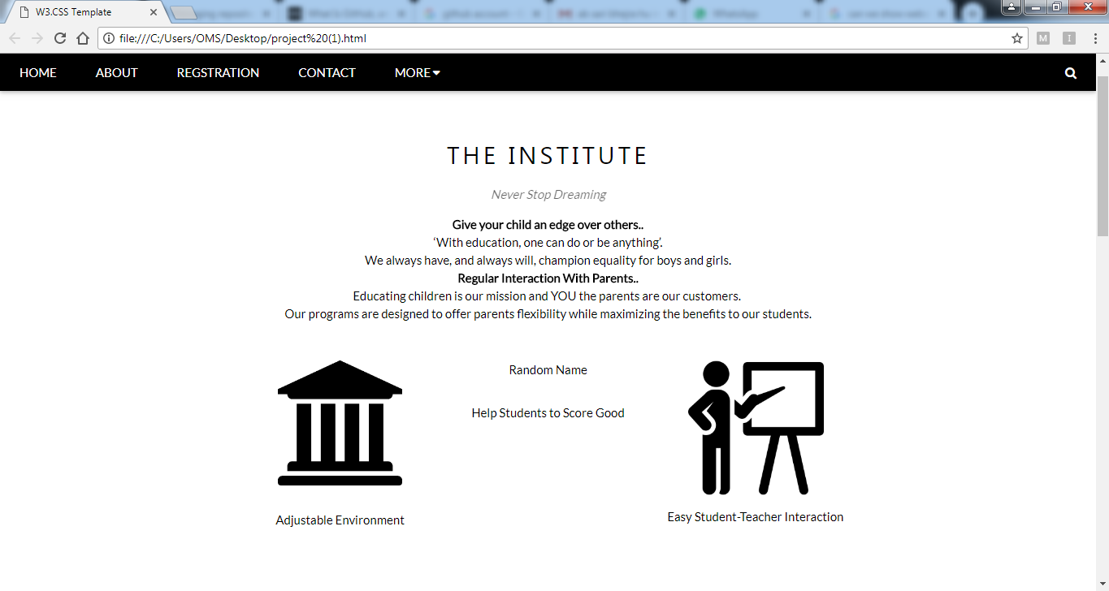

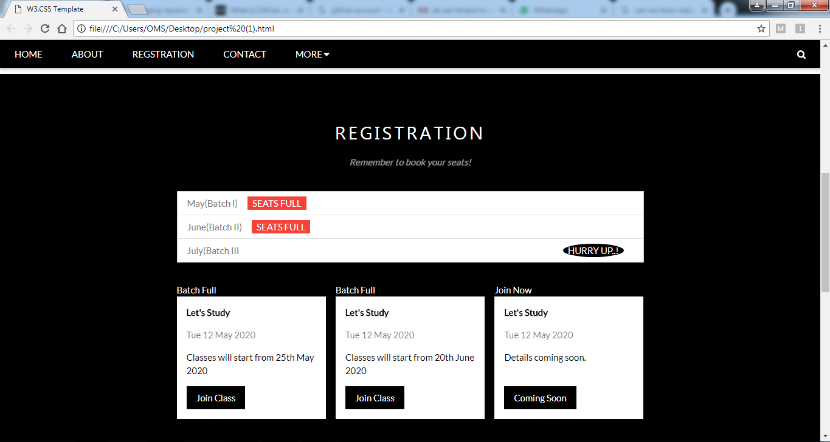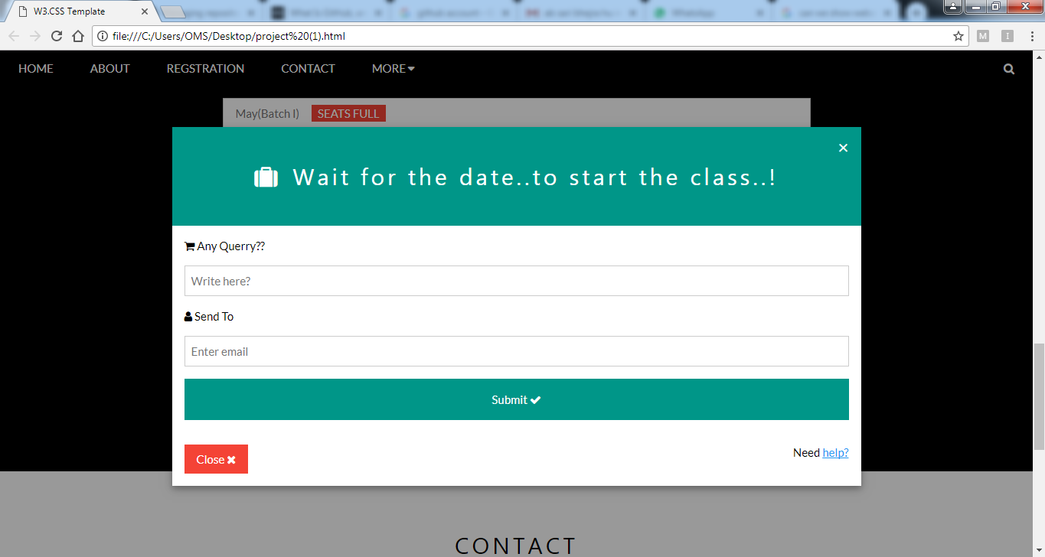

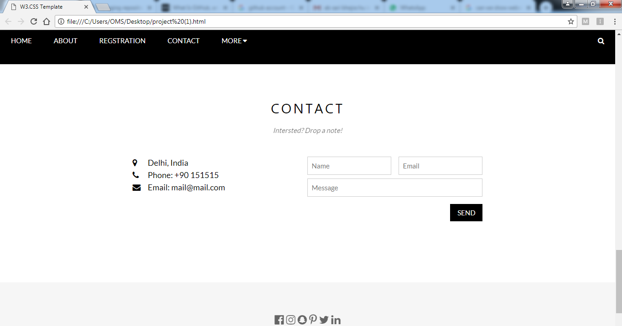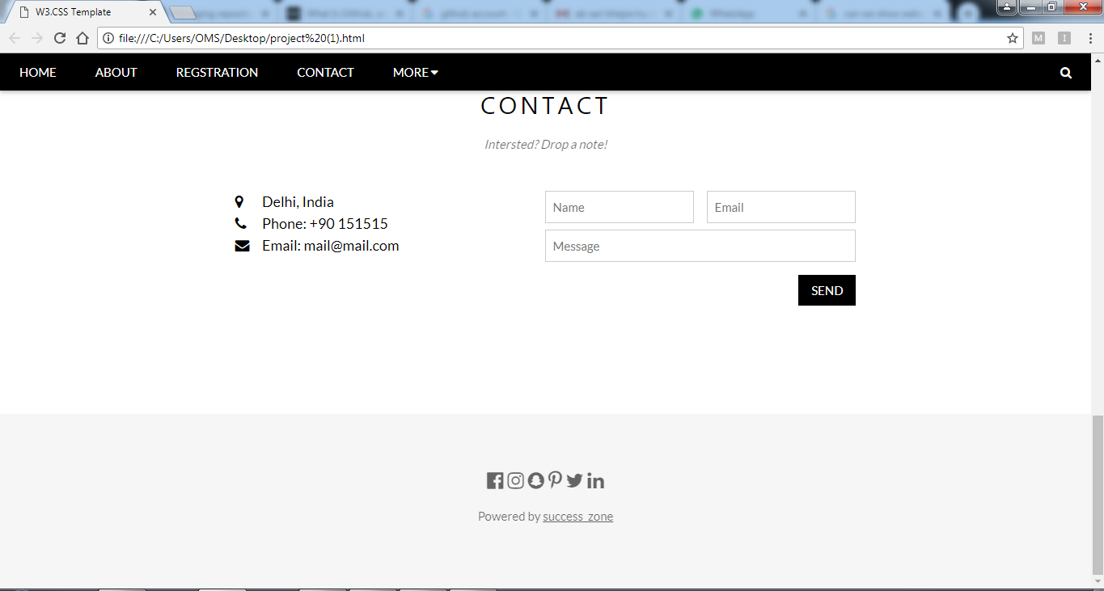

**CODE**

<!DOCTYPE html>

<html lang="en">

<title>W3.CSS Template</title>

<meta charset="UTF-8">

<meta name="viewport" content="width=device-width, initial-scale=1">

<link rel="stylesheet" href="https://www.w3schools.com/w3css/4/w3.css">

<link rel="stylesheet" href="https://fonts.googleapis.com/css?family=Lato">

<link rel="stylesheet" href="https://cdnjs.cloudflare.com/ajax/libs/font-awesome/4.7.0/css/font-awesome.min.css">

<style>

body {font-family: "Lato", sans-serif}

.mySlides {display: none}

</style>

<body>

<!-- Navbar -->

<div class="w3-top">

<div class="w3-bar w3-black w3-card">

<a class="w3-bar-item w3-button w3-padding-large w3-hide-medium w3-hide-large w3-right" href="javascript:void(0)" onclick="myFunction()" title="Toggle Navigation Menu"><i class="fa fa-bars"></i></a>

<a href="#" class="w3-bar-item w3-button w3-padding-large">HOME</a>

<a href="#band" class="w3-bar-item w3-button w3-padding-large w3-hide-small">ABOUT</a>

<a href="#tour" class="w3-bar-item w3-button w3-padding-large w3-hide-small">REGSTRATION</a>

<a href="#contact" class="w3-bar-item w3-button w3-padding-large w3-hide-small">CONTACT</a>

<div class="w3-dropdown-hover w3-hide-small">

<button class="w3-padding-large w3-button" title="More">MORE <i class="fa fa-caret-down"></i></button>

<div class="w3-dropdown-content w3-bar-block w3-card-4">

<a href="f.html" class="w3-bar-item w3-button">FACULTIES</a>

<a href="Cur.html" class="w3-bar-item w3-button">CURRICULUM</a>

<a href="#" class="w3-bar-item w3-button">SYLLABUS</a>

</div>

</div>

<a href="javascript:void(0)" class="w3-padding-large w3-hover-red w3-hide-small w3-right"><i class="fa fa-search"></i></a>

</div>

</div>

<!-- Navbar on small screens (remove the onclick attribute if you want the navbar to always show on top of the content when clicking on the links) -->

<div id="navDemo" class="w3-bar-block w3-black w3-hide w3-hide-large w3-hide-medium w3-top" style="margin-top:46px">

<a href="#band" class="w3-bar-item w3-button w3-padding-large" onclick="myFunction()">ABOUT</a>

<a href="#tour" class="w3-bar-item w3-button w3-padding-large" onclick="myFunction()">SYLLABUS</a>

<a href="#contact" class="w3-bar-item w3-button w3-padding-large" onclick="myFunction()">CONTACT</a>

<a href="#" class="w3-bar-item w3-button w3-padding-large" onclick="myFunction()">More</a>

</div>

<!-- Page content -->

<div class="w3-content" style="max-width:2000px;margin-top:46px">

<!-- Automatic Slideshow Images -->

<div class="mySlides w3-display-container w3-center">

<img src="r.jpg" style="width:100%">

<div class="w3-display-topleft w3-container w3-text-white w3-padding-32 w3-hide-small">

<h2></h2>

<p style="font-size:70px"><b>SUCCESS ZONE</b></p>

</div>

</div>

<div class="mySlides w3-display-container w3-center">

<img src="books.jpg" style="width:100%">

<div class="w3-display-topleft w3-container w3-text-white w3-padding-32 w3-hide-small">

<h2></h2>

<p style="font-size:70px"><b>SUCCESS ZONE</b></p>

</div>

</div>

<div class="mySlides w3-display-container w3-center">

<img src="8.jpeg" style="width:100%">

<div class="w3-display-topleft w3-container w3-text-black w3-padding-32 w3-hide-small">

<h2></h2>

<p style="font-size:70px"><b>SUCCESS ZONE</b></p>

</div>

</div>

<!-- The Band Section -->

<div class="w3-container w3-content w3-center w3-padding-64" style="max-width:800px" id="band">

<h2 class="w3-wide">THE INSTITUTE</h2>

<p class="w3-opacity"><i>Never Stop Dreaming<br></i></p>

<p class="w3-justify"><p><b>Give your child an edge over others..</b><br>

‘With education, one can do or be anything’.<br>

We always have, and always will, champion equality for boys and girls.<br>

<b>Regular Interaction With Parents..</b><br>

Educating children is our mission and YOU the parents are our customers. <br>

Our programs are designed to offer parents flexibility while maximizing the benefits to our students.

</p>

<div class="w3-row w3-padding-32">

<div class="w3-third">

<img src="uni.png" class="w3-round w3-margin-bottom" alt="Random Name" style="width:60%">

<p>Adjustable Environment</p>

</div>

<div class="w3-third">

<img src="s.jpeg" class="w3-round w3-margin-bottom" alt="Random Name" style="width:60%">

<p>Help Students to Score Good</p>

</div>

<div class="w3-third">

<img src="t.png" class="w3-round" alt="Random Name" style="width:65%">

<p>Easy Student-Teacher Interaction</p>

</div>

</div>

</div>

<!-- The Tour Section -->

<div class="w3-black" id="tour">

<div class="w3-container w3-content w3-padding-64" style="max-width:800px">

<h2 class="w3-wide w3-center">REGISTRATION</h2>

<p class="w3-opacity w3-center"><i>Remember to book your seats!</i></p><br>

<ul class="w3-ul w3-border w3-white w3-text-grey">

<li class="w3-padding">May(Batch I)<span class="w3-tag w3-red w3-margin-left">SEATS FULL</span></li>

<li class="w3-padding">June(Batch II)<span class="w3-tag w3-red w3-margin-left">SEATS FULL</span></li>

<li class="w3-padding">July(Batch III <span class="w3-badge w3-right w3-margin-right">HURRY UP..!</span></li>

</ul>

<div class="w3-row-padding w3-padding-32" style="margin:0 -16px">

<div class="w3-third w3-margin-bottom">

<img src="/w3images/newyork.jpg" alt="Batch Full" style="width:100%" class="w3-hover-opacity">

<div class="w3-container w3-white">

<p><b>Let's Study</b></p>

<p class="w3-opacity">Tue 12 May 2020</p>

<p>Classes will start from 25th May 2020</p>

<button class="w3-button w3-black w3-margin-bottom" onclick="document.getElementById('ticketModal').style.display='block'">Join Class</button>

</div>

</div>

<div class="w3-third w3-margin-bottom">

<img src="/w3images/paris.jpg" alt="Batch Full" style="width:100%" class="w3-hover-opacity">

<div class="w3-container w3-white">

<p><b>Let's Study</b></p>

<p class="w3-opacity">Tue 12 May 2020</p>

<p>Classes will start from 20th June 2020</p>

<button class="w3-button w3-black w3-margin-bottom" onclick="document.getElementById('ticketModal').style.display='block'">Join Class</button>

</div>

</div>

<div class="w3-third w3-margin-bottom">

<img src="/w3images/sanfran.jpg" alt="Join Now" style="width:100%" class="w3-hover-opacity">

<div class="w3-container w3-white">

<p><b>Let's Study</b></p>

<p class="w3-opacity">Tue 12 May 2020</p>

<p>Details coming soon.<br><br></p>

<button class="w3-button w3-black w3-margin-bottom" onclick="document.getElementById('ticketModal').style.display='block'">Coming Soon</button>

</div>

</div>

</div>

</div>

</div>

<!-- Ticket Modal -->

<div id="ticketModal" class="w3-modal">

<div class="w3-modal-content w3-animate-top w3-card-4">

<header class="w3-container w3-teal w3-center w3-padding-32">

<span onclick="document.getElementById('ticketModal').style.display='none'"

class="w3-button w3-teal w3-xlarge w3-display-topright">×</span>

<h2 class="w3-wide"><i class="fa fa-suitcase w3-margin-right"></i>Wait for the date..to start the class..!</h2>

</header>

<div class="w3-container">

<p><label><i class="fa fa-shopping-cart"></i> Any Querry??</label></p>

<input class="w3-input w3-border" type="text" placeholder="Write here?">

<p><label><i class="fa fa-user"></i> Send To</label></p>

<input class="w3-input w3-border" type="text" placeholder="Enter email">

<button class="w3-button w3-block w3-teal w3-padding-16 w3-section w3-right">Submit <i class="fa fa-check"></i></button>

<button class="w3-button w3-red w3-section" onclick="document.getElementById('ticketModal').style.display='none'">Close <i class="fa fa-remove"></i></button>

<p class="w3-right">Need <a href="#" class="w3-text-blue">help?</a></p>

</div>

</div>

</div>

<!-- The Contact Section -->

<div class="w3-container w3-content w3-padding-64" style="max-width:800px" id="contact">

<h2 class="w3-wide w3-center">CONTACT</h2>

<p class="w3-opacity w3-center"><i>Intersted? Drop a note!</i></p>

<div class="w3-row w3-padding-32">

<div class="w3-col m6 w3-large w3-margin-bottom">

<i class="fa fa-map-marker" style="width:30px"></i> Delhi, India<br>

<i class="fa fa-phone" style="width:30px"></i> Phone: +90 151515<br>

<i class="fa fa-envelope" style="width:30px"> </i> Email: mail@mail.com<br>

</div>

<div class="w3-col m6">

<form action="/action_page.php" target="_blank">

<div class="w3-row-padding" style="margin:0 -16px 8px -16px">

<div class="w3-half">

<input class="w3-input w3-border" type="text" placeholder="Name" required name="Name">

</div>

<div class="w3-half">

<input class="w3-input w3-border" type="text" placeholder="Email" required name="Email">

</div>

</div>

<input class="w3-input w3-border" type="text" placeholder="Message" required name="Message">

<button class="w3-button w3-black w3-section w3-right" type="submit">SEND</button>

</form>

</div>

</div>

</div>

<!-- End Page Content -->

</div>

<!-- Image of location/map -->

<img src="map.jpg" class="w3-image w3-greyscale-min" style="width:100%">

<!-- Footer -->

<footer class="w3-container w3-padding-64 w3-center w3-opacity w3-light-grey w3-xlarge">

<i class="fa fa-facebook-official w3-hover-opacity"></i>

<i class="fa fa-instagram w3-hover-opacity"></i>

<i class="fa fa-snapchat w3-hover-opacity"></i>

<i class="fa fa-pinterest-p w3-hover-opacity"></i>

<i class="fa fa-twitter w3-hover-opacity"></i>

<i class="fa fa-linkedin w3-hover-opacity"></i>

<p class="w3-medium">Powered by <a href="https://www.w3schools.com/w3css/default.asp" target="_blank">success_zone</a></p>

</footer>

<script>

// Automatic Slideshow - change image every 4 seconds

var myIndex = 0;

carousel();

function carousel() {

var i;

var x = document.getElementsByClassName("mySlides");

for (i = 0; i < x.length; i++) {

x[i].style.display = "none";

}

myIndex++;

if (myIndex > x.length) {myIndex = 1}

x[myIndex-1].style.display = "block";

setTimeout(carousel, 4000);

}

// Used to toggle the menu on small screens when clicking on the menu button

function myFunction() {

var x = document.getElementById("navDemo");

if (x.className.indexOf("w3-show") == -1) {

x.className += " w3-show";

} else {

x.className = x.className.replace(" w3-show", "");

}

}

// When the user clicks anywhere outside of the modal, close it

var modal = document.getElementById('ticketModal');

window.onclick = function(event) {

if (event.target == modal) {

modal.style.display = "none";

}

}

</script>

</body>

</html>