HR Analytics and Employee Attrition Analysis Dashboard Using Power BI

Submitted in partial fulfillment of the requirements
of the degree of
Bachelor of Technology in Information Technology
By
Riya Kharade (24101C2001)
Ankita Pawar (24101A2010)
Mukta Redij (24101A2007)

Under the Guidance of
Prof. Neha Kudu
Department of Information Technology

Autonomous Institute affiliated University of Mumbai
Vidyalankar Institute of Technology
Wadala(E), Mumbai-400437
University of Mumbai
2026-27

CERTIFICATE OF APPROVAL
This is to certify that the project entitled
“HR Analytics and Employee Attrition Analysis Dashboard Using Power BI”
is a bonafide work of
Riya Kharade (24101C2001)
Ankita Pawar (24101A2010)
Mukta Redij (24101A2007)

submitted to the University of Mumbai in partial fulfilment of the requirement for the award of the
degree of Bachelor of Technology in Information Technology.
___________________________
Prof. Neha Kudu
Project Guide
___________________________ ___________________________

Dr. Vidya Chitre Dr. Sangeeta Joshi
Head of Department Principal

PROJECT REPORT APPROVAL FOR T. E.
This project report entitled HR Analytics and Employee Attrition Analysis Dashboard Using Power BI by Riya Kharade (24101C2001), Ankita Pawar (24101A2010), Mukta Redij (24101A2007) is approved for the degree of Bachelor of Technology in Information Technology.

1.________________________________
Name and Signature External Examiner
2.________________________________
Name and Signature Internal Examiner
Date:
Place: Mumbai

DECLARATION
I declare that this written submission represents my ideas in my own words and where others' ideas or words have been included, I have adequately cited and referenced the original sources. I also declare that I have adhered to all principles of academic honesty and integrity and have not misrepresented or fabricated or falsified any idea/data/fact/source in my submission. I understand that any violation of the above will be cause for disciplinary action by the Institute and can also evoke penal action from the sources which have thus not been properly cited or from whom proper permission has not been taken when needed.
Name of student | Roll No. | Signature
1. Riya Sunil Kharade | 24101C2001
2. Ankita Pawar | 24101A2010
3. Mukta Redij | 24101A2007

Date:
Place: Mumbai

ACKNOWLEDGEMENT
Before presenting our project work entitled “HR Analytics and Employee Attrition Analysis Dashboard Using Power BI”, we would like to convey our sincere thanks to the people who guided us throughout the course of this project work.
First, we would like to express our sincere thanks to our beloved Principal Dr. Sangeeta Joshi for providing various facilities to carry out this project.
We would like to express our immense gratitude towards our Project Guide Prof. Neha Kudu for constant encouragement, support, guidance, and mentoring at the ongoing stages of the project and report.
We would like to express our sincere thanks to our H.O.D. Dr. Vidya Chitre, for the encouragement, co-operation, and suggestions for progressing stages of the report.
Finally, we would like to thank all the teaching and non-teaching staff of the college, and our friends, for their moral support rendered during the course of the reported work, and for their direct and indirect involvement in the completion of our report work, which made our endeavour fruitful.
Date:
Place: Mumbai

ABSTRACT
Human resource management plays an important role in the success of an organization. Understanding employee demographics, job satisfaction, performance, compensation, and attrition helps organizations make informed workforce decisions. The project “HR Analytics and Employee Attrition Analysis Dashboard Using Power BI” focuses on analyzing employee data and presenting meaningful insights through interactive visualizations.

The project uses the IBM HR Analytics Employee Attrition dataset, which contains information about 1,470 employees across several attributes, including age, gender, department, job role, monthly income, years at the company, job satisfaction, performance rating, and attrition status. The data was prepared and transformed for analysis using Power Query, and calculated measures were created using Data Analysis Expressions (DAX). Microsoft Power BI was used to develop an interactive dashboard with key performance indicators, charts, and filters.

The dashboard is organized into five pages: Overview, Attrition Analysis, Performance and Compensation, Workforce and Employee Insights, and Career Growth and Employee Development. It presents important metrics such as total employees, employees who left, attrition rate, average salary, average age, average tenure, job satisfaction, work-life balance, and performance rating. The analysis explores patterns across departments, age groups, job roles, gender, education fields, marital status, overtime, and employee development indicators.

The dataset contains 237 employees marked as having left the organization, representing an overall attrition rate of 16.12%. The dashboard enables users to explore these patterns through interactive visuals and compare workforce indicators across different categories. It can help highlight areas that may require further attention, such as employee retention, satisfaction, work-life balance, and career development.

The main objective of this project is to convert raw HR data into an accessible and understandable visual report. The dashboard demonstrates how business intelligence tools can support data exploration and evidence-based decision-making in human resource management.

Keywords: HR Analytics, Employee Attrition, Power BI, Data Visualization, Human Resource Management, Workforce Analysis, Employee Satisfaction, Employee Performance, Compensation Analysis, Data Cleaning, Power Query, DAX, Business Intelligence, Employee Retention, Career Development.
CONTENTS

Chapter No. | Title | Page No.
 | Abstract | i
 | List of Figures | iv
 | List of Tables | v
 | List of Abbreviations | vi
1 | INTRODUCTION | 1
1.1 | Problem Definition | 2
1.2 | Aim and Objectives | 2
1.3 | Scope of the Project | 3
2 | REVIEW OF LITERATURE | 5
2.1 | Literature Survey | 5
2.2 | Existing System | 6
2.3 | Proposed System | 6
3 | REQUIREMENT SPECIFICATION | 8
3.1 | Introduction | 8
3.2 | Hardware Requirements | 8
3.3 | Feasibility Study | 9
3.3.1 | Technical Feasibility | 9
3.3.2 | Economic Feasibility | 9
3.3.3 | Operational Feasibility | 10
3.3.4 | Schedule Feasibility | 11
3.4 | Security and Privacy Issues | 11
4 | PROJECT ANALYSIS & DESIGN | 13
4.1 | System Flowchart | 13
4.2 | System Architecture | 14
4.3 | Component Design | 14
4.4 | Operation Flow | 17
5 | METHODOLOGY | 19
5.1 | Dataset Description | 19
5.2 | Data Preprocessing | 20
5.3 | Exploratory Data Analysis (EDA) | 20
5.4 | KPI Calculation | 21
5.5 | Data Visualization | 23
5.6 | Dashboard Development Process | 23
6 | IMPLEMENTATION DETAILS | 26
6.1 | Python Implementation | 26
6.2 | Dataset Loading | 27
6.3 | Data Cleaning and Preprocessing | 28
6.4 | Exploratory Data Analysis | 28
6.5 | Power BI Implementation | 29
6.6 | KPI and Visualization Implementation | 30
6.7 | Dashboard Validation | 31
7 | RESULT ANALYSIS | 33
7.1 | Dataset Analysis Using Python | 33
7.1.1 | Python Environment and Library Import | 33
7.1.2 | Dataset Loading and Initial Inspection | 34
7.2 | Data Cleaning and Preprocessing | 34
7.3 | Exploratory Data Analysis (EDA) | 37
7.3.1 | Employee Demographics and Age Group Analysis | 37
7.3.2 | Gender-wise Employee Attrition | 38
7.3.3 | Department and Job Role Analysis | 39
7.3.4 | Department and Job Role Analysis | 40
7.3.5 | Employee Attrition Analysis | 41
7.3.6 | Overtime and Employee Satisfaction Analysis | 42
7.3.7 | Attrition Rate by Job Satisfaction | 43
7.3.8 | Attrition Rate by Work-Life Balance | 44
7.3.9 | Salary and Performance Analysis | 45
7.4 | KPI Calculation Results | 46
7.5 | Power BI Dashboard Implementation and Results | 46
7.5.1 | Overview Dashboard | 47
7.5.2 | Attrition Analysis Dashboard | 48
7.5.3 | Performance and Compensation Dashboard | 49
7.5.4 | Workforce and Employee Insights Dashboard | 50
7.5.5 | Career Growth and Employee Development Dashboard | 51
7.5.6 | Interactive Dashboard Analysis | 52
7.5.7 | Dashboard Validation | 53
7.6 | Overall Result Summary | 54
8 | CONCLUSION & FUTURE SCOPE | 55
8.1 | Conclusion | 55
8.2 | Future Scope | 55–56
9 | REFERENCES | 57

LIST OF FIGURES
Figure No. | Title | Page No.
Fig. 4.1 | System Flowchart | 13
Fig. 4.2 | System Architecture | 14
Fig. 7.1.1 | Python Environment and Library Import | 33
Fig. 7.1.2 | Dataset Loading and Initial Inspection | 34
Fig. 7.2.1 | Missing Values and Duplicate Records Check | 35
Fig. 7.2.2 | Dataset Transformation and Feature Grouping | 36
Fig. 7.3.1 | Attrition Rate by Age Group | 37
Fig. 7.3.2 | Gender-wise Employee Attrition | 38
Fig. 7.3.3 | Attrition Rate by Department | 39
Fig. 7.3.4 | Attrition Rate by Job Role | 40
Fig. 7.3.5 | Employee Attrition Distribution | 41
Fig. 7.3.6 | Attrition Rate by Overtime | 42
Fig. 7.3.7 | Attrition Rate by Job Satisfaction | 43
Fig. 7.3.8 | Attrition Rate by Work-Life Balance | 44
Fig. 7.3.9 | Average Monthly Income by Performance Rating | 45
Fig. 7.5.1 | HR Analytics Overview Dashboard | 47
Fig. 7.5.2 | Employee Attrition Analysis Dashboard | 48
Fig. 7.5.3 | Performance and Compensation Dashboard | 49
Fig. 7.5.4 | Workforce and Employee Insights Dashboard | 50
Fig. 7.5.5 | Career Growth and Employee Development Dashboard | 51
Fig. 7.5.6 | Interactive Filtering in Power BI Dashboard | 52
Fig. 7.5.7 | Dashboard Validation and KPI Verification | 53

LIST OF TABLES
Table No. | Title | Page No.
Table 3.1 | Hardware Requirements | 8
Table 3.2 | Project Development Schedule | 11
Table 5.1 | Dataset Attributes and Their Descriptions | 19
Table 5.2 | DAX Measures and KPI Formulas | 21
Table 5.3 | Important KPI Results | 22
Table 5.4 | Dashboard Pages and Their Main Focus | 24
Table 6.1 | Python Libraries and Their Functions | 26
Table 6.2 | Key Performance Indicators and Their Calculated Values | 30
Table 7.1 | Key Performance Indicators and Their Results | 46

LIST OF ABBREVIATIONS

Abbreviation | Full Form
HR | Human Resources
IBM | International Business Machines
EDA | Exploratory Data Analysis
KPI | Key Performance Indicator
DAX | Data Analysis Expressions
CSV | Comma-Separated Values
RAM | Random Access Memory
BI | Business Intelligence
AI | Artificial Intelligence
UI | User Interface
CPU | Central Processing Unit

1. INTRODUCTION
Human Resource Management (HRM) is an essential function of every organization. It involves managing employees, monitoring their performance, maintaining job satisfaction, and ensuring effective workforce planning. In today's data-driven environment, organizations generate large amounts of employee-related data. Analyzing this data can help organizations understand workforce patterns and make better decisions.

HR Analytics is the process of collecting, processing, and analyzing employee data to identify meaningful patterns and trends. It helps organizations understand important factors such as employee attrition, salary distribution, job satisfaction, performance, work-life balance, and career development.

The project “HR Analytics and Employee Attrition Analysis Dashboard Using Power BI” aims to transform employee data into meaningful insights through interactive dashboards. The project uses the IBM HR Analytics Employee Attrition dataset, containing information about 1,470 employees.
Microsoft Power BI is used to clean, transform, analyze, and visualize the data. Power Query is used for data preparation, while DAX is used to create calculated measures and key performance indicators (KPIs).

The dashboard consists of five interactive pages: Overview, Attrition Analysis, Performance and Compensation, Workforce and Employee Insights, and Career Growth and Employee Development. These dashboards allow users to explore employee-related information through charts, filters, and visual reports.

The project helps users understand workforce trends and identify areas that may require attention, particularly employee retention, satisfaction, and career development.

2. PROBLEM DEFINITION
Organizations collect large amounts of employee information, but understanding and analyzing this data can be challenging. Traditional methods of reviewing employee records may not provide a clear picture of workforce performance, employee satisfaction, and attrition patterns.
Employee attrition is an important concern for organizations because frequent employee departures can affect productivity, increase recruitment costs, and create challenges in workforce management.

The main problem addressed by this project is the difficulty of analyzing employee-related data and identifying meaningful patterns from different HR attributes.

The project focuses on the following problems:
- Difficulty in identifying employee attrition patterns across departments and job roles.
- Lack of a centralized visual representation of important HR metrics.
- Difficulty in understanding employee satisfaction and work-life balance.
- Challenges in comparing employee salary, performance, and career development indicators.
- Time-consuming analysis of large employee datasets using traditional methods.

To address these problems, an interactive Power BI dashboard is developed to present employee information in a structured and understandable format.

3. AIM AND OBJECTIVES

3.1 Aim
The main aim of this project is to develop an interactive HR Analytics Dashboard using Microsoft Power BI to analyze employee data, identify attrition patterns, evaluate workforce performance, and generate meaningful insights that support better human resource management and decision-making.

3.2 Objectives
The major objectives of the project are:
- To analyze employee information using the IBM HR Analytics Employee Attrition dataset.
- To clean, transform, and prepare employee data using Power Query.
- To develop calculated measures and KPIs using DAX.
- To analyze employee attrition across departments, gender, age groups, education fields, and job roles.
- To evaluate employee salary distribution and performance ratings.
- To understand employee job satisfaction and work-life balance.
- To analyze employee training, promotion, tenure, and career development indicators.
- To create interactive dashboards with charts, filters, and visualizations.
- To present meaningful HR insights through a user-friendly reporting interface.
- To support data-driven understanding of workforce trends and employee retention.

4. SCOPE OF THE PROJECT
The scope of this project is limited to analyzing employee-related data using Microsoft Power BI and presenting the results through interactive dashboards.

The project covers the following areas:

- Employee Overview: Provides an overall summary of the workforce, including total employees, employee departures, average salary, average age, and average tenure.

- Employee Attrition Analysis: Analyzes employee departures based on department, gender, age group, education field, job role, and marital status.

- Performance and Compensation Analysis: Examines salary distribution, salary hikes, employee performance ratings, and compensation across different departments and job roles.

- Workforce and Employee Insights: Explores employee demographics, business travel, overtime, job satisfaction, and work-life balance.

- Career Growth and Employee Development: Analyzes employee training sessions, promotion history, relationship satisfaction, environment satisfaction, and career development indicators.

- Interactive Data Visualization: Provides KPI cards, charts, graphs, and interactive filters that allow users to explore employee information and compare different HR metrics.

Project Limitations:
- The analysis is based on the available IBM HR Analytics Employee Attrition dataset.
- The dashboard uses historical employee data and does not provide real-time HR updates.
- The project does not predict future employee attrition.
- The dashboard provides analytical insights and does not automatically make HR decisions.
- The findings are limited to the attributes available in the dataset.

2. REVIEW OF LITERATURE

2.1 Literature Survey

Human Resource Analytics has become an important area of organizational management. It involves collecting, analyzing, and interpreting employee-related data to understand workforce trends and improve human resource decisions.

Several studies and existing analytical approaches highlight the importance of employee attrition analysis, employee satisfaction, performance evaluation, and workforce management.

Employee Attrition Analysis: Employee attrition refers to the reduction in the number of employees due to resignation or other reasons. Analyzing attrition helps organizations understand employee departure patterns and identify departments or job roles with higher employee turnover.

Workforce Data Analysis: Workforce analysis focuses on studying employee demographics such as age, gender, department, education, job role, and work experience. These factors help organizations understand their workforce structure and distribution.

Employee Performance and Compensation: Performance and compensation analysis helps organizations examine salary distribution, salary hikes, employee performance ratings, and differences across departments and job roles.

Employee Satisfaction and Work-Life Balance: Employee satisfaction and work-life balance are important factors in understanding employee engagement. Analyzing job satisfaction, relationship satisfaction, environment satisfaction, and overtime helps identify areas that may need improvement.

Business Intelligence and Data Visualization: Business Intelligence tools such as Microsoft Power BI help transform large datasets into meaningful visual reports. Interactive charts, graphs, KPI cards, and filters make complex information easier to understand and analyze.

Based on these concepts, the proposed project uses Power BI to analyze HR data and present important workforce insights through interactive dashboards.

2.2 Existing System

In traditional HR management systems, employee information is generally maintained using spreadsheets, databases, or manual records. HR professionals analyze employee information using basic reports and calculations.

These methods can provide employee details but may make it difficult to identify patterns across multiple HR attributes. Comparing employee attrition, salary, performance, and satisfaction across different departments can also become time-consuming.

Limitations of the Existing System:

Employee information is maintained in separate records or spreadsheets.

Manual analysis requires additional time and effort.

Identifying employee attrition patterns can be difficult.

Limited interactive visualization and filtering capabilities.

Comparing multiple HR performance indicators is challenging.

Generating meaningful reports from large datasets can be time-consuming.

Understanding relationships between employee satisfaction, overtime, and attrition requires detailed analysis.

Therefore, an efficient analytical approach is required to simplify HR data analysis and improve the presentation of workforce information.

2.3 Proposed System

The proposed system is an interactive HR Analytics and Employee Attrition Analysis Dashboard Using Power BI. It is designed to analyze employee information and present meaningful insights through different visualizations.

The system uses the IBM HR Analytics Employee Attrition dataset containing information about 1,470 employees. The dataset is cleaned and transformed using Power Query, and DAX is used to create calculated measures and key performance indicators.

The proposed dashboard consists of five main pages:

Overview Dashboard: Displays overall workforce information, including total employees, employees left, attrition rate, average salary, average age, and employee distribution.

Attrition Analysis Dashboard: Analyzes employee departures based on department, gender, education field, age group, job role, and marital status.

Performance and Compensation Dashboard: Provides insights into employee salaries, salary hikes, performance ratings, and compensation across departments and job roles.

Workforce and Employee Insights Dashboard: Analyzes employee demographics, overtime, business travel, job satisfaction, and work-life balance.

Career Growth and Employee Development Dashboard: Focuses on training sessions, employee promotions, relationship satisfaction, environment satisfaction, and career development indicators.

Advantages of the Proposed System:

Provides a centralized view of important HR metrics.

Simplifies employee attrition analysis.

Supports interactive filtering and data exploration.

Presents workforce information through easy-to-understand visualizations.

Helps compare employee performance and compensation.

Provides insights into employee satisfaction and work-life balance.

Reduces the effort required for manual report preparation.

Supports better understanding of workforce trends and HR-related decisions.

The proposed system converts raw employee data into an organized and interactive dashboard, making HR information easier to explore, understand, and interpret.

3. REQUIREMENT SPECIFICATION
3.1 Introduction
Requirement specification describes the hardware, software, and operational requirements needed to develop and use the HR Analytics and Employee Attrition Analysis Dashboard Using Power BI.

The project focuses on analyzing employee information, identifying attrition patterns, evaluating workforce performance, and presenting meaningful insights through interactive dashboards.

The system uses the IBM HR Analytics Employee Attrition dataset containing 1,470 employee records. Microsoft Power BI is used for data cleaning, transformation, analysis, and visualization.
The dashboard allows users to explore employee information through KPI cards, charts, graphs, and interactive filters. The requirements are defined to ensure that the system works efficiently and provides an easy-to-understand analytical interface.

3.2 Hardware Requirements
The following hardware configuration is suitable for developing and running the project.

Component | Minimum Requirements
Processor | Intel Core i3 or equivalent
RAM | 4 GB
Recommended RAM | 8 GB or above
Hard Disk | 500 GB
Free Storage | 2 GB
Display | 1366 × 768 resolution
Input Devices | Keyboard and Mouse
System Type | 64-bit computer

Table 3.1: Hardware Requirements

3.3 Feasibility Study
A feasibility study is conducted to determine whether the proposed project can be developed and operated successfully. It evaluates the technical, economic, operational, and scheduling aspects of the project.

The feasibility study ensures that the project can be completed using available resources, technology, and time.

3.3.1 Technical Feasibility
Technical feasibility determines whether the required technology and tools are available to develop and operate the project.

The proposed HR Analytics Dashboard is technically feasible because it uses commonly available tools and technologies.

The following technologies are used:
- Microsoft Power BI Desktop: For creating interactive dashboards and visualizations.
- Power Query: For cleaning and transforming employee data.
- DAX: For creating calculated measures and key performance indicators.
- CSV Dataset: For storing and importing employee information.
- Windows Operating System: For running Power BI Desktop.
The project does not require advanced hardware or complex infrastructure. A standard computer with an internet connection is sufficient for development and analysis.
Therefore, the project is technically feasible.

3.3.2 Economic Feasibility
Economic feasibility evaluates the cost involved in developing and maintaining the proposed system.

The project is economically feasible because it uses an existing employee dataset and Microsoft Power BI Desktop for dashboard development.
The major economic considerations are:
- Software Cost: Power BI Desktop is available free of cost.
- Dataset Cost: The IBM HR Analytics Employee Attrition dataset is publicly available for educational and analytical purposes.
- Hardware Cost: An existing personal computer or laptop can be used.
- Development Cost: The project is developed independently, so no additional development team or infrastructure is required.
- Maintenance Cost: Minimal maintenance is required for the developed dashboard.
Thus, the project can be completed with minimal additional expenses.

3.3.3 Operational Feasibility
Operational feasibility determines whether the proposed system is easy to use and suitable for its intended purpose.

The HR Analytics Dashboard provides a simple and user-friendly interface that allows users to understand employee-related information without requiring advanced technical knowledge.

The dashboard provides:
- Easy navigation between five dashboard pages.
- Interactive charts and graphical representations.
- KPI cards for displaying important HR metrics.
- Filters for exploring employee information.
- Clear presentation of attrition and workforce trends.
- Comparison of employee performance, salary, and satisfaction indicators.

The system reduces the effort required for manual data analysis and makes HR information easier to understand.

Therefore, the proposed project is operationally feasible.

3.3.4 Schedule Feasibility
Schedule feasibility determines whether the project can be completed within the available time.
The project was developed through different phases, starting from dataset selection and analysis to dashboard development and documentation.

The major development activities include:

Phase | Activities
Phase 1 | Problem identification and project planning
Phase 2 | Dataset collection and understanding
Phase 3 | Data cleaning and transformation
Phase 4 | DAX measures and KPI creation
Phase 5 | Development of five dashboard pages
Phase 6 | Testing and verification of dashboard visuals
Phase 7 | Documentation and final project preparation

Table 3.2: Project Development Schedule

The project activities were completed in a systematic manner. The use of Power BI helped simplify the development process and complete the dashboard within the available schedule.
Hence, the project is schedule feasible.

3.4 Security and Privacy Issues
Security and privacy are important considerations when working with employee-related information. The project uses the IBM HR Analytics Employee Attrition dataset for educational and analytical purposes.

The following security and privacy measures are considered:
- Dataset Privacy: Only the selected dataset is used for analysis. No real employee personal records are intentionally collected.
- Data Protection: The original dataset is maintained carefully to avoid accidental modification or loss.
- Access Control: Access to the project files and dashboard is managed by the project owner.
- Secure Storage: Project files and datasets are stored in appropriate local or cloud storage locations.
- Public Sharing: Before publishing the dashboard or uploading files to GitHub, the dataset and project files should be checked to ensure that they do not contain confidential or sensitive information.
- Data Accuracy: Data cleaning and validation are performed to maintain the reliability of the analysis.
The project is intended for educational and analytical purposes. Proper care is taken to ensure that employee information is handled responsibly and that no confidential information is exposed.

4. PROJECT ANALYSIS & DESIGN

4.1 System Flowchart

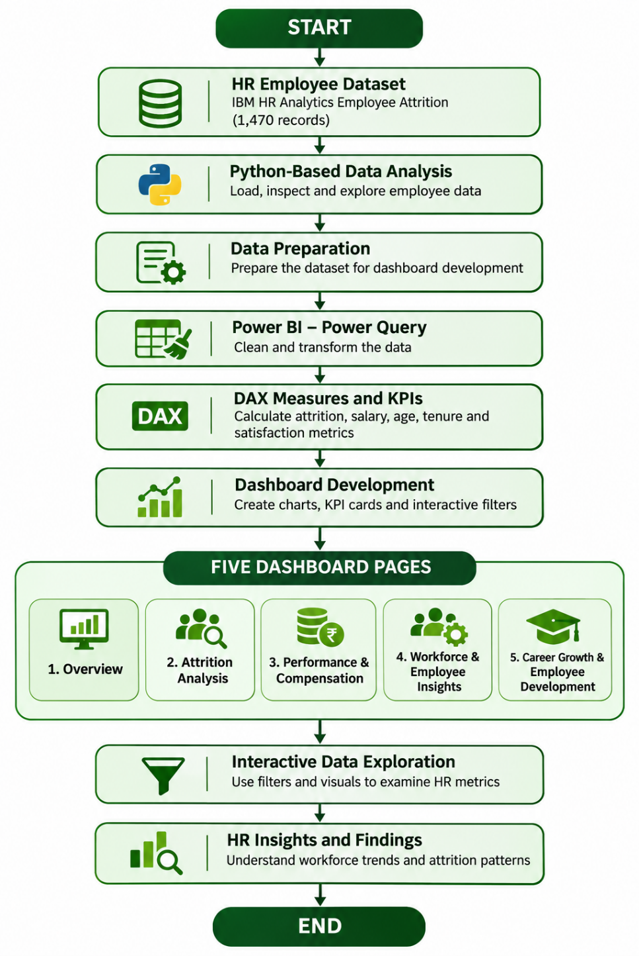

Fig. 4.1 System Flowchart

4.2 System Architecture

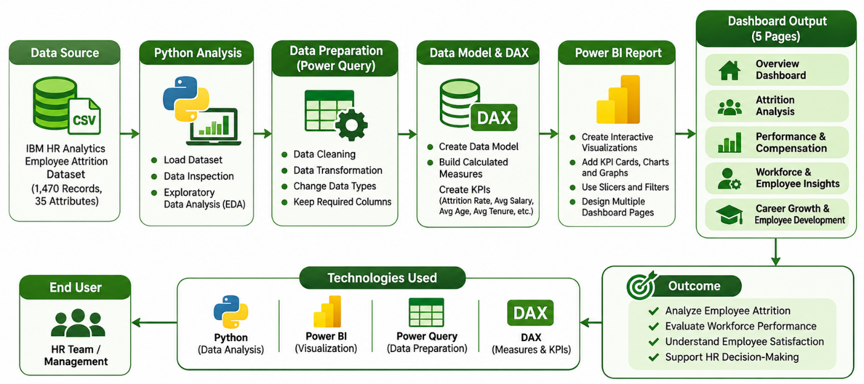

Fig. 4.2 System Architecture

4.3 Component Design

Component design describes the major components of the HR Analytics and Employee Attrition Analysis Dashboard and explains their individual functions. The project is divided into different

components that work together to process employee data, perform analysis, and display meaningful insights through interactive Power BI dashboards.

The major components of the project are explained below.

1. Data Collection Component:

This component is responsible for providing the input data required for analysis. The project uses the IBM HR Analytics Employee Attrition dataset, which contains information about 1,470 employees.

The dataset includes employee details such as age, gender, department, job role, monthly income, years at company, job satisfaction, performance rating, and attrition status.

2. Python Analysis Component:

Python is used for loading, inspecting, and exploring the employee dataset. It supports the initial analysis of employee information and helps understand the structure and attributes of the data before dashboard development.

3. Data Cleaning and Transformation Component:

Power Query in Microsoft Power BI is used to clean and transform the employee dataset. This component prepares the data for visualization and analysis by organizing the required columns and ensuring that the data is suitable for reporting.

4. DAX and KPI Calculation Component:

Data Analysis Expressions (DAX) is used to create calculated measures and important Key Performance Indicators (KPIs).

The project includes the following measures:

Total Employees

Employees Left

Attrition Rate

Average Salary

Average Age

Average Tenure

Average Job Satisfaction

Average Work-Life Balance

Average Performance Rating

Average Salary Hike

These measures help summarize important employee-related information.

5. Data Visualization Component:

This component presents the analyzed information through visual elements in Power BI. It includes KPI cards, bar charts, and other graphical representations to make employee data easier to understand.

Interactive filters and slicers allow users to explore information based on different employee categories.

6. Dashboard Component:

The dashboard component organizes the visualizations into five different pages:

Overview Dashboard: Displays overall employee statistics, attrition rate, average salary, employee demographics, and workforce distribution.

Attrition Analysis Dashboard: Presents employee departures based on department, gender, education field, age group, job role, and marital status.

Performance and Compensation Dashboard: Displays salary distribution, performance ratings, salary hikes, and compensation-related information.

Workforce and Employee Insights Dashboard: Focuses on employee demographics, overtime, business travel, job satisfaction, and work-life balance.

Career Growth and Employee Development Dashboard: Displays training sessions, employee tenure, promotion history, relationship satisfaction, environment satisfaction, and employee development indicators.

7. Interactive Filtering Component:

This component allows users to interact with the dashboard using slicers and filters. Users can select department, education field, gender, marital status, and attrition status to explore specific employee information.

It helps users compare different categories and understand workforce patterns according to their selected filters.

8. Reporting and Insights Component:

The final component presents the results of the analysis through dashboard visualizations and key takeaways. It helps users understand employee attrition, workforce distribution, compensation, satisfaction, and career development trends.

The overall component design ensures that data collection, Python analysis, data transformation, KPI calculations, and Power BI visualizations work together to provide an organized and interactive HR Analytics solution.

4.4 Operation Flow

The operation flow describes how the HR Analytics Dashboard works from the initial dataset input to the final presentation of analytical results. The system follows a sequence of operations involving Python, Power Query, DAX, and Microsoft Power BI.

The following steps explain the operation of the proposed system.

Step 1: Dataset Input
The system uses the IBM HR Analytics Employee Attrition dataset containing 1,470 employee records. The dataset includes employee details such as age, gender, department, job role, salary, job satisfaction, performance rating, and attrition status.

Step 2: Python-Based Data Analysis
Python is used to load, inspect, and explore the employee dataset. Initial data analysis helps understand the dataset structure, available attributes, and employee information.

Step 3: Data Import and Preparation
The dataset is imported into Microsoft Power BI for further processing. Power Query is used to clean and transform the data and prepare it for dashboard development.
Step 4: DAX Measure Creation
DAX is used to create calculated measures and Key Performance Indicators (KPIs), such as Total Employees, Employees Left, Attrition Rate, Average Salary, Average Age, Average Tenure, Job Satisfaction, and Work-Life Balance.

Step 5: Dashboard Development
The prepared data and calculated measures are used to develop interactive charts, graphs, KPI cards, and slicers in Power BI.

Step 6: Dashboard Navigation
The dashboard provides five pages for different areas of HR analysis:
- Overview
- Attrition Analysis
- Performance and Compensation
- Workforce and Employee Insights
- Career Growth and Employee Development

Step 7: Interactive Data Exploration
Users can interact with the dashboard using available filters and slicers, including Department, Education Field, Gender, Marital Status, and Attrition. These controls allow users to explore employee information based on selected categories.

Step 8: Result Analysis and Insights
The final dashboard displays summarized HR metrics and visual insights. Users can analyze employee attrition, workforce distribution, performance, compensation, satisfaction, and career development indicators.

5. METHODOLOGY
5.1 Dataset Description
The project uses the IBM HR Analytics Employee Attrition dataset to analyze employee information and identify workforce trends. The dataset contains 1,470 employee records and 35 attributes related to employee demographics, job roles, salary, performance, satisfaction, and attrition.

The dataset includes the following important attributes:
Attribute | Description
Age | Age of the employee
Gender | Gender of the employee
Department | Department in which the employee works
JobRole | Employee's job position
EducationField | Employee's educational background
MaritalStatus | Marital status of the employee
MonthlyIncome | Monthly salary of the employee
YearsAtCompany | Total years spent at the company
JobSatisfaction | Employee job satisfaction level
WorkLifeBalance | Employee work-life balance level
PerformanceRating | Employee performance rating
Attrition | Indicates whether an employee has left the organization
OverTime | Indicates whether the employee works overtime
TrainingTimesLastYear | Number of training sessions attended
YearsSinceLastPromotion | Years since the last promotion
Table 5.1: Dataset Attributes and Their Descriptions

The dataset provides sufficient information to perform different types of HR analysis and develop interactive dashboards.
5.2 Data Preprocessing
Data preprocessing is an important step that prepares raw employee information for analysis and visualization. In this project, Python and Power BI are used for data inspection, preparation, cleaning, and transformation.

The following preprocessing activities are performed:

- Data Loading: The IBM HR Analytics dataset is loaded into the Python environment for initial inspection and analysis.
- Data Inspection: The dataset is examined to understand its structure, number of records, attributes, and data types.
- Data Cleaning: The dataset is checked for missing values, duplicate records, and unnecessary information to maintain data quality.
- Data Transformation: Power Query in Power BI is used to transform the dataset and prepare the required columns for dashboard development.
- Feature Grouping: Additional categories such as Age Group, Tenure Group, and Income Group are used to simplify employee comparisons and visual analysis.
- Data Preparation for Visualization: The prepared dataset is used in Power BI to create charts, KPI cards, and interactive filters.
After preprocessing, the dataset contains 1,470 records and 35 columns, with no missing values or duplicate records.

5.3 Exploratory Data Analysis (EDA)
Exploratory Data Analysis (EDA) is performed to understand the employee dataset and identify patterns, distributions, and relationships among different HR attributes.
Python is used for initial data inspection and exploration, while Power BI is used to analyze employee information through visualizations.

The following areas are explored:
- Employee Demographics: Analysis of employee age, gender, marital status, and education field.
- Department Analysis: Examination of employee distribution across different departments.
- Attrition Analysis: Understanding employee departures based on department, age group, gender, job role, and marital status.
- Salary Analysis: Exploring monthly income across departments and job roles.
- Performance Analysis: Examining employee performance ratings and salary hikes.
- Satisfaction Analysis: Studying job satisfaction, relationship satisfaction, environment satisfaction, and work-life balance.
- Career Development Analysis: Exploring employee training, tenure, and promotion-related information.
- Overtime Analysis: Understanding the relationship between overtime and employee-related indicators.
EDA helps identify important workforce patterns and provides a foundation for developing meaningful dashboard visualizations.

5.4 KPI Calculation
Key Performance Indicators (KPIs) are calculated using Data Analysis Expressions (DAX) in Microsoft Power BI.
These measures provide summarized information about the employee dataset and help evaluate important HR metrics.

The following DAX measures are created:

KPI | DAX Formula
Total Employees | COUNTROWS(HR_Analytics_Final)
Employees Left | CALCULATE(COUNTROWS(HR_Analytics_Final), HR_Analytics_Final[Attrition] = "Yes")
Attrition Rate | DIVIDE([Employees Left], [Total Employees], 0)
Average Salary | AVERAGE(HR_Analytics_Final[MonthlyIncome])
Average Age | AVERAGE(HR_Analytics_Final[Age])
Average Tenure | AVERAGE(HR_Analytics_Final[YearsAtCompany])
Average Job Satisfaction | AVERAGE(HR_Analytics_Final[JobSatisfaction])
Average Work-Life Balance | AVERAGE(HR_Analytics_Final[WorkLifeBalance])
Average Performance Rating | AVERAGE(HR_Analytics_Final[PerformanceRating])
Average Salary Hike | AVERAGE(HR_Analytics_Final[PercentSalaryHike])

Table 5.2: DAX Measures and KPI Formulas

Important KPI Results:
Metric | Calculated Value
Total Employees | 1,470
Employees Left | 237
Attrition Rate | 16.12%
Average Salary | 6.50K
Average Age | 36.92
Average Tenure | 7.01
Average Job Satisfaction | 2.73
Average Work-Life Balance | 2.76
Average Performance Rating | 3.15
Average Salary Hike | 15.21

Table 5.3: Important KPI Results

These KPIs are displayed using card visuals to provide a quick summary of important HR information.

5.5 Data Visualization
Data visualization is used to represent employee information through charts, graphs, KPI cards, and other graphical elements.
Microsoft Power BI is used to create visual representations that make complex employee data easier to understand and interpret.
The project includes the following visualizations:
- KPI Cards: Display total employees, employees left, attrition rate, average salary, average age, and other important metrics.
- Bar Charts: Compare employee distribution, attrition, salary, and satisfaction across different categories.
- Column Charts: Represent department-wise and job-role-wise employee information.
- Distribution Charts: Display employee demographics such as gender, age group, and marital status.
- Interactive Slicers: Allow users to filter information based on department, education field, gender, marital status, and attrition.
A consistent green and light-colour theme is used throughout the dashboard to maintain a professional and user-friendly appearance.

5.6 Dashboard Development Process
The dashboard development process involves organizing the prepared employee data and presenting the analysis through five interactive dashboard pages in Microsoft Power BI.
The development process is divided into the following stages:

1. Dataset Import:
The prepared IBM HR Analytics dataset is imported into Power BI.

2. Data Transformation:
Power Query is used to clean, transform, and prepare employee information for analysis.

3. DAX Measure Creation:
Calculated measures are created to display important HR metrics such as total employees, attrition rate, average salary, and employee satisfaction.

4. Visualization Development: Charts, graphs, KPI cards, and slicers are added to represent different employee-related attributes.

5. Dashboard Page Design:
The report is organized into five dashboard pages:
Page No. | Dashboard Name | Main Focus
1 | Overview | Overall employee statistics and workforce distribution
2 | Attrition Analysis | Employee departures and attrition patterns
3 | Performance and Compensation | Salary, salary hikes, and performance ratings
4 | Workforce and Employee Insights | Demographics, overtime, and satisfaction
5 | Career Growth and Employee Development | Training, promotion, tenure, and employee satisfaction

Table 5.4: Dashboard Pages and Their Main Focus

6. Interactive Filter Integration:
Slicers and filters are added to allow users to explore employee information based on selected categories.

7. Testing and Validation:
The dashboard visuals, KPI values, calculations, and filters are checked to ensure that the displayed information is consistent with the prepared dataset.

8. Final Dashboard:
The completed dashboard provides an organized and interactive view of HR analytics, allowing users to explore employee attrition, workforce trends, performance, compensation, and career development.

6. IMPLEMENTATION DETAILS
This chapter explains the implementation of the HR Analytics and Employee Attrition Analysis Dashboard using Python and Microsoft Power BI. It covers dataset loading, data cleaning, exploratory data analysis, KPI calculations, visualization, and dashboard validation.
6.1 Python Implementation
Python is used for initial dataset loading, inspection, and exploratory data analysis. It helps understand the structure of the employee dataset and examine different attributes before dashboard development.
The Pandas library is used to handle and analyze structured employee data. Python provides functions to display dataset information, examine data types, identify missing values, and generate statistical summaries.
The following Python libraries are used:
Library | Purpose
Pandas | Data loading and manipulation
NumPy | Numerical operations
Matplotlib | Data visualization
Seaborn | Statistical visualization
Table 6.1: Python Libraries and Their Functions
Python helps in understanding the dataset and preparing it for further analysis using Power BI.

6.2 Dataset Loading
The IBM HR Analytics Employee Attrition dataset is loaded into the Python environment for analysis.
The dataset contains 1,470 employee records and 35 attributes. It includes information about employee demographics, departments, job roles, salary, performance, satisfaction, and attrition.
The following Python code is used to load the dataset:
import pandas as pd
import numpy as np

# Load the HR Analytics dataset
df = pd.read_csv("HR_Analytics.csv")

# Display first five records
print(df.head())

# Display dataset dimensions
print(df.shape)

# Display column names
print(df.columns)

# Display dataset information
print(df.info())

The dataset is inspected to understand its dimensions, column names, data types, and overall structure.

6.3 Data Cleaning and Preprocessing
Data cleaning and preprocessing are performed to improve data quality and prepare employee information for analysis.
The following activities are carried out:
1. Checking Missing Values
- The dataset is examined to identify missing values in different columns.
- print(df.isnull().sum())
2. Checking Duplicate Records
- Duplicate records are checked to maintain data consistency.
- print(df.duplicated().sum())
3. Statistical Summary
- Descriptive statistics are generated to understand numerical employee attributes.
- print(df.describe())
4. Feature Grouping
- Additional categories such as Age Group, Tenure Group, and Income Group are used to simplify employee comparisons and analysis.
5. Power BI Data Preparation
- The dataset is further prepared using Power Query in Microsoft Power BI. Required columns and data types are checked and transformed for dashboard development.
- After preprocessing, the dataset contains 1,470 records and 35 columns, with no missing values or duplicate records.

6.4 Exploratory Data Analysis
Exploratory Data Analysis (EDA) is performed to understand employee information and identify important workforce patterns.
Python is used for initial data exploration, while Power BI provides interactive visual analysis.
The following areas are examined:
- Employee Demographics: Analysis of employee age, gender, marital status, and education field.
- Department Distribution: Understanding employee distribution across departments.
- Employee Attrition: Examining employee departures across different categories.
- Salary Analysis: Exploring monthly income across departments and job roles.
- Performance Analysis: Understanding employee performance ratings and salary hikes.
- Employee Satisfaction: Examining job satisfaction, environment satisfaction, relationship satisfaction, and work-life balance.
- Career Development: Analyzing employee training, tenure, and promotion-related information.
- Overtime Analysis: Exploring overtime-related employee trends.
EDA helps identify meaningful patterns and provides a foundation for creating the final dashboard.

6.5 Power BI Implementation
Microsoft Power BI is used to develop the interactive HR Analytics Dashboard. The prepared employee dataset is imported into Power BI for data transformation, calculations, and visualization.
The implementation involves the following activities:
1. Data Import
The employee dataset is imported into Power BI Desktop.
2. Power Query Transformation
Power Query is used to clean and transform the dataset. Data types and required columns are checked to prepare the data for analysis.
3. Data Model Preparation
The prepared employee data is organized in Power BI for creating measures and visualizations.
4. DAX Measure Creation
DAX (Data Analysis Expressions) is used to create calculated measures for important HR metrics.
5. Report Design
The dashboard is designed using KPI cards, charts, graphs, slicers, and filters. A consistent green and light-colour theme is applied across all five pages.

6.6 KPI and Visualization Implementation
Key Performance Indicators (KPIs) are implemented using DAX measures in Power BI. These measures provide summarized information about the employee dataset.
The following KPIs are created:
KPI | Result
Total Employees | 1,470
Employees Left | 237
Attrition Rate | 16.12%
Average Salary | 6.50K
Average Age | 36.92
Average Tenure | 7.01
Average Job Satisfaction | 2.73
Average Work-Life Balance | 2.76
Average Performance Rating | 3.15
Average Salary Hike | 15.21
Table 6.2. Key Performance Indicators and Their Calculated Values

The following visualizations are implemented:
- KPI Cards: Display important employee metrics.
- Bar and Column Charts: Compare employee distribution, attrition, salary, and satisfaction.
- Demographic Charts: Represent gender, age group, and marital status distributions.
- Department Analysis Charts: Compare workforce and attrition across departments.
- Career Development Charts: Display training, tenure, and promotion-related information.
- Slicers and Filters: Allow users to interact with the dashboard and explore selected employee categories.
The visualizations are organized into five dashboard pages:
- Overview
- Attrition Analysis
- Performance and Compensation
- Workforce and Employee Insights
- Career Growth and Employee Development

6.7 Dashboard Validation
Dashboard validation is performed to ensure that the displayed information, calculations, and visualizations are accurate and consistent with the prepared employee dataset.
The following validation activities are carried out:
1. Dataset Validation: The total number of employee records is checked to ensure that the dataset contains 1,470 records.
2. KPI Validation: The calculated KPI values are checked against the employee dataset.
3. Attrition Validation: The total number of employees who left the organization is verified as 237, with an attrition rate of 16.12%.
4. Visualization Validation: Charts and graphs are checked to ensure that they represent the correct employee information.
5. Filter Validation: Interactive slicers are tested to verify that selecting different categories updates the dashboard visuals correctly.
6. Page Navigation Validation: All five dashboard pages are checked to ensure that their visualizations and information are displayed properly.
The validation process helps maintain the accuracy and consistency of the HR Analytics Dashboard.

7. RESULT ANALYSIS

The HR Analytics and Employee Attrition Analysis Dashboard was developed using Python and Microsoft Power BI. The project uses the IBM HR Analytics Employee Attrition dataset containing 1,470 employee records and 35 attributes. Python was used for dataset loading, inspection, and exploratory data analysis, while Power BI was used for data preparation, KPI calculation, visualization, and interactive dashboard development.

The results are presented through Python analysis outputs and five Power BI dashboard pages.

7.1 Dataset Analysis Using Python
Python was used to load and inspect the IBM HR Analytics Employee Attrition dataset. Pandas helped examine the dataset structure, column names, data types, and number of employee records.

7.1.1 Python Environment and Library Import

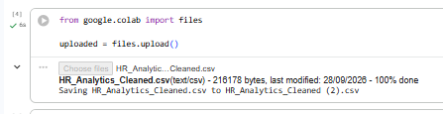
Figure 7.1.1: Python Environment and Library Import

The Python environment was initialized by importing libraries for data analysis. Pandas and NumPy were used for data handling and numerical operations, while Matplotlib and Seaborn supported data visualization.

7.1.2: Dataset Loading and Initial Inspection

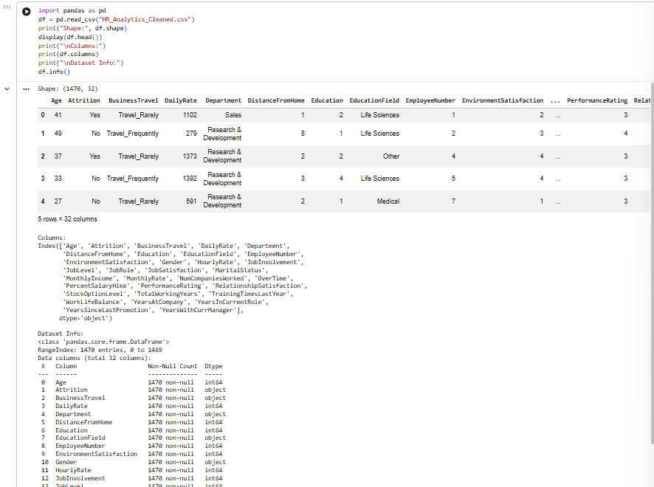
Figure 7.1.2: Dataset Loading and Initial Inspection

The dataset was loaded using Pandas. Initial inspection showed 1,470 records and 35 attributes. The first five records and dataset information were examined to understand the structure and available employee-related columns.

7.2 Data Cleaning and Preprocessing
Data cleaning and preprocessing were performed to prepare the employee dataset for analysis. The dataset was examined for missing values, duplicate records, and data consistency.
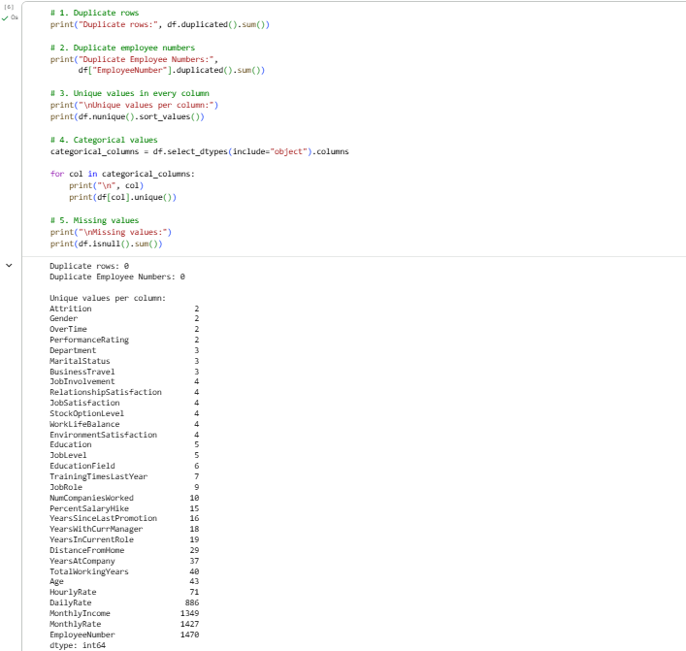
Figure 7.2.1: Missing Values and Duplicate Records Check

The dataset was checked for missing values and duplicate records. The prepared dataset contained no missing values or duplicate records, helping maintain data consistency.
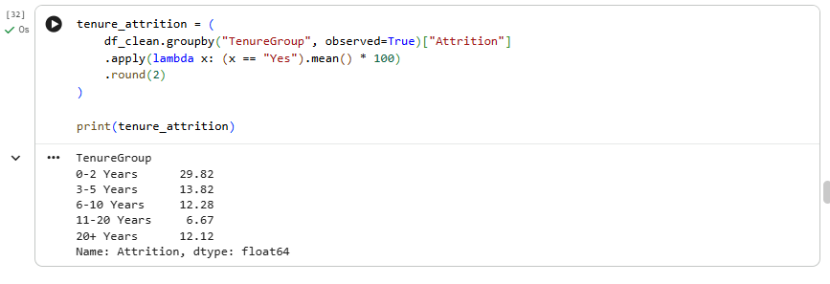
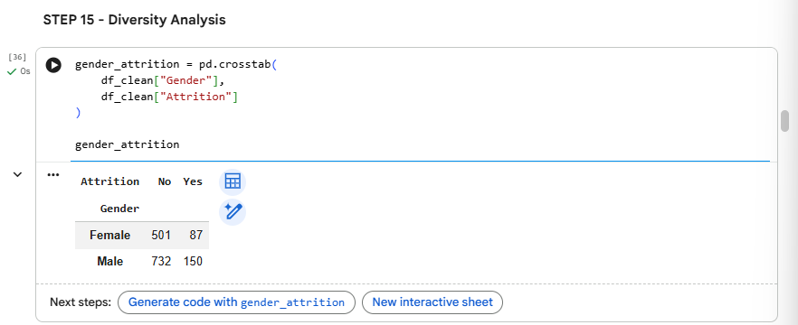
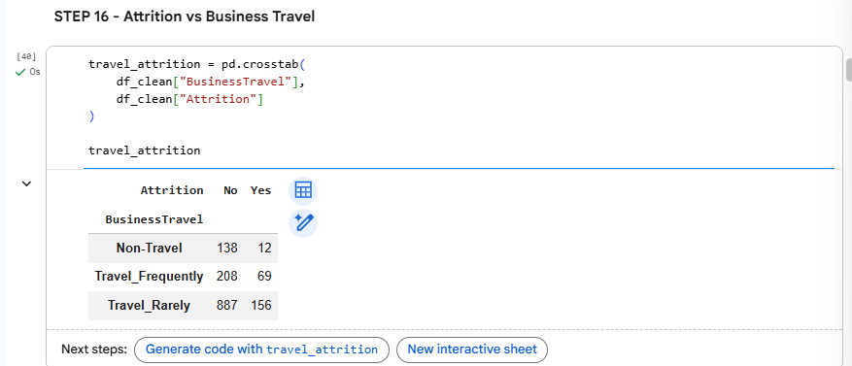
Figure 7.2.2: Dataset Transformation and Feature Grouping
Additional categories such as Age Group, Tenure Group, and Income Group were prepared to simplify employee comparisons and visual analysis.
7.3 Exploratory Data Analysis (EDA)
Exploratory Data Analysis was performed to understand employee characteristics and identify patterns within the dataset. Python was used to analyze employee attrition across departments, job roles, overtime, satisfaction, work-life balance, age groups, and other employee attributes.

7.3.1 Employee Demographics and Age Group Analysis
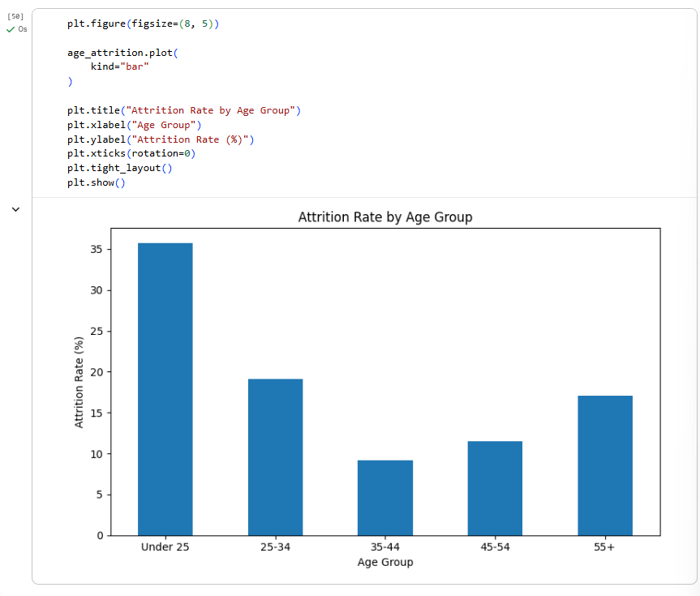
Figure 7.3.1: Attrition Rate by Age Group

Employees were grouped into different age categories to examine attrition patterns. The analysis compares attrition rates across age groups and helps identify differences in employee departures based on age.

7.3.2 Gender-wise Employee Attrition
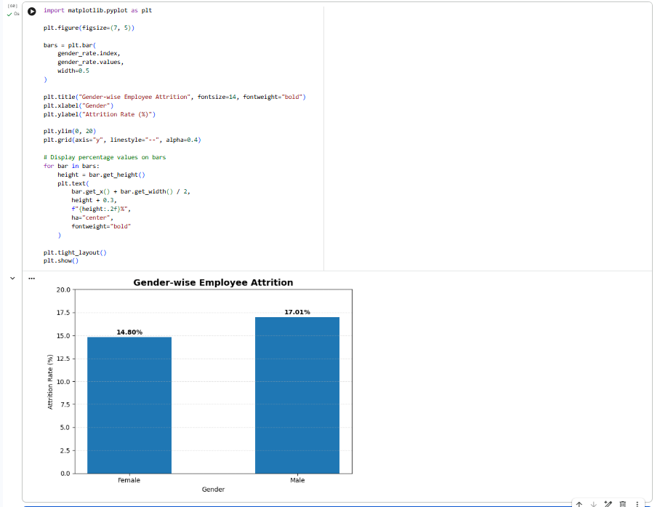
Figure 7.3.2: Gender-wise Employee Attrition

A cross-tabulation was performed to compare employees who stayed and left across gender categories. The analysis recorded 87 female and 150 male employees who left the organization.
7.3.3 Department and Job Role Analysis

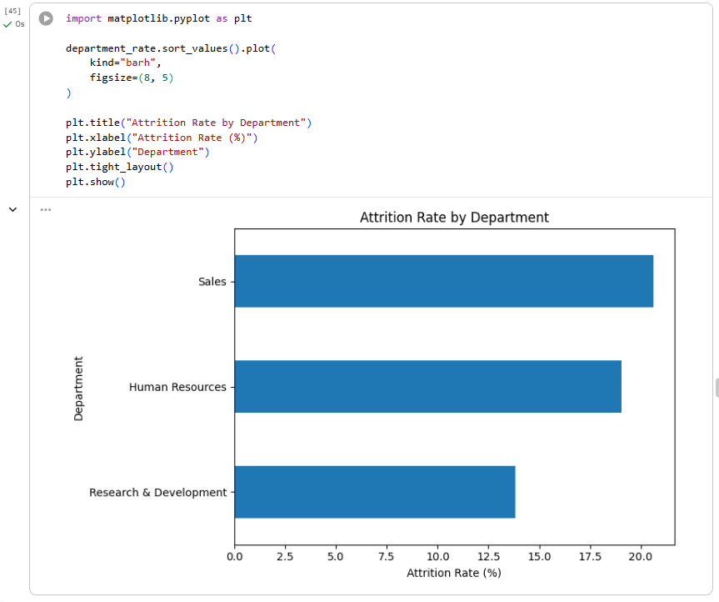

Figure 7.3.3: Attrition Rate by Department

Department-wise attrition rates were calculated and visualized to compare employee departures across Human Resources, Research and Development, and Sales. Sales recorded the highest attrition rate at 20.63%.

7.3.4 Department and Job Role Analysis

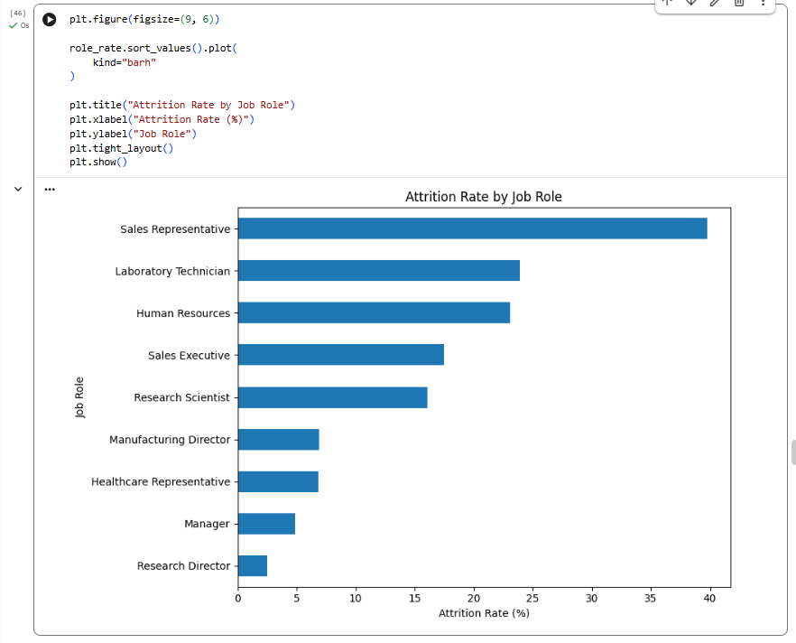

Figure 7.3.4: Attrition Rate by Job Role

The analysis compares attrition rates across different job roles. Sales Representatives recorded the highest attrition rate at 39.76%, followed by Laboratory Technicians at 23.94%.

7.3.5 Employee Attrition Analysis

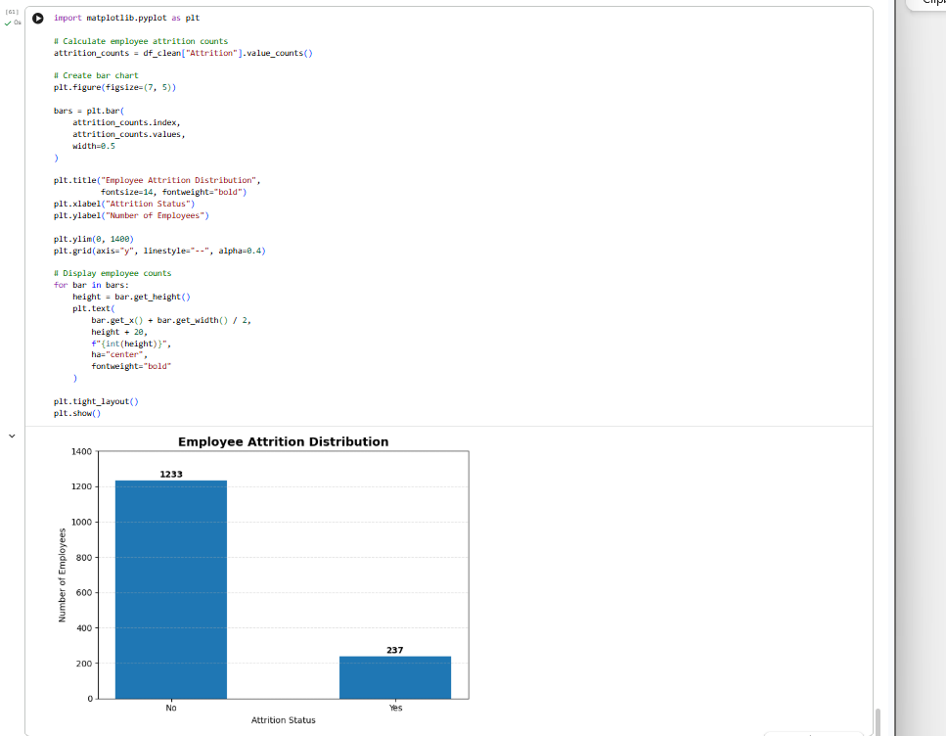

Figure 7.3.5: Employee Attrition Distribution

The dataset contains 1,233 employees who stayed and 237 employees who left the organization. The calculated overall attrition rate is 16.12%.

7.3.6 Overtime and Employee Satisfaction Analysis

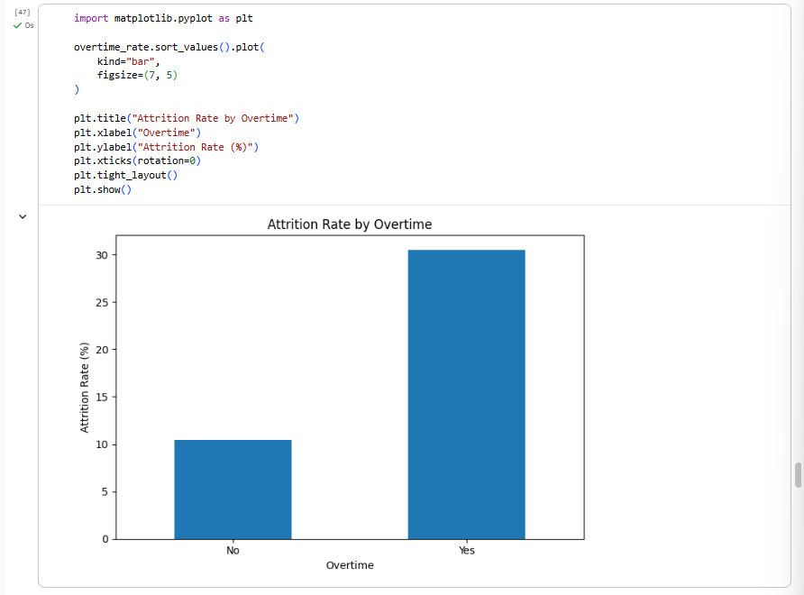

Figure 7.3.6: Attrition Rate by Overtime

The analysis compares attrition rates between employees working overtime and those not working overtime. Employees working overtime recorded an attrition rate of 30.53%, compared with 10.44% for employees not working overtime.

7.3.7: Attrition Rate by Job Satisfaction

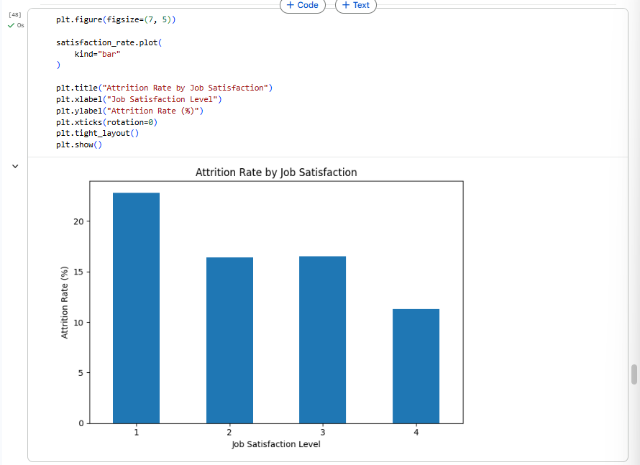

Figure 7.3.7: Attrition Rate by Job Satisfaction

Employee attrition rates were examined across four job satisfaction levels. The highest attrition rate of 22.84% was observed at satisfaction level 1.

7.3.8 Attrition Rate by Work-Life Balance

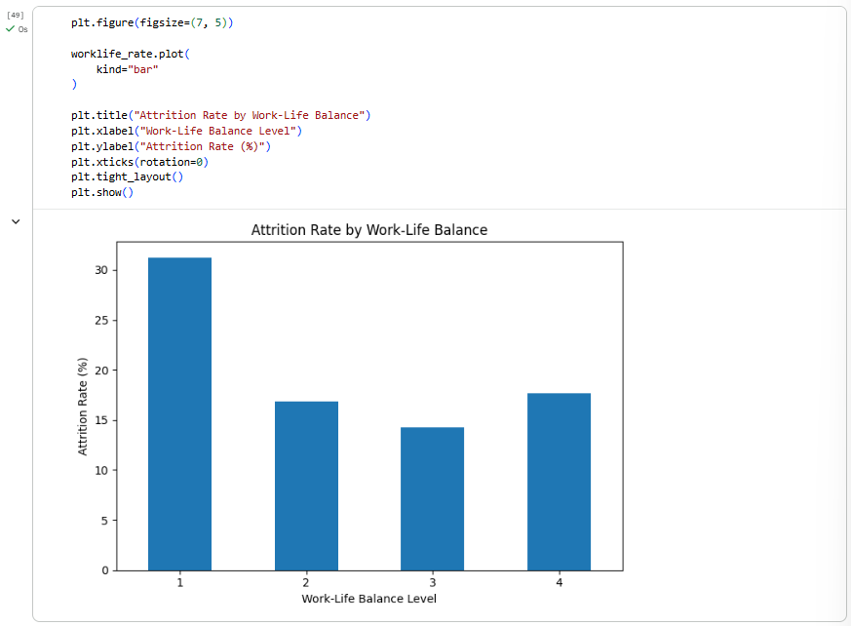

Figure 7.3.8: Attrition Rate by Work-Life Balance

The analysis compares employee attrition across different work-life balance levels. The highest attrition rate of 31.25% was observed at level 1.

7.3.9 Salary and Performance Analysis

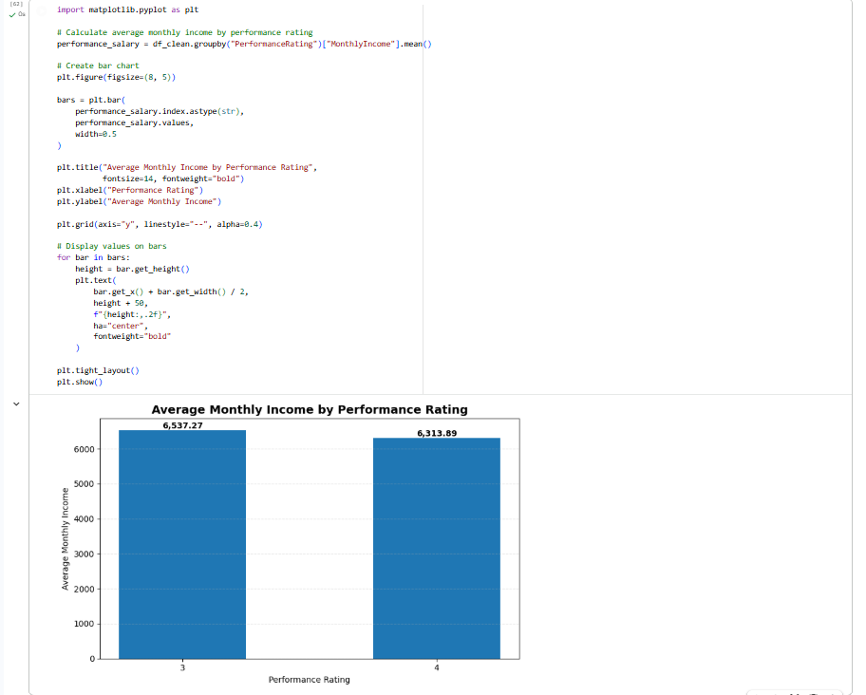

Figure 7.3.9: Average Monthly Income by Performance Rating

The average monthly income was calculated for each performance rating. The analysis shows an average monthly income of 6,537.27 for rating 3 and 6,313.89 for rating 4.

7.4 KPI Calculation Results
Key Performance Indicators were created using DAX measures in Power BI. These measures provide a summarized view of important HR metrics.

KPI | Result
Total Employees | 1,470
Employees Left | 237
Attrition Rate | 16.12%
Average Salary | 6.50K
Average Age | 36.92
Average Tenure | 7.01
Average Job Satisfaction | 2.73
Average Work-Life Balance | 2.76
Average Performance Rating | 3.15
Average Salary Hike | 15.21

Table 7.1: Key Performance Indicators and Their Results

The KPI calculations provide important workforce statistics. The total number of employees is 1,470, while 237 employees have left the organization. The calculated attrition rate is 16.12%. Other indicators summarize average salary, age, tenure, satisfaction, and performance.

7.5 Power BI Dashboard Implementation and Results
The final dashboard was developed in Microsoft Power BI using KPI cards, charts, graphs, slicers, and interactive filters. The report consists of five dashboard pages, each focusing on a specific area of HR analysis.

7.5.1 Overview Dashboard
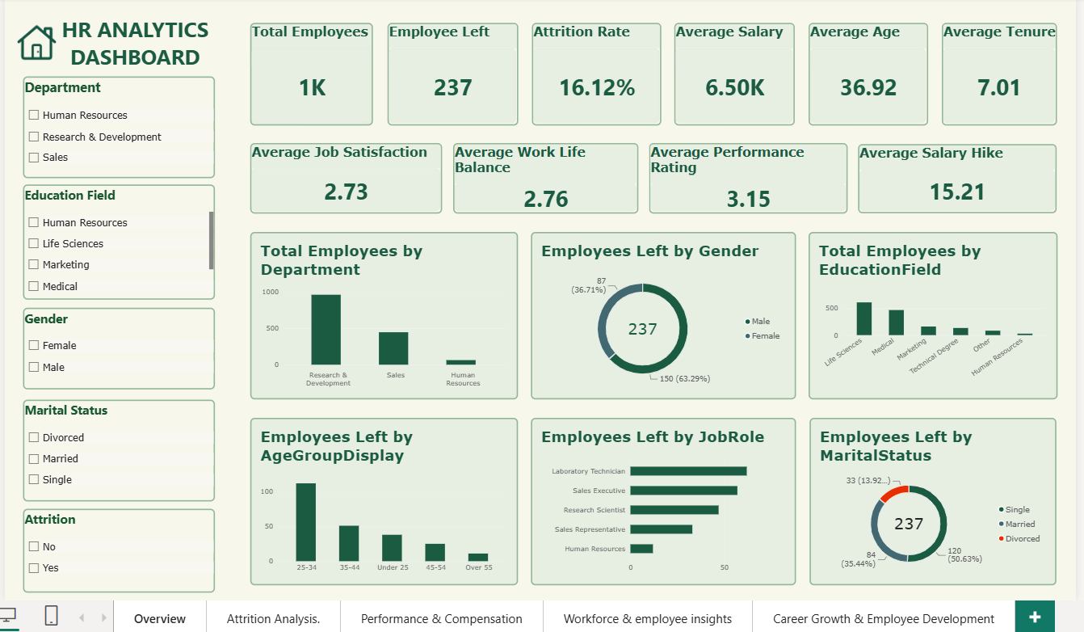
Figure 7.5.1: HR Analytics Overview Dashboard

The Overview Dashboard provides a summary of the IBM HR Analytics dataset through KPI cards, charts, and interactive filters.
It displays key metrics such as total employees, employees left, attrition rate, average salary, average age, average tenure, job satisfaction, work-life balance, performance rating, and salary hike.
The charts present employee distribution by department, gender, education field, age group, job role, and marital status.
Interactive slicers for Department, Education Field, Gender, Marital Status, and Attrition allow users to filter the data and explore specific employee categories.
Overall, this dashboard provides a quick overview of workforce distribution and employee attrition patterns.

7.5.2 Attrition Analysis Dashboard
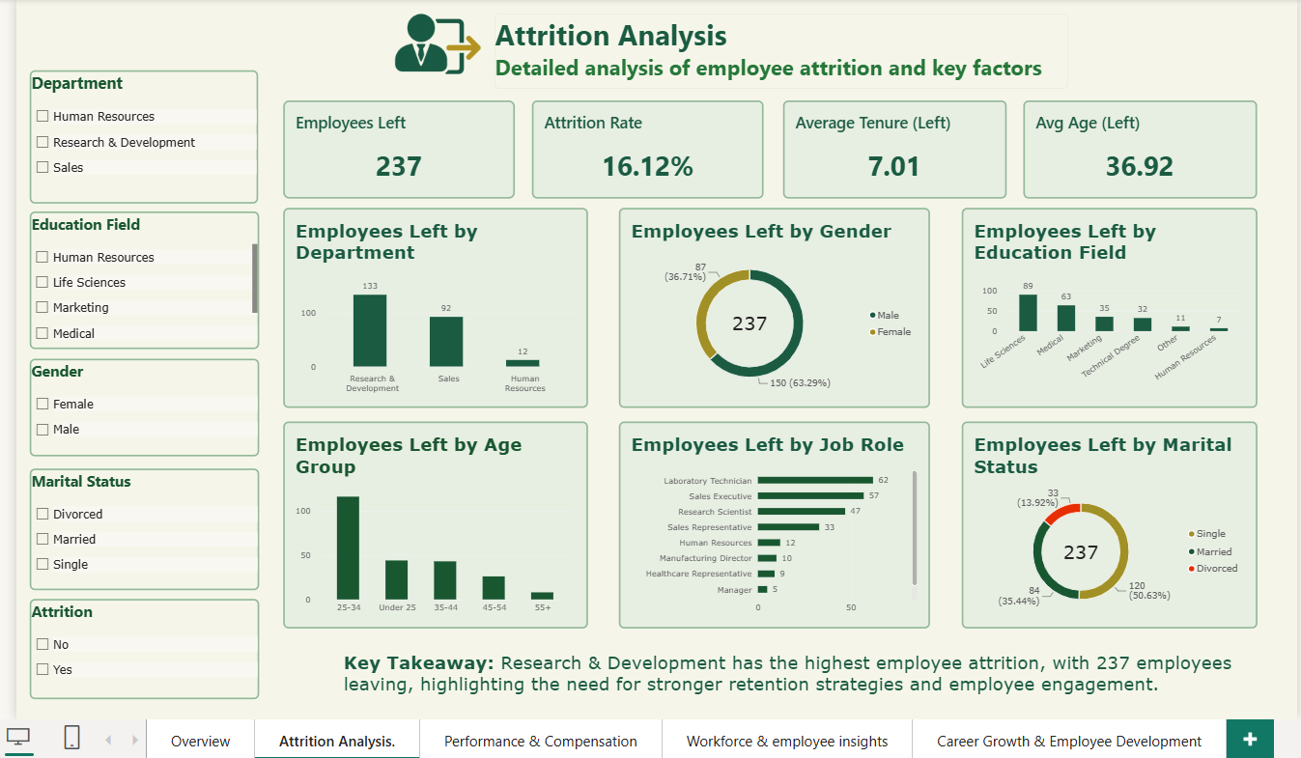
Figure 7.5.2: Employee Attrition Analysis Dashboard

The Attrition Analysis Dashboard focuses on employees who have left the organization. It displays key metrics such as Employees Left (237), Attrition Rate (16.12%), Average Tenure (7.01 years), and Average Age (36.92 years).
The charts analyze employee departures by department, gender, education field, age group, job role, and marital status.
Interactive slicers allow users to filter the results by different employee categories and explore attrition patterns.
Overall, this dashboard helps identify employee departure trends and understand attrition across different workforce categories.

7.5.3 Performance and Compensation Dashboard
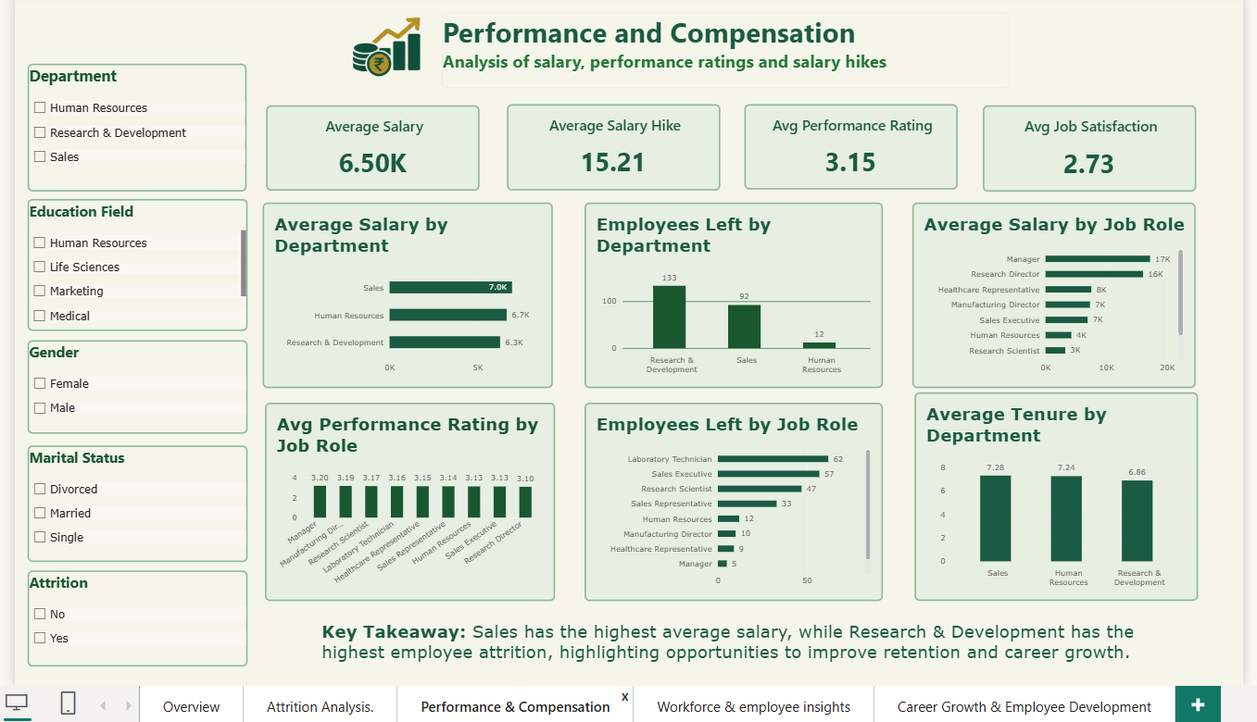
Figure 7.5.3: Performance and Compensation Dashboard

The Performance and Compensation Dashboard presents employee salary, performance, and satisfaction information through KPI cards and visualizations.
It displays key metrics such as Average Salary (6.50K), Average Salary Hike (15.21), Average Performance Rating (3.15), and Average Job Satisfaction (2.73).
The charts compare average salary across departments and job roles, employee departures by department and job role, performance ratings by job role, and average tenure by department.
Interactive filters allow users to explore the results based on different employee categories.
Overall, this dashboard helps analyze compensation patterns, employee performance, and workforce trends across departments and job roles.

7.5.4 Workforce and Employee Insights Dashboard
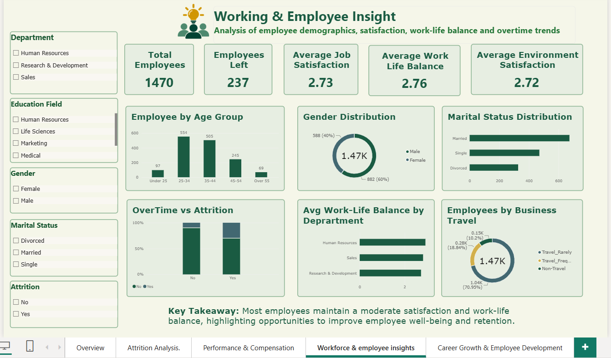
Figure 7.5.4: Workforce and Employee Insights Dashboard
The Workforce and Employee Insights Dashboard provides an overview of employee demographics, satisfaction, and workplace conditions.
It displays key metrics such as Total Employees (1,470), Employees Left (237), Average Job Satisfaction (2.73), Average Work-Life Balance (2.76), and Average Environment Satisfaction (2.72).
The charts present employee distribution by age group, gender, and marital status. They also examine overtime in relation to attrition, average work-life balance by department, and employee distribution by business travel.
Interactive filters allow users to explore workforce information across different employee categories.
Overall, this dashboard helps understand workforce composition, employee satisfaction, and workplace-related trends.
7.5.5 Career Growth and Employee Development Dashboard
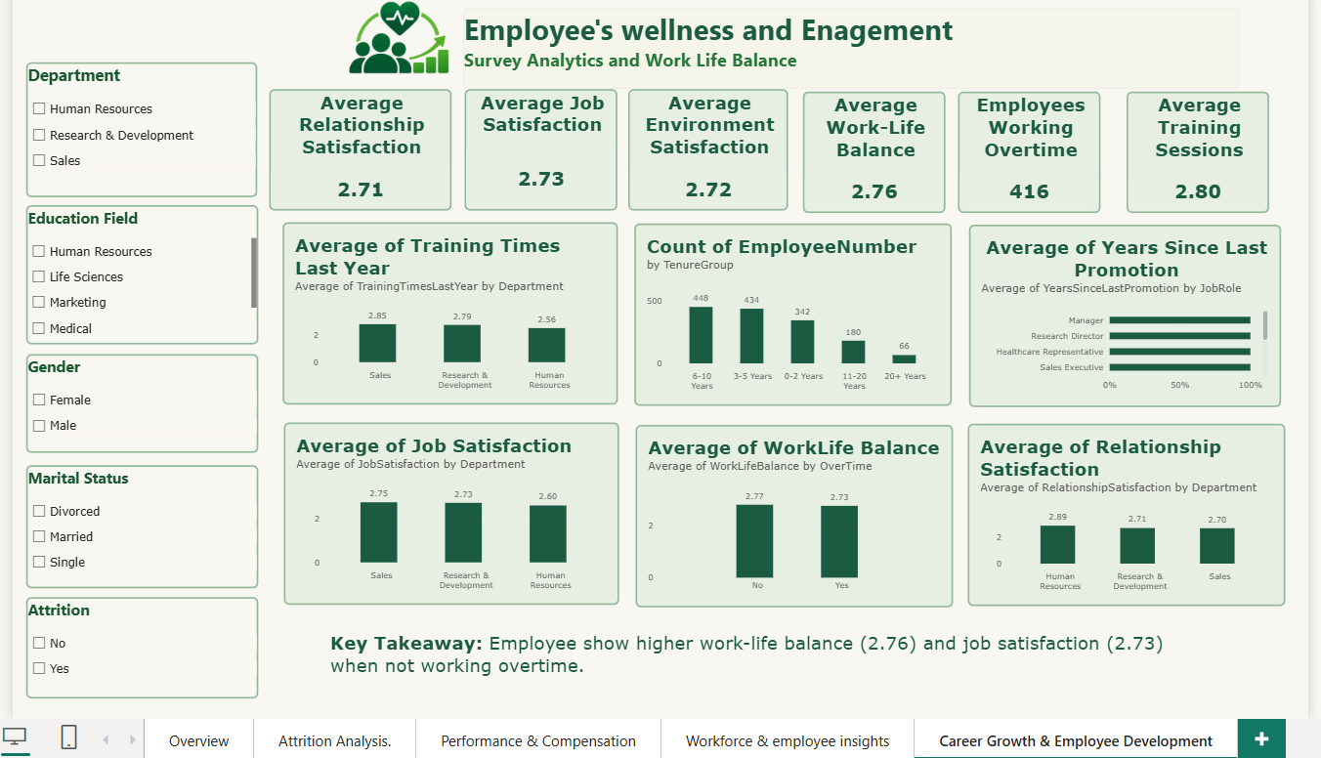
Figure 7.5.5: Career Growth and Employee Development Dashboard

The Career Growth and Employee Development Dashboard focuses on employee satisfaction, training, work-life balance, and career development.
It displays key metrics such as Average Relationship Satisfaction (2.71), Average Job Satisfaction (2.73), Average Environment Satisfaction (2.72), Average Work-Life Balance (2.76), Employees Working Overtime (416), and Average Training Sessions (2.80).
The charts present training sessions by department, employee distribution by tenure group, years since last promotion by job role, job satisfaction by department, work-life balance by overtime, and relationship satisfaction by department.
Interactive filters allow users to explore employee information across different categories.
Overall, this dashboard helps examine employee development, workplace satisfaction, training, and career growth patterns.
7.5.6 Interactive Dashboard Analysis
The dashboard includes interactive slicers and filters that allow users to explore employee information based on selected categories.
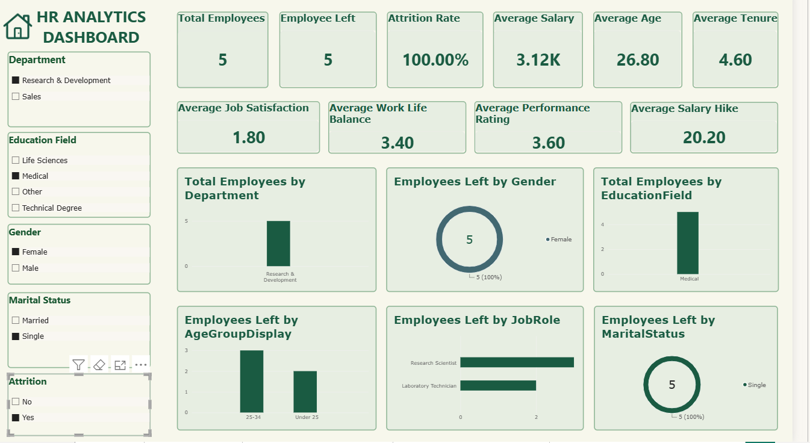
Figure 7.5.6: Interactive Filtering in Power BI Dashboard

The Interactive Dashboard Analysis demonstrates how slicers and filters can be used to explore employee information. Users can filter the dashboard based on Department, Education Field, Gender, Marital Status, and Attrition.
When a category is selected, the KPI cards and charts automatically update according to the selected data. This allows users to examine specific employee groups and compare their workforce statistics.
Overall, the interactive filtering feature makes the dashboard more flexible and helps users explore employee data according to their requirements.

7.5.7 Dashboard Validation
Dashboard validation was performed to verify the accuracy of KPI calculations, charts, and interactive filters.
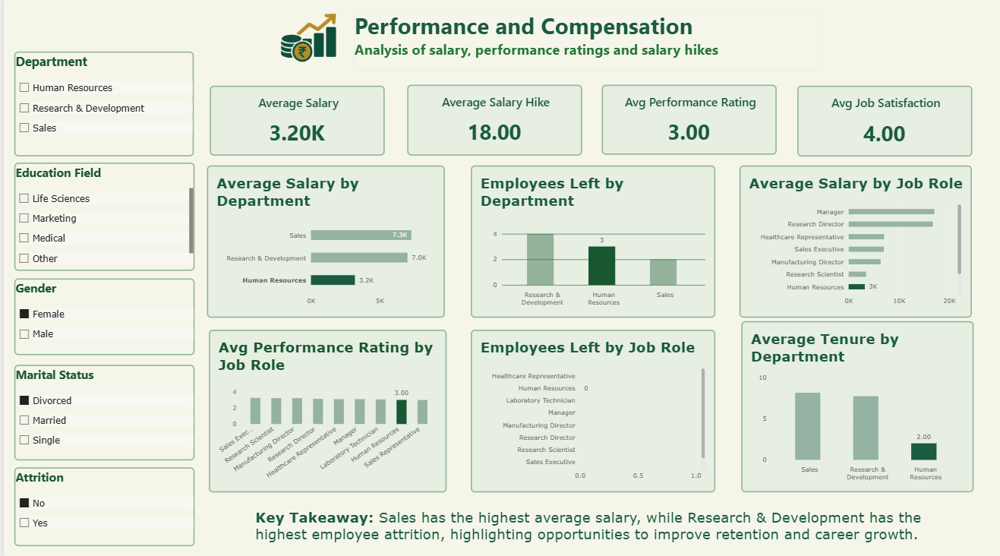
Figure 7.5.7: Dashboard Validation and KPI Verification

The Dashboard Validation process was performed to check the KPI calculations, charts, and interactive filters. The dashboard was tested by applying different slicer selections and verifying whether the displayed values and visualizations updated accordingly.
In the selected view, the dashboard displays 5 total employees, 5 employees left, and an attrition rate of 100%. Other KPI values, including average salary, salary hike, performance rating, and job satisfaction, also update based on the selected filters.
The charts were checked to ensure that employee information was displayed according to the applied filters.
Overall, the validation confirmed that the dashboard visuals and KPI cards respond to user selections and provide an interactive way to explore employee data.

7.6 Overall Result Summary
The project demonstrates how Python and Microsoft Power BI can be used together to analyze employee information and develop interactive HR dashboards.
- Successfully analyzed 1,470 employee records.
- Identified 237 employees who left the organization.
- Calculated an overall attrition rate of 16.12%.
- Calculated important workforce KPIs using DAX.
- Analyzed employee demographics and department distribution.
- Examined salary, performance, and compensation indicators.
- Explored employee satisfaction and work-life balance.
- Analyzed training, tenure, and promotion-related indicators.
- Developed five interactive dashboard pages with slicers and filters.
The HR Analytics Dashboard transforms employee data into meaningful visual insights. Python supports initial data inspection and exploratory analysis, while Power BI provides data transformation, KPI calculations, and interactive visualizations. The completed dashboard makes HR information easier to understand and explore, supporting analysis of employee attrition, workforce trends, compensation, satisfaction, and career development.

8. CONCLUSION & FUTURE SCOPE

8.1 Conclusion
The HR Analytics and Workforce Data Visualization project was successfully developed using Python and Microsoft Power BI. The project analyzes the IBM HR Analytics Employee Attrition dataset containing 1,470 employee records and 35 attributes.
Python was used for dataset loading, cleaning, preprocessing, and Exploratory Data Analysis (EDA). Microsoft Power BI was used for data transformation, DAX-based KPI calculations, and interactive dashboard development.
The project identifies 237 employees who left the organization, with an overall attrition rate of 16.12%. It also provides insights into employee demographics, department distribution, salary, performance, job satisfaction, work-life balance, and career development.
Five interactive dashboard pages were developed to present the analysis through KPI cards, charts, and slicers. These features allow users to explore employee information and understand workforce trends.
Overall, the project demonstrates how Python and Power BI can transform raw employee data into meaningful visual insights and support data-driven HR analysis.

8.2 Future Scope
The project can be further enhanced by adding the following features:
- Predictive Analytics: Implement machine learning models to predict employee attrition based on historical employee data.
- Advanced Visualizations: Add more detailed charts and analytical views for better workforce understanding.
- Real-Time Data Integration: Connect the dashboard with updated HR databases to analyze newly available employee information.
- Employee Performance Tracking: Include additional performance indicators to monitor employee development.
- Automated Reporting: Generate periodic HR reports automatically to reduce manual work.
- Advanced Filtering: Introduce additional filtering options for more detailed employee analysis.
- Cloud Deployment: Host the interactive dashboard online to make it accessible to users through a web link.
These enhancements can make the system more flexible and useful for detailed workforce analysis and HR decision-making.

9. REFERENCES
1. IBM HR Analytics Employee Attrition Dataset – Dataset used for employee data analysis.
https://www.kaggle.com/datasets/pavansubhasht/ibm-hr-analytics-attrition-dataset

2. Python Documentation – Official documentation for Python programming.
https://docs.python.org/3/

3. Pandas Documentation – Used for dataset loading, cleaning, and data manipulation.
https://pandas.pydata.org/docs/

4. NumPy Documentation – Used for numerical operations and data analysis.
https://numpy.org/doc/

5. Matplotlib Documentation – Used for creating data visualizations.
https://matplotlib.org/stable/

6. Seaborn Documentation – Used for statistical data visualization.
https://seaborn.pydata.org/

7. Microsoft Power BI Documentation – Reference for dashboard development, data transformation, and visualization.
https://learn.microsoft.com/en-us/power-bi/

8. Data Analysis Expressions (DAX) Reference – Reference for creating calculated measures and KPIs.
https://learn.microsoft.com/en-us/dax/

9. GitHub Repository – HR Analytics and Workforce Data Visualization
https://github.com/Riya-Kharade/HR-Analytics-PowerBI-Dashboard

