Name | Riya Sunil Kharade
Internship Role | AI & Cloud Research Intern

1. Introduction
As part of my internship, I was assigned the task of conducting research on User Interface (UI) and User Experience (UX) designs of various AI-based tools, Agentic AI platforms, and AI Copilot systems.
The purpose of this task is to understand how modern digital platforms design their interfaces to attract users, generate leads, and convert visitors into customers. This research also focuses on improving content structure, navigation flow, and overall user experience.
Through this task, I studied different AI tools, analyzed their screen designs, and documented important observations to help in building rich, user-friendly, and highly functional applications.

2. Objective of the Task
The main objectives of this task are:
To study UI/UX design patterns used in AI tools.
To analyze screen flows and navigation systems.
To understand how design influences user engagement.
To observe effective content presentation methods.
To identify best practices for modern applications.
To suggest improvements for better usability.

3. Task Description
This task includes:
Studying different AI tools and platforms.
Collecting and analyzing screenshots.
Understanding onboarding and dashboard designs.
Observing user journeys and interactions.
Preparing detailed documentation.
Connecting research findings with practical application.

4. Purpose of This Report
This report is prepared to document the research work done during the internship and to present key findings related to UI/UX design. It highlights important design elements and provides useful suggestions for creating better digital products.

Tool 1: Eloquent AI
Screenshot 1: Chatbot Demo Interface
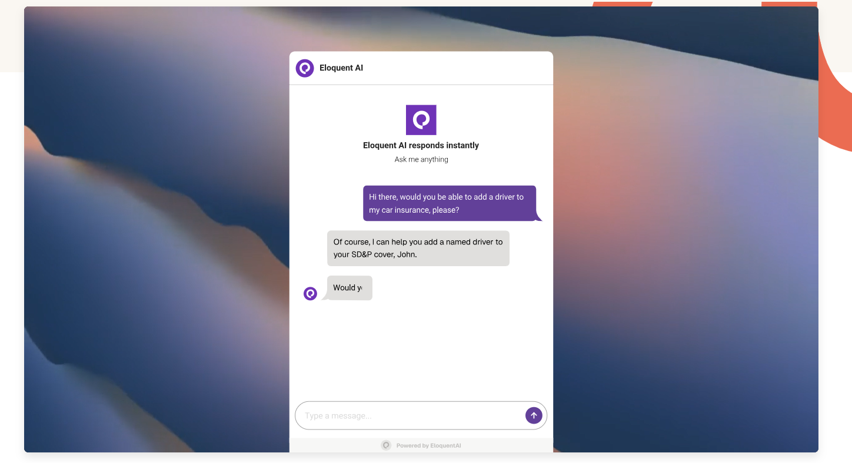
Why this is added:
- Shows live demo on homepage
- Helps users understand product quickly
- Clean chat interface
- Proper input box and icons
Design Learning:
- Demo increases user engagement
- Simple UI builds trust
- Interactive elements attract users
- Can be used in our product homepage

Screenshot 2: Product Tabs and Feature Cards
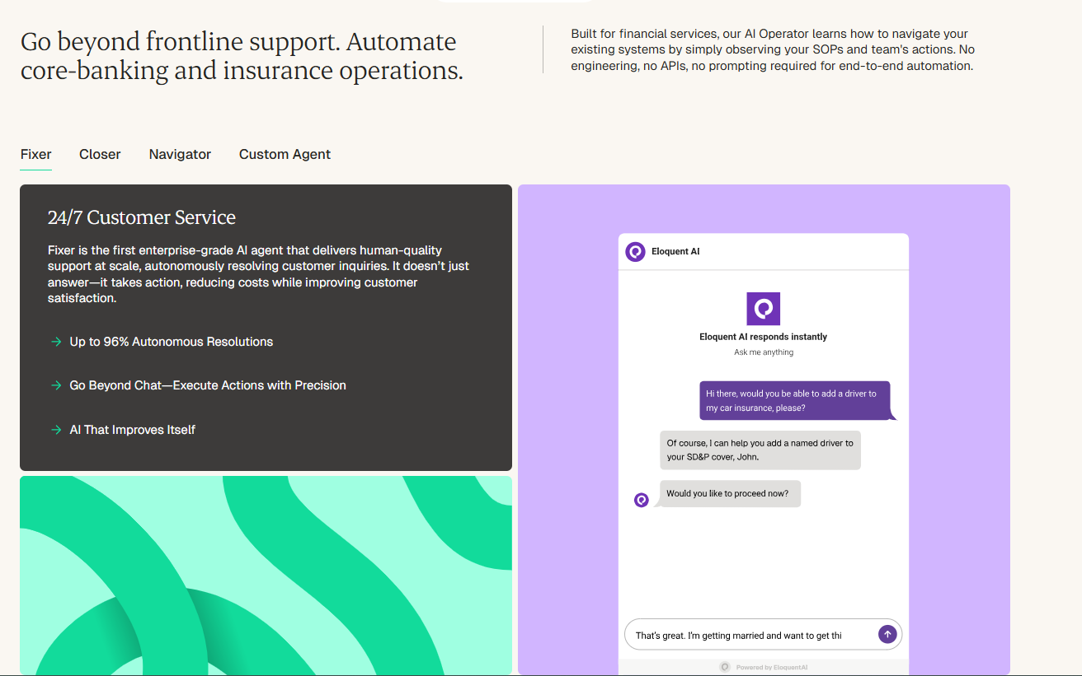
Demo Video: Product Overview and Feature Demonstration See Demo
Why this is added:
- Shows different products in tab format
- Helps users switch between features easily
- Displays product name and short description
- Provides demo preview before request
- Organizes content in one place
Design Learning:
- Tab layout improves navigation
- Reduces page clutter
- Makes comparison easy
- Improves user understanding
- Can be used for modules/features section in our website

Tool 2: Eloquent AI
Screenshot 1: Partnership Tiers

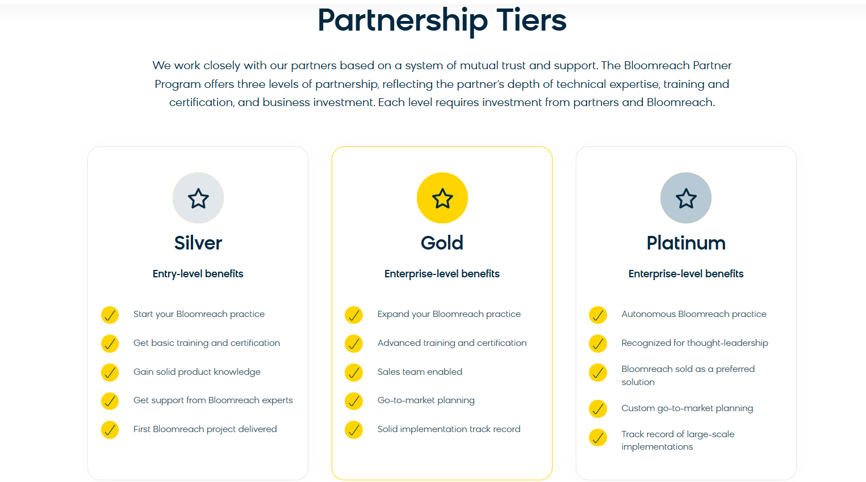

Why this is added:
- Shows tier-based layout for different partner levels
- Uses cards for easy comparison
- Icons highlight important features
- Clear separation between plans
Design Learning:
- Card layout improves readability
- Icons make content more attractive
- Proper alignment looks professional
- Can be used for pricing/modules in our website

Tool 3: CoreWeave
Screenshot 1: Service Cards Layout
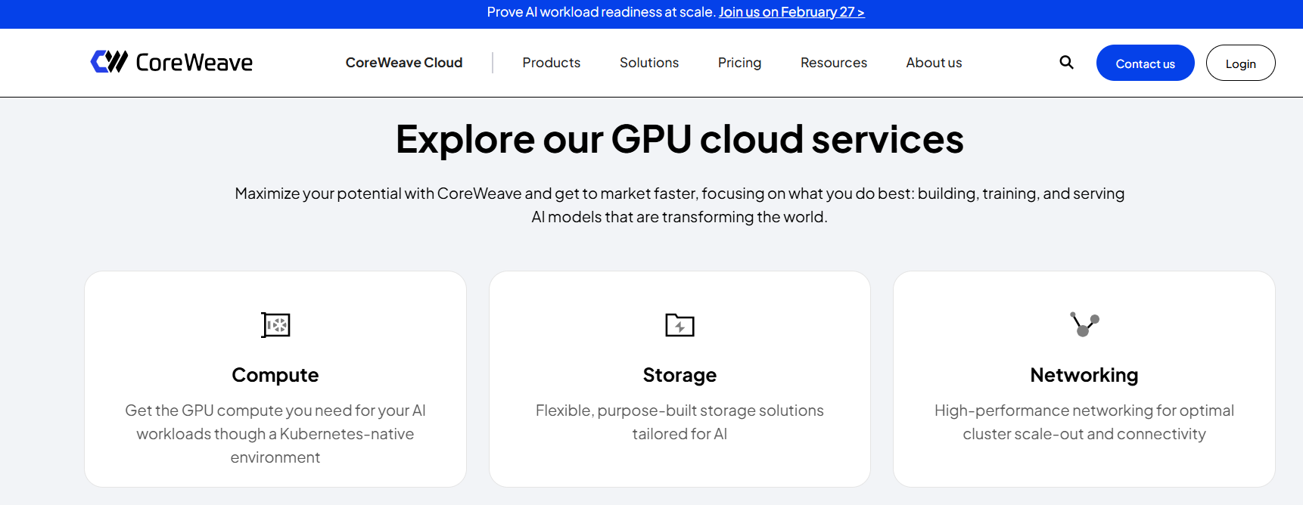
Why this is added:
- Shows main section with multiple service cards
- Each card has centered icon, title, and description
- Clean and structured layout
- Proper spacing between cards
- Cards are not stuck to the main layout
Design Learning:
- Center alignment makes content look balanced
- Proper margin from main layout improves visual clarity
- Good padding inside cards improves readability
- Icon + title + short description structure is effective
- Can use similar card layout for our services/modules section

Screenshot2 : Service Cards with Hover Effect
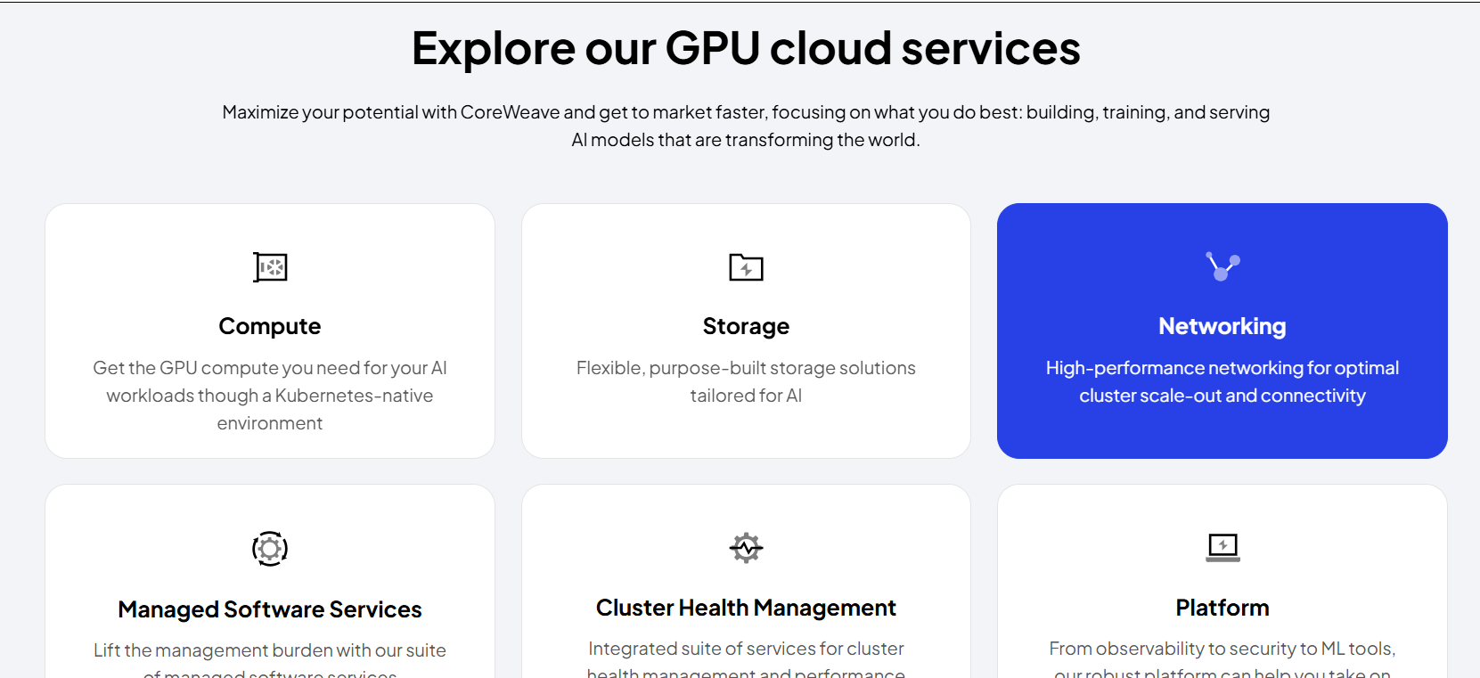
Demo Video: Service Cards with Hover Effect : See Demo
Why this is added:
- Shows multiple service cards in grid format
- Each card has centered icon, title, and description
- Hover effect highlights the selected card
- Changes background color on interaction
- Improves user engagement
- Proper margin and padding used
Design Learning:
- Hover effects improve interactivity
- Highlighted cards attract user attention
- Center alignment looks clean and balanced
- Good spacing improves visual structure
- Can use similar hover-based cards in our website

Tool 4: Lambda.ai
Screenshot1: Hero Section with CTA Buttons (Lambda)
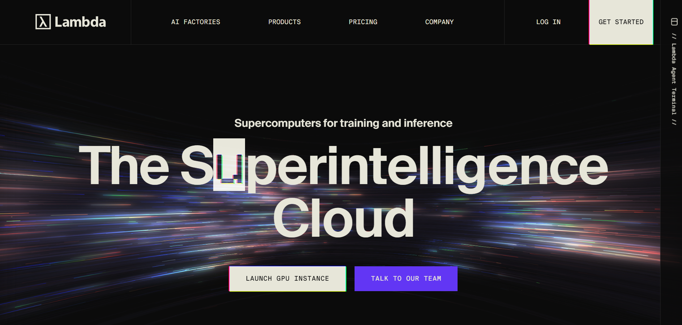
Why this is added:
- Strong and bold main title
- Dark theme with high contrast text (Toggle button for theme Light/Dark)
- Two clear CTA buttons (Get Started / Talk to Team)
- Simple top navigation
- Clean and focused hero layout
Design Learning:
- Large bold heading grabs attention
- Dark background with light text improves visibility
- Dual CTA buttons improve conversion
- Simple layout keeps focus on main message
- Can follow similar hero layout with improved font and color styling

Screenshot2: Login Page UI
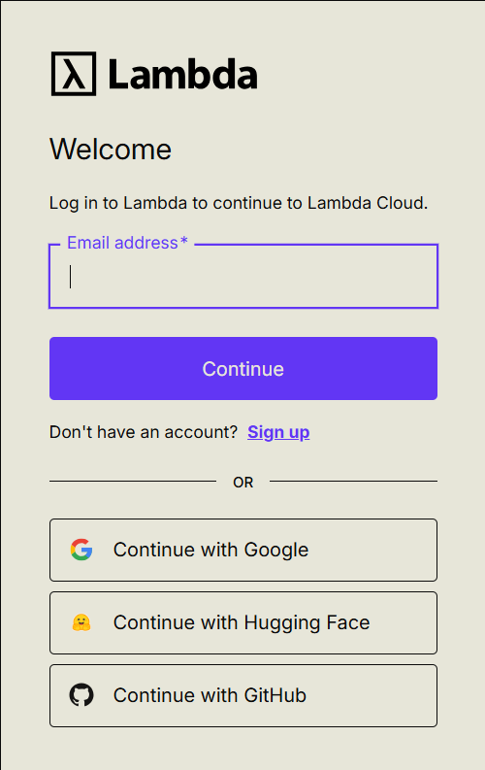
Why this is added:
- Simple and clean login layout
- Clear email input field
- Large and visible Continue button
- Social login options (Google, GitHub, Hugging Face)
- Easy Sign Up option
Design Learning:
- Minimal design reduces user confusion
- Clear buttons improve usability
- Social login saves user time
- Proper spacing improves readability
- Can use similar layout for our login system

Tool 5: together.ai
Screenshot1: Solutions Dropdown Hover Card
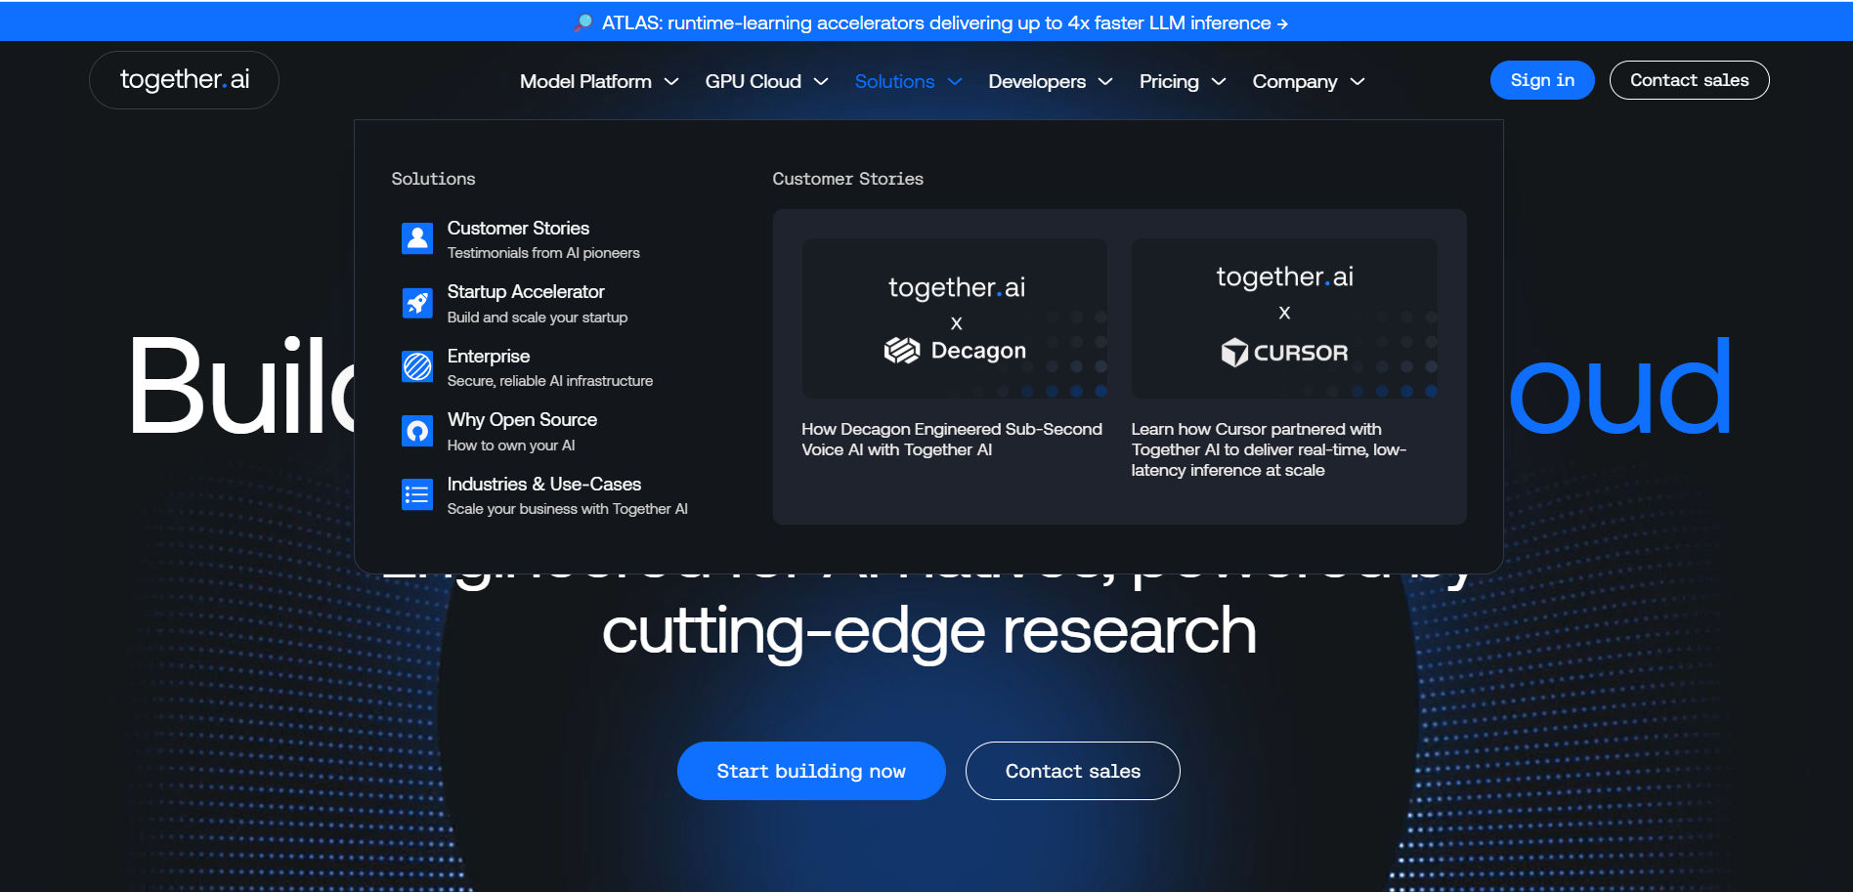
Why this is added:
- Dropdown opens on hover from navbar
- Shows structured solution categories
- Includes icons and short descriptions
- Displays featured customer stories
- Organized multi-column layout
Design Learning:
- Hover dropdown improves navigation
- Categorized layout makes content easy to scan
- Icons improve visual clarity
- Featured cards increase engagement
- Can implement similar hover dropdown for Product and Solutions tab in our website

Tool 6: RankAI
Screenshot1: Footer Design and Layout
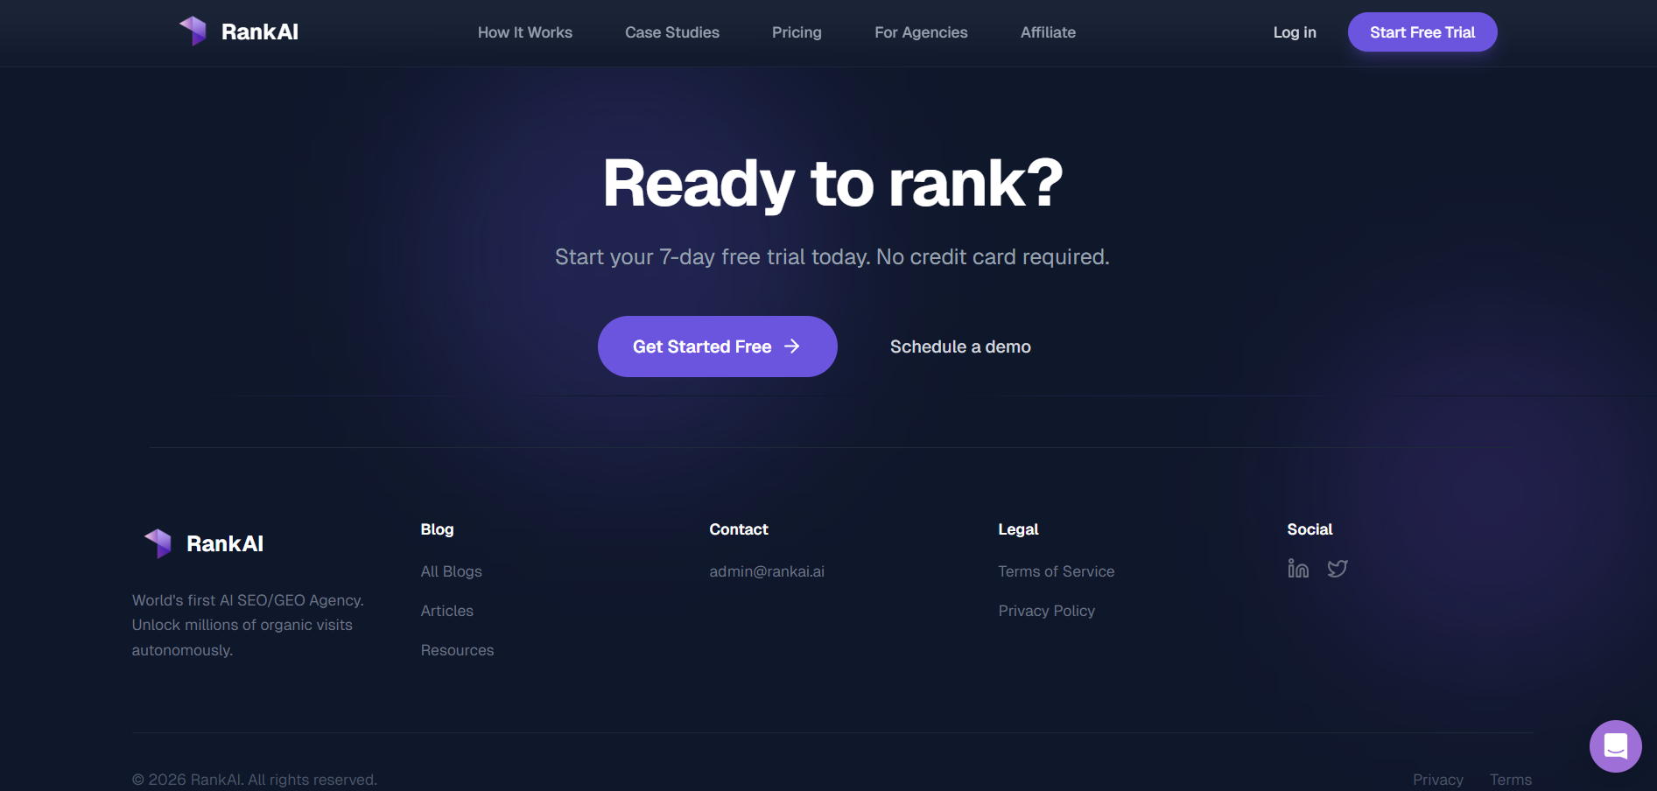
Why this is added:
- Shows structured footer with multiple sections
- Includes company logo and tagline
- Displays important links clearly
- Contains contact and legal information
- Includes social media icons
Design Learning:
- Multi-column footer improves organization
- Separating links and contact details improves clarity
- Social icons increase brand visibility
- Footer looks more professional and complete
- Can create 4-column footer: Company Info, Links, Contact, Social Media
- Add Terms & Conditions and Privacy Policy at bottom
- Maintain consistent spacing and alignment
- Use clear headings for each section

Screenshot2: Help Widget and Scroll-to-Top Button
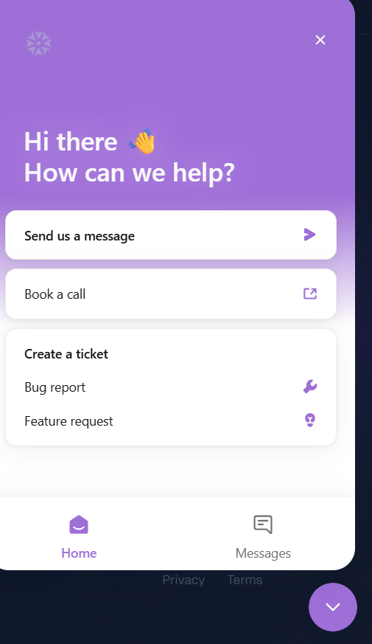
Why this is added:
- Provides quick access to customer support through a floating help widget
- Allows users to send messages, book calls, and create tickets easily
- Improves user experience by offering multiple support options in one place
- Includes a bottom-to-top arrow for fast navigation on long pages
- Helps users avoid unnecessary scrolling
Design Learning:
- Floating support icons improve accessibility and visibility
- Organized layout makes support options easy to understand
- Consistent color theme improves brand identity
- Proper margin and padding make the interface look clean
- Clear icons improve usability and reduce confusion
Tool 7: Tejas AI [https://www.trytejas.ai/]
Screenshot1: Pricing Section Layout
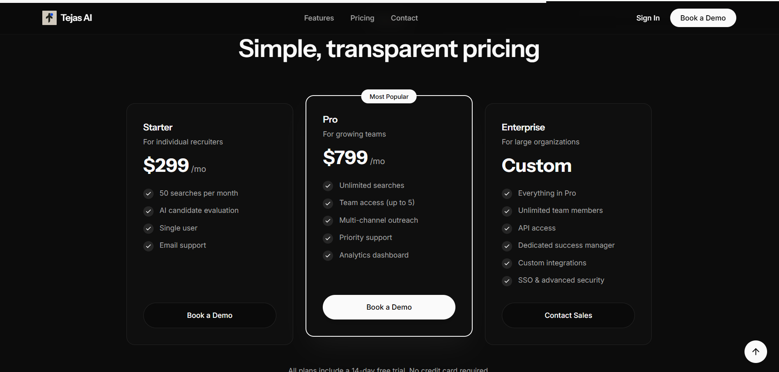
Why this is added:
- Shows clear pricing plans in card format
- Displays price, features, and target users for each plan
- Highlights the most popular plan in the center
- Includes clear CTA buttons (Book a Demo / Contact Sales)
- Helps users compare plans easily
Design Learning:
- Card-based pricing layout improves readability
- Highlighting popular plans guides user decisions
- Clear feature lists improve transparency
- Proper spacing makes content easy to scan
- Well-structured layout improves overall user experience

Screenshot2: FAQ Section with Expandable Questions
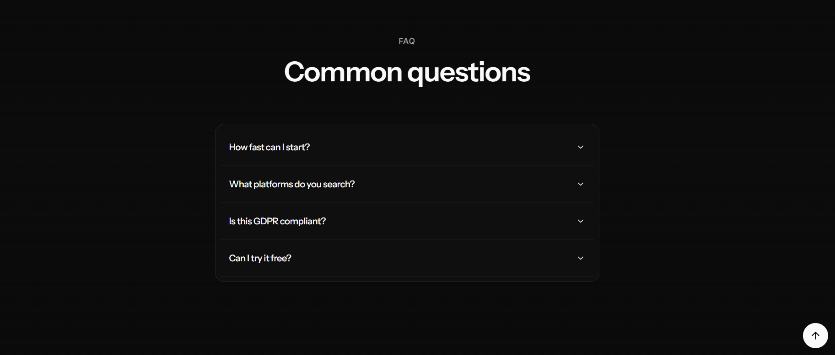
Why this is added:
- Shows FAQ section with collapsible questions
- Allows users to view answers by clicking the arrow
- Keeps the page clean by hiding extra content
- Helps users quickly find common information
- Improves understanding of the product
Design Learning:
- Expandable layout saves screen space
- Clean design improves readability
- Smooth interaction improves user experience
- Organized FAQs reduce support queries
- Can add similar section to explain features clearly

Tool 8: Palomma [https://www.palomma.com/es]
Screenshot1: Header Navigation with Language Selector

Why this is added:
- Shows clean and simple header layout
- Provides easy access to main navigation links
- Includes clear CTA buttons (Schedule a Demo / Portal)
- Supports language selection for different regions
- Improves accessibility for international users
Design Learning:
- Simple navigation improves user experience
- Language switch option supports global users
- Clear buttons improve engagement
- Hover effects improve interactivity
- Can implement similar header design for better usability

Conclusion
In this UI/UX research task, I analyzed screenshots from eight different AI-based platforms and websites to understand how modern digital products design their interfaces for better user experience, engagement, and conversion.
From the analysis of chatbot demos and interactive interfaces, it was observed that showing live product functionality on the homepage helps users quickly understand the product and builds trust.
The study of service cards and feature layouts showed that well-structured card designs with proper icons, titles, and spacing improve readability and make information easy to scan.
The navigation and dropdown menu analysis highlighted the importance of organized menus, hover effects, and categorized layouts, which help users explore products and solutions smoothly.
The pricing section analysis demonstrated that transparent and well-aligned pricing cards improve clarity and support better decision-making by users.
The footer design comparison showed that multi-column footers with clear sections for company information, links, contact details, and social media improve website professionalism and accessibility.
The help widget and scroll-to-top button analysis emphasized the importance of quick support access and easy navigation for enhancing overall usability.
The FAQ section analysis proved that expandable question layouts help users find answers easily while keeping the interface clean and organized.
Finally, the header and language selector analysis showed that simple navigation and regional language support improve accessibility and create a better experience for global users.
Overall, this research helped in understanding how good UI/UX practices such as clean layouts, proper spacing, clear call-to-action buttons, interactive elements, and organized content structure can significantly improve website appearance and user satisfaction. These learnings can be applied to improve our website design, increase user engagement, and support better lead conversion.

