From Strategy to Automation: AI Agents & n8n for Business Leaders
Event: n8n Business Lab (November 2025)
Speaker: Amal – CTO & Co-founder, Avani | n8n Ambassador
From Strategy to Automation: AI Agents & n8n for Business Leaders - n8n Business Lab (November 2025) - YouTube

~ Prepared by Riya Sunil Kharade

1. Overview
This session explains the concept of AI Agents and demonstrates how they can be used in real-world business workflows using n8n (NA10). The speaker focuses on moving from strategy to practical automation, showing how AI agents act as digital coworkers that automate repetitive, time-consuming tasks.

2. Speaker Introduction
Amal introduces himself as the CTO and co-founder of Avani.
He is an n8n ambassador conducting workshops globally across multiple cities.
The objective of the talk is to provide a holistic understanding of AI agents, from basic concepts to live, real-world use cases.
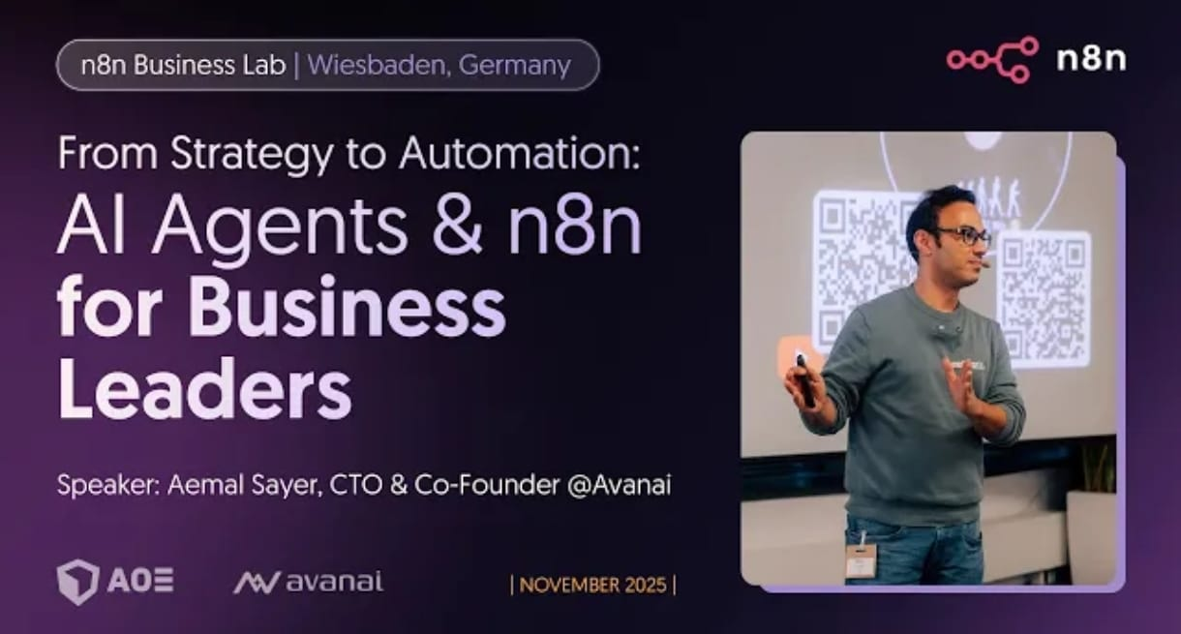

3. Live Demo: Invoice Automation Workflow
- Use Case: Invoice & Receipt Processing
- Amal demonstrates a real-life workflow used daily during business travel.
- Receipts are scanned using the Google Drive mobile app.
- The scanned invoice triggers an n8n workflow.
- Mistral AI OCR extracts structured data from the receipt.
- The processed data is automatically shared with the accounting team, including:
- Invoice details
- Key Outcome: Manual invoice handling is eliminated, saving time and reducing errors.

4. What is an AI Agent?
- An AI agent is described as a digital coworker.
- It can understand natural language
- Reason and make decisions
- Use tools and workflows
- Operate autonomously
- Key Insight: AI agents are not future technology they are already actively used in daily work.

5. AI-Based Voice Automation Architecture
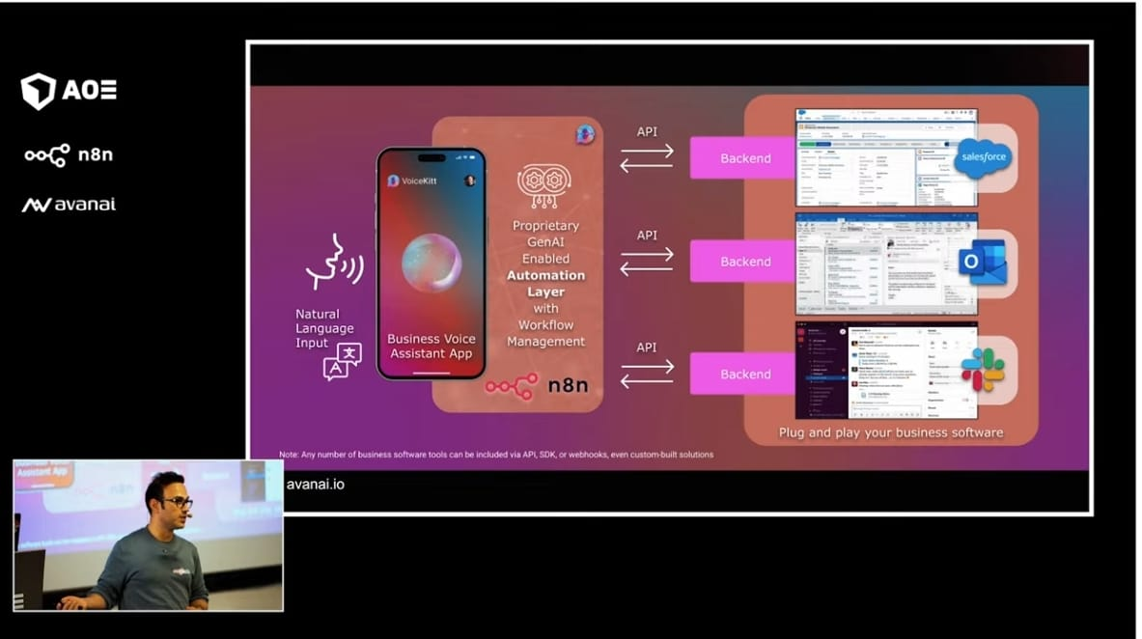
AI-Based Voice Automation Architecture using n8n

Description:
This image shows an AI-powered business voice assistant architecture where natural language input is processed through a GenAI automation layer using n8n, enabling seamless API-based integration with backend business tools like CRM, email, and collaboration platforms.

6. Voice AI Agent Demonstration
- Amal showcases a voice AI agent built using his own voice clone.
- A volunteer interacts with the AI agent in real time.
- The agent responds naturally and contextually.
- Importance: Voice AI enables human-like interaction, making AI agents more accessible and practical.

7. AI Agents as Digital Coworkers
- AI agents are positioned as full-time coworkers with:
- 24/7 availability
- High intelligence
- No fatigue
- Low operational cost
- Key Statement:
- Organizations that adopt AI agents early will gain a major productivity advantage.

8. Business Use Cases for AI Agents
- High-Impact Applications:
- Invoice reconciliation
- Cash flow prediction
- Compliance and auditing
- Contract analysis and optimization
- Automated voice calls for rent reminders
- These tasks involve large volumes of data, where AI agents outperform humans in speed and accuracy.

9. Blindclick
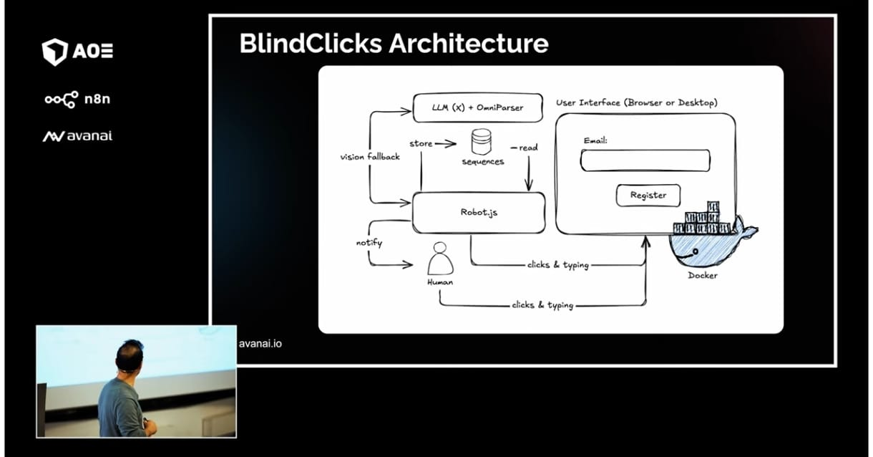
BlindClicks AI Automation Architecture
Description:
This diagram shows the BlindClicks architecture, where an AI agent uses an LLM with vision support to understand screen content and automate user interface actions such as clicking and typing inside browser or desktop applications running in Docker, with human fallback when needed.

10. AI in Software Development
- Coding has been heavily disrupted by AI agents.
- Concept of “vibe coding” introduced.
- AI agents can autonomously build workflows and applications in hours.

11. Tools & Platforms Mentioned
- n8n – workflow orchestration
- CrewAI – Python-based agent orchestration
- ElevenLabs – voice AI and cloning
- OpenAI & Google SDKs – AI development
- Mastra – TypeScript-based AI agent framework

12. Sample Workflow
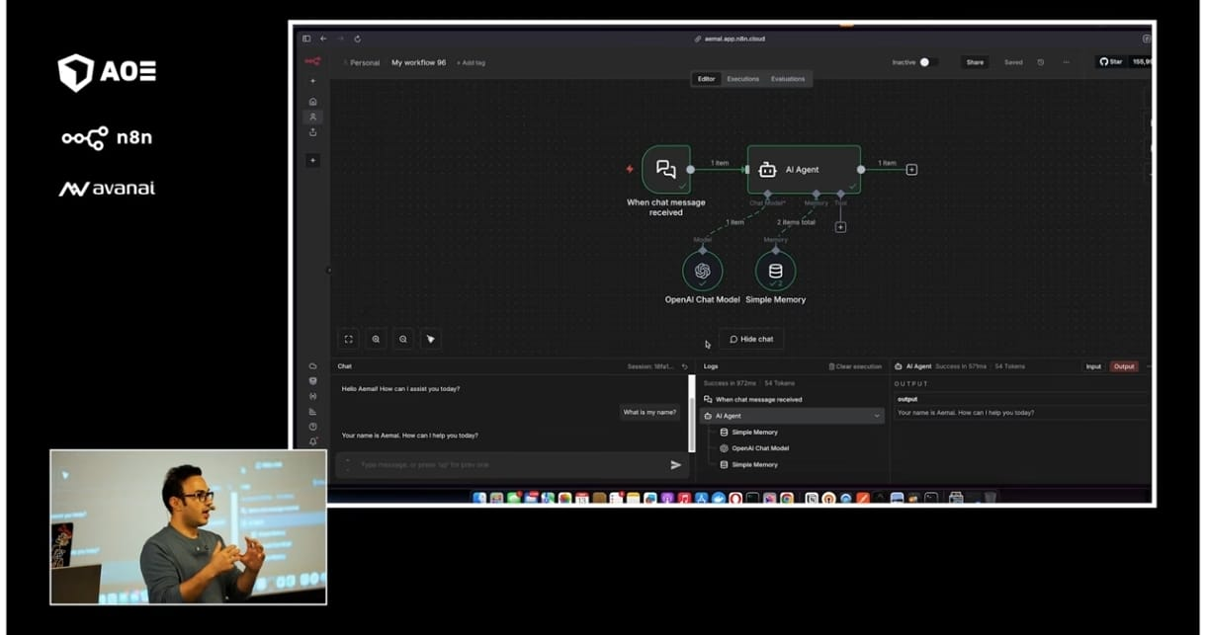
AI Agent Workflow with Memory in n8n
Description:
This image displays an n8n workflow where an AI agent is triggered by a chat message, uses an OpenAI chat model, and stores context using a simple memory node to generate consistent and personalized responses.
13. Automation Without APIs: Computer-Using AI
- AI agents can now:
- Move mouse
- Read screens
- Click buttons
- Fill forms
- Project Highlight: Blind Clicks
- Open-source project created by Amal.
- Uses computer vision and LLMs to automate software that has no APIs.
- Executes tasks inside Docker containers using screenshots and UI understanding.

14. Key Insights
- AI agents are already transforming knowledge work.
- The biggest barrier to adoption is mindset, not technology.
- Human-in-the-loop systems are essential to maintain control and accuracy.
- AI agents will significantly reduce working hours while increasing productivity.

15. Conclusion
- The session demonstrates that AI agents are operational, scalable, and practical today.
- With platforms like n8n, businesses can rapidly build automation workflows without heavy coding.
- AI agents will soon become standard digital coworkers, fundamentally reshaping how work is done.

