Combining Company Knowledge with AI using Retrieval-Augmented Generation (RAG)
https://youtu.be/ERQCq1RUTQc?si=3TFPs3szu3bkeF9l

~ Prepared by Riya Sunil Kharade

1. Introduction
- Large Language Models (LLMs) such as ChatGPT are powerful tools that can answer general questions using publicly available data. However, they do not have access to company-specific or internal knowledge, which is critical for real business use cases.
- To solve this problem, organizations combine company data with AI models using a technique called Retrieval-Augmented Generation (RAG). This document explains:
- Why company knowledge is important for AI
- How RAG works
- Challenges in naïve RAG
- Advanced RAG and agent-based approaches
- Importance of AI evaluation

2. Why Company Knowledge is Important
- LLMs have the following limitations:
- They are trained only on public data
- They have a knowledge cutoff date
- They may generate hallucinated (incorrect but confident) answers
- They lack traceability and trust
- For business applications, AI must:
- Use domain-specific knowledge
- Access up-to-date internal data
- Provide grounded and trustworthy answers
- Instead of training custom models, modern AI systems add company knowledge at query time using prompts and retrieval mechanisms.

3. Challenges with Large Context Windows
- Although modern LLMs support large context windows, using them has problems:
- High cost
- Slower responses
- Confusing the model with too much information
- “Needle in a haystack” problem
- To solve this, AI systems should provide only the most relevant data, not everything.

4. Why LLMs Cannot Access Internal Company Knowledge
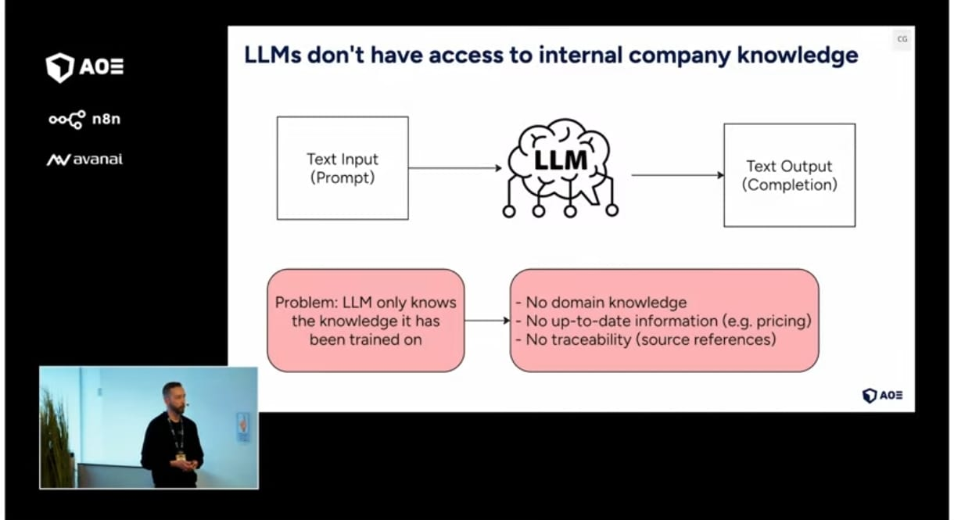
Limitation of Large Language Models in Enterprise Use Cases

Description:
This image explains that Large Language Models (LLMs) generate answers only based on their training data. They do not have access to internal company knowledge, real-time information, or source traceability, which limits their effectiveness for business applications.

5. What is Retrieval-Augmented Generation (RAG)
- RAG is a framework that allows LLMs to access external knowledge sources.
- RAG has two main components:
- Indexing (Ingestion):
- Company data is prepared and stored
- Data is converted into vector embeddings
- Stored in a vector database
- Retrieval (Inference):
- Relevant information is retrieved based on the user query
- Retrieved data is added to the prompt
- LLM generates a grounded answer
- Vector databases store information based on meaning, not keywords, allowing semantic search.

6. Naïve RAG Example (Recipe Use Case)
- A recipe database was used as an example:
- Recipes stored with name, ingredients, steps, and time
- Data chunked and embedded into a vector store
- On user query, relevant chunks are retrieved and sent to the LLM
- Problems observed:
- Mixed recipe instructions
- Loss of context due to small chunks
- Incorrect or irrelevant answers

7. Key Challenges in Naïve RAG

7.1 Poor Indexing and Retrieval
- Chunks from different documents mix together
- Context is lost
- Leads to wrong answers
- Solution:
- Use larger chunks
- Attach metadata like recipe ID or name
- Preserve document-level context

7.2 Hallucination
- LLM answers even when no relevant data is found
- Answers appear correct but are not grounded
- Solution:
- Strict system prompts
- Guardrails to check if data was actually retrieved
- Block responses when no valid knowledge exists

7.3 Semantic Search Fails for Structured Data
- Semantic search alone cannot handle:
- Numeric filters (time, price, quantity)
- Structured fields (servings, preparation time)
- Solution:
- Combine semantic search with metadata filtering
- Extract structured data during indexing
- Example: filtering recipes under 12 minutes

8.High-Level Architecture of Retrieval-Augmented Generation (RAG)
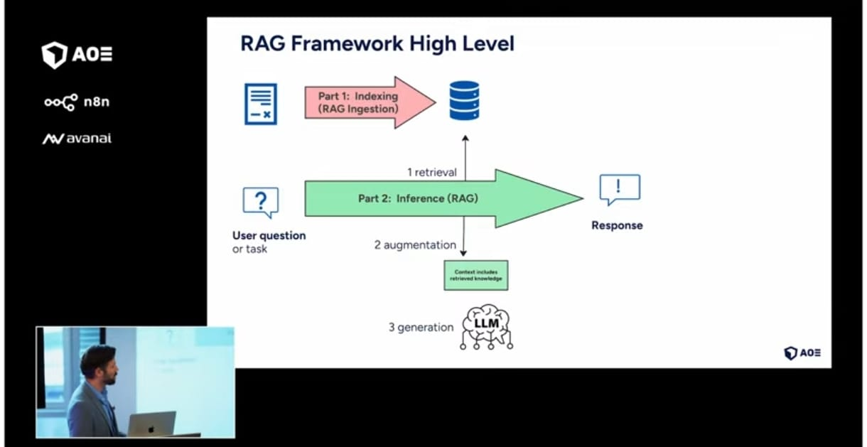
RAG Framework: Indexing and Inference Workflow

Description:
This image shows the high-level working of the RAG framework. It consists of two main parts: indexing, where company data is prepared and stored, and inference, where relevant knowledge is retrieved, added to the prompt, and used by the LLM to generate a grounded response.

9. Advanced RAG with AI-assisted Indexing
- AI is now used during indexing to:
- Extract preparation time from text
- Normalize ingredients
- Summarize long documents
- Enrich metadata
- This improves retrieval quality and enables complex queries.

10. Agentic RAG Architecture
- Agent-based RAG gives AI more autonomy.
- Key features:
- AI decides which tool to use
- Multiple retrieval tools available
- Iterative retrieval if needed
- Dynamic query rewriting
- Examples of tools used:
- Vector search
- Metadata-based filters
- Text-to-SQL queries
- Knowledge graphs
- API calls
- This approach is more flexible than linear RAG pipelines.

11. AI Evaluation: Why It Is Essential
- LLMs are:
- Non-deterministic
- Frequently updated
- Sensitive to prompt changes
- Manual testing is not scalable for enterprise systems.
- Evaluation Approach:
- Prepare a dataset of questions and expected answers
- Run AI on all questions
- Store actual responses
- Use another LLM as a judge to compare answers
- Evaluation Metrics:
- Correctness
- Groundedness
- Helpfulness
- Relevance
- This enables evaluation-driven AI development, similar to test-driven development in software engineering.

12. Vector Database – How It Works
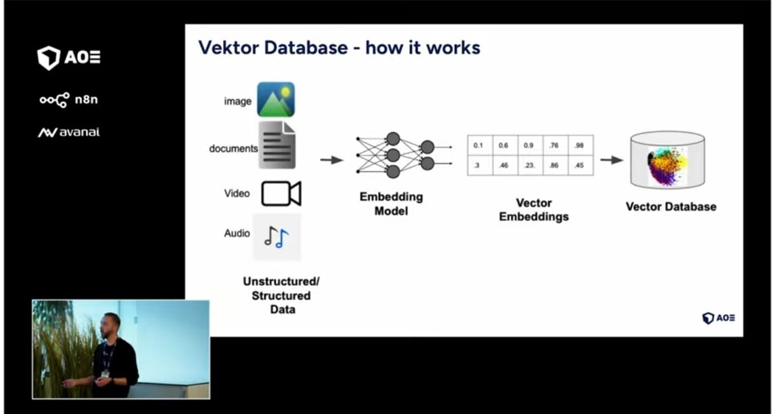
This image explains how a vector database stores and retrieves data based on meaning instead of exact keywords. Different types of data are converted into numerical vectors using embedding models and stored for semantic search.

Working Explanation (Step-by-Step)
- Step 1: Input Data
- The system starts with different types of data, such as:
- Text documents
- Images
- Videos
- Audio files
- This data can be structured or unstructured.

- Step 2: Embedding Model
- An embedding model processes the input data and converts it into numerical representations called vector embeddings.
- Each piece of data is converted into a list of numbers
- These numbers represent the meaning and context of the data

- Step 3: Vector Embeddings
- The generated vectors look like numeric arrays (for example: 0.1, 0.6, 0.9, etc.).
- Similar data produces similar vectors
- Different data produces distant vectors

- Step 4: Storage in Vector Database
- These vector embeddings are stored in a vector database.
- The database

13. Evaluation Pipeline in n8n for AI Applications
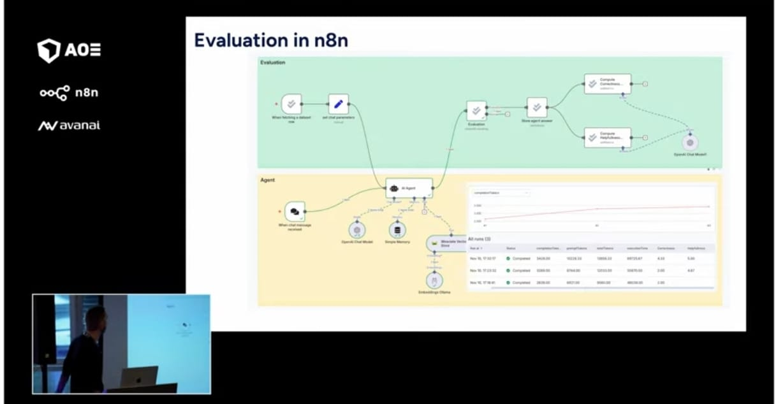
Evaluation Pipeline in n8n
This image shows how AI responses are automatically evaluated in n8n. The workflow compares expected answers with actual AI outputs and calculates evaluation metrics to measure the quality and reliability of the AI system.

Working Explanation (Step-by-Step)
- Step 1: Input Evaluation Dataset
- A predefined dataset is used that contains:
- Test questions
- Expected (ideal) answers
- This dataset acts as a benchmark for evaluation.
- Step 2: AI Agent Execution
- Each question from the dataset is passed to the AI agent:
- The agent retrieves knowledge (RAG)
- Generates an actual response
- Stores the output for evaluation
- Step 3: Store Expected and Actual Answers
- Both expected answers and AI-generated answers are stored in a data store for comparison.
- Step 4: Automated Evaluation using LLM
- Another LLM is used as a judge to compare:
- Expected answer vs Actual answer
- The evaluator checks:
- Correctness
- Relevance
- Helpfulness
- Groundedness
- Step 5: Metric Calculation
- The evaluation workflow calculates metrics such as:
- Completeness score
- Helpfulness score
- Correctness score
- These scores help measure AI performance objectively.
- Step 6: Visualization and Analysis
- The results are displayed using:
- Tables
- Graphs
- Trends over time
- This helps in tracking improvements or regressions after changes in prompts, models, or retrieval logic.

14. Why Evaluation in n8n is Important
- LLMs are non-deterministic
- Model versions change over time
- Manual testing is not scalable
- Automated evaluation ensures consistent AI quality

11. Key Takeaways
- Data preparation is business logic
- A strong indexing pipeline is critical for good AI results.
- RAG architectures are evolving
- Agentic and tool-based RAG systems are becoming standard.
- Evaluation is mandatory
- Automated AI evaluation ensures reliability and quality at scale.

12. Conclusion
Retrieval-Augmented Generation enables AI systems to use company knowledge effectively. By improving indexing, using metadata, adopting agent-based architectures, and implementing automated evaluation, organizations can build trustworthy, scalable, and enterprise-ready AI applications.

