Name: Riya Sunil Kharade
Module 2
Integrations & Node Mastery | HTTP Request node (critical skill)
 | API pagination and authentication patterns
 | Working with SaaS nodes (Slack, Jira, Salesforce, GitHub, etc.)
 | Custom headers, OAuth, token refresh
 | Lab 2 - Build an API-to-API sync workflow
 | Build an API-to-API sync workflow
 | Implement retry logic and rate-limit handling

Objective:
This module focuses on mastering integrations in n8n by effectively using the HTTP Request node and built-in SaaS nodes. The goal is to understand how APIs communicate, handle authentication, manage pagination, and build reliable API-to-API synchronization workflows with proper error handling.

1. HTTP Request Node (Critical Skill)
The HTTP Request node is one of the most important nodes in n8n. It allows workflows to interact with external APIs when a dedicated n8n node is not available.
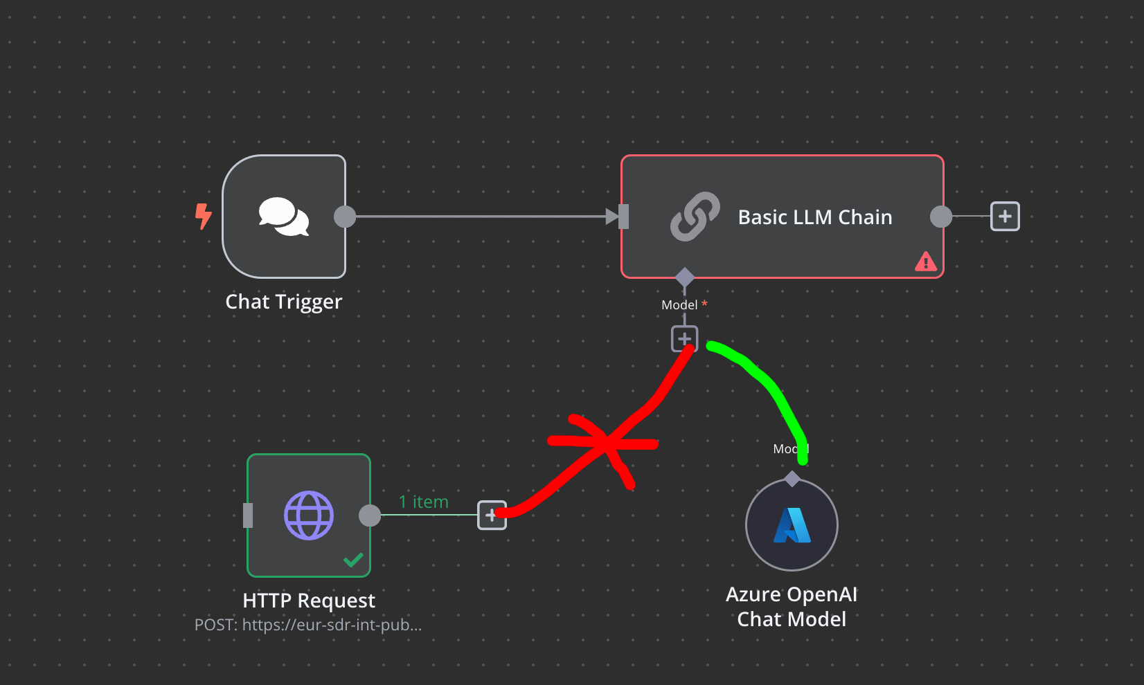
Key Capabilities
- Supports HTTP methods: GET, POST, PUT, PATCH, DELETE
- Sends and receives JSON data
- Handles authentication and headers
- Works with REST APIs and web services
Common Use Cases
- Fetch data from external systems
- Send data to third-party applications
- Integrate custom or internal APIs
- Replace manual API calls with automation
Configuration Parameters
- URL: API endpoint
- Method: Type of HTTP request
- Headers: Custom headers such as Authorization
- Body: JSON payload for POST/PUT requests
- Query Parameters: Used for filtering and pagination

2. API Pagination and Authentication Patterns
API Pagination: Many APIs return data in pages instead of sending all records at once.
Common Pagination Techniques
- Page-based: page=1, page=2
- Offset-based: offset and limit
- Cursor-based: next_cursor or next_token
Implementation in n8n
- Use Looping with IF and Merge nodes
- Store page or cursor value in workflow variables
- Continue execution until no more pages exist
Authentication Patterns: APIs require authentication to ensure secure access.
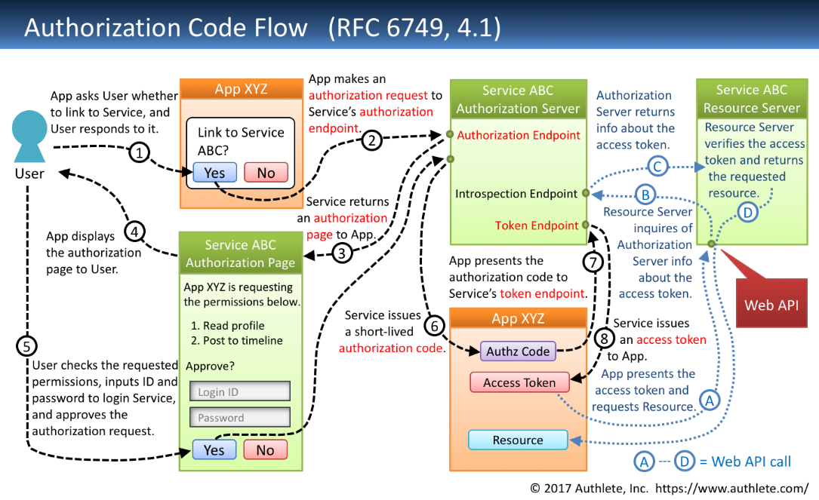
Common Types
- API Key Authentication
- Bearer Token Authentication
- OAuth 2.0
- Basic Authentication
n8n supports credentials management to securely store and reuse authentication details.

3. Working with SaaS Nodes (Slack, Jira, Salesforce, GitHub, etc.)
n8n provides pre-built nodes for popular SaaS platforms.
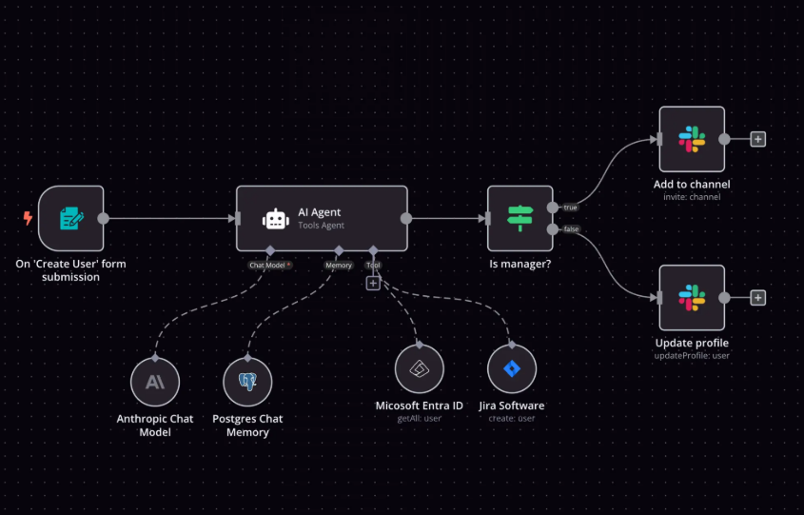 Advantages of SaaS Nodes
- No need to manually handle API endpoints
- Built-in authentication support
- Simplified configuration
- Faster workflow development
Examples
- Slack: Send messages, alerts, and notifications
- GitHub: Create issues, fetch repositories, manage commits
- Jira: Create and update tickets
- Salesforce: Manage CRM records
Best Practice
- Use SaaS nodes when available
- Use HTTP Request node for unsupported or advanced API operations

4. Custom Headers, OAuth, and Token Refresh
Custom Headers: Used to pass additional information such as:
- Authorization tokens
- Content type
- API version
Example:
Authorization: Bearer <access_token>
Content-Type: application/json
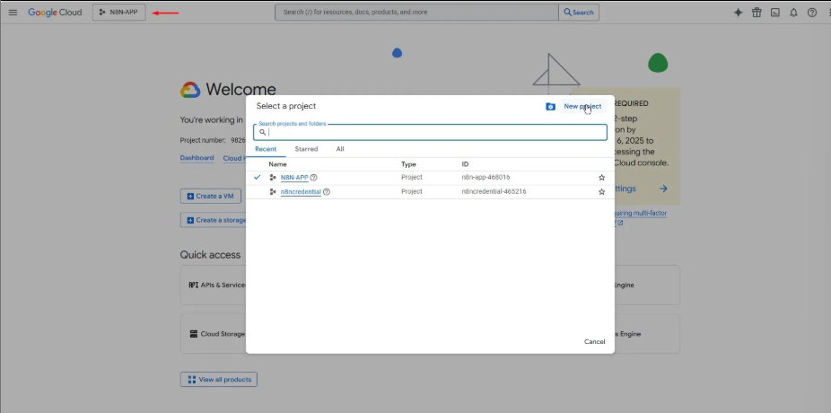
OAuth 2.0 Authentication: OAuth is commonly used by SaaS platforms for secure access.
OAuth Flow in n8n
- User authorizes application
- Access token is generated
- Token is stored in credentials
- Token is refreshed automatically when expired
Token Refresh Handling
- n8n automatically refreshes tokens when configured
- Prevents workflow failures due to expired tokens
5. Lab 2: Build an API-to-API Sync Workflow
Objective: Create a workflow that synchronizes data between two different APIs automatically.
Workflow Overview
- Fetch data from Source API
- Transform data into required format
- Send data to Destination API
- Handle errors and retries
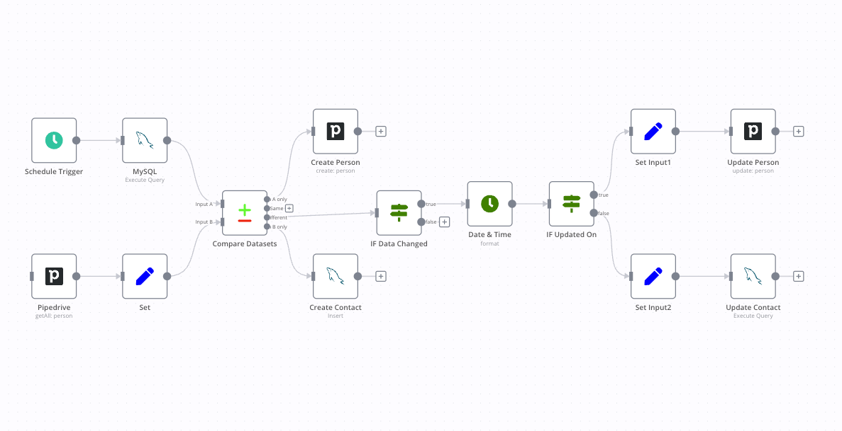
Nodes Used
- HTTP Request (Source API)
- Set / Function node (Data transformation)
- HTTP Request (Destination API)
- IF node (Validation)
- Error handling workflow

Steps
- Trigger workflow manually or using Cron
- Fetch records from Source API
- Map required fields
- Push data to Destination API
- Log success or failure

6. Implement Retry Logic and Rate-Limit Handling
Retry Logic
Retry logic ensures reliability when APIs temporarily fail.
Implementation
- Configure Retry on Fail in HTTP Request node
- Set retry count and delay
- Handle network or timeout errors gracefully

Rate-Limit Handling
APIs limit the number of requests per minute/hour.
Strategies
- Introduce delays using Wait node
- Batch requests
- Respect API rate-limit headers
- Avoid parallel execution when limits are strict

7. Outcome of This Module
After completing this module, the learner will be able to:
- Integrate any REST API using n8n
- Handle authentication securely
- Manage pagination efficiently
- Build robust API-to-API sync workflows
- Implement retries and handle rate-limits
- Work confidently with SaaS and custom APIs

Conclusion
This module builds a strong foundation in API integrations using n8n. Mastering these concepts is essential for building scalable, reliable, and production-ready automation workflows.

