**Project Title : Ecommerce Website Using React JS**

**Steps to create the React application:**

**Step 1: Create React Project**

npm create-react-app myreactapp

**Step 2: Change your directory and enter your main folder charting as**

cd myreactapp

**Step 3: Project Structure**

Organize Your Project:

Create separate folders for components, pages, services, and styles to keep your project organized.

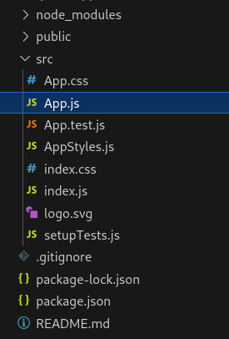

**Step to Run Application: Run the application using the following command from the root directory of the project:**

npm start

**Step 4:** **Authentication**

User Authentication:

Implement user authentication for both admin and regular users.

**Step 5: Admin Panel**

Admin Panel:

Create an admin panel with components for login, signup, and the admin dashboard.

Admin Login:

Create a login page for the admin.

Admin Signup:

Create a signup page for new admin accounts.

Admin Dashboard:

After successful login/signup, display the admin dashboard where you can manage products.

**Step 6: Product Management**

Product Management:

Implement functionality to add, delete, and view products in the admin dashboard.

Add Products:

Create a form to add new products with details like name, brand, price, etc.

View Products:

Display a list of existing products with options to edit or delete.

**Step 7: User Interface**

User Interface:

Create the user interface for the eCommerce website.

Product Listing:

Display a list of products on the main page.

Filter and Search:

Implement filters (e.g., by brand) and a search feature to help users find products.

**Step 8: Final Touches**

Styling:

Add styles to your components for a better user experience.