**Complete Hybrid Framework Structure : One hybrid framework is created using the following componnets :**

* **Maven**
* **Java**
* **POM using PageFactory**
* **Property File**
* **Log4j API**
* **TestNG**
* **ExtentReport**

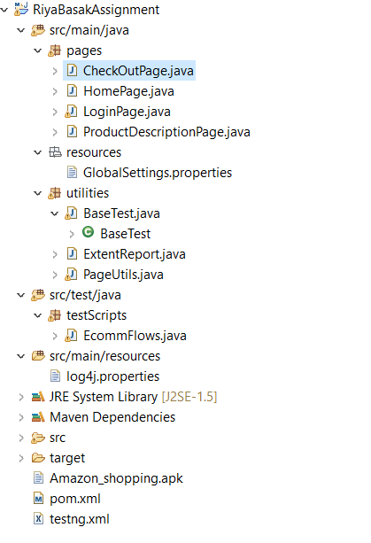

**Page Object Model**

Page Object Model has been implemented using Page Factory. All the pages are created under “pages” package. All mobile elements and methods are written in respective pages.

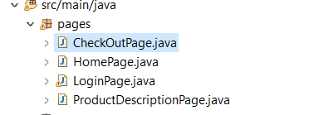

**Common Utilities:**

BaseTest file is created to invoke and pass driver to child class. All reusable methods are written under PageUtils.Java. Reporting has been handled using ExtentReport.java .

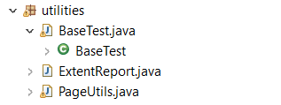

**Test Scripts :**

Test cases are created in the following “testScripts” package .

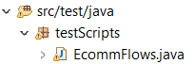

**Global Resources :**

Global property file and log4j file are created under resources section.





**Available Apk,testNG XML and Maven POM.XML :** .apk file is inserted in the code repository and pom.xml is configure for triggering testNG.xml using maven command.

