E-Commerce Customer & Sales Analysis
SQL • Excel • Python/Pandas customer analytics project

Executive Summary
The project models a normalized e-commerce database with Customers, Orders, Products, Order_Items and Payments. Delivered revenue is 20,630,199.58 across 1,567 delivered orders.

Key Performance Indicators
The KPI view measures transaction scale, revenue economics and repeat purchasing.
KPI | Value
Delivered Orders | 1,567
Revenue | 20,630,199.58
Average Order Value | 13,165.41
Active Customers | 591
Repeat Customer % | 76.0%

Customer Behavior
Approximately 76.0% of active customers are repeat purchasers. Customer-level frequency and monetary value are used for basic segmentation into One-time, Regular, Loyal and Champions.

Revenue Analysis
Beauty contributes the highest category revenue in this generated dataset. Monthly revenue analysis provides the base for seasonality and growth monitoring.
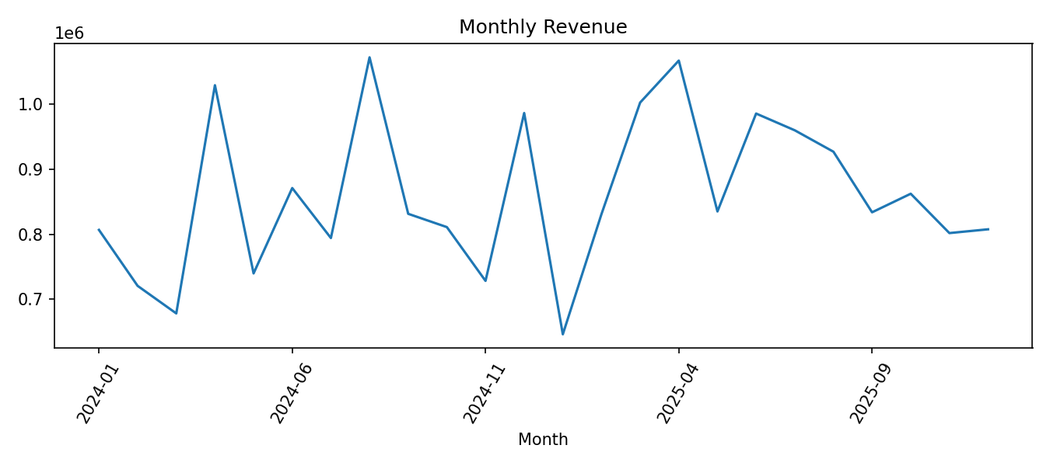
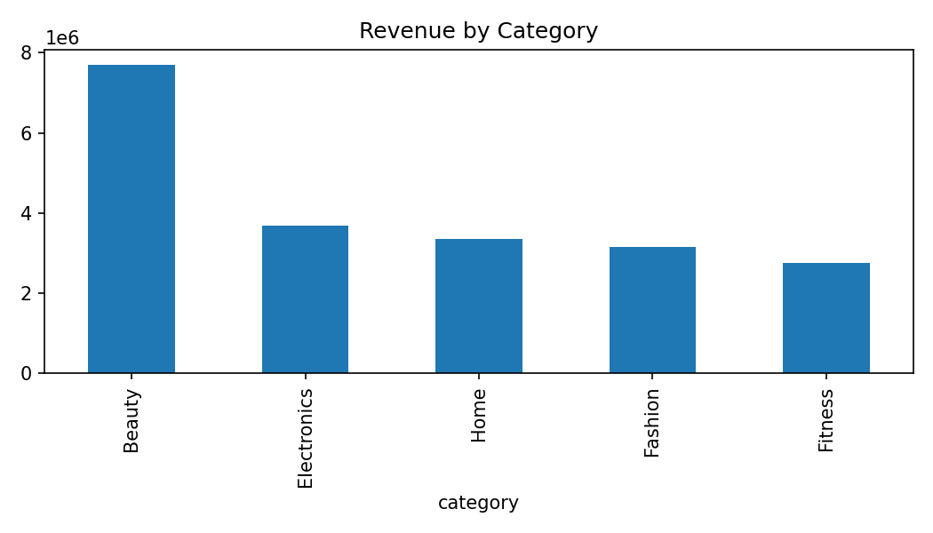

SQL Techniques Demonstrated
- INNER JOINs across transactional tables
- GROUP BY aggregations
- CASE WHEN segmentation
- Subqueries for above-average customer revenue
- CTEs for reusable customer-level calculations
- Window functions for new vs returning classification and cumulative revenue share

Business Recommendations
- Build retention campaigns around high-value repeat customers rather than treating all buyers equally.
- Track category revenue and product-level units together to distinguish high-price from high-volume winners.
- Monitor new vs returning revenue monthly to avoid growth that depends only on new customer acquisition.
- Create customer tiers using frequency and monetary value, then tailor offers and service levels by tier.

