Assignment 1 – Using the cp Command
Create a directory named my_files in your home directory.
Inside the my_files directory, create three text files:
file1.txt
file2.txt
file3.txt
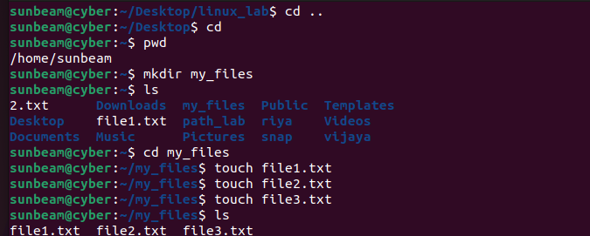
Create a directory named backup inside the my_files directory.
Use the cp command to create a backup of:
file1.txt
file2.txt
inside the backup directory
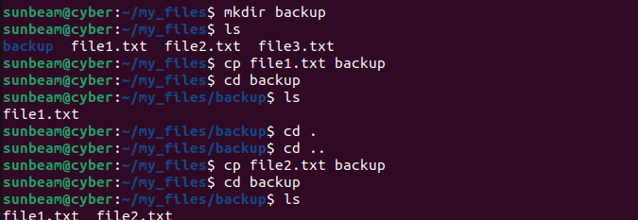

Use the cp command to copy file3.txt to your Desktop
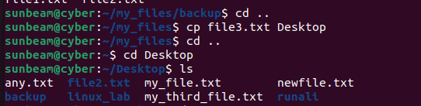
Copy the entire my_files directory (inside home) with a new name my_old_files .
(Hint: Use recursive option -R )
Copy the backup directory to your home directory
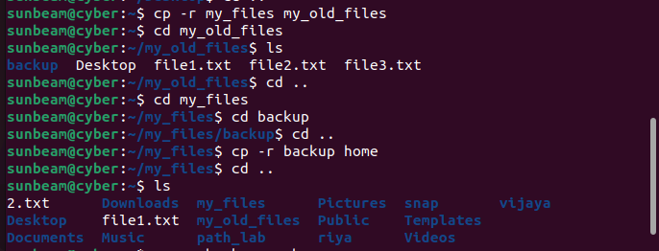
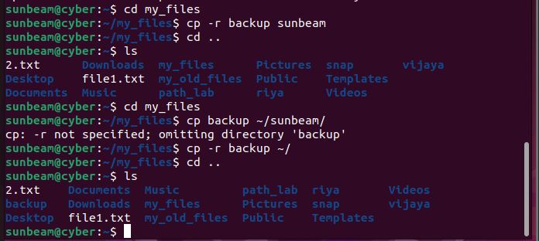

Assignment 2 – Using the mv Command
Create a directory named my_music in your home directory.
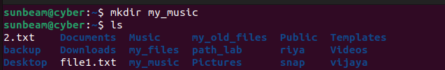
Create the following files inside my_music :
song_1.mp3
song_2.mp3
song_3.mp3

Create a subdirectory named old_music inside the my_music directory.

Move song_1.mp3 to the old_music directory using the mv command

Rename song_3.mp3 to new_song_3.mp3 using the mv command.
Move song_2.mp3 to your Desktop
