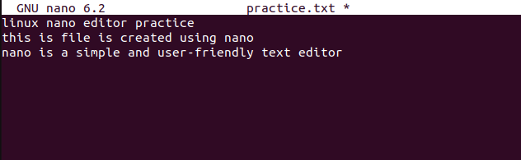
Q1. Create a new file using nano Create a new file named nano_practice.txt using the nano command.

Q2. Write basic content in the file
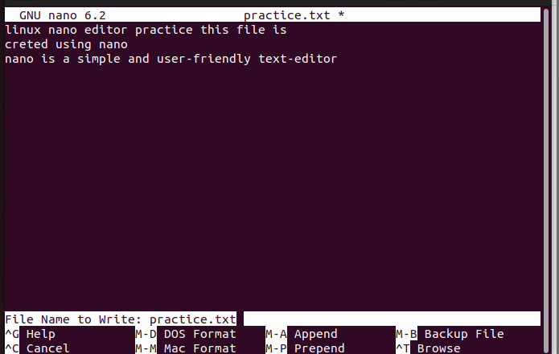

Reopen the file and edit content
Reopen nano_practice.txt and add the following line at the end:
This line was added later using nano.
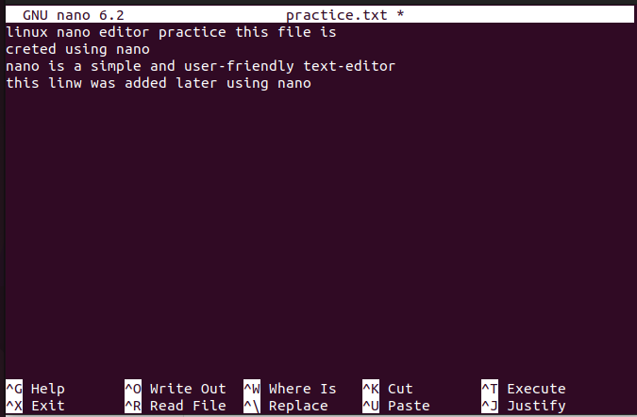
Search for a word Inside the nano editor, search for the word “nano”.

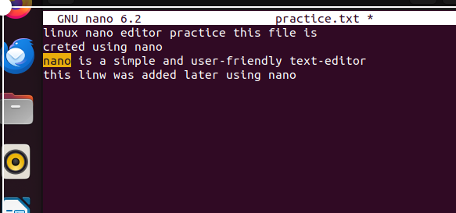
Cut and paste a line Cut the last line Paste it at the top of the file
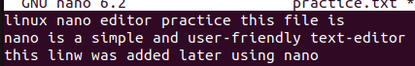
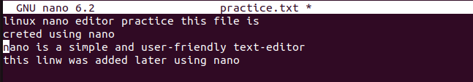

Q7. Undo and redo Undo the last change Redo the change
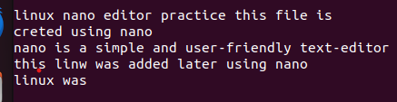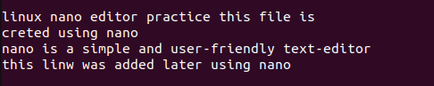
Q8. Enable line numbers Open the file with line numbers enabled.
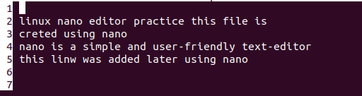
Replace a word Replace the word “simple” with “powerful” in the file.
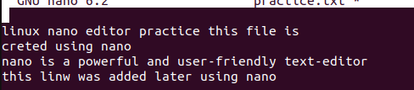
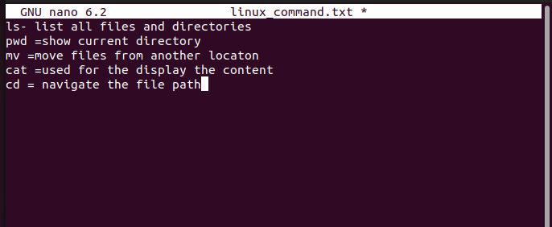
10. Create another file using nano Create a new file named linux_commands.txt and write any 5 Linux commands with their purpose.

