Q1: Create Your First Git Repository
Q2: Check Git Status
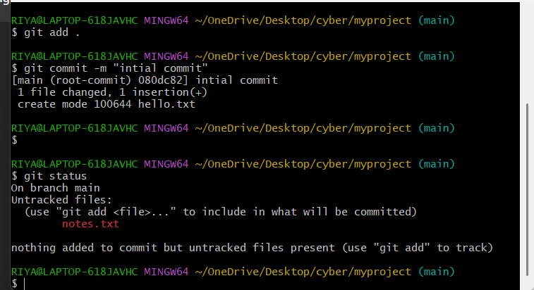
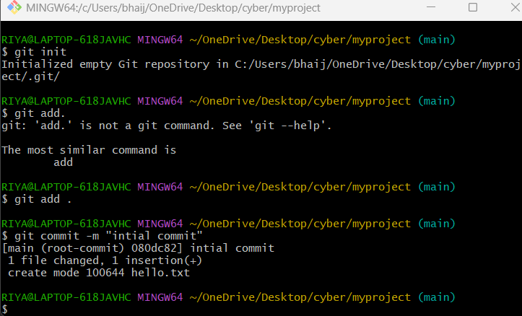

Q3: Add & Commit Multiple Files
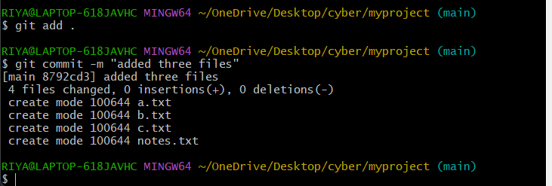
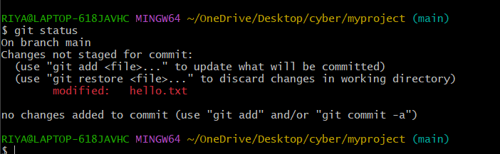

Q4: Modify a File and Commit Change

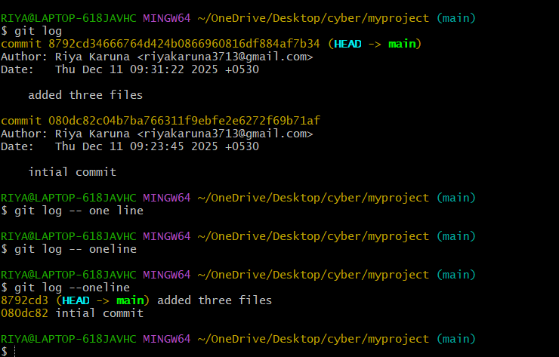
Q5: View Commit History

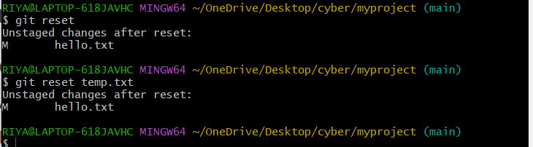
Q6: Undo Staged Changes

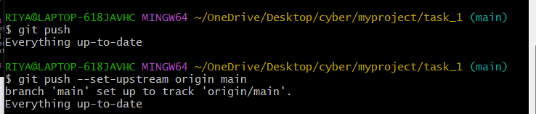
Q7: Push Code to GitHub
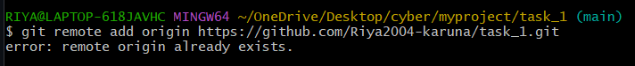
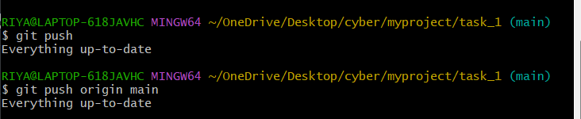

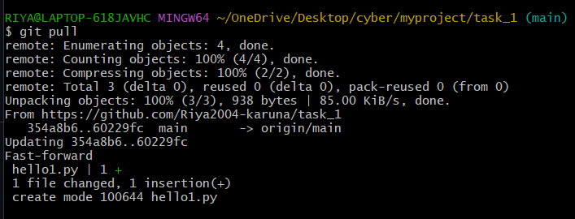
Q8: Pull Latest Changes

