Q1 - Create 2 VMs (NAT + Host-Only) & Test Connectivity
VM-1
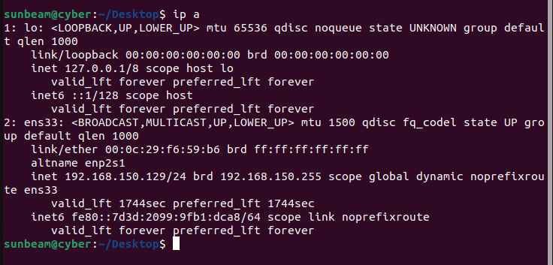

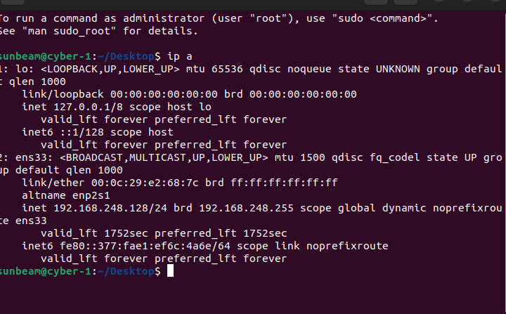
VM-2

Nat
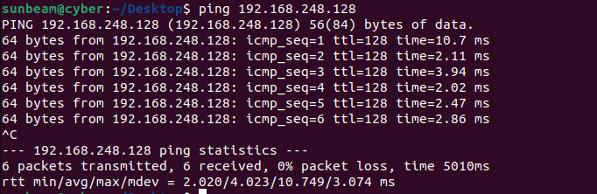

Host


Final answer: Explain whether NAT ↔ Host-Only communication works. Why/why not?
NO — NAT and Host-Only networks cannot communicate with each other.
NAT and Host-Only networks are isolated in VMware.
A VM in NAT mode cannot communicate with a VM in Host-Only mode because both networks are separate and VMware does not route packets between them.
Therefore, NAT ↔ Host-Only communication does not work.
VM-1 (NAT) → VM-2 (Host-Only): No direct communication
VM-2 (Host-Only) → VM-1 (NAT): Fails (Network unreachable)

Q2 - Create 2 VMs in NAT Mode & Test Connectivity Task
1. Set VM-1 → NAT 2. Set VM-2 → NAT
3. Check both IP addresses
VM-1
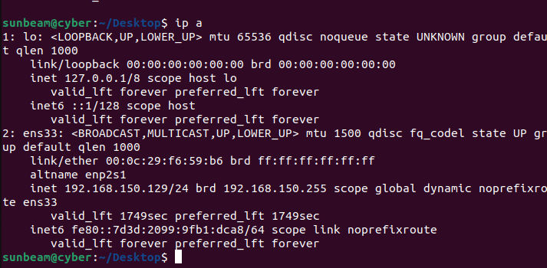
VM-2
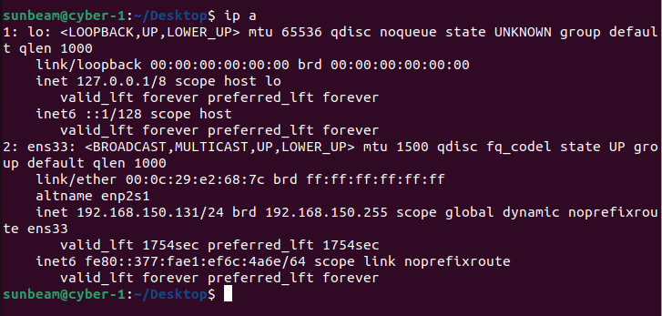
4. Try pinging each other Submit IPs Ping results Explanation: Do NAT VMs communicate inside the virtual network?
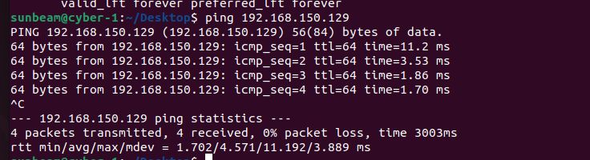
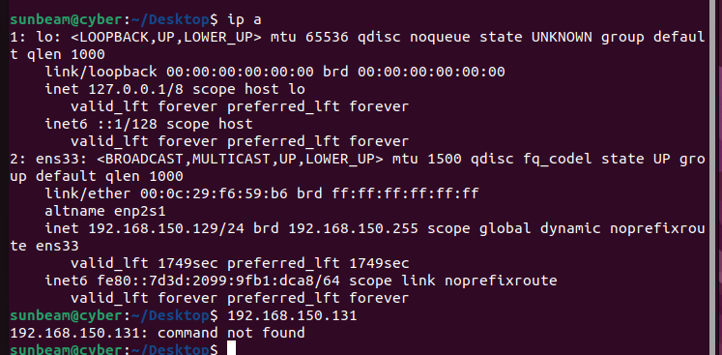
YES, NAT VMs can communicate with each other.
- In VMware, NAT mode creates a virtual LAN behind a virtual NAT router.
- All NAT-mode VMs join the same private network (e.g., 192.168.150.0/24).
Q3 - Create 2 VMs in Host-Only Mode Task 1. Set VM-1 → Host-Only
2. Set VM-2 → Host-Only
vm-1
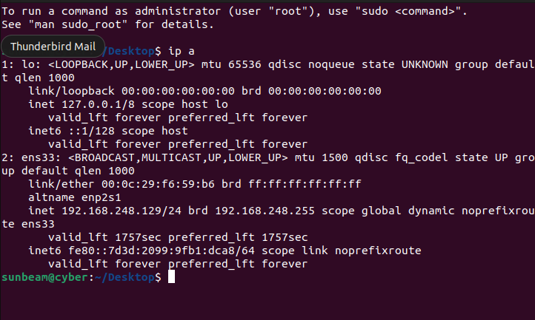
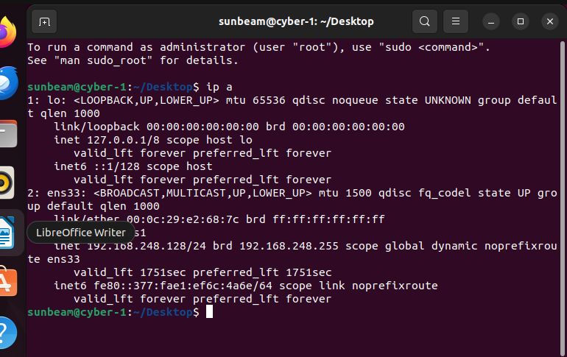
vm-2
3. Check IPs 4. Ping VM-1 → VM-2
5. Ping VM-1 → Base Machine
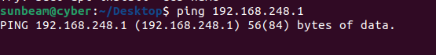
6. Ping VM-2 → VM-1
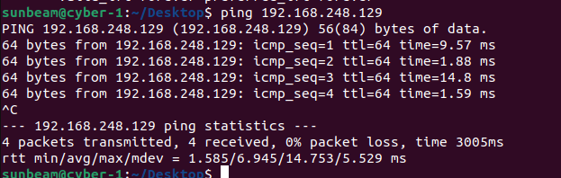
7. Ping VM-2 → Base Machine
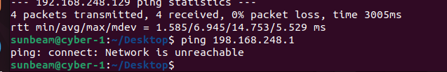

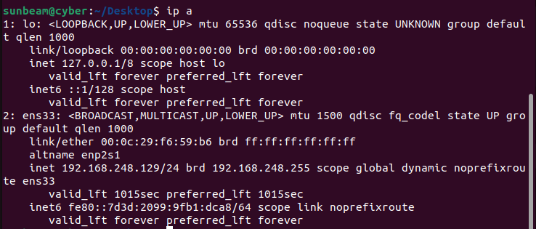
Q4 - Internet Connectivity Test (Different Modes)
for the host

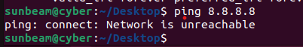

For the network
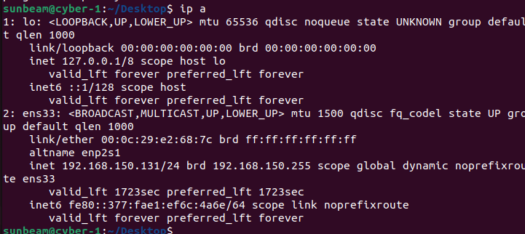

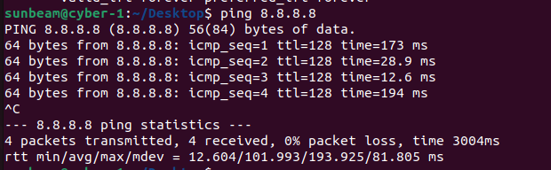

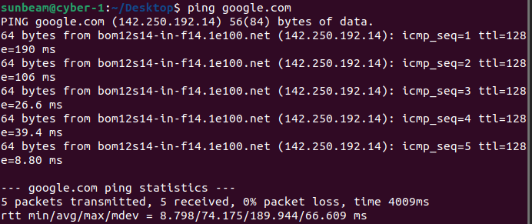

4)Internet yes/no?
in the mode of the network it is working
Why NAT has internet?
Because NAT mode shares your host’s (Windows) internet connection.
Can access internet

Q5 - Install Basic Utility Packages
Update package lists
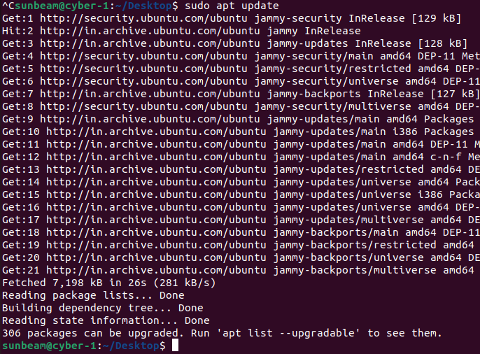
Install the following packages: curl tree

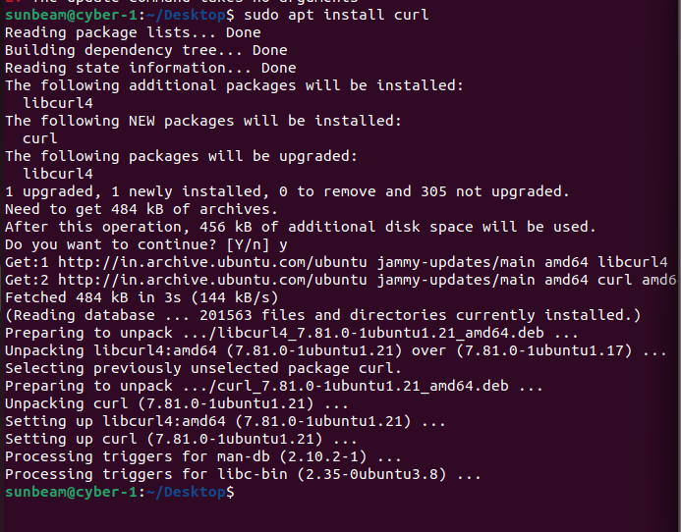

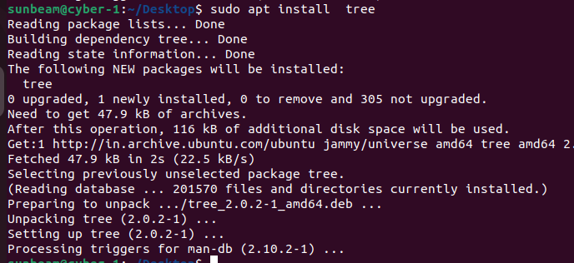
. Verify installation:

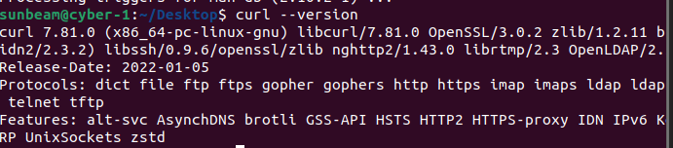

Q6 - Install a Package
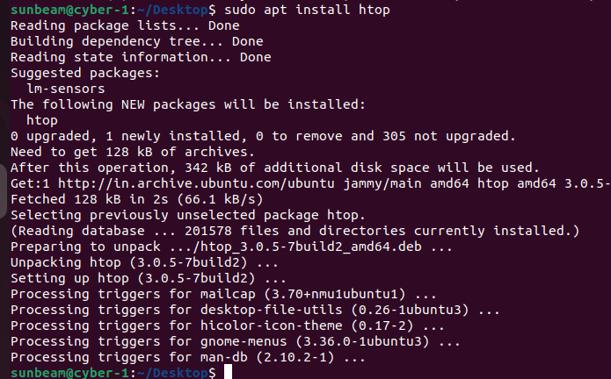

2. Launch it:

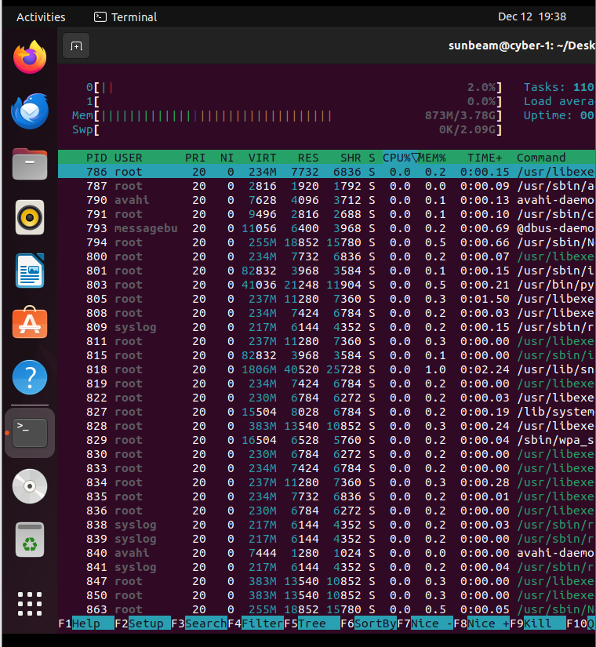
Q7 - Install Net-tools & Compare with ip Command
1. Install: sudo apt install net-tools
2. Run: ifconfig ip a
3. Compare both outputs Write differences in 3 lines.
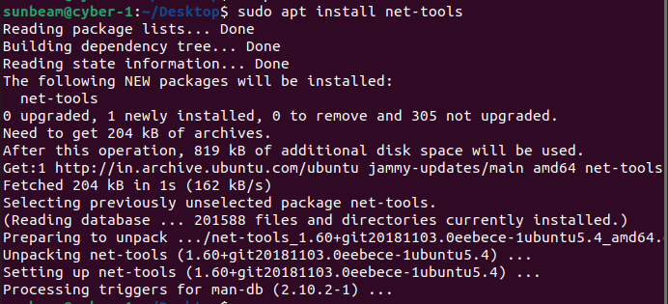
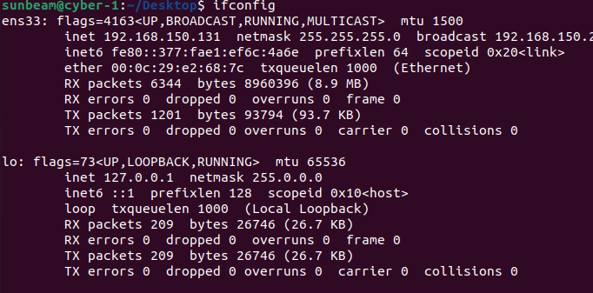
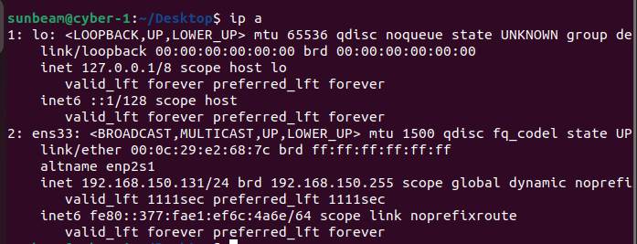
ifconfig is older and part of the deprecated net-tools package, while ip a is the modern, recommended command used in all new Linux systems.
ip a shows more detailed information, including IPv6, MAC, qdisc, state, and advanced interface properties.
ifconfig displays limited, simpler output and sometimes does not show inactive interfaces, whereas ip a shows all interfaces and complete network details.

