Q1: Basic Terminal Commands
1. Open the Terminal.
2. Check the current working directory.
3. List all files and folders.
4. Clear the terminal screen.
5. Display the current date and time. date
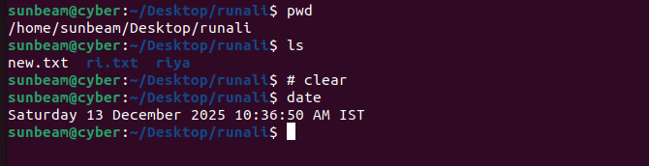

Q2: Directory Management
1. Create a directory named linux_lab .
2. Inside linux_lab , create two folders: docs and scripts .
3. Navigate to the docs directory.
4. Go back to the home directory.
5. Remove the scripts directory.
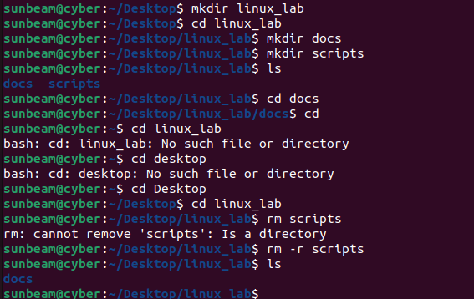

Q3: File Management
1. Create a file named test.txt .
2. Write your name inside the file.
3. Display the content of the file. cat
4. Rename test.txt to linux_test.txt .
5. Delete the file
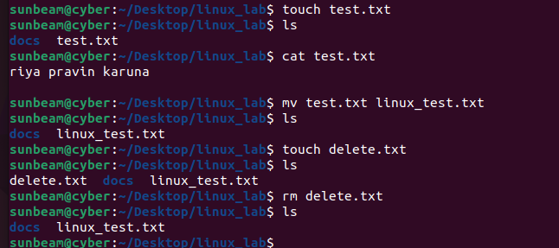
Q4: Copy & Move
1. Create a directory called backup .
2. Copy any text file into the backup directory.
3. Move the file back to the home directory.
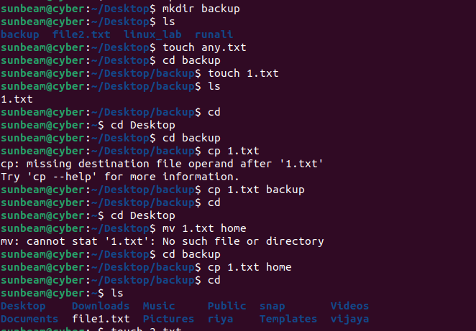

Q5: User & System Information
1. Display the current logged-in user.
2. Show system hostname.
3. Display Linux kernel version. uname -a
4. Check system uptime. Uptime
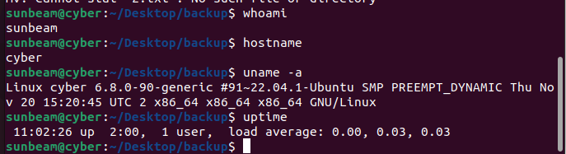

Q6: Package Management
1. Update the package list.
2. Install tree package.
3. Use tree command in home directory.
4. Remove the tree package

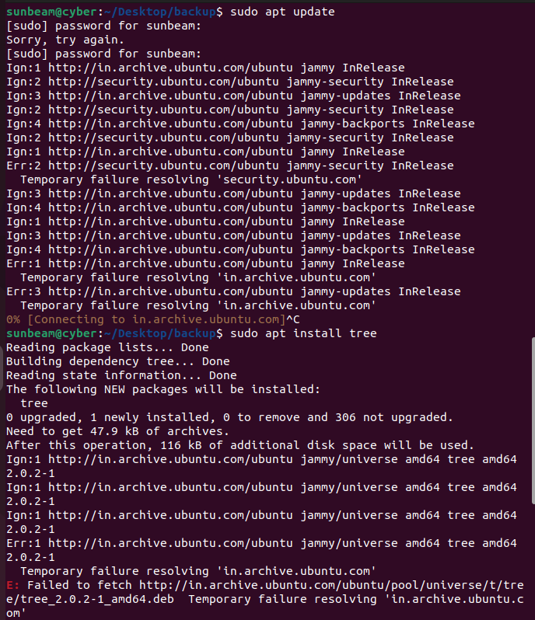

Q7: Networking Commands
1. Check IP address.
2. Check network interfaces.
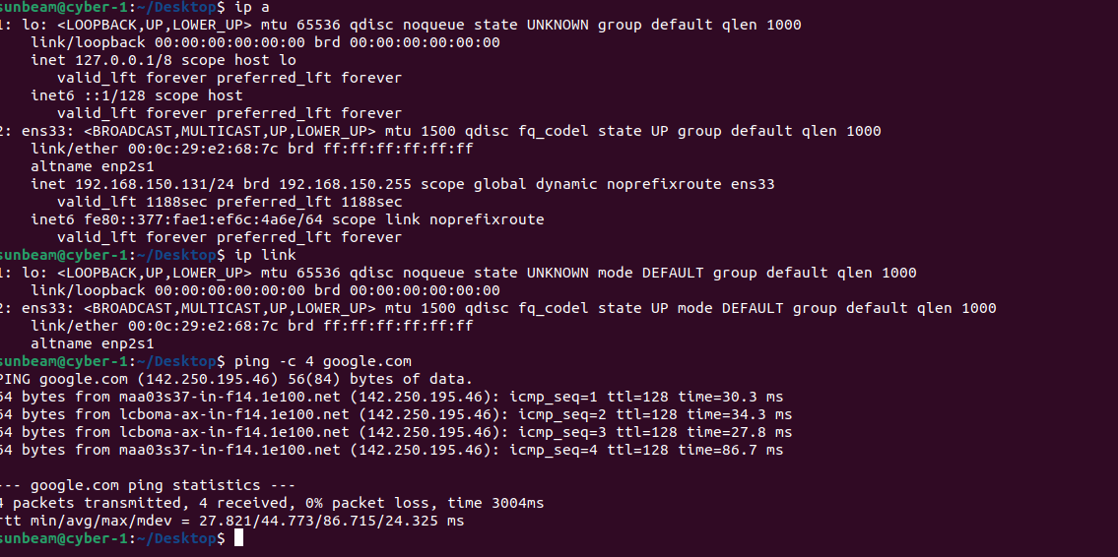
3. Ping Google (4 packets only).

