1. Install Snort on Ubuntu
Step 1: Update System
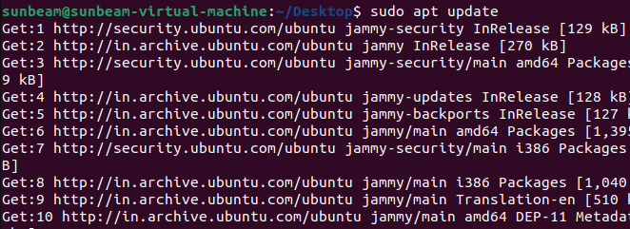
Step 2: Install Dependencies
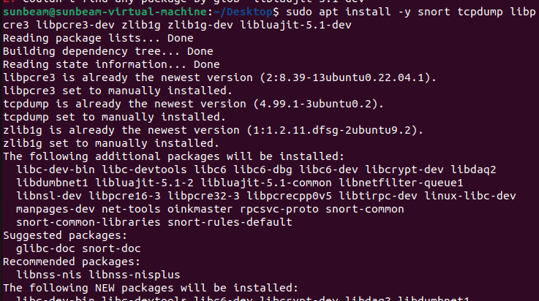
Step 3: Verify Snort Installation
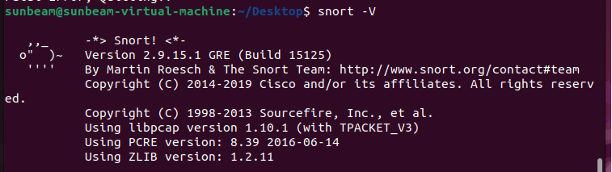

Configure Snort
Step 1: Find Network Interface
Step 2: Edit Snort Configuration
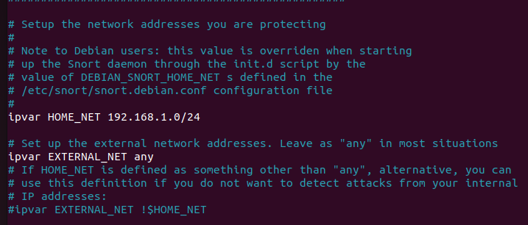
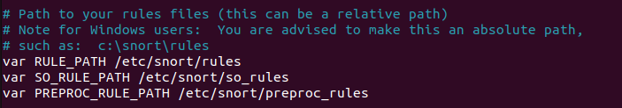
Create Snort Rule File
Create a custom rule file:
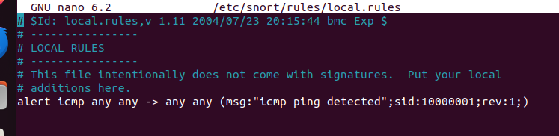

Running Snort
Step 1: Test Snort Configuration
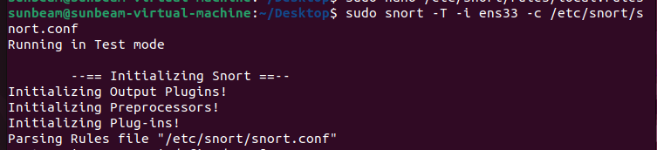
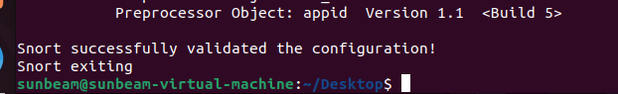
Start Snort in IDS Mode
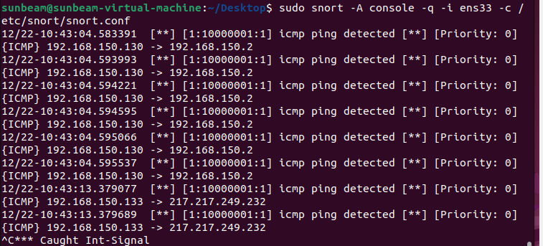
Generate a Test Attack (ICMP Ping)
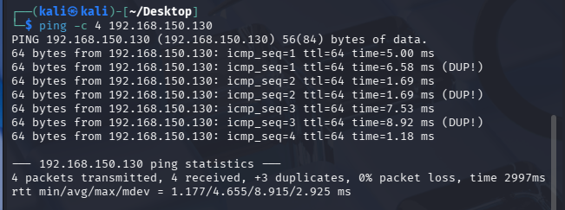

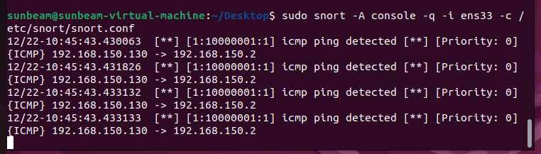

Reporting & Logs
