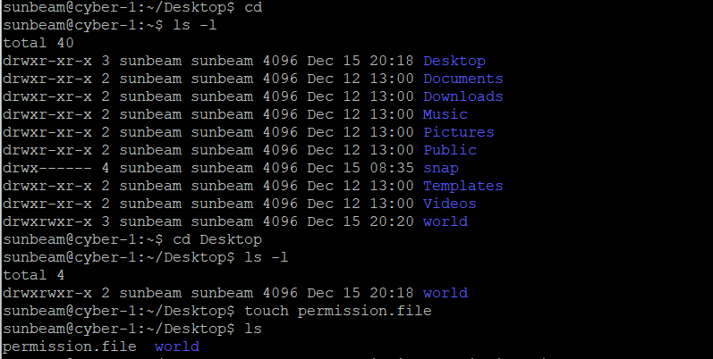
Understanding ls -l Output

Two Ways to Use chmod
Method 1: Symbolic Mode
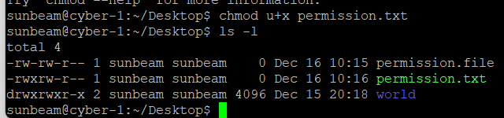

Give read permission to owner:
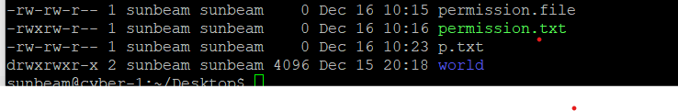
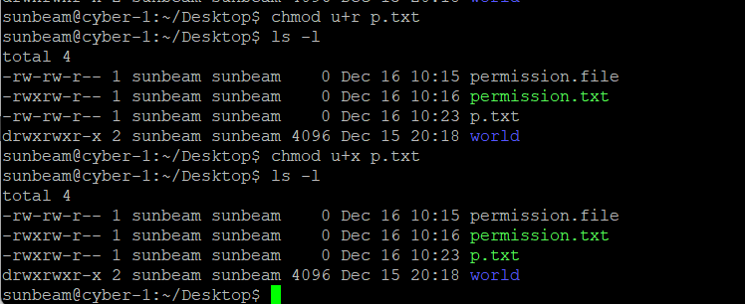
Remove write permission from group:
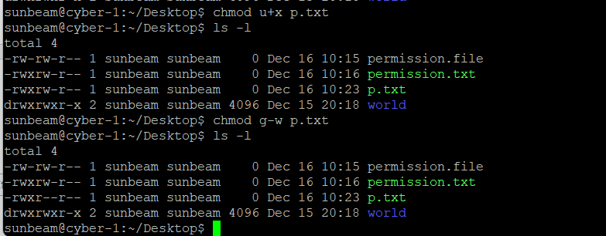
Give execute permission to everyone:
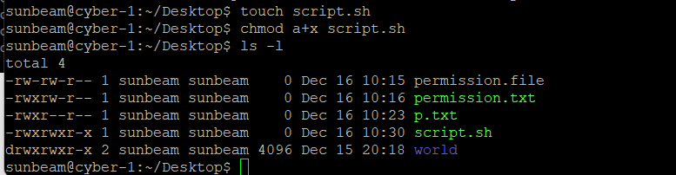
Method 2: Numeric Mode (Important for Interviews)
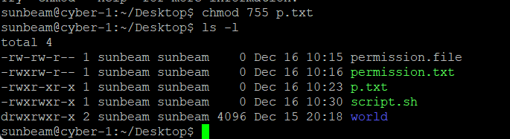
Basic chown Syntax
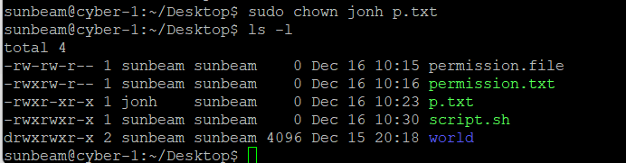

Change Owner and Group Together
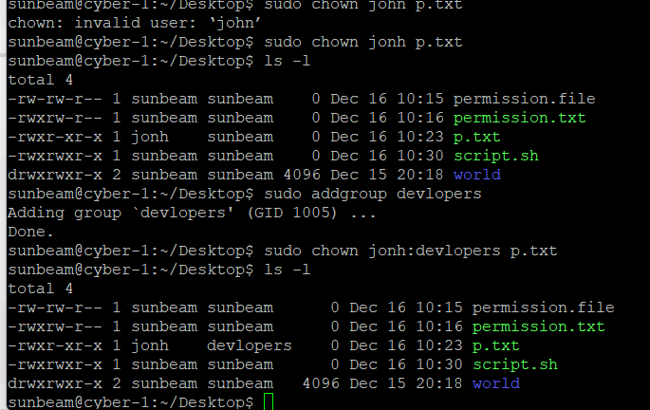
Changing Group Only
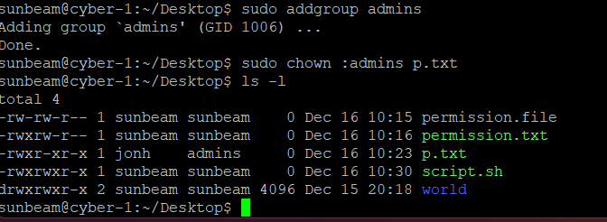
Recursive Ownership Change
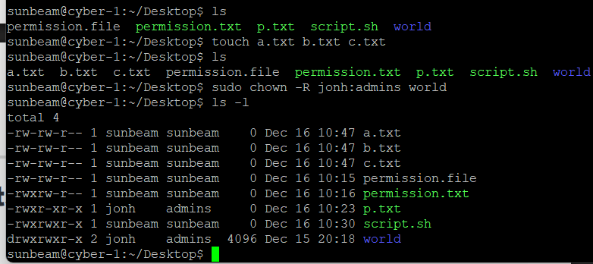

1. Create files and directories
2. Check permissions using ls -l
3. Apply chmod (symbolic first)
4. Apply chmod (numeric)
5. Change ownership using chown
6. Verify changes again using ls -l
