Part A: File and Directory Creation
1. Create a regular file named example.txt in your home directory.
2. Create a shell script file named script.sh .
3. Create another file named template.txt .
4. Create a directory named docs .
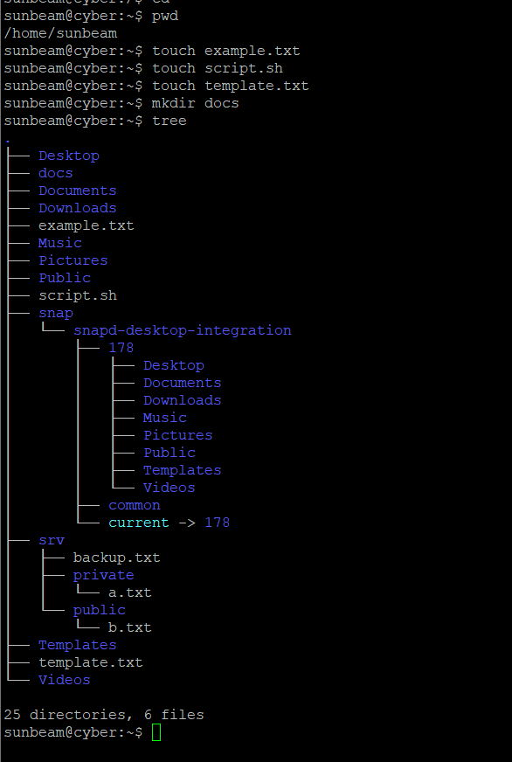
5. List all created files and directories and verify their existence using appropriate commands.

Part B: File Permission Tasks using chmod
1. Change the permissions of the file example.txt so that:
The owner has read and write permissions
The group has read-only permission
Others have no permissions
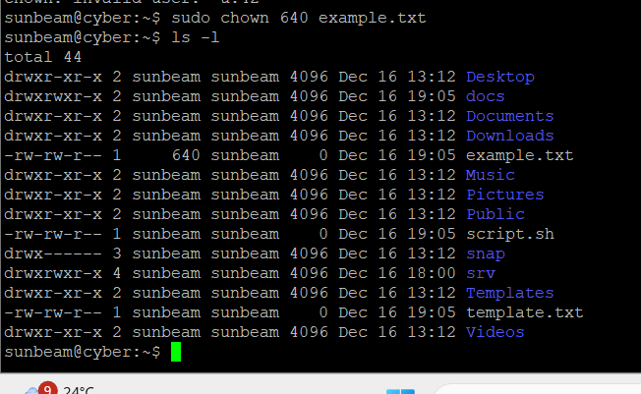
2. Add only execute permission to the file script.sh for:
Owner
Group
Others
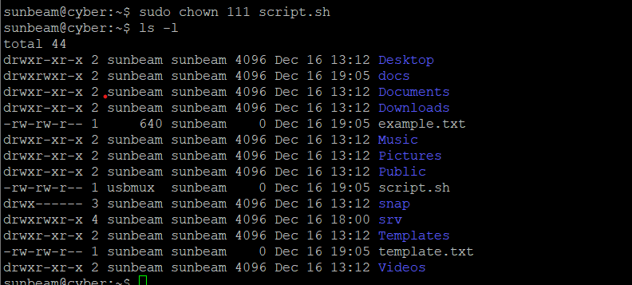

3. Remove the write permission from the file example.txt for:
Group users
Other users
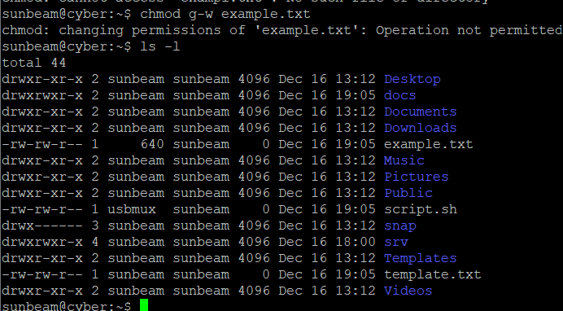
4. Change the permissions of the directory docs so that:
The owner has read, write, and execute permissions
The group has read and execute permissions
Others have read-only permission
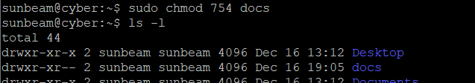
5. Set the permissions of example.txt to be exactly the same as the permissions of the file template.txt .
