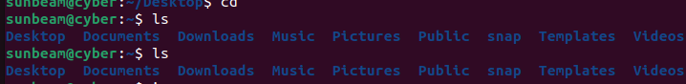
Q1: File Server Architecture
Tasks 1. List all directories present in the root ( / ) directory.

2. Identify and write the purpose of the following directories: 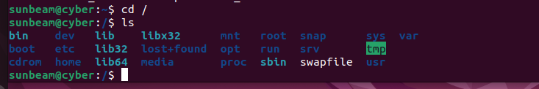
/etc
Purpose:
- Stores system configuration files
- Text files that control system behavior
Examples:
- /etc/passwd → user accounts
- /etc/ssh/sshd_config → SSH settings
Think: etc = editable text configuration

/home
Purpose:
- Stores home directories of users
- Personal files like Desktop, Documents, Downloads
Example:
/home/riya
/home/sunbeam

/var
Purpose:
- Stores variable data that changes frequently
Examples:
- Logs → /var/log
- Mail → /var/mail
- Cache → /var/cache
Think: var = variable data

/usr
Purpose:
- Stores user applications & libraries
- Most installed software lives here
Subfolders:
- /usr/bin → user commands
- /usr/lib → libraries
- /usr/share → shared data

/bin
Purpose:
- Essential basic commands for all users
Examples:
- ls
- cp
- mv
- cat

/sbin
Purpose:
- System administration commands
- Mainly for root / admin
Examples:
- reboot
- shutdown
- ifconfig

/tmp
Purpose:
- Temporary files
- Files deleted automatically on reboot

3. Create the following directory structure:
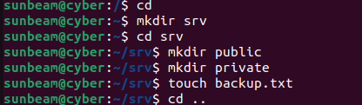
4. Create one file inside each directory.
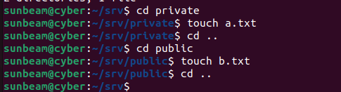
5. Display the complete directory structure using a single command
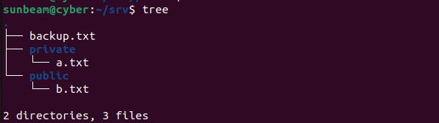
Tasks -3
1. Install the OpenSSH server package.
2. Verify whether SSH is running.
3. Find the IP address of your Ubuntu VM.
4. Connect to the Ubuntu VM using SSH from Putty or CMD
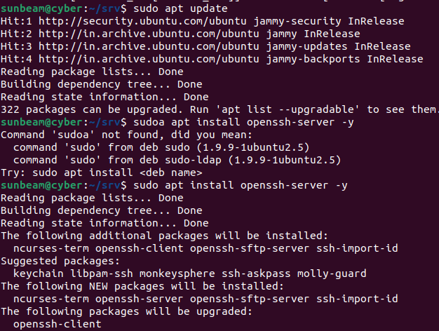
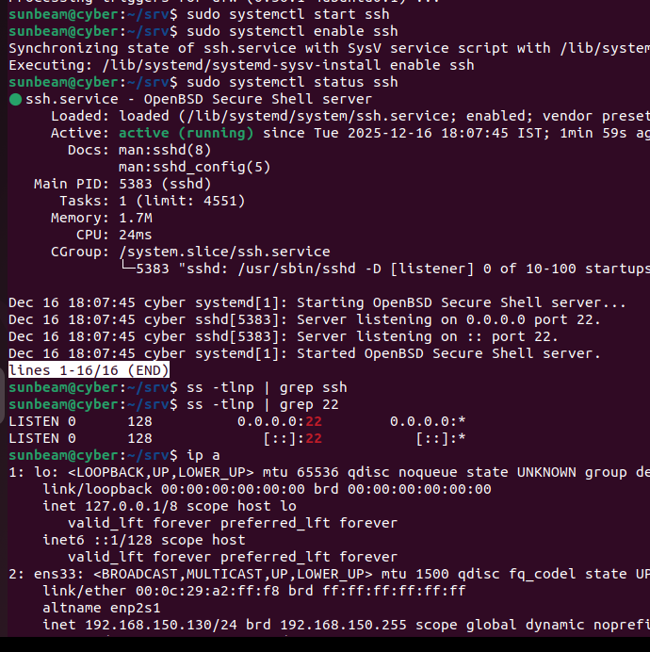
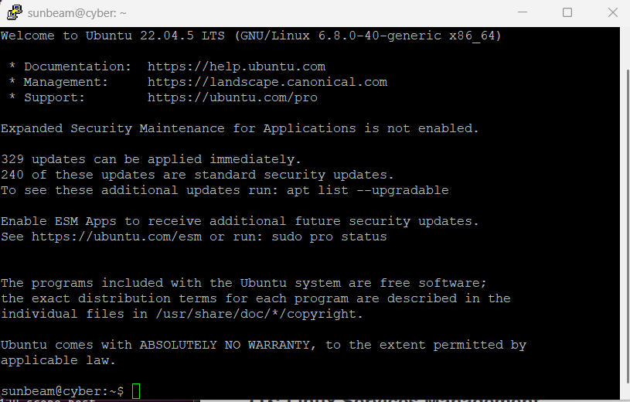
Why should root SSH login be disabled?
For security reasons — to protect the system from unauthorized access and attacks.
Q3: Linux Services Management
Tasks 1. Check the status of the SSH service.
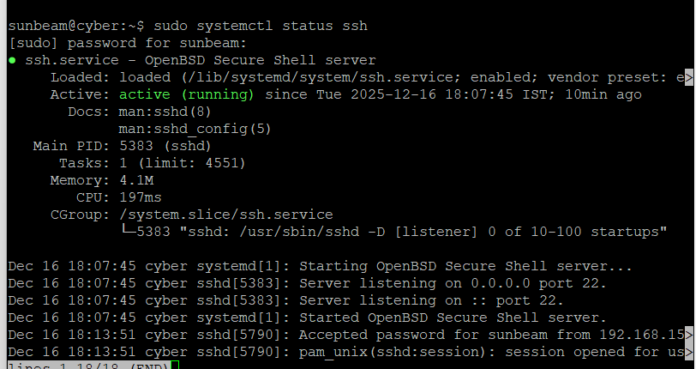

2. Stop the SSH service.
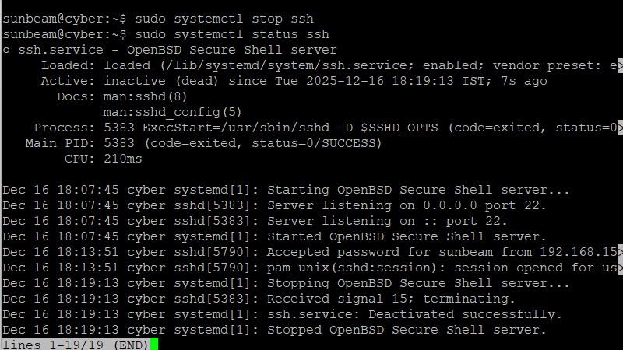
4. Restart the SSH service.
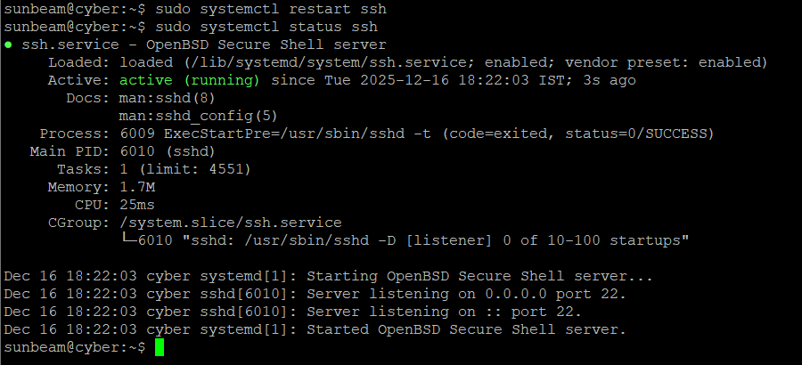
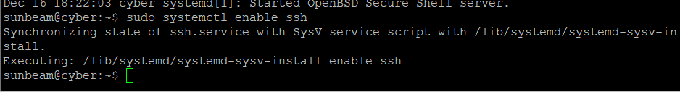

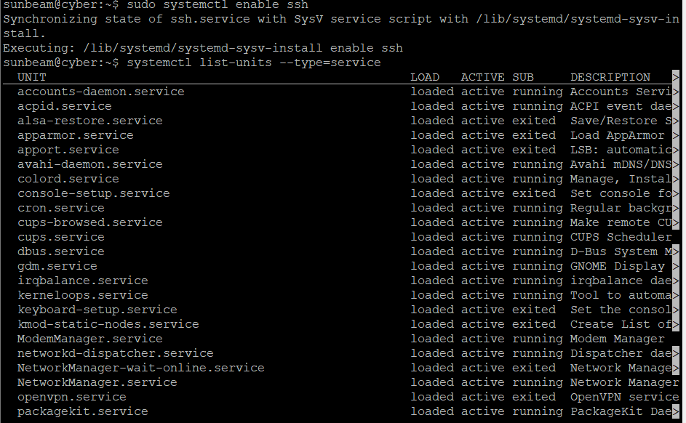
What is a service in Linux?
A service in Linux is a background program (daemon) that:
- Runs continuously or on demand
- Provides system or network functionality
- Starts during boot or when required
Examples:
- ssh → remote login service
- cron → scheduled tasks
- network-manager → networking
- apache2 → web server
Services are managed using systemd (systemctl).

Difference between start and enable
Command | Meaning | When it works
start | Starts the service now | Current session only
enable | Starts the service automatically at boot | Future reboots

🔹 start
sudo systemctl start ssh
- Service starts immediately
- Will stop after reboot

🔹 enable
sudo systemctl enable ssh
- Service does not start immediately
- Starts automatically after reboot
Q4: Linux Users and Permissions
1. Create two users:
user1
user2
2. Set passwords for both users.
3. Create a directory named /shared .
4. Assign ownership of /shared to user1 .
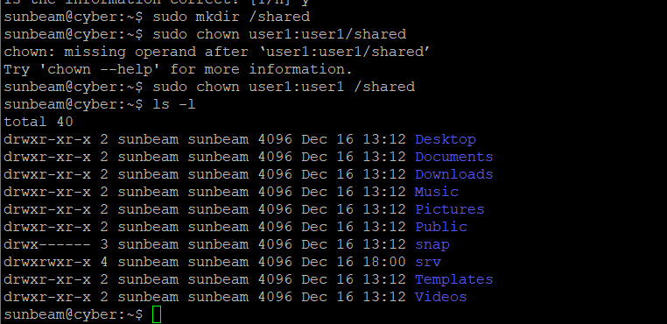
6. Login as user2 and try to access /shared .

7. Capture the access result.
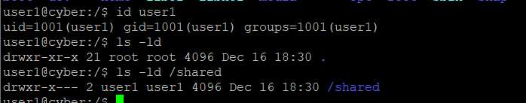
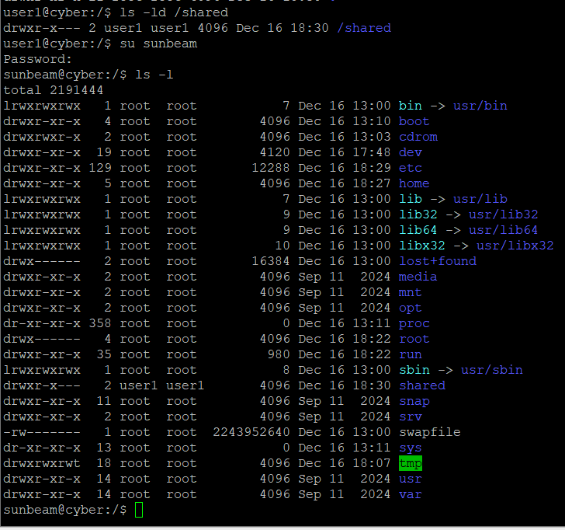
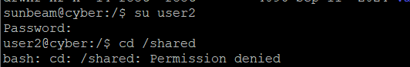

Explain r , w , and x
Permission | Meaning (File) | Meaning (Directory)
r (read) | View file contents | List files
w (write) | Modify file | Create/delete files
x (execute) | Run file as program | Enter directory
What happens if permissions are set to 777 ?
Meaning:
- Owner → rwx
- Group → rwx
- Others → rwx
Everyone can read, write, and delete files
How does permission help in securing data?
Why it is dangerous:
- Any user can modify or delete data
- Security risk
- Used only for testing, never in production
Q5: /etc/passwd File Analysis
1. Open and view the /etc/passwd file.

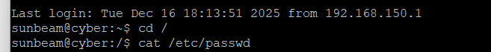
2. Select any one normal user entry and note its fields.
3. Identify the following from /etc/passwd : Username UID GID Home directory Login shell
username:sunbeam
uid:1000
gid:1000
home :sunbeam,,,
directory:/home/sunbeam
login shell:/bin/bash
4. Find system users (UID less than 1000).
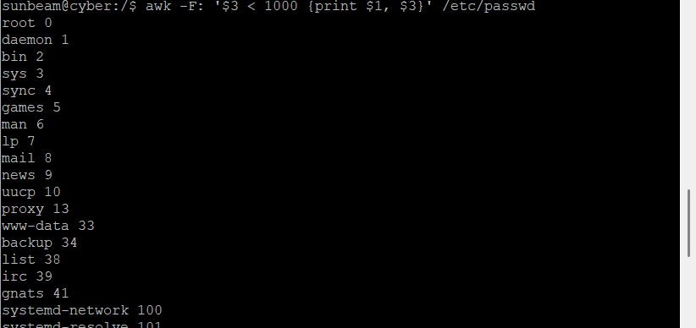
5. Locate your own user entry
Questions
What does the x field indicate?
The x indicates that the encrypted password is stored in /etc/shadow, not in /etc/passwd.
Why are passwords not stored in /etc/passwd ?
Because /etc/passwd is publicly readable, storing passwords there would expose them. Passwords are stored in /etc/shadow for security.

