Task 1: Install MariaDB on Ubuntu
1. Update the system packages.
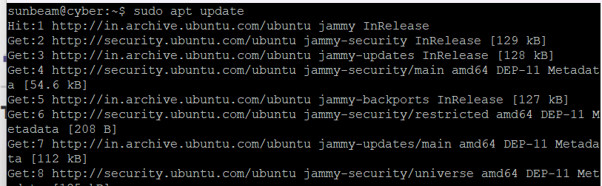
2. Install the MariaDB Server package.
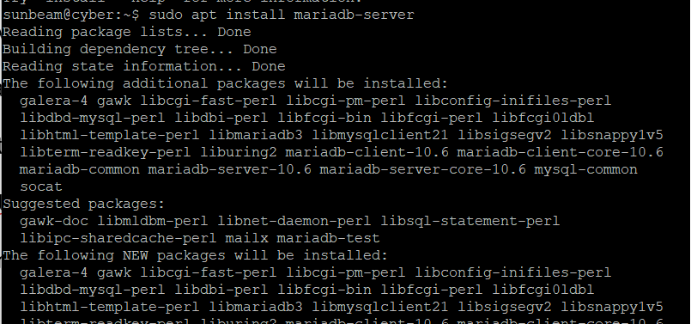
3. Check whether the MariaDB service is running.
sudo systemctl status mariadb
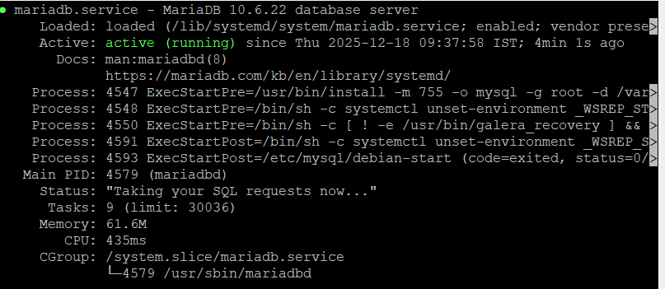
4. Verify the installed MariaDB version.
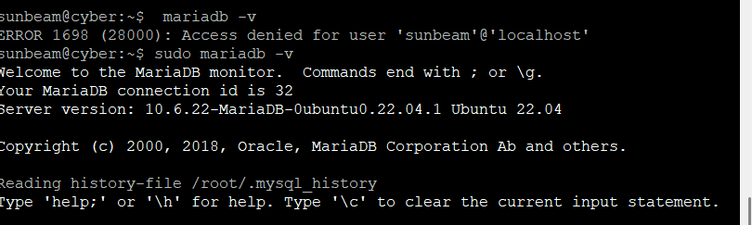
Task 2: Create a New Database
User 1. Login to mysql as root. 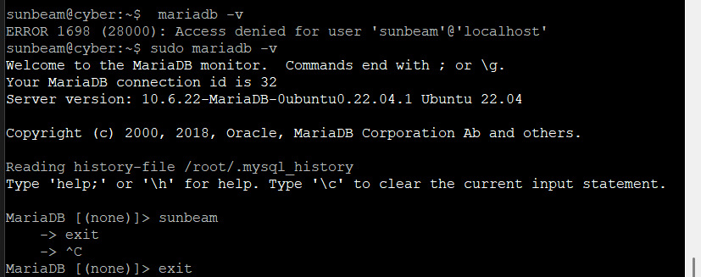
2. Create a new database user. & Set a password of your choice. 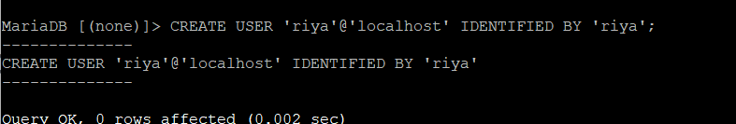
4. Verify that the user is created
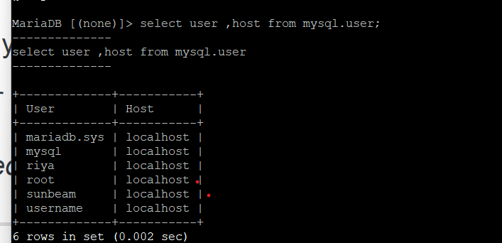
Task 3: Assign Permissions to the User
Grant only the following permissions to the newly created user:
SELECT
INSERT
DELETE
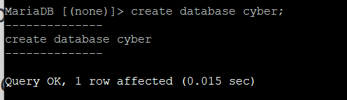
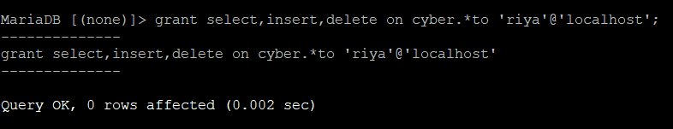
1. Assign the permissions.&Apply the privilege changes.
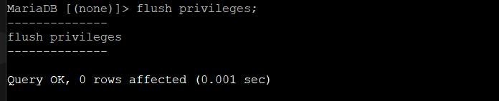
3. Verify the granted privileges.
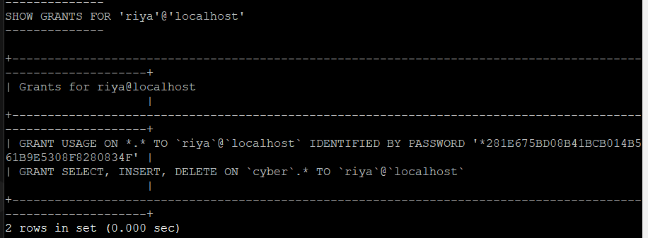
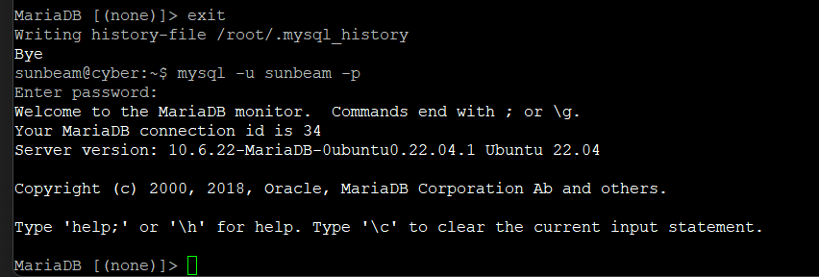

Task 5: Login Using the New User
1. Logout from the root user.
2. Login using your own-name database user.
3. Confirm successful login.
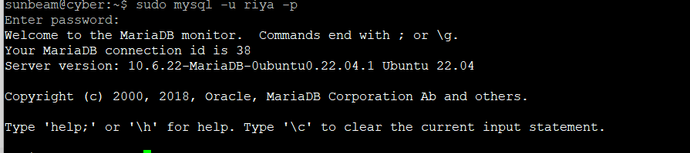
Task 6: Create Database
1. Using the new user account, create a database.
Database Name (Mandatory):
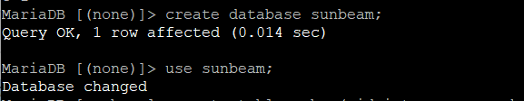
2. Display the list of databases to confirm creation.
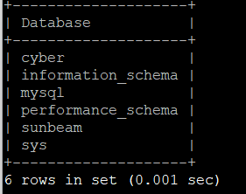
Task 7: Create Table
1. Select the Sunbeam database.
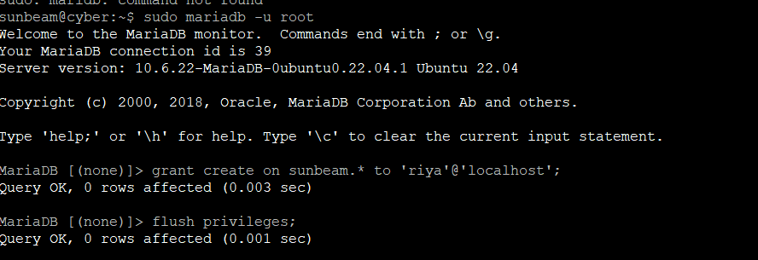
2. Create a table.
🔹 Table Name (Mandatory):
Cyber
🔹 Table Structure (must be exactly the same):
Column Name Description
id Integer – Student ID
name Student Name
course Course Name
marks Integer – Marks
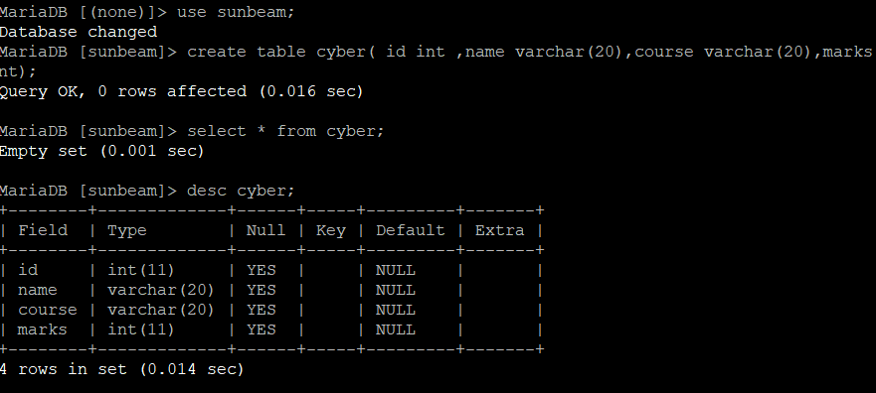

Task 8: Insert Data into Table
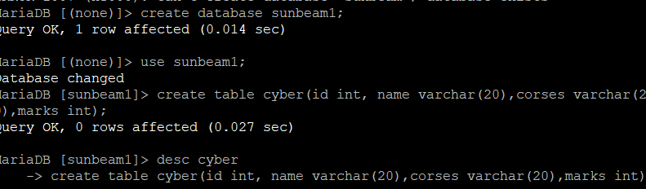
Insert exactly the following records into the Cyber table:
id name course marks
1 meet Cyber Security 78
2 janhavi Ethical Hacking 85
3 saurabh Networking 72
1. Insert all records.
2. Display the table data
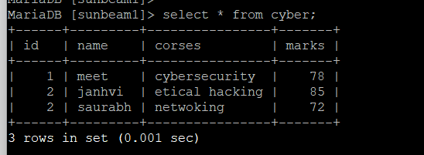
Task 9: Delete Data
1. Delete the record where id = 3 .
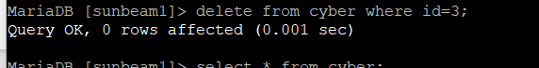
2. Display the table again to confirm deletion.
