**Pre-Requisite**: *Python, Robot Framework, Selenium Library*

**IDE Used**: *RIDE Editor*

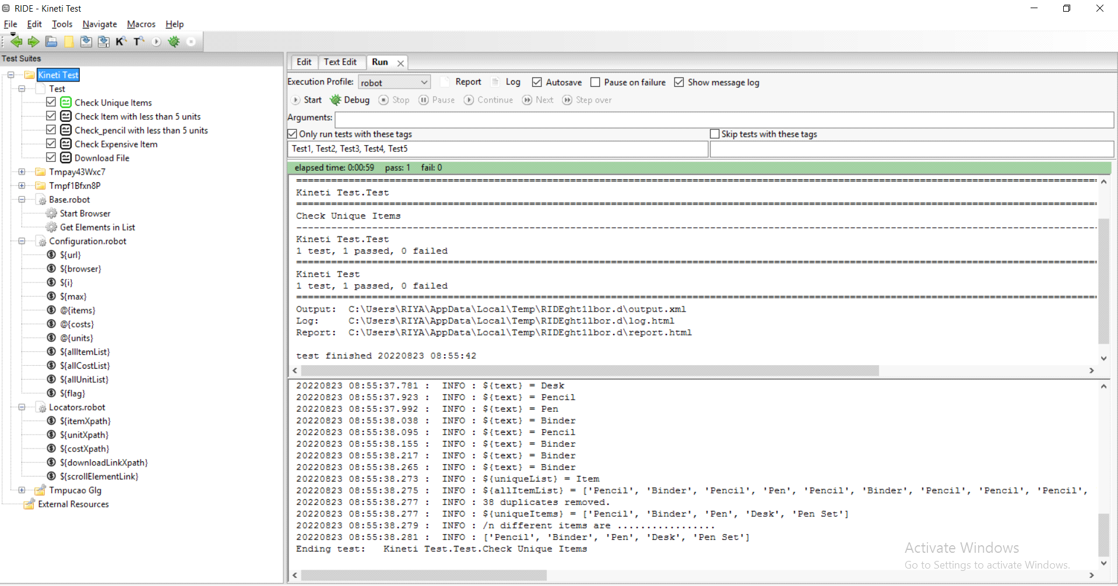

**Framework Elements:**

**Libraries used**: *Selenium, Collections*

*Test Suit* I have Create a test Suit with Name “Test”

*Test Cases* Multiple Test cases are the part of Test suit.

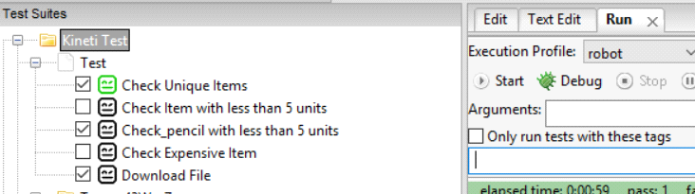

**Resource Files:**

*Base.robot* : Contains Reusable Functions/Keywords.

*Locators.robot* : Contains xpath of mostly used WebElement.

*Configuration.robot*: Contains Variables for Easy Maintainence

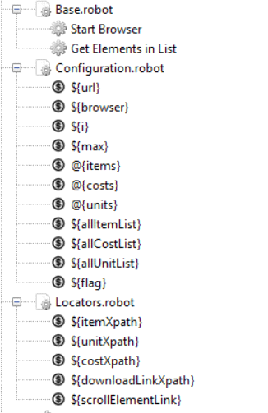

**Updating Test Cases:**

*Test cases can be updated via text editor*

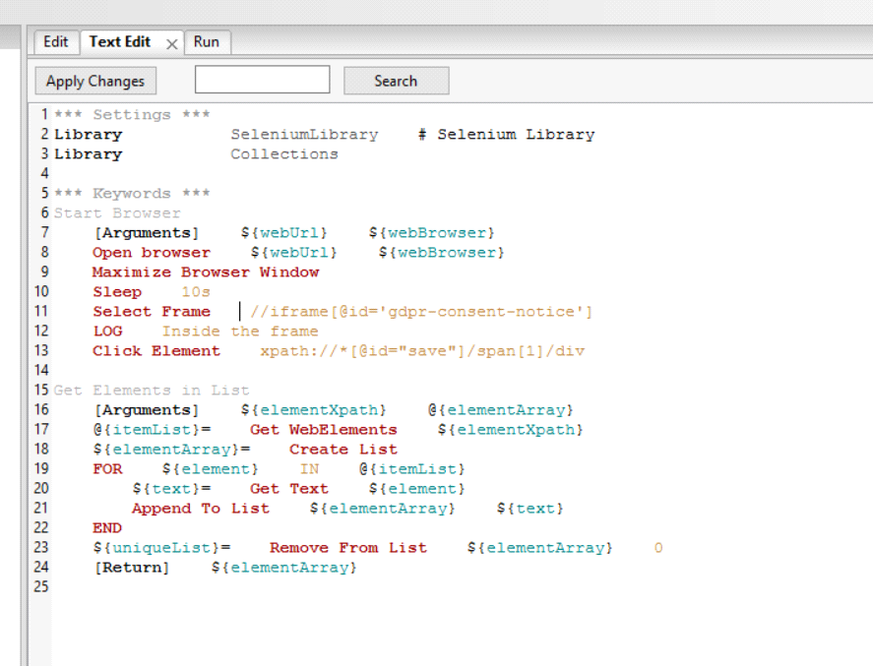

*Test cases can be also updated via UI editor*

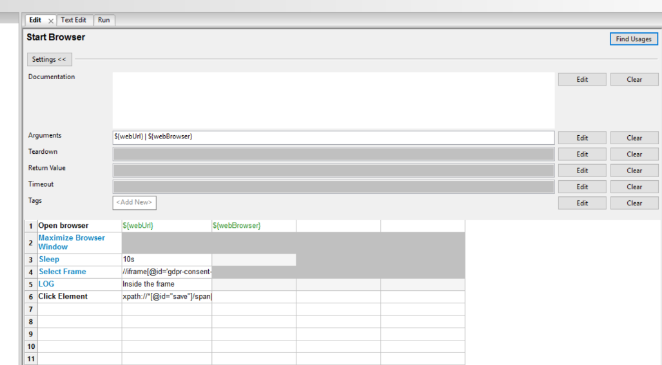

**Executing Test Cases**

*1. Single Test Run*



*2. Multiple Test Run*

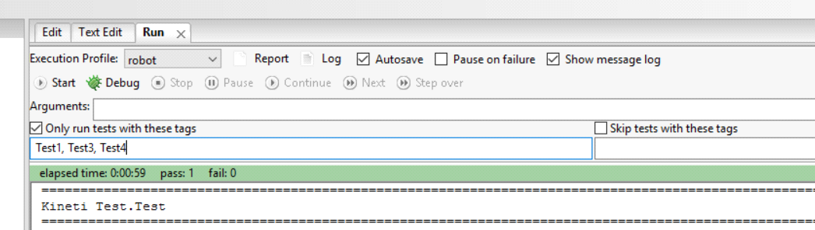

**Test Output:**

*Console Level*



*In-built Reports*

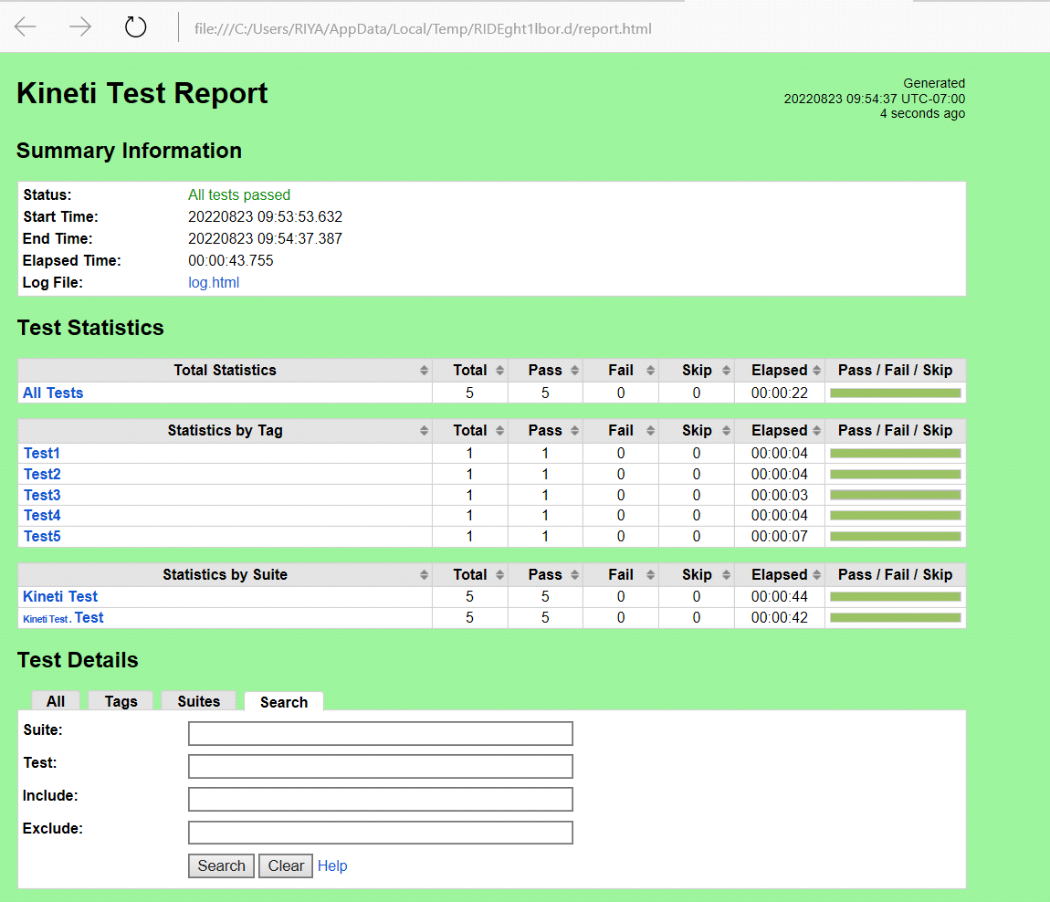

*In-built LOGS*

